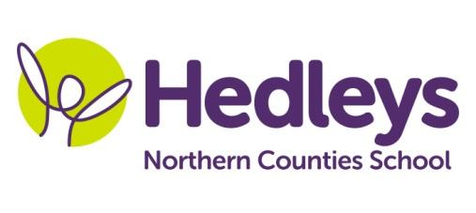
Winter Newsletter 2018 -19
Dear Parents and Carers,
It was lovely to see all the pupils back after the Christmas break and hear all about what they had been doing during the festive period. All the pupils have settled in quickly and are already working on our new topic; ‘Popular Culture’ with the topic learning goal; to take part in a range of game shows such as ‘Fun House’ and ‘The Great British Bake Off’ during Enrichment week. This topic will be embedded throughout the whole curriculum.

This term, pupils will continue to do lots of community based learning, including practicing using public transport and continuing to develop communication and numeracy skills in a functional community setting, by visiting a range of cafés on Monday afternoons and supermarkets on Tuesday afternoons. We will be continuing to visit a range of local parks and museums on a Thursday afternoon as part of our humanities curriculum. Please ensure that pupils come to school on these days with appropriate clothing and footwear for the activity and the weather.

Pupils will continue their individual swimming lessons on a Friday and will take part in PE on a Thursday. Please ensure that you provide appropriate swimming attire and a towel for this lesson. We can keep these at school and wash them each week.

We will be investigating electricity during science lessons, identifying items that use electricity and carrying out practical experiments identifying the effects of static electricity. We will be working towards identifying place value within maths sessions by making place value biscuits. In art this term we will be exploring the topic of television advertising and creating our own versions of popular advertising from the past 40 years.

In speech and language therapy sessions we will continue to develop each pupil’s communication skills, social skills and relationships through their preferred method of communication (verbal, sign, PECS, VOCA and gesture) in a variety of motivating sessions throughout the week based around popular quiz shows and board games. These areas will be targeted in a range of group and individual settings and will be reviewed throughout the year to ensure we are provided appropriate and effective input.

In occupational therapy sessions this term the pupils will continue to develop their independence in different areas such as self-care and community access. Individual occupational therapy sessions will focus on each pupil’s level of independence and building on this. Each pupil will also engage in any relevant sensory programmes to develop self-regulation using activities that each pupil is motivated by. These targets will be worked on using both group and individual sessions enabling opportunity to review and change sessions to ensure the pupils are being provided with opportunity to meet full potential.

Please don’t hesitate to contact us on p.stephenson@percyhedley.org.uk (teacher) s.garrity@percyhedley.org.uk (Occupational Therapist) l.allport@percyhedley.org.uk (Speech and Language Therapist)
Best wishes,
Peter and the class team

