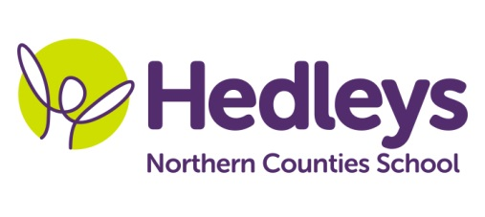
Autumn Newsletter 2018-19
Dear Parents and Carers,
Welcome back, we have all been really pleased to see the children back at school following our summer break, full of smiles and enthusiasm.
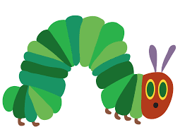
Staff working in our class this term are Penny (teacher of the Deaf), Kelly (artist in residence), Brett (BSL tutor), Poppy (Speech and Language Therapist), Asia (Occupational therapist), Mandy (Higher Level Teaching Assistant), Laura (Specialist Support Assistant) and Steff/Michelle (therapy assistants).
Our topic this term is Food which will help us find out about the world around us and how we can how we can stay healthy by eating well and looking after our bodies.
In literacy we will be working on our communication, reading and writing, reading stories such as ‘The Very Hungry Caterpillar’. Extending the success of ‘The Gingerbread Man’ last term, we will be making our own books both fiction and non-fiction about and which foods are healthy to eat. We will be linking this into our food technology sessions by making a variety of soups and salads.
In maths we will continue working at our own individual pace with our knowledge of number and time (calendar – days, months) and we will be also be having lots of fun using the outdoor environment to explore numbers in context in our communication in the community sessions. We will also be using comparison vocabulary such as same as, different, big, middle, little, tiny, long and short. We will also be using a variety of practical activities and learning about 2D and 3D shapes in space and measure.
We will continue to be using ICT throughout our learning and in our science work will be performing simple tests and classifying and sorting animals and foods, looking at growth, basic needs and exercise, food and hygiene.
Poppy our speech and language therapist will be continuing individual SaLT programmes over the year, developing our language and communication in a range of settings, through a combination of group and individual sessions
Asia our occupational therapist will be working on further development of student's independence skills and these will be encouraged throughout the school day. During relevant sessions, students will work on their fine motor and gross motor skills including balance and body coordination. This term's food topic provides fantastic opportunities for food exploration. Integrated work will continue to facilitate achievement of individualised, child-centred goals.
Kelly will also be linking our topic into our art work where we will be using different types of materials and art techniques to make a huge variety of objects linked to our topic work.
As you can see we already have lots planned. We are all looking forward to this term and are planning to keep the children really busy learning lots of new things. If there is anything you wish to discuss please feel free to contact me – email p.johnson@percyhedley.org.uk or telephone me.
With best wishes
Penny and the team

