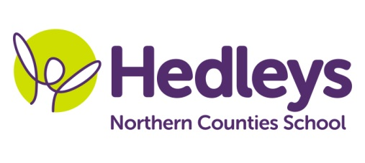
Winter Newsletter 2018-19
Dear Parents and Carers,
Welcome back, we have all been really pleased to see the children back at school following our Christmas break, full of smiles and enthusiasm.
Two new members of staff join our team this term – we welcome back Michelle Hunter SSA from her maternity leave and also as Kelly has jetted off to pastures new, we look forward to working with Lauren Tate who is our new art teacher and has lots of great new ideas planned for us.
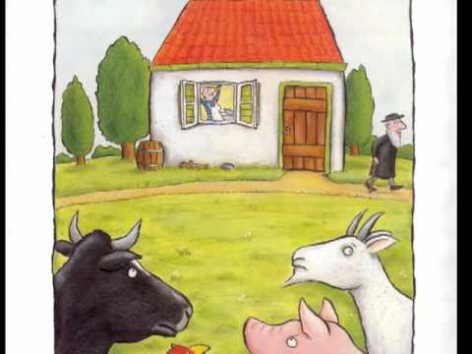
Our topic this term is ‘Homes and houses’ which will help us find out about the world around us and how our houses are ‘similar but different.’
In literacy we will continue to develop our English skills, working on our individual targets for communication, reading and writing, and our focus story will be ‘A squash and a squeeze’ by Julia Donaldson.
In maths we will be looking at properties of shapes – such as looking at how different shapes are used inside homes and in building homes. We will also continue working at our own individual pace with our knowledge of number and place value.
We will continue to be using ICT throughout our learning and in our science work we will be looking at the physics of electricity and how we use electricity in our daily lives. In RE Mandy will be helping us learn all about the different types of ‘Gods houses’ and different faiths. Lauren will also be linking our topic into our art work where we will be designing houses, fairy houses, using a variety of mixed media and junk modelling. Kerry will continue to develop our PE and swimming skills and Pamela will be teaching us lots of different rhythms and songs linked to our topic.
Poppy our speech and language therapist will be continuing with our individual SaLT programmes, developing our language and communication in a range of settings, through a combination of group and individual sessions. Brett will also be working in paired and 1-1 sessions for focused BSL. Asia our occupational therapist will also be continuing to work on our individual needs to develop our independence skills.
As you can see we already have lots planned. We are all looking forward to this New Year and new term and are planning to keep the children really busy learning lots of new things. If there is anything you wish to discuss please feel free to contact me – telephone or email p.johnson@percyhedley.org.uk .
With best wishes
Penny and the team

