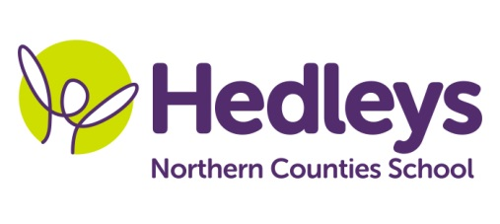
Winter Newsletter 2018-19

Dear Parents and Carers,
Welcome back and Happy New Year. We wish you a happy and healthy 2019. It was lovely to see the children on the first day back full of smiles.
This year our team remains much the same with Kim, Charlotte, Lisa, Nicola, Dawn, Lucy and Claire working 1:1 with the students. Our therapy team continues to be Nicola Leonard (SaLT), Michele McCafferty (OT) and Roz Middleton (Physiotherapist) who will be going on maternity leave next week to be replaced by Sophia. We are also fortunate to receive support from Hannah Ashman (Music Therapist) and Steph Richards (SaLT assistant).
This term the class topic will be ‘Shops and Cafes’ and we have linked this theme very carefully into many sessions ensuring all of the senses are covered. The Interactive Story is The Tiger who Came to Tea, it will be led by Pam and we will be exploring a range of textures, sounds, smells and resources connected with the story. We will explore different textures and smells in sensory exploration and sensory art.
We will focus on the following areas of learning:
- Peer interaction – children will be supported to become aware of their peers and interact with them.
- The sensory room has now been finished and we look forward to accessing the magic carpet, bubble tube, fibre optics, sensory wall panel and other fantastic resources.
In speech and language therapy sessions we will continue to focus on engaging with peers in sessions such as; social games and intensive interaction. In addition, students will be continuing to focus on the development of ICT skills in partnership with the occupational therapist. This will develop skills in the areas of switching and eyegaze.
In occupational therapy sessions we will be working collaboratively with the physio and speech and language therapist on all targets during individual and group sessions. This includes ICT, postural management, upper limb and hand function.
In physiotherapy sessions we will continue to maximise the student’s physical activity throughout the curriculum including motor sessions, hydrotherapy and rebound. We are also keen to discuss and support the students being active in their home and leisure time.
Please don’t hesitate to contact us on p.wiltshire@percyhedley.org.uk
n.leonard@percyhedley.org.uk and m.mccafferty@percyhedley.org.uk

Best wishes,
Pam and the team

