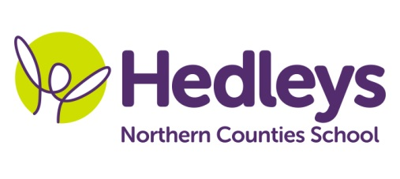
Winter Newsletter 2018-19

Dear Parents and Carers,
Welcome back, we hope you have had a lovely Christmas and Happy New Year. This year our team is Michelle Waugh, Vicky Hanson, Emma Lip, Amber McAvoy, Lindsey Nicholson, Claire McGinney Burke, Mahi Khanam, Fiona Alexander, Ellen Sankey, Emma Rogers, Rebecca Clark, Alison Lapman, Kori Johnson and Abi Cowie. Donna has commenced her maternity leave and Emily has left us for career development, taking up a Speech and Language Therapy post in Stockton. Our therapy team will stay the same, with Emily Searle and Gemma Cooke providing both direct and indirect therapy.
This term the class topic will be Popular Culture – Bake off! We will be using the book, ‘Charlie and the Chocolate Factory’ as a stimulus for learning. We will be looking at story structure, being able to use phonic knowledge to decode words, practising writing letters consistently and building sentences using PECS, VOCAs and speech. In Maths, we will build on last term’s work about understanding and telling the time, alongside increasing knowledge about numbers. Science work will fit into our topic, looking at exciting chemical reactions with confectionary, how liquids change to solids and how we can make a simple circuit.
Our speech and language therapist Emily will continue to work on individualised programmes with the students using their preferred methods of communication (PECS, symbol support, spoken language, shape and colour coding) through a combination of individual and/or group sessions and integrated target setting. Narrative therapy this term will be based on the story of The Three Little Pigs and will incorporate individual targets as well as developing expressive language skills and responses to different types of questions relating to the sequence of the story. Lego therapy will also continue in order to further develop social interaction skills through motivating play activities.
In occupational therapy sessions Gemma will continue to work on individual programmes within play skills sessions to develop social communication with peers as well as the fine motor skills group to develop self-help and independence skills. Sessions will be a combination of group and individual sessions that will include activities that aim to develop skills in relation to individual targets. Individual sessions will also include a combination of sensory and emotional regulation related activities providing students with opportunity to develop sensory and emotional regulation in order to ensure they remain regulated enough for learning.
Please don’t hesitate to contact us on alee@percyhedley.org.uk or m.waugh@percyhedley.org.uk
Best wishes,
Michelle, Abi & the Team

