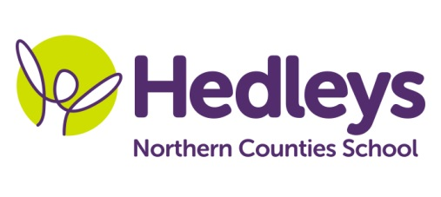
Autumn Newsletter 2018-19

Welcome back!
All of the students in our class have made a fantastic start to the term. They have come back from their holidays with excellent attitudes and have been working hard already. Long may it continue!
Welcome to Euan who is new to our class after a successful induction towards the end of last term. Our class group now includes; Aaron, Callum, Deacon, Euan, Jake, Michael and Millie.
We welcome some new staff into the team this year, too. Tiffany, Nancy and Tracey join our team. Many of the staff team for September 2018 were with the students last year; Nichola, Brooke, Jooli, Colin, Carrie and Rachel.
Our speech and language therapist, Emily, will continue to work on and develop individualised programmes with the students using their preferred method of communication (BSL, VOCAs, symbol support, verbal language). This may take place on an individual basis and/or through group sessions, such as smiLE (strategies and measurable interaction in Live English), where students are supported and encouraged to develop their skills in interacting with unfamiliar hearing adults that do not sign within a variety of school and community settings.
Julie Osborne and Asia Koszuta are our occupational therapists this year and will focus on working in class during sessions, promoting fine motor skills, independence and emotional regulation.
Gemma James is our named physiotherapist this year and will continue to work on individual therapy programmes. Mary Kay is the physiotherapist who will be continuing the group therapy work.
Our Topic for this term is ‘Self Advocacy’. Self-advocacy means you know your rights and responsibilities, you speak-up for your rights, and you are able to make choices and decisions that affect your life. The students in our class will be exploring the Topic under the title ‘Me My Needs, My Rights, My Responsibilities.’ They will be exploring ways to ask for what they need and want and tell people about their thoughts and feelings.
We will continue to work on developing their functional reading and writing skills and develop life skills in all areas of the curriculum. Many of the students will be working towards the ASDAN ‘Personal Progress’ Entry 1 accreditation.
Please do not hesitate to contact me via the home school diary, by phone or email: m.tyreman@percyhedley.org.uk . I will not be working on a Tuesday this year. Please contact Claire Ramsey on these days if you need to get in touch.
Best wishes
Mairead Tyreman
(Teacher of the Deaf)

