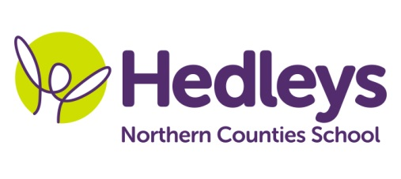
Autumn Newsletter 2018-19

Hello Everyone,

I hope everyone has had a fantastic summer holiday. The students have come back full of exciting stories from their time off it has been lovely to hear they have done so much.
My class has had a few changes this year. Firstly we have moved classroom and are now located at the back of the school hall. Secondly we welcome a new support assistant into the class, Abbey Colquhoun. Abbey is a fantastic signer and will be a great addition to myself, Lisa, Becky and Kate.
We are going to be working more thematically this year across the curriculum meaning the students will have an overall topic that will flow throughout all of their lessons. Our topic for this term is Inventions and we will cover this in the different subjects as follows:
Literacy – Charlie and the Chocolate Factory
Science – Solids, liquids and gases
Maths – We will continue to develop our skills in all areas of maths
Computing – Creating a computer game
Humanities – Inventions and Inventors
Art – Charlie and the Chocolate Factory (through art activities)
Poppy Welsh our speech and language therapist will be continuing individual SaLT programmes over the year, developing our language and communication in a range of settings, through a combination of group and individual sessions. In smiLE we will be building on the skills learnt in our café module last year and learning how to make more complex requests, for example a sandwich in a shop.
Occupational therapy this term, with Julie Osborne, will centre around small group work focusing on fine motor skills with a link to the Charlie and the Chocolate factory theme and small group work based on emotions and calming strategies.
If you need to contact us about anything please do not hesitate to call on 0191 281 5821 or to email us: h.blakelock@percyhedley.org.uk, j.osborne@percyhedley.org.uk and p.welsh@percyhedley.org.uk

Best wishes,
Helen and the Class Team

