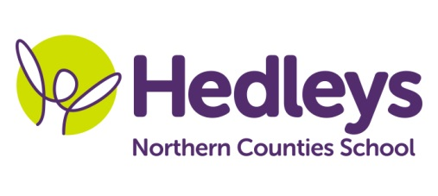
Winter Newsletter 2018-19

Dear Parents and Carers,

I hope everyone has had a fantastic Christmas. The students have come back ready to work and well rested.

Our new topic this year is ‘People’ and we will cover this in the different subjects as follows:

- Literacy – Greek Myths and Legends
- Science – Electricity
- Maths – we will continue to develop our skills in all areas of maths
- Computing – Creating a map for the beebot
- Humanities – Greece and Greek Gods
- Art – Greek Mythology (through art activities)
- Food Technology – Greek food
- PSHE – personal care and body changes

Poppy Welsh our speech and language therapist will be continuing individual SaLT programmes over the year, developing our language and communication in a range of settings, through a combination of group and individual sessions. In smiLE we will be building on the skills learnt in our ‘subway’ module to generalise to other sandwich shops. We will also be looking at appropriate and inappropriate behaviour when out in a coffee shop or sandwich shop.

Occupational therapy this term, with Julie Osborne, will continue our small group work focusing on fine motor skills emotions and calming strategies. She will also be helping us in our personal hygiene topic to be able to complete personal care tasks more effectively and independently.

If you need to contact me about anything please do not hesitate to call 0191 2815821

Helen and the Class Team

