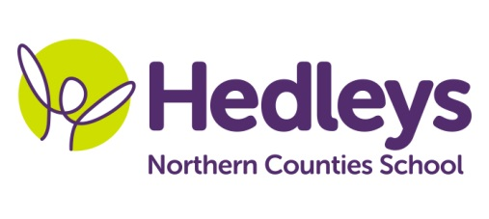
Winter Newsletter 2018-19

Dear Parents and Carers,
Happy New Year to you all. I hope you all had a lovely Christmas and did not over indulge too much!!! It was lovely to hear all about the pupil’s holiday news and what their favourite presents were.
This year our team is (HLTA) Megan, (SSA) John, Joanne, Gemma, Julie, Gemma E and Rosie.
This term the class topic will be ‘Popular culture ‘with a theme based around ‘Gameshows’ and ‘The great British bake-off’.
Maths will be developing skills in shape and space, number and place value. Pupils will also continue to extend their knowledge in recognising the correct coins to purchase items on their shopping list.
Our literacy focus will be familiarising ourselves with key stories such as Charlie and the chocolate factory and the gingerbread man where pupils will extend their vocabulary using their preferred means of communication to complete the tasks such as PECS, BSL signing, writing or a combination. Pupils will also continue to work on their individual programmes.
Within science sessions we will be exploring the topic of hot and cold through completion of fun and exciting experiments and experience using a wide range of scientific equipment.
The end of the topic will see the Hillcrest centre coming together to compete in the Enrichment competition where each class will take part in a game show event, with a range of shows to participate in, including a Bake-off event.
Within a variety of speech and language therapy and occupational therapy sessions we will be focusing on developing our play skills, social communication, engagement and behaviours for learning. Students will continue to access a range of group and community based sessions within therapy.
Please don’t hesitate to contact us on the below emails should you need to
crawlinson@percyhedley.org.uk
s.garrity@percyhedley.org.uk
c.lyndsey@percyhedley.org.uk

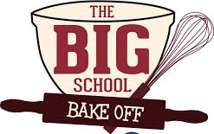
Best wishes.
Carol and Team

