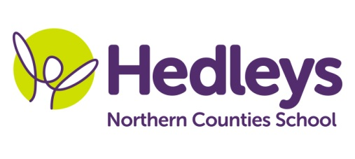
Autumn Newsletter 2017

Welcome back!
We hope that you have all had a lovely summer break and enjoyed some rest and relaxation during the holidays. It is great to be back into school and lovely to see the children again. We missed them!
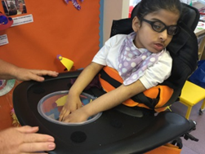
Our topic this term is ‘The Ancient World’ and we have once again linked this theme into many of our sessions throughout the week. The interactive story will be led by Ashleigh (SaLT) and is based on the Greek myth of Perseus and Medusa and as always we will be using a wide range of sensory resources to make the story much more exciting and meaningful for the children. During sensory exploration sessions we will be exploring resources linked to Ancient Egypt, the Roman Empire and Ancient Greece and creating artefacts and models based on the art and culture of those times. We will also be exploring some recipes and food from the past!
Our physical activities continue as before, with the children working on individual programmes in class each day as well as hydro, rebound, hand function and posture groups. Music lessons will focus on making instrument choices, keeping rhythms, locating sounds and tracking the movement of sounds in the room.
We are very pleased to welcome Amy Sibley, Julie Munson and Claire Logan into the class team and we hope you will get to know them very soon. Ashleigh Laidlaw has returned from maternity leave and will take over as class SaLT. Gemma James is the physio for our group and Michele McCafferty continues as OT.
As always please do not hesitate to get in touch if you have any questions or things we need to know. Please contact us at any time by telephone or email,
f.henderson@percyhedley.org.uk, p.wiltshire@percyhedley.org.uk

Thank you all for your continued support.
With best wishes
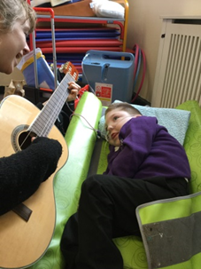
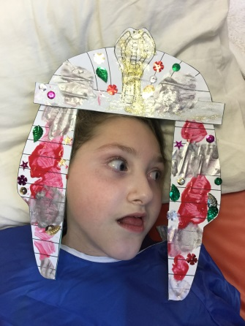
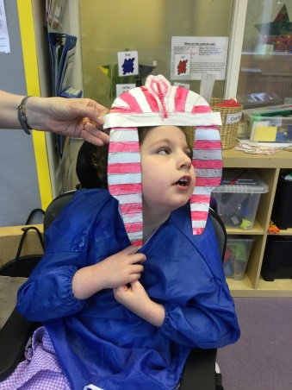
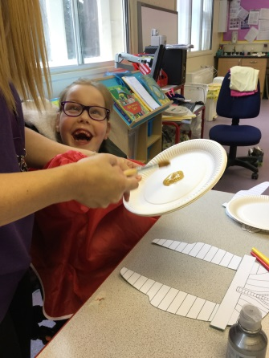
Frances, Pam and the team

