

Attendance Policy

Attendance Policy

Policy Review
This policy will be reviewed in line with the Mosaic Federation policy review cycle.
The policy was last reviewed and agreed by the Governing Board in Autumn 2024
It is due for review in Autumn 2026

Head Teacher: | Date:
Chair of Governors: | Date:
Vice Chair of Governors: | Date:



Attendance Policy

Key Aims

School is committed to providing a full and successful education for every child so that they achieve the best possible education, establish good and lasting relationships with their peers and are well prepared for Key Stage 3 and beyond. Regular and punctual attendance is both a legal requirement and crucial for pupils to maximise the educational opportunities available to them. To achieve this, staff in school work closely and fully support all parents and families to establish the strong home school links and communication systems to underpin these. Staff are committed to working in partnership to strive to achieve a minimum of 96% attendance throughout school.

Rationale
This policy is designed to adhere to the expectations of the document:

The government expects school to:

- Develop and maintain a whole school culture that promotes the benefits of high
attendance.
- Have a clear school attendance policy which all staff, pupils and parents
understand.
- Accurately complete admission and, with the exception of schools where all pupils
are boarders, attendance registers and have effective day to day processes in place
to follow-up absence.
- Regularly monitor and analyse attendance and absence data to identify pupils or
cohorts that require support with their attendance and put effective strategies in
place.
- Build strong relationships with families, listen to and understand barriers to
attendance and work with families to remove them.
- Share information and work collaboratively with other schools in the area, local
authorities, and other partners when absence is at risk of becoming persistent or
severe.

We will work collaboratively with families to:
EXPECT
Aspire to high standards of attendance from all pupils and parents and build a culture where all can, and want to, be in school and ready to learn by prioritising attendance improvement across the school.
MONITOR
Rigorously use attendance data to identify patterns of poor attendance (at individual and cohort level) as soon as possible so all parties can work together to resolve them before they become entrenched.
LISTEN AND UNDERSTAND
When a pattern is spotted, we will discuss with pupils and parents to listen to under
stand barriers to attendance and agree how all partners can work together to resolve them.
FACILITATE SUPPORT
Remove barriers in school and help pupils and parents to access the support they need to overcome the barriers outside of school. This might include an early help or whole family plan where absence is a symptom of wider issues.
FORMALISE SUPPORT
Where absence persists and voluntary support is not working or not being engaged with, we will work with families to explain the consequences clearly and ensure support is also in place to enable families to respond. Depending on the circumstances this may include formalising support through a parenting contract or education supervision order.
ENFORCE
Where all other avenues have been exhausted and support is not working or not being engaged with we will action this policy to address low attendance.

Procedures

Parents/carers will:

- Perform their legal duty by ensuring their children has regular and punctual attendance.
- Notify school on the first day of absence before 9.30am by phone/letter and inform the school of every subsequent absence. If your child is absent from school without the school being informed, staff will ring home or send a text message to ascertain reason for absence. Please note that informing school of the absence will not automatically result in the school authorising this absence.
- Provide medical evidence when requested (Medical evidence can take the form of prescriptions, appointment cards, etc. rather than doctors’ notes)
- Meet with Head teacher, Attendance Team, Local Authority Attendance Officer to discuss their child’s attendance and/or punctuality when requested.

Staff will:

- Complete register at the start of each session please note that each day is two separate sessions (morning and afternoon).
- Contact parents or another family member (who are on the contact list) to ascertain reason for absence.
- Monitor attendance/punctuality and take appropriate action, this includes sending out reminders, warning letters, unannounced home visits and inviting parents and families in for attendance meetings. This procedure is detailed further on in this policy.
- Where appropriate home visits will take place to bring the child into school.
- Celebrate improvements in attendance and punctuality.
- Make referrals to the Attendance Monitoring Team where appropriate, when attendance/punctuality is a serious cause for concern or no improvement has been noted.
- Provide the Attendance Monitoring Team with attendance/punctuality details, as required.
- Will monitor attendance over a 2 year period in line with new legislation introduced from 19 August 2024

Pupils:

- Are listened to and respected by all staff.
- Have individual records of attendance and punctuality acknowledged by the school.
- Will be welcomed back and receive assistance following periods of absence.

Local Authority Attendance Monitoring Officer will:

- Provide good communication and sharing of effective practice
- Organise targeted support meetings with the school and parents/carers
- Take part in multi-disciplinary support for families
- Provide legal intervention
- Monitor and improve the attendance of children with a social worker through their virtual school head.

Registration

The register is a legal document and must be marked accurately, recording pupils’ attendance or absence and in the latter case if authorised or unauthorised. An authorised absence is still an absence and will ultimately affect the overall percentage for attendance. A certified extract from the register can be used in legal proceedings against parents for failing to ensure their child’s regular attendance. Registers must be kept for a minimum of three years following completion at the end of the academic year.
- A manual registration system is used.
- Registers are marked in ink and where alteration is necessary this must be clearly identified showing both the original entry and the change. Correction fluid must not be used.
- Staff are made aware of the registration process as part of our induction procedure and it is detailed in the Staff Handbook.
- Every pupil should be called by name when the register is taken.
- Registers are returned to the school office at the end of the registration period for safety and will be secured but accessible in case of an emergency.
- The administrative team log attendance information onto the Pupil Management Information System and ensure that registers are kept safely and available for inspection by relevant professionals. Notes from parents regarding pupil absence are stored and retained for 3 years.
- Up until closure a child can be marked late but should still report to the office.
- If a pupil arrives after a register has closed, they and their parents should report to the school office so that time of arrival and reason for lateness can be noted in the late book.
- A pupil arriving after the register has closed without an acceptable reason will be marked unauthorised absence for that session.
- Doors open at 8:45am and close at 9.05am registration is 8.45am to 8.50am, anyone arriving after this time will be marked as late. Anyone arriving after 9.30am will be marked as an unauthorised absence. Registration for the afternoon session is 12.30pm for Nursery, 1:00pm for Reception & KS 1; 1.00pm KS2 each school day and register close 35 minutes after these times, both morning and afternoon sessions.

The Attendance Team is responsible for attendance issues and liaises regularly with class teachers and the Head teacher to identify and discuss any attendance / punctuality concerns. Support is provided to the parents and families to help with any attendance issues. The Attendance Team will work closely with parents/families and where appropriate outside agencies to help overcome any barriers to pupils attending school.

Procedures for children with attendance/punctuality concerns:

- Attendance is tracked every half term, with each child from reception to year 6 coded into very clear ‘traffic light’ zones. The red is classed as the danger zone- below 90%, Amber is the at risk zone- 90%-94.9% and green is the safety zone - 95%-100%.
- All parents/carers will be informed of concerns regarding their children’s attendance and punctuality at parent’s evenings or via the attendance team.
When children have been identified on the attendance tracker or class teacher has raised concern about attendance or punctuality, the following procedures will be followed:

- Where a pupil is persistently late the school will write to the parent/carer reminding them of their responsibility to get their child to school on time and prepared for school and if there is no improvement the school will write to the parent/carer inviting them to a school based meeting. The school may also make an unannounced visit home to parent/carers.
- Attendance is monitored and recorded in procedures tracking and attendance monitoring file by the Attendance Team and Head teacher every half term and by the Local Authority every term.
- Parents are notified by the school by phone call or letter if their child’s attendance falls below 95%.
- A formal warning, in the form of a letter or an invitation to attend a meeting in school will be issued if a child’s attendance falls below 90%. We recognise attendance below 90% may not mean a significant amount of time has been missed early in the school year however, evidence shows that those children below 90% within the first half term will continue to have attendance issues for this reason letters will be sent as soon as this threshold is breached. This letter may ask that medical evidence is provided for any subsequent absence.
- If attendance does not improve, parents are invited to a school meeting and our Attendance Monitoring Officer from Local Authority, Services for Young People may attend, at this point an attendance plan might be devised.
- If there are 10 unauthorised absences in any 10 week period a referral will be made to services for young people, attendance monitoring team for enforcement action.
- All unauthorised holidays or suspected holidays that have been taken, will be referred to the Attendance Monitoring Officer from Services for Young People, which can result in a penalty notice.

Please see appendix 1 and Appendix 2 for the flowchart of procedures.

Unauthorised absence
Absences will be unauthorised in the following circumstances:

- After two illnesses in a three week period the third absence will be unauthorised or if a child has been absent for 5 days or more subsequent absences will be unauthorised, until medical evidence is provided.
- If a child’s attendance falls below 90% and reasons for absence are not sufficient or patterns of absence are evident.
- Where there are attendance concerns already highlighted absence will be unauthorised without medical evidence being provided.
- Where an element of doubt is raised for the reason for absence. Absence will be unauthorised. For example, when a member of staff witnesses the child fit and well.

Authorisation of absence

Absence for the following reasons could be authorised where parents have advised school of the absence by telephone or in writing on the child’s return to school (consideration will be given to procedures where parents have difficulty with the written word, or where English is not the first language):
- Illness (Please note, where this is classed as persistent, then medical evidence can be asked for in order to authorise the absence.)
- Religious observance, only the actual day of the religious observance will be authorised.
- Terminal illness of an immediate family member (proof will be required)
- Transport arranged by the LEA has failed to arrive where the pupil lives beyond statutory walking distance.

HOLIDAYS
Important Information for Parents/Carers
Changes as of 19th of August 2024 to the issue of Penalty Notices to address School Attendance.

THE EDUCATION (PENALTY NOTICES) (ENGLAND) (AMENDMENT)
REGULATIONS 2024 No. 210.

New legislation comes into force on 19.08.24 regarding the criteria and the issue of penalty notices to address school attendance to commence in South Tyneside September 2024.
The following changes have been made:
• the number of unauthorised absences to 10 unauthorised absences (5 days) in the most recent 10 school week period.
• the number of penalty notices that can be issued to a parent in respect of the same individual child to 2 within a 3-year period.
• It increases the amount of the penalty notice from £120 to £160 (if paid within 28 days) and £60 to £80 (if paid within 21 days) for the first penalty notice issued to a parent in respect of the same individual child in a 3-year period.
• It sets the amount of any second penalty notice issued to the same parent in respect of the same individual child within 3 years of the date the first penalty notice was issued to £160 to be paid within 28 days. No discount is offered.
• Further absences will proceed for prosecution in the Magistrate Court for the same parent in respect of the same child within 3 years of the date of the first penalty was issued.

Further information can be found at:
https://www.gov.uk/government/publications/working-together-to-improve-school-attendance
Email SYP@southtyneside.gov.uk

Also see the poster which is on display in our school in Appendix 3
Letter communicated to parents 3 times before the 19 August in Appendix 4

Holidays
From September 2013, Head teachers are no longer able to authorise absence from school for the purpose of a family holiday.
School will only consider a leave of absence during term time in exceptional circumstances for example to visit with a family member that is terminally ill (proof will be required) or for armed service personnel families where parents have been on active duty during holiday periods.
Parent/carers will be expected to take holidays during school holiday periods these can be found at:
Hedworthfield Primary
https://www.southtyneside.gov.uk/article/36915/Hedworthfield-Primary-School
Valley View Primary
https://www.southtyneside.gov.uk/article/37695/Valley-View-Primary-School
Holidays taken during term time will not be authorised.
- Where families have siblings attending other schools the school office will liaise with the other school to inform them of their decision not to authorise a holiday request.
- Different schools will have different attendance policies however this policy will still apply even if another sibling’s attendance has been authorised.
Penalty Notices in relation to unauthorised holidays will be issued by the Local Authority. The Penalty is £160 per parent, per child, discounted to £80 if paid within 21 days of receipt of the notice, rising to £160 if paid after this time but within 28 days.

If the Penalty Notice is not paid in full by the end of the 28 day period, the Local Authority will prosecute for the original offence of failing to secure the regular attendance of a child at school under Section 444 of the Education Act 1996 for non-attendance Notices.

Reporting attendance

The school have a statutory duty to report all attendance to the local authority. This includes unauthorised absences, including holidays. The local authority, school attendance monitoring team will enforce all unauthorised absences of 10 sessions or more.

If there is an extensive period of absence due to medical reasons the school or the Attendance Monitoring Officer may ask for the permission of the parent/carer to contact the child’s GP/ school nurse to confirm that the medical condition prevents the child from attending school and to establish a possible return date for the child. If there is no confirmed medical reason for the individual’s absence given by a General Practitioner, then the absence will be unauthorised by the school. Policy and procedures given by the Local Authority following any unauthorised absences will then be adhered to.

Penalty Notice Warnings

Penalty Notice Warnings are intended to provide an early intervention to deter patterns of unauthorised absence developing. Parents and pupils are supported both at school and at Local Authority level to overcome irregular attendance to hopefully prevent this.
Circumstances in which a Penalty Notice Warning would be a suitable intervention include:
- 10 or more unauthorised sessions in a 10 week period.
- Persistent lateness.

Penalty Notice Warnings are to be issued by Services for Young People in South Tyneside

From 19.8.24:
The rules for term-time holidays have changed. Penalty notices can now be issued for 10 sessions of unauthorised absence within a 10-week period, even if those sessions are not consecutive. So, if you have 10 individual days of unauthorised absence within that timeframe, it would meet the criteria for a penalty notice.

Strategies for promoting attendance/punctuality:

- In the belief that pupils are more likely to attend regularly if the curriculum is lively and meets their needs, the curriculum is regularly reviewed.
- 100% attendance is rewarded each half term with a certificate and a small gift. Children can earn 100% attendance at any point of the year, so for example they might not achieve it for the first half term but still have the opportunity to be awarded the next half term, if they have full attendance. Children have the opportunity to earn up to 6 certificates and 6 gifts throughout the whole school year.
Communication with parents

- Attendance statistics are collected and used to inform pastoral and curriculum practices. Expectations are made clear to parents with regard to attendance and punctuality in the Home School Agreement, and School prospectus. Attendance figures for each class will be published on the school website.
- Opportunities to maintain awareness of attendance and what constitutes authorised and unauthorised absence, through telephone calls, parents’ evenings and pupil reports are used. Pupils with known attendance concerns may be set targets for improvement.

Child Missing from Education

Schools have a safeguarding duty (under section 175 of the Children Act 2002), in respect of all pupils and as part of this, should investigate any unexplained absences.

When the whereabouts of child is unclear or unknown, as recommended by the Children Missing Education (2016) guidance, school will complete and record one or more of the following actions:
- Make contact with the parent, relatives and emergency contacts held by school.
- Check with agencies known to be involved with the family.
- Home visits may be carried out
- Check school2school (s2s) systems
- Follow local information sharing arrangements and where possible make enquiries via other local databases and agencies e.g. school admissions, health services, police, children’s social care.

The list is not exhaustive or prescriptive and school will treat each case on its individual circumstances and use their judgement.

If, after 2 weeks (10 school days) the child does not return to school, the matter will be referred to the attendance team, services for young people, where the procedures for ‘missing pupils’ will be followed. If after 20 days the child does not return to school they will be removed from school roll.

The same applies when a pupil is expected to join the school and he/she does not arrive. The LA attendance team and CME officer must also be informed at the earliest opportunity, no more than 10 school days.

If there is a reason to believe a child is in immediate danger or risk of harm, a referral will be made to children’s social care, and police if required/appropriate.
Procedures outlined in Children Missing from Education will be followed.

Protocol for children not collected from school

If a child has not been collected from school, the school should make every possible attempt to contact the parent(s)/carer(s), if unsuccessful, relatives and emergency contacts held by school, will then be contacted.
A home visit may also be carried out.
If no contact has been made and no one has arrived to collect the child by 5pm, school will have to contact children’s social care.

Supporting documents:
- Working together to improve school attendance September 2024

https://assets.publishing.service.gov.uk/media/65f1b048133c22b8eecd38f7/Working_together_to_improve_school_attendance__applies_from_19_August_2024_.pdf

- Department for Education- School attendance, guidance for maintained schools, academies, independent schools and local authorities. September 2018,
- The Education Act 1996 - sections 434(1)(3)(4)&(6) and 458(4)&(5)
- The Education (Pupil Registration) (England) Regulations 2006
- The Education (Pupil Registration) (England) (Amendment) Regulations 2010
- The Education (Pupil Registration) (England) (Amendment) Regulations 2011
- The Education (Pupil Registration) (England) (Amendment) Regulations 2013
- The Education (Pupil Registration) (England) (Amendment) Regulations 2016
- The Education Act 2002
- Anti-bullying Policy
- Equality and Diversity Policy.
- Anti-social Behaviour Act 2003
- Children Missing From Education Policy and Procedures September 2019
- Keeping Children Safe In Education 2024

Appendix 1 Attendance

100 – 95% | No action, Parents will receive attendance updates at parent review meetings and whole class attendance results each week via DOJO.
90-94%  (without context) | Supportive telephone call home parents will be verbally advised that medical evidence may be requested.
Below 90%  (without context) | Medical evidence letters issued to parents. Parents invited into school for a meeting with the attendance team
Persistently below 90% with no improvement | Parents invited to attend a meeting with the attendance team and the Local Authority in school or at the Local Authority.
PNW | 10 absences in a 10 week period
Fine | Single absence in the 3 week PNW review period

Context could be an authorised holiday, bereavement or illness/operation supported by medical evidence.

Appendix 2 Attendance Flowchart
Attendance below 95%
Whole School Reception – Year 6
Nursery

Letter home

Half termly tracking conducted. Attendance below 95% without medical evidence – Supportive telephone call home.

Improvement
No Improvement

90 - 95%
Telephone call
95% +
90 - 95%
Tel call, parents may be invited into school to meet with the attendance team for a supportive meeting. Warning that medical evidence may be requested.
Below 90%
Medical evidence letters sent to parents.
Persistent
Absentee Meeting in school. With attendance team. Attendance monitored weekly.

Invitation to attend a meeting in school or at the Local Authority with the attendance team and a LA. attendance officer.

Appendix 3 Changes to Working Together to Improve Attendance August 2024

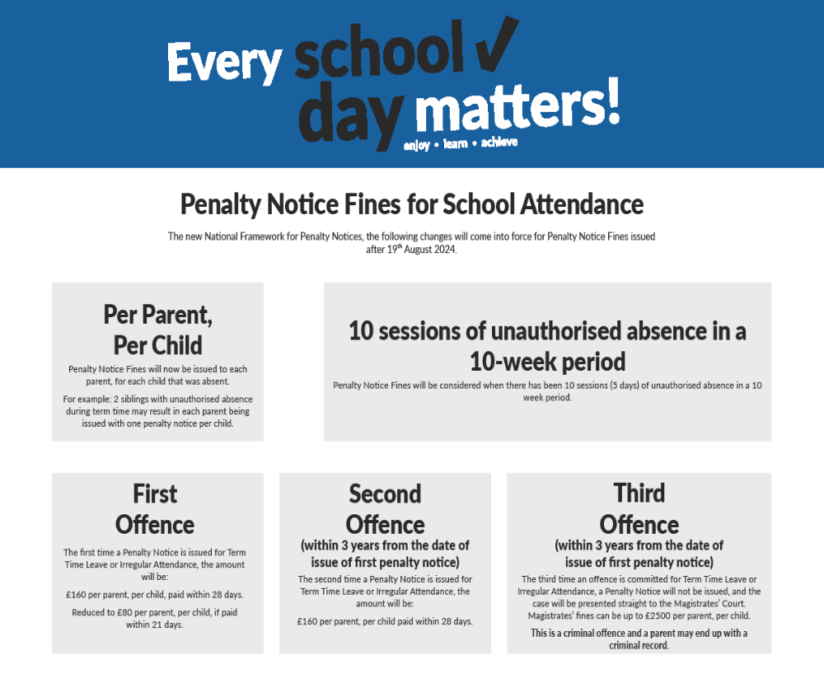

Appendix 4


Important Information for Parents.

Changes as of 19th of August 2024 to the issue of Penalty Notices to address School Attendance.

Dear Parent,

THE EDUCATION (PENALTY NOTICES) (ENGLAND) (AMENDMENT)
REGULATIONS 2024 No. 210.
New legislation comes into force on 19.08.24 regarding the criteria and the issue of penalty notices to address school attendance to commence in South Tyneside September 2024.
The following changes have been made:
• the number of unauthorised absences to 10 unauthorised absences (5 days) in the most recent 10 school week period.
• the number of penalty notices that can be issued to a parent in respect of the same individual child to 2 within a 3-year period.
• It increases the amount of the penalty notice from £120 to £160 (if paid within 28 days) and £60 to £80 (if paid within 21 days) for the first penalty notice issued to a parent in respect of the same individual child in a 3-year period.
• It sets the amount of any second penalty notice issued to the same parent in respect of the same individual child within 3 years of the date the first penalty notice was issued to £160 to be paid within 28 days. No discount is offered.
• Further absences will proceed for prosecution in the Magistrate Court for the same parent in respect of the same child within 3 years of the date of the first penalty was issued.
Further information can be found at:
https://www.gov.uk/government/publications/working-together-to-improve-school-attendance
Email SYP@southtyneside.gov.uk
You can ring/email your child’s school.
Yours sincerely,
Graeme Stobbs – Attendance Manager

