Maths with the National Curriculum
Mathematics is a creative and highly interconnected discipline that has been developed over centuries, providing the solution to some of history’s most intriguing problems. It is essential to everyday life, critical to science, technology and engineering, and necessary for financial literacy and most forms of employment.
A high-quality mathematics education therefore provides a foundation for understanding the world, the ability to reason mathematically, an appreciation of the beauty and power of mathematics, and a sense of enjoyment and curiosity about the subject. (National Curriculum, 2014)
Intent
At Hedworthfield we believe that all of our pupils can achieve in mathematics. We believe that at each stage of learning, children should be able to demonstrate deep, conceptual understanding of a topic and build on this over time. We want children to be able to not only become fluent and use the maths taught but to also be able to transfer and apply it in different contexts, being able to explain, prove, reason and problem solve.
Instead of learning mathematical procedures by rote, we want children to build a deep conceptual understanding of concepts which will enable them to apply their learning in different situations. We aim to provide a range of reasoning and problem solving activities which are weaved throughout each aspect of mathematics and help give it a real life context. This helps children to think critically, look at all of the possibilities, identifying patterns and rules which they can apply to other contexts.
Through mathematical talk, children will develop the ability to articulate, discuss and explain their thinking. We aim to expose all of our children to the correct mathematical language in order for children to learn and understand how to communicate mathematically, which supports our ‘cultural capital’ curriculum intent.
We aim to provide the children with the necessary resources to allow all children to access the curriculum and encourage them to use this where appropriate to explain their logic and reasoning.

Implementation
In order to fulfil our curriculum intent ensuring that every child gains a deeper conceptual understanding of a topic we aim to ensure our maths lessons are broad and balanced, allowing the opportunity to explore mathematical concepts in depth. To inspire children to be future mathematicians we provide mathematical experiences that engage the children and make them want to develop their learning further.
We use the White Rose Hub schemes of learning as a guideline for our medium and long term plans. We follow the White Rose Hub small steps and objectives to inform our planning ensuring that teaching is engaging and relevant to real life. Teachers provide activities which allow children to practice their fluency, reasoning and problem solving in every lesson through thought provoking-questions, arithmetic starters, misconception activities and through the main task they are set. Reasoning is evident in everything we do in maths and children encouraged are expected to prove they understand a concept, either verbally or through writing.

Maths curriculum links in the wider curriculum
To help embed the real life context of mathematics, we have made sure to provide meaningful opportunities to link maths throughout our broad and balanced curriculum. In history, children gain a sense of time. Through looking at people and events in the past, children develop a sense of chronology by using vocabulary relating to the passing of time and plotting events on a timeline. Within science and geography, there are strong links to statistics. Children hypothesise, gather and analyse data such as sorting categories into Venn and Carroll diagrams and recording data on bar charts and pie charts.

Coverage
Year 1
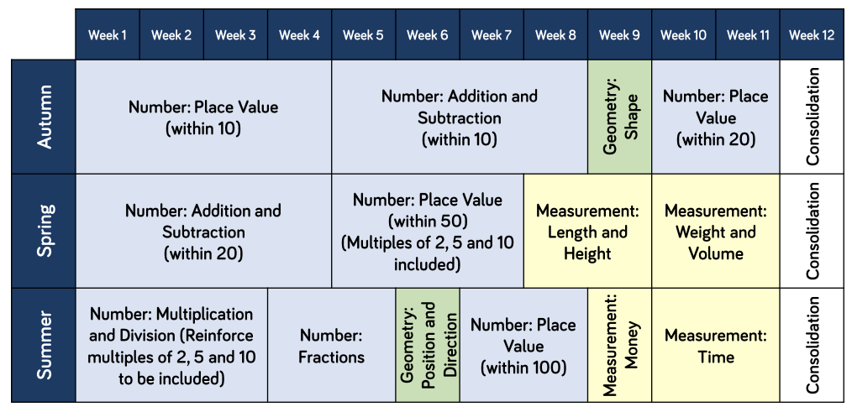
Year 2
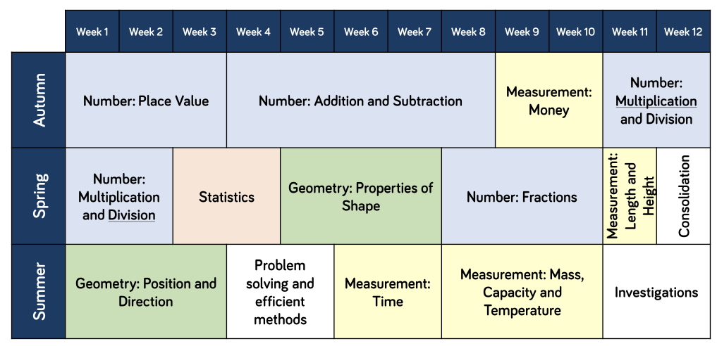

Year 3

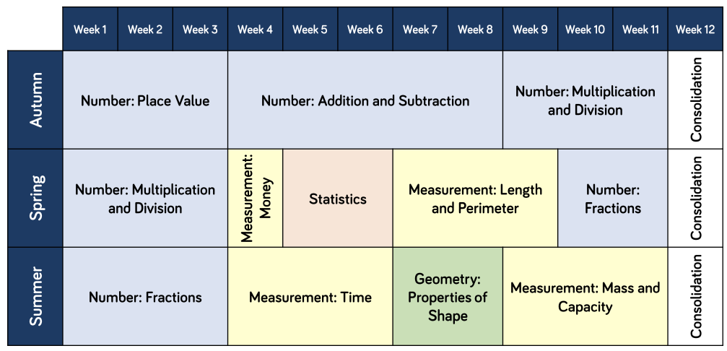

Year 4
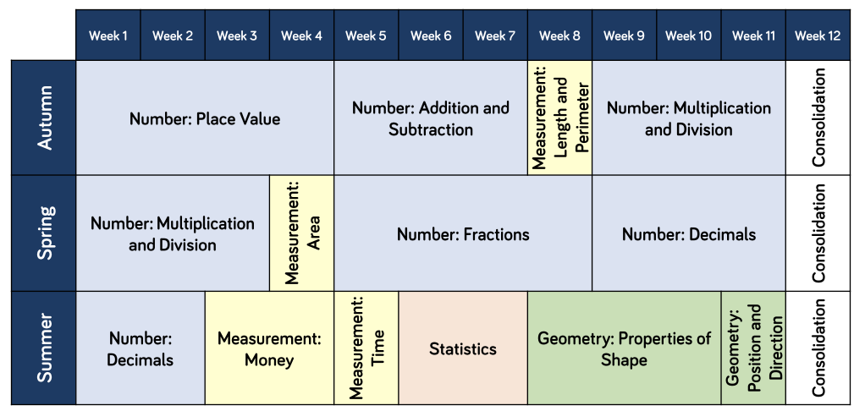

Year 5
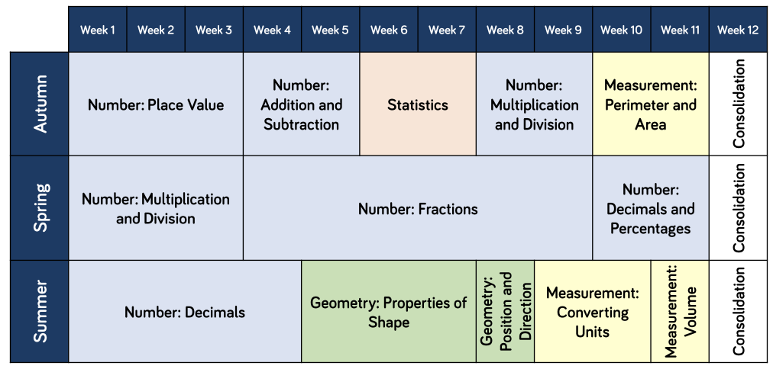
Year 6
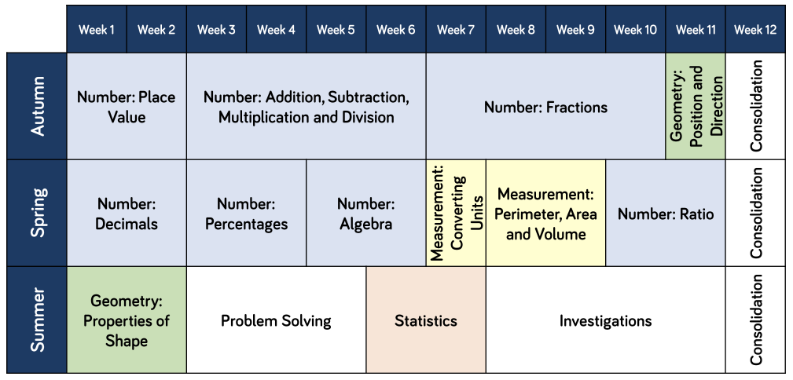

Impact
Teaching staff and support staff use a wide range of formative assessment tools during the lesson to judge the impact that the teaching is having on the children’s learning. Where it is evident that children have not developed a deep understanding of a concept, they will receive immediate intervention and/or verbal feedback. This is a chance for the children to work individually or in a small group; exploring the concept further and addressing any misconceptions that may have arisen. We identify children who would benefit from pre-teach intervention and where appropriate a concept is introduced to them in preparation for the next lesson. This approach is designed to allow the children to ‘keep up’ with their learning rather than having to ‘catch up’ and has a positive impact on the learning taking place.

To further measure the impact of maths teaching and learning we have introduced summative assessments at the end of each term. These assessments are designed to cover all of the work that has been covered during that term. This is a helpful tool to measure how deep the children have learned a concept when it is assessed out of context and at a later date to the initial teacher input. Question level analysis of these tests is then completed to measure impact and help inform intervention planning for the next term.
As a school we strive to ensure that our children’s attainment is in line, or exceeds, their potential when we consider the varied starting points of all our children. We measure this using a range of materials, whilst always considering the age-related expectations for each year group. Children will make at least good progress in Maths from their last point of statutory assessment and from their starting point in EYFS. We intend the impact of our Maths curriculum will ensure our pupils are academically prepared for life beyond primary school and throughout their educational journey. Through scrutiny of planning, lessons and books, we can be sure that progress is made across all year groups. If progress is not being made, support is immediate and steps are provided to ensure all pupils achieve and make progress.

TTRS
Mathletics
IXL

