

East Boldon Infant School

Calculation Policy

This policy has largely been adapted from the White Rose Maths Hub calculation policy with additional material added.
It is a working document and will be revised and amended as necessary.

Aims of this policy

This policy outlines progression through calculation strategies for addition, subtraction, multiplication and division in line with the EYFS Guidance and the National Curriculum. It also sets out a range of recommendations and effective practice teaching ideas for outstanding teaching and learning in maths. Through the policy, we aim to link key manipulatives (practical methods) and (visual) representations in order that the children can be vertically accelerated through each of the four strands of arithmetic. Having a school wide policy helps to ensure consistency of approach, enabling children to progress stage by stage through models and representations they recognise from previous teaching, allowing for deeper conceptual understanding and fluency. The policy is best used as the basis of planning along with the White Rose Maths Hub Scheme of Work. Always use Assessment for Learning to identify suitable next steps in calculation and if, at any time, children are making significant errors, return to the previous stage in calculation. As children move at the pace appropriate to them, teachers will be presenting strategies and equipment appropriate to children’s level of understanding. However, it is expected that the majority of children in each class will be working at age-appropriate levels as set out in the EYFS Guidance and National Curriculum 2014 and in line with school policy.

Maths Mastery

The idea that every child has the ability to succeed is at the core of the mastery approach to teaching mathematics. The curriculum should be the same for them, and instead of being expanded upon with new knowledge, they should work on difficult and varied issues to enhance their conceptual grasp. The same is true for arithmetic tactics; children need to show that they grasp the steps by using real objects and visual aids rather than just memorising them by heart. The many calculation techniques that our school should teach in accordance with the 2014 Primary National Curriculum's standards are outlined in this policy.

Mathematical Language
The 2014 National Curriculum is explicit in articulating the importance of children using the correct mathematical language as a central part of their learning (reasoning). Indeed, in certain year groups, the non-statutory guidance highlights the requirement for children to extend their language around certain concepts. It is therefore essential that teaching using the strategies outlined in this policy is accompanied by the use of appropriate and precise mathematical vocabulary. New vocabulary should be introduced in a suitable context (for example, with relevant real objects, apparatus, pictures or diagrams) and explained carefully. High expectations of the mathematical language used are essential, with teachers only accepting what is correct.
Addition- EYFS
Objectives | Concrete | Pictorial | Abstract
- Knows that a group of things change in quantity when something is added.  - Find the total number of items in two groups by counting all of them.  - Says the number that is one more than a given number.  - Finds one more from a group of up to five objects, then ten objects.  - In practical activities and discussion, beginning to use the vocabulary involved in adding.  - Using quantities and objects, they add two single digit numbers and count on to find the answer.  - Solve problems including doubling. | 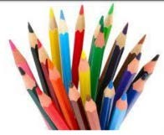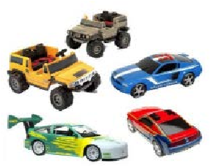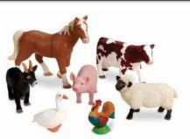  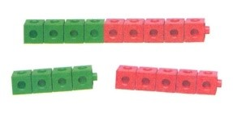  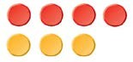  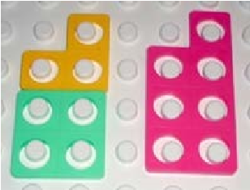    Use toys and general classroom resources for children to physically manipulate, group/regroup.  Use specific maths resources such as counters, snap  cubes, Numicon etc.  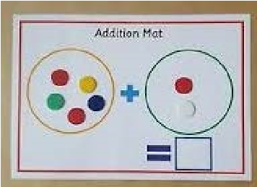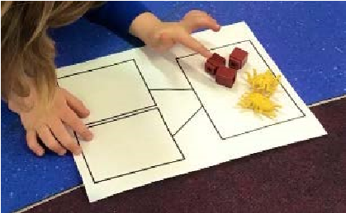  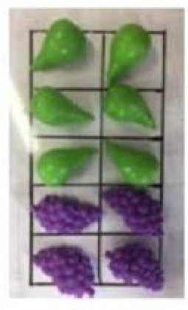  Use visual supports such as ten frames, part whole and addition mats, with the physical objects and resources that can be manipulated. | 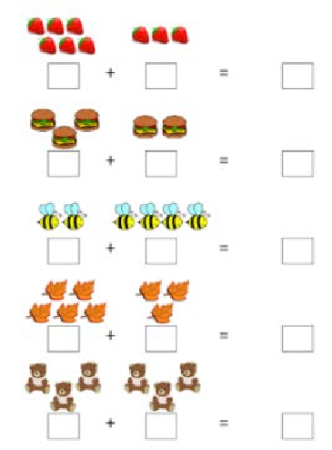  Two groups of pictures so children are able to count the total.  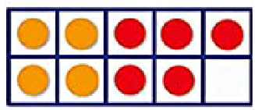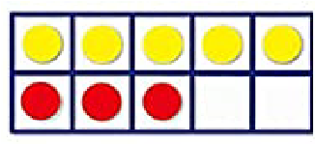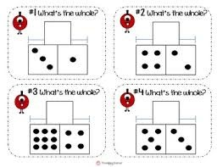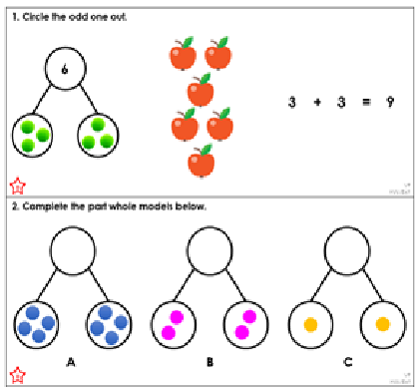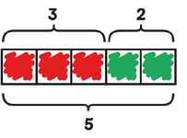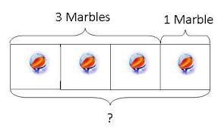  Use visual supports part part whole and addition mats with pictures/icons.  Bar model using visuals, pictures/icons or colours. | A focus on symbols and numbers to form a calculation.  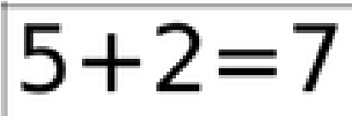  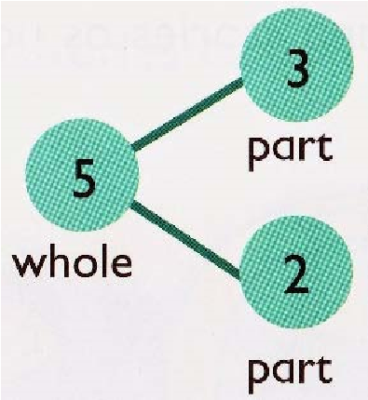  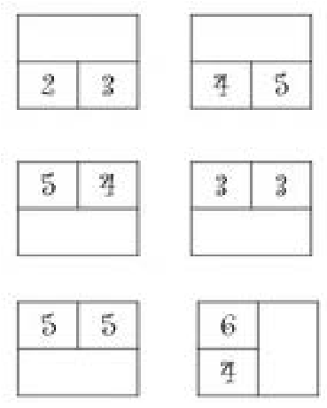  * No expectation for children to be able to record a number sentence/addition calculation.

 | Objective | Concrete | Pictorial |  | Abstract
Year 1 | Number bonds of 5, 6, 7, 8, 9 and 10 | 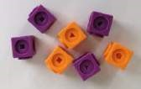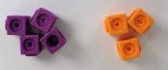  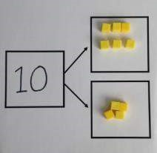  Use cubes to add  two numbers  together as a  group or in a bar.  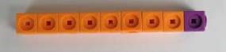 | 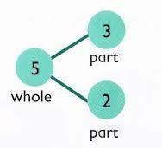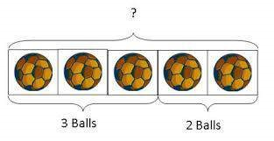    Use pictures to add two numbers together as a group or in a bar. | - + 3 = 5  - + 2 = 5  5 = 3 + 2  5 = 2 + 3  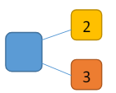 | Use the part whole diagram as shown below to move into the abstract.
    3 |   2
Year 1 | Counting | 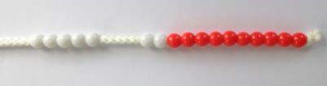  Start with the larger number on the bead string and then count on to the smaller number 1 by 1 to find the answer.  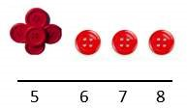 | Use a number line to count on in ones.  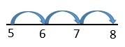 | 5 + 3 = 8

 | Objective | Concrete | Pictorial | Abstract
 | Regrouping to make 10 | 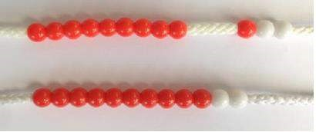  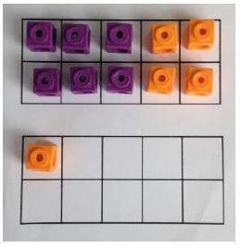  6 + 5 = 11  Start with the bigger number and use the smaller number to make 10. | 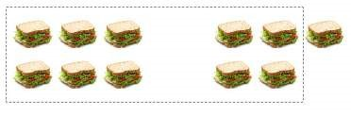  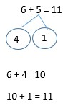 | 6 + 5 = 11
Year 2 | Adding 3 single digit numbers | 4 + 7 + 6= 17  Put 4 and 6 together to make 10. Add on  7.  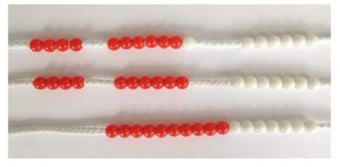  Following on from making 10, make 10 with 2 of the digits (if possible) then add on the third digit. |   +  +  +    +  +  Add together three groups of objects. Draw a picture to recombine the groups to make 10. | 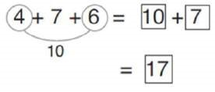  Combine the two numbers that make 10 and then add on the remainder.

 | Objective |  | Concrete |  |  | Pictorial |  |  | Abstract
Year 2 | Add across ten. |  | 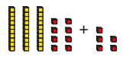  Use Base 10 to add crossing ten. |  |  | After using Base 10, Use a number line to add crossing ten.  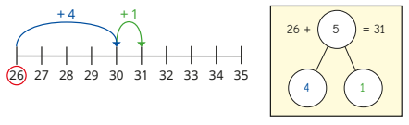 |  |  | 26 + 9 =  111111111  Add ones by partitioning 9 into ones.
Year 2 | Adding 2-digit numbers and multiples of ten. |  | Explore that the ones digit does not change.  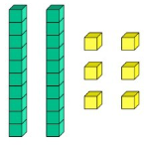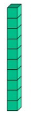  +  26 + 10 = 36  Explore adding other multiples of ten.  26 + 20 = 46 |  |  | 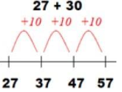  Base 10 may be used alongsde number line initially. |  |  | 27 + 10 = 37  27 + 20 = 47  27 + __ = 57
Year 2 | Add 2-digit number and ones. |  | 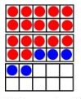  17 + 5 = 22  Use tens frame to make 10.  Explore the pattern.  17 + 5 = 22  27 + 5 = 32 |  |  | Use part whole and number line to model.  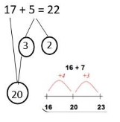  Use bar models.  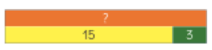 |  |  | 17 + 5 = 22  Explore related facts.  17 + 5 = 22  5 + 17 = 22  22- 17= 5  22 – 5 = 17  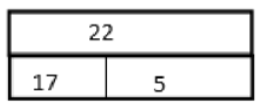
Year 2 |  |  | Add together the ones first, then add the tens. Use the Base 10 blocks first before moving onto place value counters.  24 + 15 =  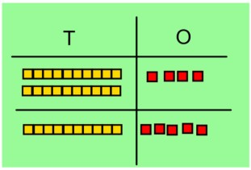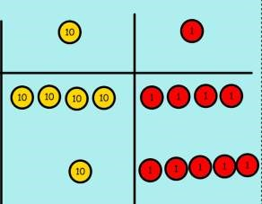44 + 15 = |  |  | After physically using the base 10 blocks and place value counters, children can draw the counters to help them to solve additions.  10  s 1s  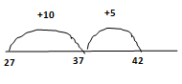  or  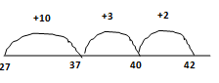  Bridge ten |  |  | 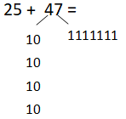  Partition to add. Add the tens then the ones.  Recording addition in columns supports place value and prepares for formal written methods with larger numbers. Toward the end of the year, children move to more formal recording using partitioning method:  47 + 32 =  40 + 30 = 70  7 + 2 = 9  79
 |  |  |  |  | Subtraction- EYFS
Objectives |  |  |  |  | Concrete |  |  | Pictorial |  |  | Abstract
- Knows that a group of things change in quantity when something is taken away  - Find one less from a group of five objects, then ten objects.  - In practical activities and discussion, beginning to use the vocabulary involved in subtracting.  - Using quantities and objects, they subtract two single digit numbers and count back to find the answer. |  |  |  |  | 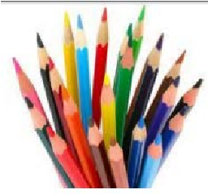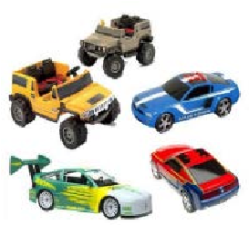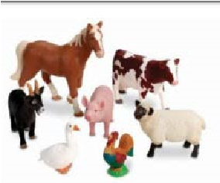    Use toys and general classroom resources for  children to physically manipulate, group/regroup.  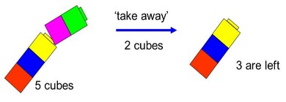  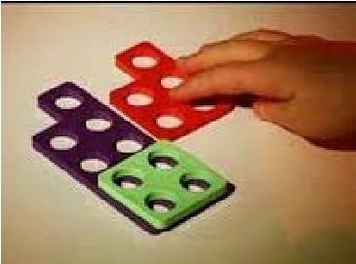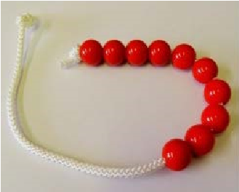    Use specific maths resources such as snap cubes,  Numicon, bead strings etc.  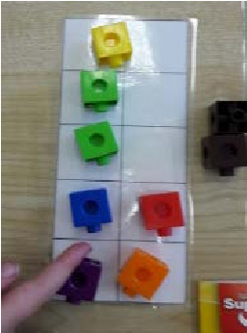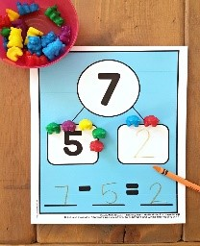    Use visual supports such as ten frames, part whole and subtraction mats, with the physical objects and resources that can be manipulated. |  |  | 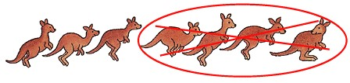  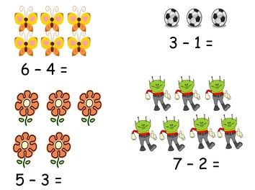  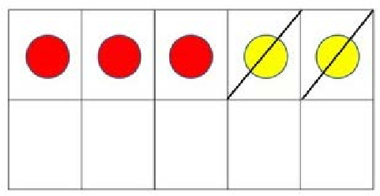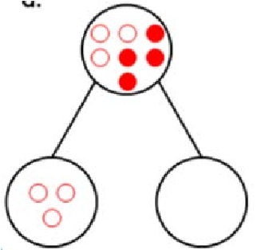  A group of pictures for children to cross out or cover quantities to support subtraction.  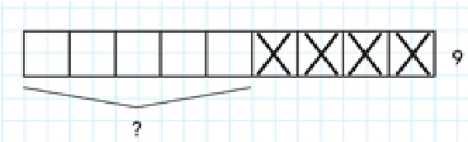    Use visual supports such as ten frames, part whole and bar model with pictures/icons. |  |  | A focus on symbols and numbers to form a calculation.  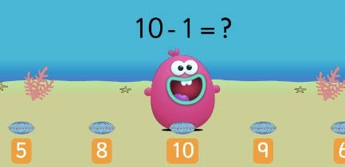  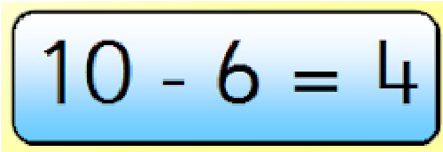  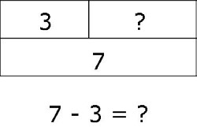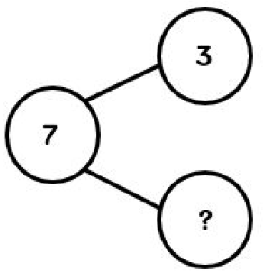  * No expectation for children to be able to record a number sentence/addition calculation.
 | Objective |  | Concrete |  |  | Pictorial |  |  | Abstract
Year 1 | Taking away ones |  | Use physical objects, counters, cubes etc. to show how objects can be taken away.      4 – 2 = 2 |  |  | Cross out drawn objects to show what has been taken away.  4 – 2 = 2 |  |  | 4 – 2 = 2
Year 1 | Counting back |  | Make the larger number in your subtraction. Move the beads along your bead string as you count backwards in ones.  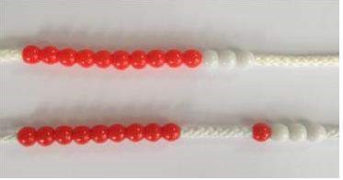  13 – 4 = 9 |  |  | Count back on a number line or number track  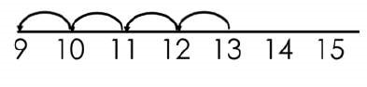  Start at the bigger number and count back the smaller number, showing the jumps on the number line. |  |  | Put 13 in your head, count back 4. What number are you at?  Use your fingers to help.
 | Find the difference |  | Compare amounts and objects to find the difference.  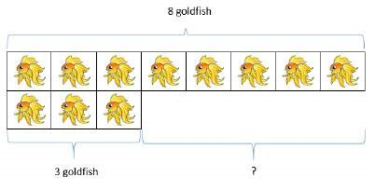  Use cubes to build towers or make bars to find the difference. Use basic bar models with items to find the difference. |  |  | 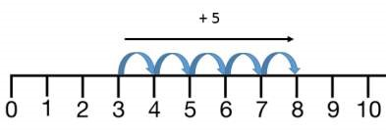  Count on to find the difference.  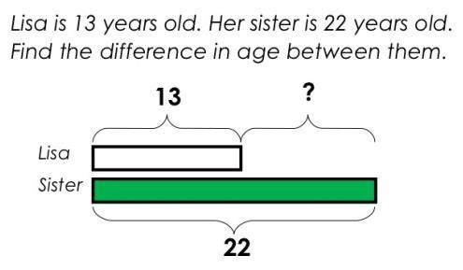  Draw bars to find the difference between 2 numbers. |  |  | Hannah has 8 goldfish.  Helen has 3 goldfish.  Find the difference between the number of goldfish the girls have.
 |  | Objective |  | Concrete |  |  | Pictorial |  |  | Abstract
Year 2 |  | Subtract 1-digit numbers across ten. |  | Use tens frames and counters to subtract.  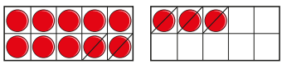 |  |  | Use number lines to subtract, crossing ten. |  |  | 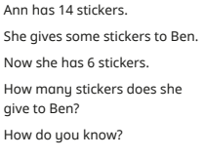
 |  | Subtract a two-digit number and ones, a twodigit number and tens, two two-digit numbers.  Partition to subtract. |  | Use Base 10 to show how to partition the number when subtracting.  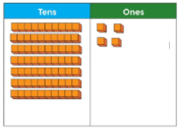  74 – 12 = 62 |  |  | 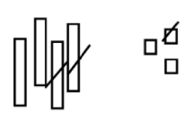  Draw a representation of Base 10 and cross off  43 – 21 = 22  Use number line to subtract.  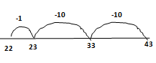 |  |  | 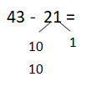  Recording subtraction in columns supports place value and prepares for formal written methods with larger numbers. Toward the end of the year, children move to more formal recording using partitioning method:  43 – 21 =  40 – 20 = 20  3 - 1 = 2  22

 | Multiplication-EYFS
Objectives | Concrete | Pictorial | Abstract
- Solve problems  including doubling | 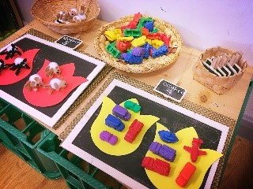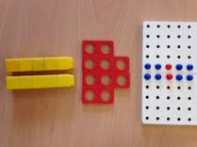  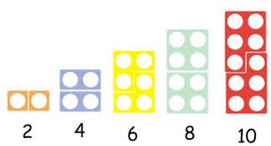  Counting and other maths resources  for children to  make 2 equal  groups.  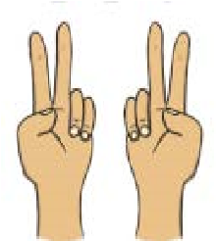  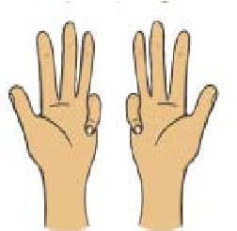  Physical and real  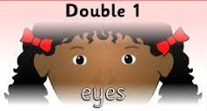  life examples  children to see concept of doubling as adding two equal groups.  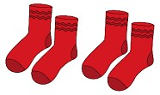 | 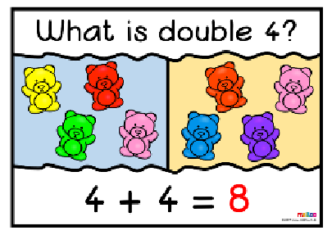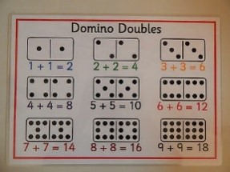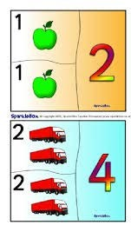    Pictures and icons that encourage children to see concept of doubling as adding two equal groups. | 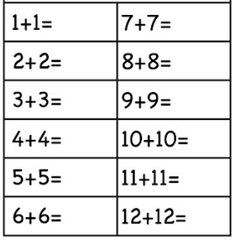  Addition calculations to model adding two equal groups.

Multiplication Year 1
 | Objective | Concrete | Pictorial | Abstract
 | Doubling | Use practical activities and manipulatives to demonstrate doubling.  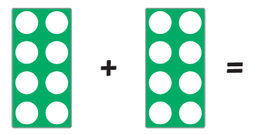  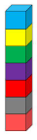 | Draw pictures to show doubles.  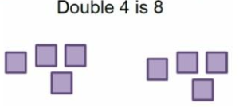 |  | 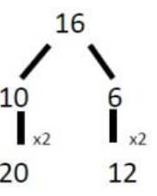  Partition a number then double each number before recombining.
 | Counting in multiples. | Count in multiples supported by manipulatives.  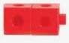   | 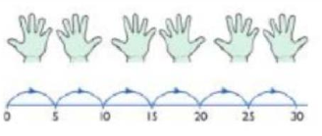  Use a number line or pictures to continue to support counting in multiples. |  | Count in multiples. Write sequences with multiples of numbers.  2, 4, 6, 8, 10  5, 10, 15, 20, 25
 | Repeated addition. | Use objects to add equal groups.    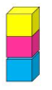 | There are 3 plates. Each plate has 2 biscuits on. How many biscuits are there?  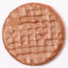  2 + 2 + 2 = 6  Use a number line to show repeated addition.  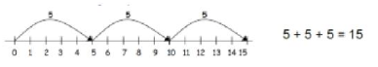 |  | Write addition sentences to describe objects and pictures.  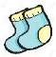  2 + 2 + 2 = 6
 | Understand arrays. | Use objects laid out in arrays to find answers.  2 lots of 5  5 lots of 2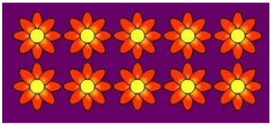 | Create own arrays to answer questions.  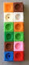 |  | 3 x 2 = 6  2 x 5 = 10

Multiplication Year 2
 | Objective | Concrete | Pictorial | Abstract
Year 2 | Count in multiples of 2, 3, 5 and 10. (Repeated addition) | Use manipulatives to count in steps of 2, 3, 5, and 10.    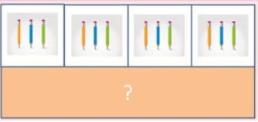 | Represent counting in multiples using number lines, counting sticks and bar models.  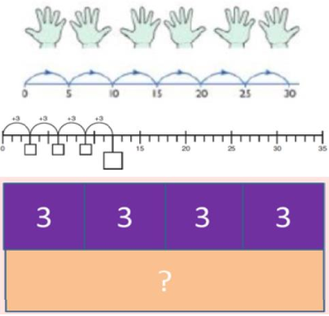 | Count in multiples aloud.  0, 2, 4, 6, 8, 10, 12,  0, 3, 6, 9, 12, 15, 18  0, 5, 10, 15, 20, 25  Answer multiplication questions for the 2, 3, 5 and 10 times table.  4 x 5 = __
Year 2 | Multiplication is commutative. | Create arrays using cubes, numicon and counters.  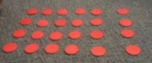  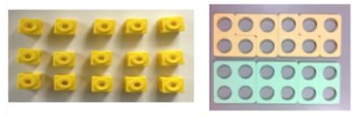  Children should understand that an array can represent different equations and that as multiplication is commutative, the order of the multiplication does not affect the answer.  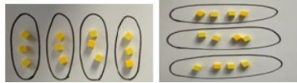 | Use representations or arrays to show different calculations and explore commutativity.  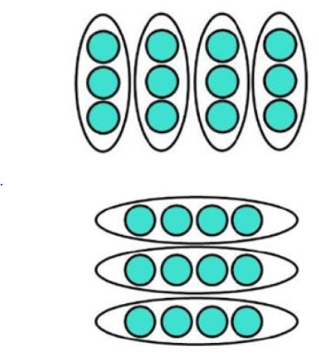 | 12 = 3 x 4  12 = 4 x 3  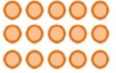  3 x 5 = 15  5 x 3 = 15  5+5+5= 15  Use an array to write multiplication sentences and reinforce repeated addition.
Year 2 | Using inverse.  This should be taught alongside division. | Create arrays and talks about what can be seen. 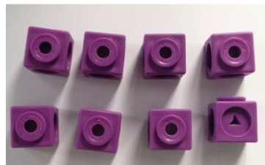  2 x 4 = 8  4 x 2 = 8  8 ÷ 2 = 4  8 ÷ 4 = 2 | 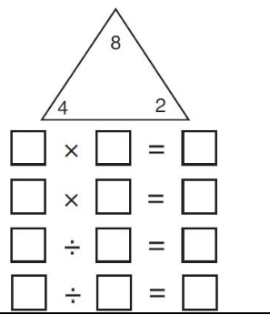 | Children can show all related facts.  10 = 2 x 5  5 x 2 = 10  5 x 2 = 10  10 ÷ 2 = 5  10 ÷ 5 = 2  Ensure children know equals sign and are familiar with it in different positions within number sentences.

 | Division- EYFS
Objectives | Concrete | Pictorial | Abstract
Solve problems including halving and sharing.  - Halving a whole, halving a quantity of objects.  - Sharing a quantity of objects. | 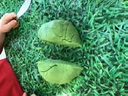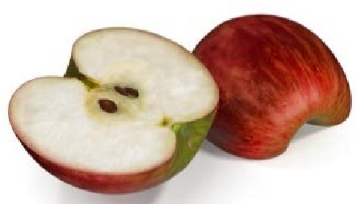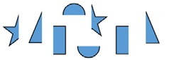  Children have the opportunity to physically cut objects, food or shapes in half.  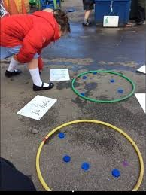  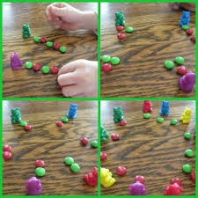  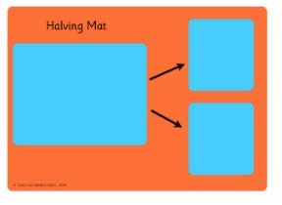  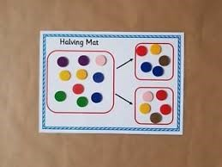  Counting and other  maths resources for  children to explore  sharing between 3 or  more.  Use visual supports such as  halving mats and part  whole, with the physical  objects and resources that  can be manipulated.  Counting and other maths resources for children to share into two equal groups. | 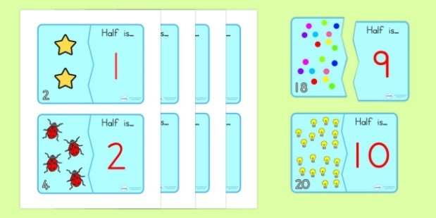    Pictures and icons that encourage children to see concept of halving in relation to subitising, addition and subtraction knowledge. i.e. Knowing 4 is made of 2 groups of 2, so half of 4 is 2.  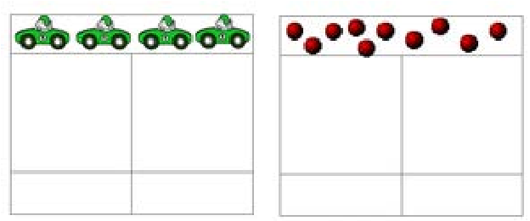    Bar model with pictures or icons to support understanding of finding 2 equal parts of a number, to further understand how two halves make a whole.  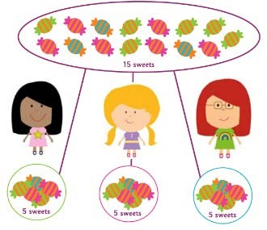  Pictures for  children to  create and  visualise 3 or  more equal  groups.

 | Objective | Concrete | Pictorial | Abstract
Year 1 /2 | Sharing | I have 8 cubes, can you share them equally between two people?  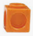  Year 1 can work with support. | Children use pictures or shapes to share quantities.    8 ÷ 2 = 4 | Share 8 buns between two people.  8 ÷ 2 = 4  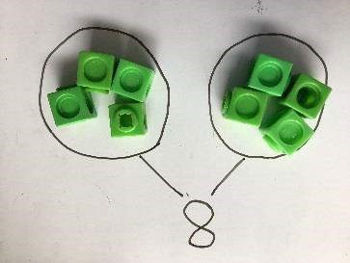
Year 1 /2 | Grouping | Divide quantities into equal groups. Use cubes, counters, objects or place value counters to aid understanding.  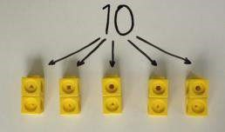  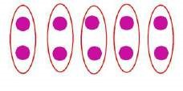  Year 2 solve division problems independently. | Use a number line to show jumps in groups. The number of jumps equals the number of groups.  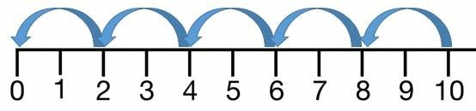  Think of the bar as a whole. Split it into the number of groups you are dividing by and work out how many would be within each group.  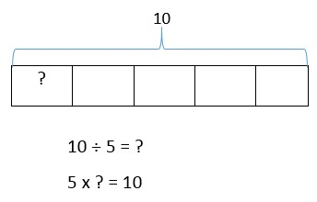 | 10 ÷ 5 = 2  Divide 10 into 5 groups. How many are in each group?  Solve problems involving division.  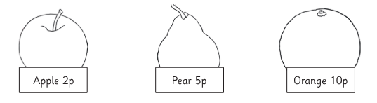  Sam buys 5 apples. How much does he spend?  Class 4 bake 45 cakes. They put 5 in each bag. How many bags do they fill?

