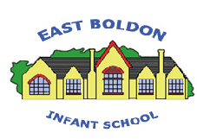
EAST BOLDON INFANT SCHOOL
Handwriting Policy
Here at East Boldon Infant School we are very proud of our pupil’s handwriting and take particular care in our cursive/joined up handwriting style. We use Letter Join as the basis of our handwriting policy that covers all of the requirements of the 2014 National Curriculum.
Handwriting is a basic skill that influences the quality of work throughout the curriculum. As an Infant School we recognise that by the end of Key Stage 2 all pupils should be able to produce fluent, legible and increasingly speedy joined up handwriting. Our aim in EYFS and Key Stage 1 is to develop the foundational skills necessary for our pupils to achieve this expectation. By using the Letter Join programme we are confident that we are supporting our pupils effectively on their journey towards confident, high quality handwriting.
We aim to make handwriting an automatic process that does not interfere with creative and mental thinking.
We encourage parents and carers to use the Letter Join resources at home and can arrange for free access to the home addition of Letter Join.

School Aims
By the end of Key Stage 1 we aim for our pupils to develop a neat, legible, speedy handwriting style using continuous cursive letters that leads to producing letters and words automatically in independent writing.
Method
Our teachers in Key Stage 1 are encouraged to use neat joined-up writing for all handwriting tasks including marking and comments.
Consistency throughout the school
Pupils should experience coherence and continuity in the learning and teaching of handwriting across all school years and be encouraged to take pride in the presentation of their work. Our aim is to help pupils enjoy learning and developing their handwriting with a sense of achievement and pride.
Handwriting Frequency
Handwriting is a cross-curriculum task and will be taken into consideration during all lessons. Formal teaching of handwriting is to be carried out regularly and systematically to ensur Key Stage 1 targets are met.

Early Years Foundation Stage
Following guidance from the 2025 DfE Writing Framework our Reception children will develop their handwriting skills through daily activities including
- Movements to enhance gross motor skills such as air writing, pattern making, ribbon sticks and pen disco sessions.
- Exercises to develop fine motor skills such as making marks on paper, whiteboards, dough disco, sand trays, IPads and tablets.
- Letter learning to familiarise letter shapes, formation and vocabulary within daily phonics sessions with an additional daily handwriting session in the Spring Term.
Key Stage 1
Tuition will continue with two or three weekly sessions covering:
- Gross and fine motor skills exercises.
- Cursive handwriting from Year 1 when printed handwriting is neat, consistent and correctly formed.
- Numerals, capitals and printed letters: where and when to use, learning and practice.

Correct posture and pencil grip for handwriting
Pupils should be taught to sit correctly at a table, holding a pencil comfortably and correctly.

SITTING POSITION

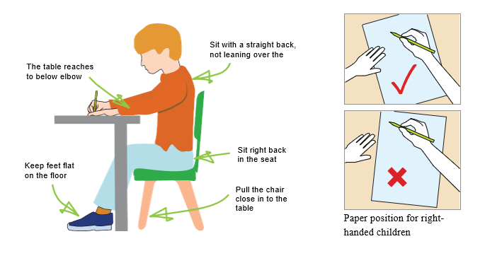
THE TRIPOD PENCIL GRIP
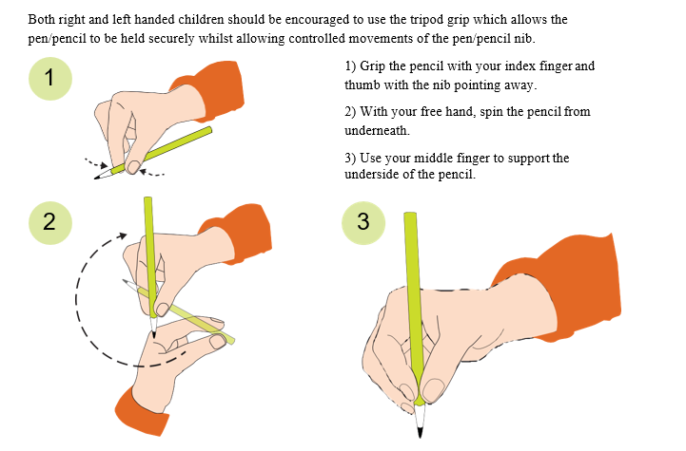

LEFT HANDED CHILDREN
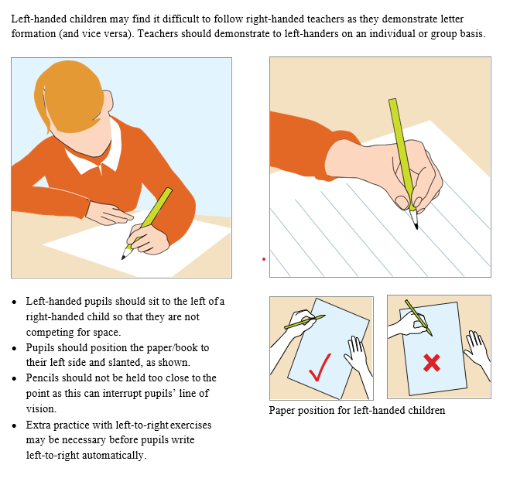

INCLUSION
Children whose handwriting is limited by problems with fine motor skills, including left-handed children, children with special educational needs will be given one to one tuition and interventions to support them to achieve their optimum handwriting level.

Key Stage Teaching
Early Years Foundation Stage
- Hold a pencil in an effective manner for writing and be encouraged to correct any errors in grip or stature.
- Understand that letters are written on a baseline.
- Begin to form recognisable letters including capital letters and numerals.
- Understand where each letter starts and ends.
- Understand different shaped letter families
- Sit in the correct position and hold a pencil correctly to allow fluid movement of the nib.
- Improve fine and gross motor skills by enjoying drawing patterns in a variety of writing material such as in shaving foam, air writing, sand trays, felt pens, crayons, pencils, Interactive Whiteboard, IPdas and tablets.
- Understand the language needed to describe pencil movements in preparation of letters.

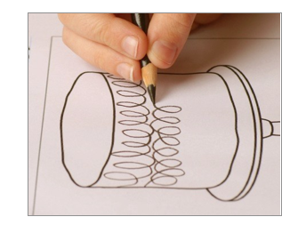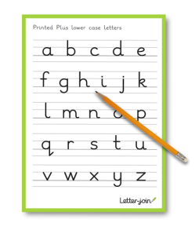
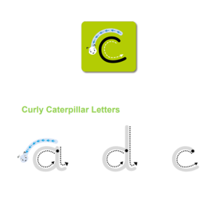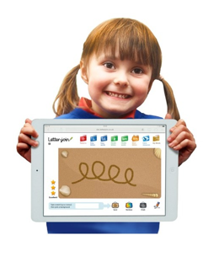
Key Stage 1
Children in Key Stage 1 will begin cursive writing once their printed handwriting is well established demonstrating consistent, accurate letter formation, appropriate spacing and control.
- Write legibly using upper and lower case letters with correct joins.
- Ensure that letters sit on the base line and are consistent in size with ascenders that are the correct length and formation.
- Leave the correct space between words.
- Form capital letters and use where appropriate.
- Form numerals that are consistent in size and sit on the base line.
- Begin to form printed letters and understand when they are to be used.
- Improve the speed of writing and begin to write automatically so promoting creativity in independent writing.

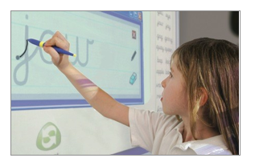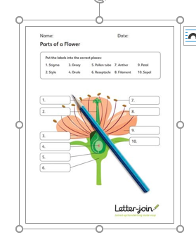

Reviewed December 2025
A Verity

