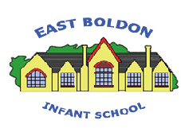
EAST BOLDON INFANT SCHOOL
Spelling Policy

Intent
At East Boldon Infants we encourage our pupils to think and write creatively, be adventurous with their use of language and to write with clear purpose and for pleasure. It is therefore essential that our pupils learn the knowledge and skills to spell accurately. Children who can spell feel confident and are able to write with enjoyment. We want our pupils to be equipped with the knowledge and range of strategies for learning spelling and to be able to apply their strategies when spelling words in their independent writing.

Implementation
These aims are embedded across our curriculum, particularly the weekly literacy planning. We have a rigorous and well organised English curriculum that provides many purposeful opportunities for spelling development.
Further to this, children from reception to year 2 develop a sound knowledge of spelling strategies as part of our Power Phonics programme as outlined in the phonics policy. Small groups and regular assessment, ensure that children progress through the programme at a rate appropriate to their level of understanding.
The school’s marking policy also places a strong emphasis on supporting the improvement of spelling, with an initial focus on high frequency words.

Impact
First and foremost, our pupils are given opportunities to explore and investigate the English language and its patterns through speaking and listening. As pupils move through our key stages, they develop, consolidate and secure the skills needed to read, share, enjoy and interpret a wide variety of literature. Our pupils acquire the knowledge and learn the skills to apply their spelling, grammar and punctuation skills to a variety of purposes in a range of
cross-curricular contexts. Our pupils are encouraged to think creatively, to be adventurous with their use of language and to write with clear purpose.

When spelling, our pupils:
- Use their phonic skills effectively when blending phonemes for reading and when segmenting phonemes for spelling
- Have an interest in words, their meanings and their origins, developing a growing vocabulary both for speaking and writing (weekly vocabulary lists linked to texts used in English lessons)
- Write with confidence and creativity, while developing the skills to self-edit, correct and improve
- Are encouraged to be imaginative, creative and challenge themselves

Teaching and Learning

In order for children to achieve a high standard of spelling they need to be explicitly taught the knowledge and skills needed. Spelling lessons take place in KS1 following the spelling rules and expectations set out in the National Curriculum English Appendix 1: Spelling
Our focus on teaching spelling embraces the knowledge of spelling conventions, patterns and rules, including combining the teaching of spelling and handwriting.
At East Boldon Infants we use Power Phonics National Curriculum Spelling programme.
Reading and Spelling is taught daily in Power Phonics until our pupils can read and spell all phonemes and graphemes.
EYFS
In the early years, Power Phonics includes all National Curriculum Spelling for green words. Green words = ‘decodable’ words, words which can be decoded by sound, to read and spell.
In the early years, we also teach National Curriculum Common Exception Words or red words.
Red words = ‘non-decodable’ words, words which can not be decoded by sound, to read or spell.
Reading red words is taught incrementally, in a logical sequence during daily Power Reading.
Spelling red words is taught daily, throughout writing using our Red Books as a dictionary.
The strategy for red words is SAY-CLAP-SAY.
Our Panda is called RED and helps children remember and use SAY-CLAP-SAY.
SAY the word out loud
CLAP the letter NAMES
SAY the word out loud.

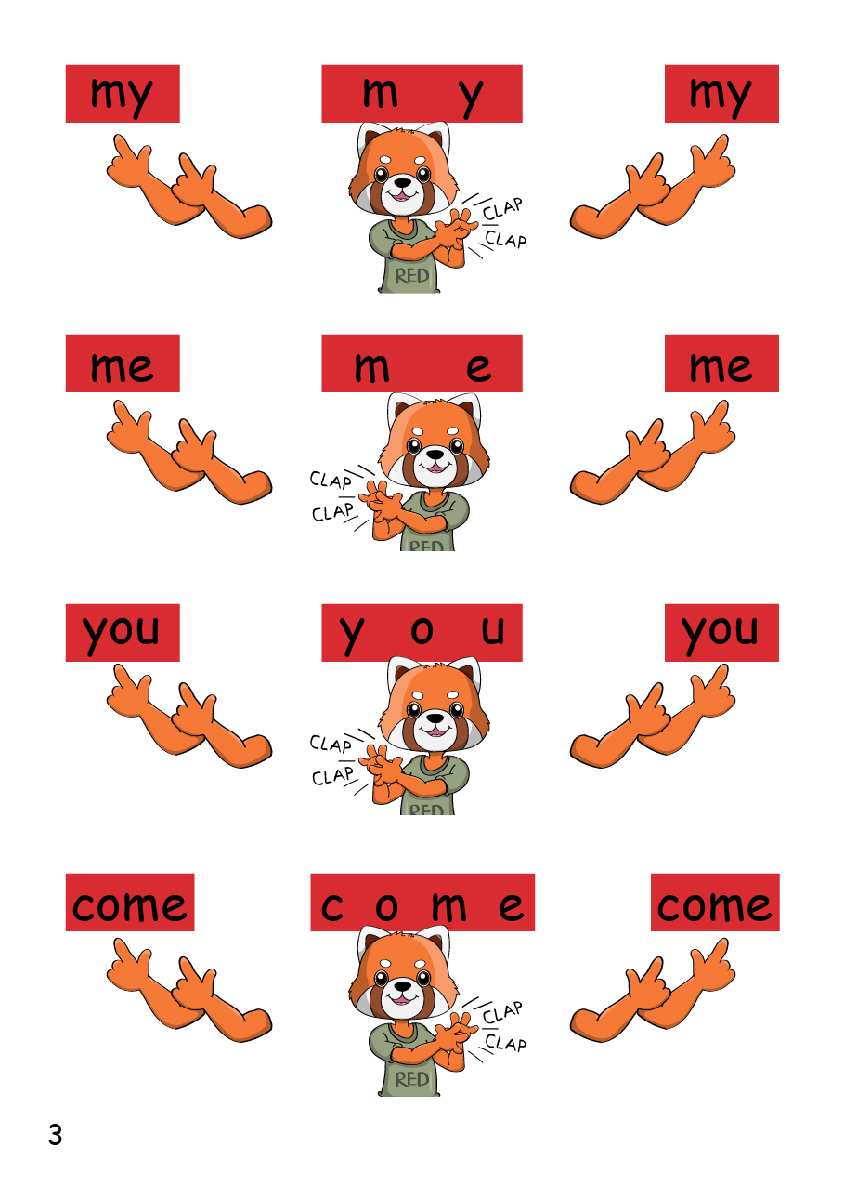

Y1 and Y2
In Y1 and Y2, Power Phonics includes most National Curriculum Spelling for green words.
Green words = ‘decodable’ words, words which can be decoded by sound, to read and spell.
In Y1 and Y2, we also teach more Spelling Rules and the Common Exception Words or red words.

Spelling Rules
The National Curriculum sets out the spelling rules which must be taught in Y1 and Y2. We teach the rules and words containing those rules using a fun and engaging system to make sure children know, apply and remember the rules in any writing across the school day. We use Spelling Rule Books for each year group and teach each one. The books are also on tables during any writing during the day, to help children remember the rules and use them in their writing. Each rule has a funny picture and phrase to help children remember it.

Red Words
Red words = ‘non-decodable’ words, words which cannot be decoded by sound, to read or spell.
Reading red words is taught incrementally, in a logical sequence during daily Power Reading.
Spelling red words is taught daily, throughout writing using our Red Books as a dictionary.
The strategy for red words is SAY-CLAP-SAY.
Our Panda is called RED and helps children remember and use SAY-CLAP-SAY.
SAY the word out loud
CLAP the letter NAMES
SAY the word out loud.

At East Boldon Infants we believe that children should not be inhibited or overly cautious in their approach to spelling as it can restrict their enjoyment and progress in other areas of writing. Therefore, while spelling corrections are included sensitively in the marking of work. These should primarily be high frequency words or technical words relating to the piece of writing. Incorrect spelling of high frequency words are included on children’s target cards.

Assessment

The assessment of spelling is in line with the school’s Assessment Policy.
our assessment is mainly through assessment in context. For example:

  - Spellings in an unseen, dictated sentence
  - Spellings in independent writing

Inclusion
Our pupils are taught challenging age-related content and it is our expectation that the vast majority of our pupils will achieve age-related expectations at the end of each year and key stage.
Children with EAL
Children with EAL are encouraged to make the same outstanding progress in spelling as their peers. To support their understanding spelling should be consistently modelled by the class teacher and pictorial aids used wherever possible. New and unfamiliar spelling words should always be taught in context and examples of how they fit into a sentence given.

Children with SEND
Where pupils have fallen behind their peers and cannot access age-related content, class teachers will differentiate the spelling curriculum to ensure those pupils are able to progress, succeed and close gaps in their spelling knowledge and skills. All classes have access to the previous year groups spelling rule book.

Reviewed September 2025 – A Verity

