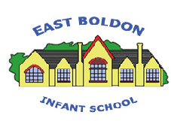
East Boldon Infants School
Early Reading Strategy
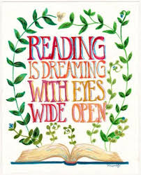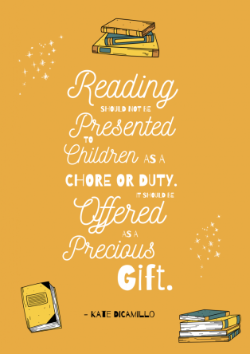

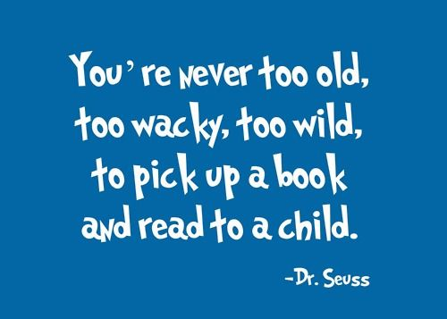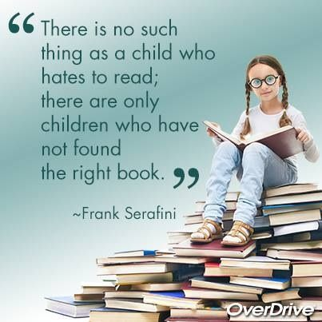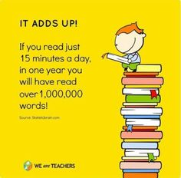

Phonics (reading and spelling)
At East Boldon Infant School, we believe that all our children can become fluent readers and writers. This is why we teach reading through McKie Mastery Power Phonics, which is a systematic and synthetic phonics programme. We start teaching phonics in Reception and follow the Power Phonics progression which ensures children build on their growing knowledge of the alphabetic code, mastering phonics to read and spell as they move through school. Reception and Year 1 pupils have a daily phonics session which follows the consistent approach of review, teach, practise, apply. Children are taught in whole class groups and work in mixed ability pairings.
As a result, all our children are able to tackle any unfamiliar words as they read. At East Boldon Infants School we also model the application of the alphabetic code through phonics in shared reading and writing, both inside and outside of the phonics lesson and across the curriculum. We have a strong focus on language development for our children because we know that speaking and listening are crucial skills for reading and writing in all subjects.
At East Boldon Infant School we value reading as a crucial life skill. By the time children move on to Key Stage 2 they read confidently for meaning and regularly enjoy reading for pleasure. Our readers are equipped with the tools to tackle unfamiliar vocabulary. We encourage our children to see themselves as readers for both pleasure and purpose.
Daily Keep-up lessons ensure every child learns to read
- Any child who needs additional practice has daily ‘Keep-up’ support, taught by a fully trained adult. Keep-up lessons match the structure of class teaching, and use the same procedures, resources and mantras, but in smaller steps with more repetition, so that every child secures their learning.
- We timetable daily phonics interventions for any child in Year 2 who is not fully fluent at reading or has not passed the Phonics Screening Check. These children urgently need to catch up, so the gap between themselves and their peers does not widen. We use a phonics tracker to identify the gaps in their phonic knowledge and teach to these using the same whole school approach.
Paired Reading
Paired reading takes place in differentiated groups every day. In EYFS children read individually and Paired Reading is introduced at an appropriate time. Children read with a partner daily - one child tracking as the other reads then swapping over roles. Pupils support each other offering decoding strategies when needed. The same text is read daily during paired reading to develop reading fluency and expression. Children assess their partner using a fluency check. Mini tasks are also set within paired reading to offer challenge and develop comprehension skills. Paired reading takes place with a group of children, of similar ability in pairs. Teachers use assessment grids to assess individual children’s progress. Texts of graded difficulty are carefully chosen and matched to children’s phonics ability. It is intended that paired reading provides a forum for children to demonstrate what they have learned about reading and to further develop and extend their reading fluency and comprehension skills cooperatively with a partner.

Love of Books and Reading
In Key stage one our English lessons follow The ‘Take One Book’ approach. This is a book-based, process-led approach to teaching reading for meaning and depth of understanding. Take One book ensures Skills for reading, comprehension, fluency and vocabulary are taught through exciting book-based units which offer engaging reading experiences. Teachers model
- think alouds - what they are thinking as they read
- retrieval – finding answers within the text
- inference – answering questions by digging deeper
- vocabulary – identify new and challenging vocabulary in the text, explain what it means making links to the context in the story.

Children work in mixed ability pairings and have access to a copy of the text one between two. They engage in independent reading and choral reading too.

Vocabulary

At East Boldon Infants we recognise the correlation between vocabulary size and life chances.

Learning vocabulary is key to ‘learning and progress across the whole curriculum’ since it allows pupils to access a wider range of words when writing and for them to understand and comprehend texts efficiently. We encourage our pupils to have a wide and growing vocabulary in a number of ways, these include:
- Word of the day – each class chooses a word to display and discuss daily. The children are encouraged to use this higher level vocabulary when speaking and in their writing.
- Display of key words linked to topics and subjects.
- Using the correct vocabulary orally – teachers modelling full sentences when needed providing a sentence stem for children who need this. We firmly believe children need to speak in full sentences to progress to write in full sentences.
- Using dictionaries and thesauruses
Home Reading
Children have access to a range of book banded appropriate texts to support their reading at home. Books are matched to the children’s phonic knowledge. Children are encouraged to read daily at home rereading books to develop fluency.
Teachers ensure:
- children are taking home decodable books matched to their phonic knowledge
- children are reading regularly at home and are returning reading records daily.
- parents are informed of their child’s reading progress

Ensuring reading for pleasure
‘Reading for pleasure is the single most important indicator of a child’s success.’ (OECD 2002)
‘The will influences the skill and vice versa.’ (OECD 2010)
We value reading for pleasure highly and work hard as a school to grow our Reading for Pleasure pedagogy.
- We read to children every day. We choose these books carefully as we want children to experience a wide range of books.
- Every classroom has an inviting book corner that encourages a love for reading. We curate these books and talk about them to entice children to read a wide range of books.
- In Reception, children have access to the reading corner every day in their free flow time and the books are continually refreshed.
- Children from Reception onwards have a home reading record. The parent/carer records comments to share with the adults in school and the adults will write in this on a regular basis to ensure communication between home and school.
- All pupils choose a book weekly from our Mobile Library
- Children across the school have regular opportunities to engage with a wide range of Reading for Pleasure events (book fairs, author visits and workshops, national events etc). We invite parents and carers into to school to share with some of these events.
- We have links with our local library
- Children have access to our outdoor reading shed where they can read for pleasure during playtimes.
Assessment
Assessment is used to monitor progress and to identify any child needing additional support as soon as they need it.
- Assessment for learning is used:
  - daily within class to identify children needing Keep-up support
- Summative assessment is used:
  - every half term to assess progress, to identify gaps in learning that need to be addressed, to identify any children needing additional support and to plan the Keep-up support that they need.
  - by SLT and scrutinised through our online phonics tracker tool, to narrow attainment gaps between different groups of children and so that any additional support can be put into place.
Statutory assessment
- Children in Year 1 sit the Phonics Screening Check. Any child not passing the check re-sits it in Year 2.

Reviewed September 2025 – A Verity

