Kindness, Resilience, Respect

Valley Gardens Middle School
Visitors Handbook

Welcome to our school. Please take time to read this handbook as it contains particularly important information regarding the safeguarding of children and school procedures and expectations for visitors on our site.

Valley Gardens Middle School
Whitley Bay
NE25 9AQ

(0191) 917 6667

VGMSOffice@valleygardensmiddle.org

Welcome to our school
Valley Gardens is a large middle school in the heart of the Whitley Bay community. With 732 pupils, we are bigger than many secondary schools. The school has always been a popular school which is oversubscribed each year.

Valley Gardens is a school with high attainment, significantly in excess of the national averages. Alongside academic success, the school is well known for its incredible range of extra-curricular opportunities which adds to its appeal.

We remain very proud of the broad and rounded education that Valley Gardens Middle School pupils receive. Pupils are given the opportunity to succeed in so many areas during their time at our school. Academic success sits alongside artistic flair, physical development, spiritual growth and social responsibility in our list of priorities. We want all our learners to be the best that they can be in all of these areas. Our key values of kindness, resilience and respect are embedded through everything we do.
Our staff
Headteacher | Mr D Godfrey
Deputy Headteacher | Mr N Heaford
Deputy Headteacher & DSL | Mr M Hope
Assistant Headteachers | Mr P Baggett & Mrs L Kerr
SENDCO | Mrs S Wilson
Heads of Year (5-8) | Mr J Roys,  Mr P McIntosh  Mrs K Ferguson  Mr N Wallbank
Head of PE | Mr D Best
Head of Science | Mrs F Bradley
Head of Humanities | Mr P Oliver
Head of Computing | Mr D Fairlamb
Head of Maths | Mr S Gibson
Head of Art | Mr K Grundy
Head of Technology | Mrs S Hill
Head of English | Mrs L Kerr
Head of Music | Mrs J MacNaughton
Head of MFL | Mrs S Vickers
Pupil Premium Lead | Mrs V Scurfield
Mastery Lead | Mr S Wragg
Teaching staff | Mrs S Brunskill  Mr S Burnside  Mrs E Campbell  Mrs D Charlton  Mr T Dibden  Mrs A Goel  Miss K Grimshaw  Mrs S Harker  Mrs H Heaney  Miss N Horsman  Mrs C Jackson  Mrs R Knowles  Miss H McElderry  Mrs D McMorrow  Mrs J Murray  Mrs H Orchard  Mr M Poxon  Mr D Robson  Miss V Scurfield  Mrs J Twizell
Cover Supervisors | Mrs R Webb  Miss M Askins  Mr P Murton
Learning Mentor | Mrs L Fairley
Teaching Assistants | Miss J Laidler  Mr R Coates  Mr J Murphy  Mrs C Richardson  Mrs A Robson  Mrs S Wall  Mrs J Warkcup  Miss V Witherspoon  Mrs S Laffey
Network Manager | Mr D Adams
Office Staff | Mrs C Butterworth  Mrs J Wilson  Mrs J Robson
Head’s PA | Mrs H Tate
Business Manager | Mrs M Tate
Financial Assistant | Mrs D Tyler
School Technician | Mrs K Wilson
Caretakers | Mr T Ford  Mr G Foster
Midday Supervisors | Ms J Collins  Mrs C Holmes-Franklin  Mr S Miah

Governing Body
The school is held accountable to an elected Governing body which is composed of parents, staff, co-opted governors and trust governors. The school is part of North Tyneside Learning Trust.
The Chair of Governors is Mr David Nisbet and can be contacted at: david.nisbet@valleygardensmiddle.org
The clerk to the Chair of Governors is Mrs Lynn LeCornu and can be contacted at: LeCornu@valleygardensmiddle.org

Map of the school
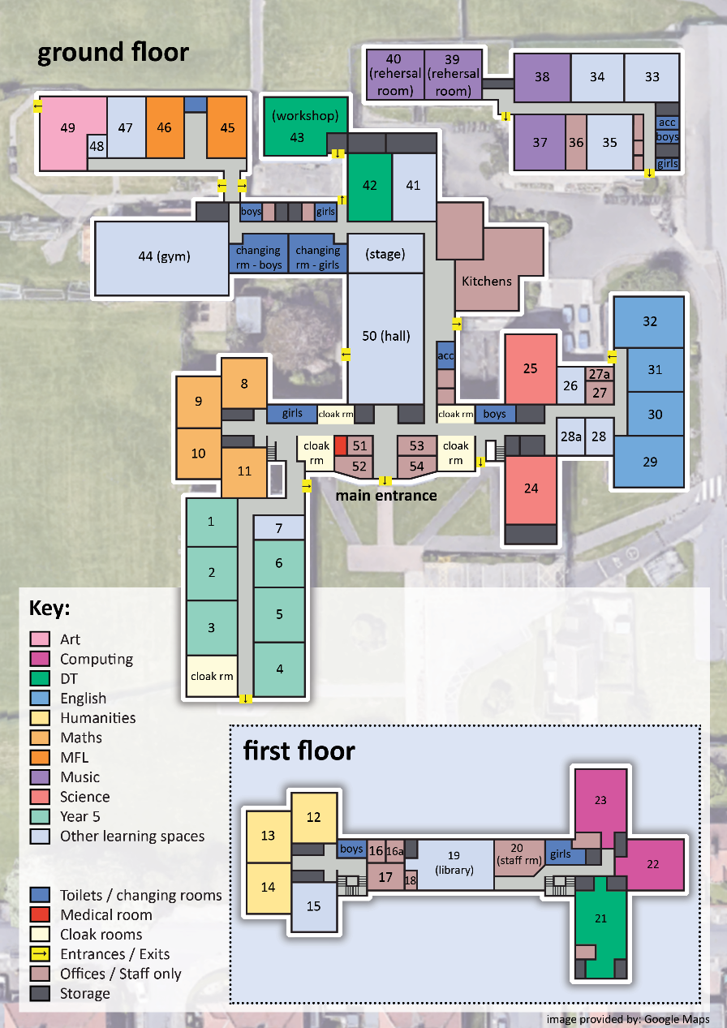
Timings of the day (COVID 19)
Due to the current national circumstances surrounding the return to school during the COVID 19 crisis – the timings of the school day have been temporarily altered as from September 2020.
First Staggered Start 8.30 (Y5 +Y7)
Second Staggered Start 8.40 (Y6 + Y8)
L1: 8.55-9.50
L2: 9.50 - 10.50
L3: 11.05-12.05
L4: 1.05-2.05pm
L5: 2.05-3.05pm
Form Time - 3.05-3.25pm
Visiting our school (COVID 19)

Due to the current national circumstances surrounding the return to school during the COVID 19 crisis – our advice to visitors has been adjusted as from September 2020.
Visiting during COVID 19
Visitors should only attend school if it is necessary. Visitors should notify the school of any medical requirements or equality of access provisions that may need to be put in place.
If you are visiting our Schools with an appointment, please make sure that:
- You sign in on arrival at the front desk.
- You wash and/or sanitise your hands when you arrive and as necessary during your visit
- You carry a mask or face covering and wear it as required
- You maintain a safe distance (at least 1 metre, and ideally two meters) from other people at all times
- You wear your visitor lanyard at all times and return it to the office on the way out.
We have comprehensive processes in place to keep our community safe. Further details are available on request, but key points include:
- We have developed a clear protocol and provision in the event of a member of staff or pupil presenting with COVID-19 symptoms while at school. This includes clearly defined safe areas for isolation until an individual can safely travel home.
- We have put in place enhanced handwashing facilities. This includes the installation of additional external sink units, and the installation of hand gel dispensers at all external entry points and classrooms.
- We will provide tissues to all classrooms, along with lidded waste bins for the safe storage of used tissues.
- We are asking visitors to wear masks in corridors and other shared areas. Masks are optional in classes.
- We have put in place a comprehensive communications plan, delivered through posters across the site and verbal reminders from staff, to ensure good hand and respiratory hygiene.
- We have significantly enhanced cleaning provision. All our cleaning personnel have received specific training on cleaning for Covid-19.
- Our students have been grouped in “bubbles”, to help minimise any unnecessary contact and enable us to track any close contacts quickly if need arises.
- We are enforcing social distancing: verbal reminders and posters are reiterating the messaging, classrooms and dining rooms have been laid out to minimise face to face contact, and physical reminders such as barriers and line markings are in place to minimise inadvertent contact.
- We have designated discrete, distinct year group drop off and pick up locations to avoid mixing at the beginning and end of each day.
- We have strict controls in place to ensure parents/carers do not come into school unless it is essential, and by appointment only.
- All staff have completed safety training in respect of Covid-19.

DBS (Disclosure and Barring Service)
Visitors will not need to undergo a DBS check or barred list check unless the risk assessment undertaken indicates that they will be engaging in regulated activity which is essentially:
- Unsupervised activities: teach, train, instruct, care for or supervise children, or provide advice/guidance on well-being, or drive a vehicle only for children
- Relevant personal care, eg. washing or dressing or health care by or supervised by a professional
Our parent/carer helpers in school and on school trips will be supervised by the teachers and support staff.
DBS information should be sent to our school office or our Business Manager (Rm 54), Michelle Tate (Michelle.Tate@valleygardensmiddle.org) and if required – provide valid photo I.D on the day.
Visitors without DBS must be accompanied by a member of staff at all times and must stay to allocated areas of the school.
Safeguarding
The Designated Safeguarding Lead for the school is Mr M Hope (Rm54) and any safeguarding concerns by visitors should be immediately reported to him. Visitors should familiarise themselves with the code of conduct for visitors.
Accidents
Accident books are kept at the main school office to record the date, type of injury, how it happened and first aid treatment administered for children on site. More serious accidents must also be reported to the business manager immediately.
Accident forms for staff and visitors are available from the school office.
Fire or other Evacuation
If the fire alarm sounds (a whooping continuous tone), adults and children should exit quietly by the nearest fire exit and walk to the fire assembly point – which is our school yard. See maps on walls throughout the building which show evacuation routes and assembly points. Visitors will be registered by our office staff and should not leave the premises until this has been completed.
Intruder or other incident requiring lock down
In the case of an intruder or other incident requiring invacuation/lockdown, the procedure is as follows:
Lockdown will be signalled by a continuous monotonous ring tone on the alarm (as distinct from the evacuation tone which is a whooping tone). The alarm will sound for approximately three minutes. The alarm stopping does NOT signal that the lockdown is over.
Teachers must check whether all children are present by completing a headcount and report the outcome to the school office by telephone as soon as possible. All windows and doors must be secured.
If the children are playing outside then adults should get the children into the nearest building as quickly as possible.
The all clear will be signalled by three short blasts on the alarm. Until that signal is received, the lockdown remains in effect.
Health and Safety
All visitors must follow our safe working practices and procedures and it is everyone's duty to report any issues they become aware of which may lead to an accident or injury. They must also take responsibility for their own safety particularly during COVID 19. All health and safety concerns should be reported to the school office and Michelle Tate in Rm 54.
Use of technology within school
The network manager for the school is Mr Dave Adams. Any technology requests for your visit can be arranged with him at Dave.adams@valleygardensmiddle.org
Issues with damaged or faulty equipment should be reported to him.

Code of conduct for visitors
This Code of Conduct cannot provide a complete checklist of what is, or is not, appropriate behaviour. However, it does highlight behaviour that is illegal, inappropriate or inadvisable in relation to pupils.
Confidentiality
All volunteers, students and governors in school must appreciate and respect the need for complete trust and confidentiality. Confidential or personal information about a pupil or her/his family must never be disclosed to anyone. If a parent requests information from you about their child and what you have seen in school, please ask them to talk to the class teacher.
Safeguarding Children: Sexual Contact with Children and Abuse of Trust
Any sexual behaviour, by a member of staff, volunteer or governor with or towards a child or young person is illegal. They are additionally protected by specific legal provisions regardless of whether there is consent or not. •
- All adults working in the school who have contact with pupils are in positions of trust. The Sexual Offences (Amendment) Act 2000 specifically established a criminal offence of the abuse of trust in relation to teachers and others who are in positions of trust.
- Sexual behaviour includes non-contact activities, such as causing a child or young person to engage in or watch sexual activity or the production of indecent images of children
- There are occasions when adults embark on a course of behaviour known as 'grooming' where the sole purpose is to gain the trust of a child or young person, and manipulate that relationship so that sexual abuse can take place. Staff and volunteers should be aware that conferring special attention without good reason or favouring a pupil has the potential to be construed as being part of a 'grooming' process, which is a criminal offence.
Safeguarding Children: Social Contact and Social Networking
Visitors and volunteers working with children should not establish or seek to establish social contact with pupils for the purpose of securing a friendship or to pursue or strengthen a relationship.
- This includes social networking sites such as Facebook, Twitter and blogging. Even if a pupil seeks to establish social contact, or if this occurs coincidentally, the adult should exercise her/his professional judgment in making a response and be aware that such social contact in person, by phone or on the internet could be misconstrued and may place the adult in a very vulnerable position.
- Visitors and volunteers must not give their personal details such as home/mobile phone number, home or e-mail address to pupils unless the need to do so is agreed with senior management. Neither must they ask for such information from pupils.
Safeguarding Children: Behaviour Management and Physical Intervention
Please refer any issues of behaviour management directly to the class teacher. All pupils have a right to be treated with respect and dignity. Corporal punishment is unlawful in all schools. Staff and volunteers must not use any form of degrading treatment to punish a pupil. The use of sarcasm, demeaning or insensitive comments towards pupils is not acceptable in any situation.
Safeguarding Children: Child Protection concerns and Whistle Blowing
The Deputy Headteacher Mr Hope is the Designated Safeguarding Lead for Valley Gardens Middle School. If you have any concern about a child (or member of staff) you should bring it to his immediate attention or if he is not available the Headteacher, other Deputyhead or one of the Heads of Year.
Safeguarding Children: Adult changing areas
If adults need to change their clothing for an activity they must always change in one of the adult toilets and not where there are children.
Safeguarding Children: “Transparent” Classrooms and our policy for lone working with children
All spaces where children work with an adult must be open to casual observation.
Unplanned visits to classrooms are carried out on a regular basis including break, lunchtimes and after school. If a person is working alone with a child or children, he or she should ensure that the area in which they are working has clear visibility from the outside, for example by keeping the door open, through a glass panel in the door or through windows where other adults are regularly passing outside At times of the school day when certain areas are not generally used, for example classrooms at lunchtimes, members of staff and visitors should avoid wherever possible working alone in such an area with a child or children, and should always seek to work in an open area or a room with clear visibility and where other members of staff or adults are around if not actually in the same room. To facilitate this policy all glass panels on doors will be kept clear, and all blinds or curtains on windows will be drawn back whenever practicable.
Safeguarding Children: Photography and Video
Visitors to school should NEVER photograph or video children unless asked to do so by the class teacher and they should only ever use school equipment to do so. Your own camera, phone or other device must never be used to take photographs in school. Many school activities involve recording images. These may be undertaken as part of the curriculum, extra school activities, for publicity, or to celebrate achievement.
The General Data Protection Regulation affects the use of photography.
An image of a child is personal data and it is, therefore, a requirement under the Act that consent is obtained from the parent of a child for any images made such as those used for school web sites, productions or other purposes. The school office has a list of children who do not have permission for images photographs and videos to be taken by school.

APPENDIX A:
Request for safeguarding information from Visitors
To be completed by person organising visitor and authorised by Headteacher prior to visit.
Date(s) of visit:
Full name:
Name, address and contact details of organisation (please provide e mail address and telephone number):

Reason for visit:
Member of staff responsible:
Does the visitor require DBS? | DBS IS REQUIRED FOR - Unsupervised activities: teaching, training, instructing, caring for or supervising children, or providing advice/guidance on well-being, or driving a vehicle only for children. Providing relevant personal care, eg. washing or dressing or health care.
 | YES/NO
If YES please confirm the individual(s) have Enhanced Disclosure (DBS) with Barring:
If so, DBS Certificate no. and date of disclosure.
Please detail any medical conditions/specific needs (if applicable):
Please detail any further information you wish to provide:
Photo identification witnessed: | Yes | No
Visitor Handbook given, read and signed for:
I can confirm that all of the necessary safeguarding checks have been carried out for this activity.
Signed by (member of staff responsible:)
Position:
Approved and signed by D Godfrey:
(Headteacher)

