**Valley Gardens Middle School**

***What do you want to achieve?***

**Accessibility Plan 2019-2021**

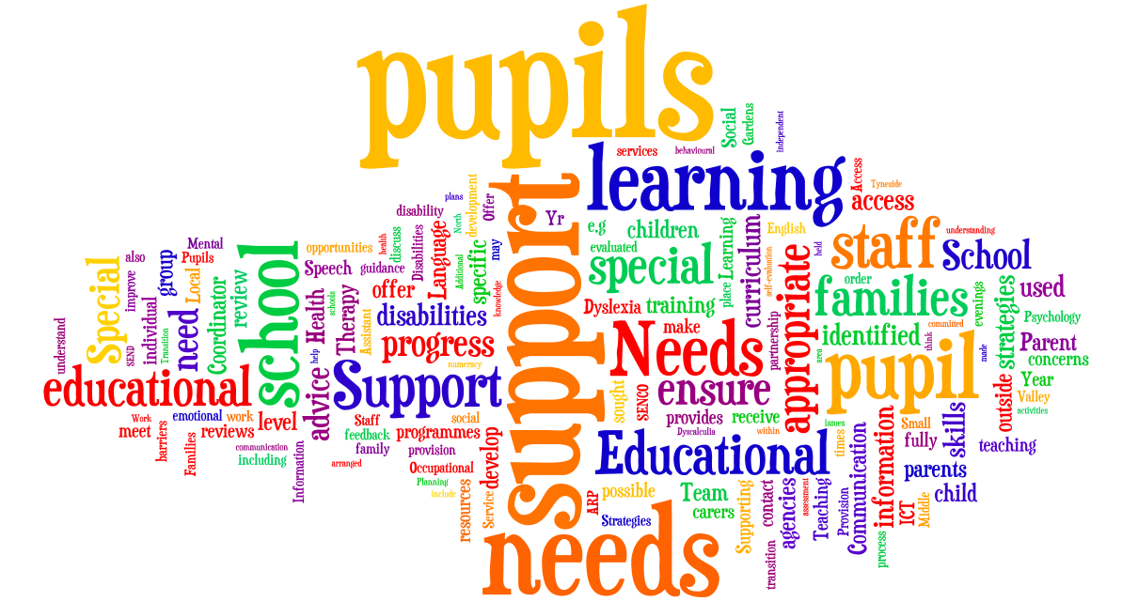

**Valley Gardens Middle School**



**Accessibility Plan 2019 - 2021**

**February 2020**

**Purpose**

## This plan has been written to meet the requirements of the School to carry out accessibility planning for disabled pupils and visitors as stated in the Equality Act 2010 and the SEND Code of Practice 2014.

## Valley Gardens Middle School recognises its duty to:

## Not discriminate against disabled pupils in terms of exclusions and provision of education and associated service

## Not to treat disabled pupils less-favourably

* Treat all stakeholders, including pupils, prospective pupils, staff, governors and other members of the school community favourably and, wherever possible, takes reasonable steps to avoid placing anyone at a substantial disadvantage.

## To publish an accessibility plan.

Valley Gardens Middle School aims to:

* Increase the extent to which disabled pupils can participate in the curriculum, which includes teaching and learning and the wider curriculum of the school, such as participation in after school clubs, leisure and cultural activities or school visits;
* Sustain and improve access to the physical environment of the school to enable disabled pupils to take better advantage of education, benefits, facilities and services provided
* Promote positive attitudes to disabled people in the school
* Sustain and improve the availability of accessible information to disabled pupils and their families.
* Work closely with disabled pupils, their families and any relevant outside agencies to remove or minimise any potential barriers to learning.

**Legal Background**

The Equality Act 2010 introduced a single Public Sector Equality Duty that applies to public bodies, including maintained schools and Academies, and which extends to all protected characteristics – race, disability, sex, age, religion or belief, sexual orientation, pregnancy and maternity and gender reassignment. This combined equality duty came into effect in April 2011.

Valley Gardens Middle School’s commitment to equal opportunities is driven by a desire to be totally inclusive and raise standards for all students.

The School:

* Sets suitable learning challenges for all students
* Responds to students’ diverse needs
* Overcomes potential barriers to learning and assessment for individuals and groups of students.

Details

The policy supports the production of an accessibility plan. This plan will consider:

* Increased access to the curriculum for disabled students
* Improvements to the physical environment
* Improvements in the provision of information

|  |  |  |  |  |
| --- | --- | --- | --- | --- |
| Targets | Strategies | Outcomes | Timeframe | Achieved |
| **EQUALITY AND INCLUSION** | | | | |
| To ensure that the accessibility Plan is an annual item at the VGMSGB meetings. | Clerk to governors to add to list for VGMSGB meetings. | Adherence to legislation | Annually |  |
| To improve staff awareness of disability issues. | Review staff training needs. Provide training for members of the school community as appropriate. | Whole school community aware of issues. | Ongoing |  |
| Provision of information for those who find standard forms of printing a barrier | Facilities in place to produce alternative forms  Access through Learning Support Department | Appropriate differentiation | Ongoing/supported on a need’s basis. |  |
| Make staff familiar with technology and practices developed to assist students with disabilities | SEN Support Plans and use of teacher guides/outside agency support as necessary. | Appropriate differentiation | Ongoing/supported on a need’s basis |  |
| Improvements in the provision of information to students and parents. | Increased variety of methods for information to be sent (Twitter, texts, letters, phone calls)  Brail / Enlarged text to be used when contacting parents with visual impairment.  SEN Support Plans to communicate information to staff about specific methods of communication for staff. | All parents able to be contacted and able to understand information being sent to them. | Ongoing/supported on a need’s basis |  |
| To ensure that all policies consider the implications of disability access. | Consider during review of policies. | Policies reflect current legislation. | On-going |  |
| **CURRICULUM** | | | | |
| To continue to train staff to enable them to meet the needs of children with a range of SEND. | Ongoing programme of staff training in disability awareness to reflect diverse needs of students within the school and anticipatory duties. SENCo to review the needs of children and provide training for staff as needed.  Inset and Induction. | Staff are able to enable all children to access the curriculum. | On-going. |  |
| Create effective learning environments for all utilising feedback from student groups. | Reinforce responsibilities of all teachers as outlined in the National Curriculum Inclusion Statement.  Ensure all classrooms and resources are organised in accordance with student need.  Seek issues and feedback through pupil voice- School council.  Opportunities for all. | An appropriate and accessible curriculum for all pupils where engagement and success are seen through both results academically but also the positive feedback from pupils. | On-going. |  |
| Increase participation in school activities. | Monitor participation in extra-curricular activities and identify any barriers.  Ensure school activities are accessible to all students. | All students able to partake in all areas of the curriculum, including wider curriculum outside of normal school hours. | On-going. |  |
| Lessons responsive to student diversity | PSHE is an integral part of the curriculum. | Appropriate differentiation | On-going. |  |
| Staff recognise and allow for the mental effort expended by some disabled students | Include in SEN Support Plans. | Appropriate differentiation | On-going. |  |
| Staff recognise and allow for the additional time required to use equipment in practical work | Include in SEN Support plans.  Included in lesson planning | Appropriate differentiation | Ongoing/supported on a need’s basis |  |
| Access to appropriate ICT | Allocation of ICT through Learning Support Department where appropriate | Appropriate differentiation | Ongoing/supported on a need’s basis |  |
| All out of School visits are accessible | Risk assessment completed.  Additional staffing where necessary | No student is prevented from attending visits on the grounds of disability | On-going. |  |
| Reduce background noise | Include in SEN Support Plans.  Inform caretakers if these are environmental factors that can be repaired. | Background noise not affecting learning | On-going. |  |
| **PHYSICAL ENVIRONMENT** | | | | |
| To ensure that, where possible, the school buildings and grounds are accessible for all children and adults and continue to improve access to the school’s physical environment for all. | Audit of accessibility of school buildings and grounds by Governors. Suggest actions and implement as budget allows. | Modifications will be made to the school building to improve access. | On-going. |  |
| Evacuation system to inform all students | Signs at right height and in appropriate formats  Visual alarm installed  Staff trained to deploy Evac chairs. | Safe evacuation of all students | On-going. |  |
| All areas well lit | Ensure lighting in car parks | Areas well lit | On-going. |  |
| Appropriate furniture and equipment | Adjustable height desk available | No barrier to learning | On-going. |  |