**Valley Gardens Middle School**

***What do you want to achieve?***

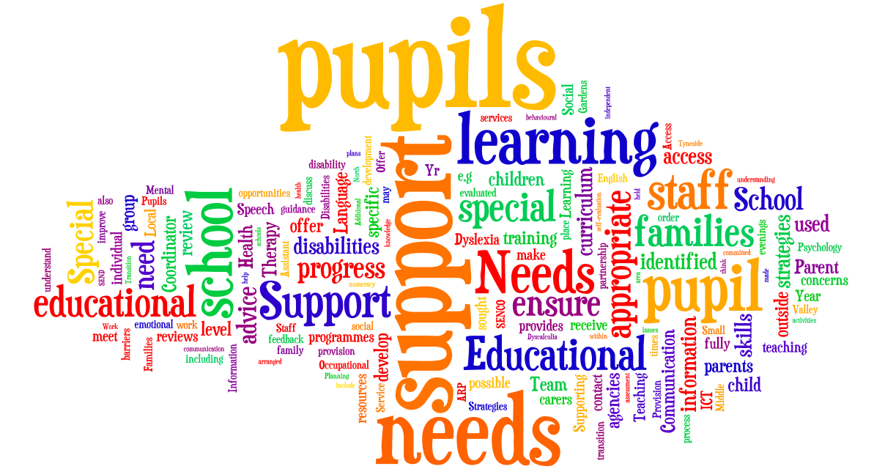**Local Offer for Pupils with Special Educational Needs and / or Disabilities**

**Valley Gardens Middle School**



**Local Offer**

**February 2020**

**The Special Educational Needs and Disabilities (SEND) Local Offer sets out the support and services that are available for children and young people aged 0-25 years across North Tyneside.** Details can be found at [www.northtyneside.gov.uk](http://www.northtyneside.gov.uk) or by telephoning the ‘Front door’ service on 0345 2000 109.

Our Local Offer lets you understand how we support pupils with special educational needs and disabilities within School.

We consult with pupils and their families on our local offer by:

* Gathering feedback at Parent/Carer Evenings.
* Gathering family and pupil’s feedback through the review process.

**Valley Gardens Middle School (VGMS)** is a fully inclusive school which aims to ensure that **all** pupils achieve their potential personally, socially, emotionally, physically and educationally.

**Supporting pupils with Special Educational Needs (SEN) / Disabilities and their families.**

We will let families know about any concerns about a pupil’s learning by:

* Form and/or subject teachers contacting families directly to discuss any concerns.
* Providing opportunities for families to discuss pupil’s progress and learning needs at Parent/Carer Evenings.
* Contacting families if SEN information is shared when your child transfers to VGMS from First or another School.
* Contacting families to arrange a meeting with the Special Educational Needs Coordinator (SENCO).

**How does Valley Gardens Middle School know if my child needs extra help?**

* Information about your child is shared by their current school to ensure that provision can be made for any additional needs in good time for their arrival at VGMS.
* Pupils’ progress is regularly assessed and monitored. If a child is not making expected progress, their teachers will target teaching at the pupil’s area of difficulty. Form and/or subject teachers will contact families directly to discuss these concerns.
* Should a child continue to not make progress, their teacher will seek further advice from their Head of Department and SENCO to assess whether there may be a barrier to learning.
* The SENCO will contact you to arrange a meeting to plan support based on your child’s needs and identify the responsibilities of the parent/carer, pupil and School. Your child will be identified for ‘School Support’.

**What should I do if I think my child may have a Special Educational Need or Disability?**

* If you have any questions or concerns, you can contact the school to discuss your child with the SENCO, Samantha Wilson.

**How will I know how Valley Gardens Middle School supports my child?**

* If your child has been identified for ‘School Support’, their needs, effective strategies and the provision to meet their needs will be will be recorded in a Support Plan. Your views and those of your child are important, therefore this plan will be discussed and agreed with you and all staff involved with your child.

**How will the curriculum be matched to my child’s needs?**

* The School’s self-evaluation process will look at teaching and learning for pupils with Special Educational Needs and Disabilities.
* All teachers are responsible for providing high-quality teaching, differentiated to meet the needs of their pupils.
* Your child’s Support Plan will support teachers in planning to meet their needs in the classroom.

**How will I know how my child is doing?**

* Valley Gardens Middle School shares details of progress through issuing reports twice a year (interim and final).
* Progress evenings are held for each year group (at least 2 per year).
* Pupils identified for ‘School Support’ will have a Key Worker. They will make contact with you at least termly to discuss your child’s progress and address any queries you may have.
* Your child’s Support Plan will be shared and reviewed with you.
* You will be invited to meet with the SENCO/form tutors to review your child’s needs, plan any support needs and identify the responsibilities of the parent/carer, pupil and School, three times a year.
* Your child’s Key worker will contact you to keep you updated as to their progress.

**How will you help me to support my child’s learning?**

* Your child’s teachers will be able to identify areas that you can work on together and effective strategies and approaches.
* Details of current topics for each year group can be found in the ‘Curriculum’ area for each subject on the School’s website.
* Your child’s Support Plan will give details of successful strategies and approaches to support your child’s learning as well as any specific programmes and resources that may help support their progress.

**What support will there be for my child’s overall well-being?**

* All pupils have a Form tutor who has daily contact with your child.
* There is a Pastoral Head of Year who can deal with any concerns.
* For ‘School Support’ pupils, we aim to support the ‘whole pupil’ through the provision of a ‘Key Worker’.
* Support is available for those pupils who require provision for unstructured time; we have a supported lunchtime provision to provide opportunities for structured social interaction.
* A Learning Mentor is available to provide advice, support and guidance to pupils who may experience personal or emotional difficulties.
* Pupils can get involved in the range of Extra-Curricular activities on offer.
* Families are also signposted to additional services / organisations through the Local Offer: details can be found at [www.northtyneside.gov.uk](http://www.northtyneside.gov.uk) or by telephoning the ‘Front door’ service on 0345 2000 109.

**What specialist services and expertise are available at or accessed by the School?**

The other professionals, agencies and teams providing services to children with a Special Educational Need /Disability in School include:

* Support Assistants.
* Learning Mentor.
* School Nurse.
* Health services to meet individual’s specific needs.
* Language and Communication Team.
* Dyslexia Team.
* Sensory Support Service.
* Occupational Therapy.
* Speech and Language Therapy.
* Educational Psychology.
* CAMHS (Child and Adolescent Mental Health Service).
* Secondary Support Team.
* Whitley Bay Student Support Centre.
* Educational Welfare Officer.

**What training have the staff supporting children and young people with SEND had or are having?**

All staff have completed, and will continue to receive, on-going training in Special Educational Needs and Disabilities.

All staff have had recent training delivered by our partner agencies including the Dyslexia Team, the Language and Communication Team and Educational Psychology. All teachers have access to training around specific learning needs provided by North Tyneside Local Authority.

Our fully-qualified Special Educational Needs Coordinator provides advice and guidance to staff and is committed to ensuring all staff are fully supported and receive opportunities to develop their knowledge and understanding of the range of needs and effective strategies for supporting all pupils’ learning.

Our SEND support staff has a range of experience and qualifications and are committed to their own professional development, actively seeking opportunities to further their own knowledge and understanding in order to provide the best quality support.

**How will my child be included in activities outside the classroom, including School trips?**

* All school-related activities are evaluated in terms of their benefit to the learning and inclusion of pupils with SEND.
* We pride ourselves in being fully inclusive and aim to include all pupils in trips and activities outside the classroom; wherever there may be a challenge to this, we will do our best to make alternative arrangements.
* Should your child need specific provision, please contact the SENCO to discuss requirements.

**How accessible is the School environment?**

* The School has accessible entrances, some with ramps to allow for wheelchair access.
* There is a lift to give access to the upper floor.
* There are toilets and a shower with disabled access.

**How will the School prepare and support my child when joining Valley Gardens Middle School or transferring from, or to, a new school?**

We will work in partnership with other education providers to ensure that pupils make a successful transition to the next stages of their learning, through careful and coordinated planning of the transition. We provide the following support to pupils when they are entering and leaving the School:

* SENCO attends Year 4 Transition reviews, wherever possible.
* Year 8 Transition reviews- held in autumn term for those with the highest level of need.
* Joint reviews held for identified pupils and their families who are moving to Whitley Bay High School, arranged by SENCOs.
* Close liaison between Schools to ensure appropriate transfer arrangements are in place.
* Up to 5 additional transition visits may be appropriate for some pupils (to be arranged jointly by SENCOs).
* Year 5 and 8 ‘Moving-up’ days held in the summer term.
* Transfer of any records/ information prior to pupil’s arrival at School.

**How are the School’s resources allocated and matched to children’s Special Educational Needs?**

* Support staff are placed where they are needed throughout the school to ensure pupil progress, independence and value for money.
* Support staff may be present in lessons to support identified pupils under the direction of the class teacher.
* Other pupils may be identified for small group work to support a specific area of their learning, such as reading, spelling, numeracy or social skills and communication.

**How is the decision made about the frequency and type of support my child will receive?**

* Levels of support are dependent on the child’s needs and levels of progress; decisions are taken following discussions with you, your child and your child’s teachers.
* For some pupils, outside agencies will be involved to give advice, guidance and recommendations about appropriate types and levels of support. This will be taken into consideration in discussion held with pupils and families when allocating support.
* Some pupils will be allocated specific support as identified by their Education, Health and Care plan. This support will be allocated by the SENCO, in discussion with the pupil and their family.

**How will I be involved in discussions about and planning for my child’s education?**

* If your child is identified for ‘School Support’ you will be invited to meet with the SENCO and any other relevant agencies or services involved with your child to discuss and plan for your child’s education.

**Who can I contact for further information?**

* If you would like further information about what we offer here at Valley Gardens Middle School**,** then please contact the Special Educational Needs Coordinator on: 0191 917 6667 (Ext: 242)
* Parents can contact SENDIASS (Special Educational Needs and Disability, Information, Advice & Support Service) for impartial information, advice and support in relation to their child’s special educational need and / or disability on tel. (0191) 643 8313 or (0191) 643 8317.
* Behaviour and anti-bullying policies are regularly reviewed with a focus on how they affect pupils with Special Educational Needs or Disabilities.
* Other useful documents such as our Special Educational Needs and Inclusion Policy are also available on the School website.

|  |  |
| --- | --- |
| **School offer to pupils with Special Educational Needs or Disabilities.** | |
| **AREA OF NEED** | **Support available within School** |
| **Communication and Interaction:**  **e.g.**   * Autistic Spectrum Disorders * Speech, Language and Communication Needs * Social communication difficulties | * Visual timetables * Areas of low distraction * Support / supervision at unstructured times of the day- lunchtime club and supervised outside area. * Social skills programme / support including strategies to enhance self-esteem. * Small group work to improve skills. * ICT is used to support learning where appropriate. * Strategies / programmes to support speech and language development. * Strategies to reduce anxiety / promote emotional wellbeing. * Where appropriate we will use support and advice from other partners to meet the needs of pupils. * Planning, assessment and review. * Work with pupils, parents, carers and staff to develop and review plans based on the need of the pupil. * Teaching resources are routinely evaluated to ensure they are accessible to all pupils. * Differentiated curriculum and resources * Home/School book to support communication, where necessary. |
| **Cognition and Learning Needs:**  e.g.   * Moderate Learning Difficulties * Dyslexia * Dyscalculia | * A 10- place, Additional Resourced Provision (ARP) for pupils with Moderate Learning Difficulties (see ARP outline document for further information). * Strategies to promote/develop literacy and numeracy. * Provision to support access to the curriculum and to develop independent learning. * Small group targeted intervention programmes are delivered to pupils to improve skills in a variety of areas, i.e. reading skills groups etc. * ICT is used to reduce barriers to learning where possible. * Support and advice is sought from outside agencies to ensure any barriers to success are fully identified and responded to. * Planning, assessment and review. * Access to teaching and learning for pupils with special educational needs is monitored through the school’s self-evaluation process. * Teaching resources are routinely evaluated to ensure they are accessible to all pupils. * Work with pupils, parents, carers and staff to develop and review plans based on the need of the pupil. * Differentiated curriculum and resources |
| **Social, Emotional and Mental health**  e.g.   * Behavioural needs * Social needs * Mental health needs * Emotional Health and Wellbeing | * The school ethos values all pupils. * Behaviour management systems encourage pupils to make positive decisions about behavioural choices. * The school’s behaviour policy identifies where reasonable changes can be made to minimise the need for exclusions. * Risk assessments are used and action is taken to increase the safety and inclusion of all pupils in all activities. * The school provides effective pastoral care for all pupils. * Support and advice is sought from outside agencies to support pupils, where appropriate. * Small group programmes are used to improve social skills and help them deal more effectively with stressful situations. * There is a nurture group at lunch times / break times to support pupils. * Information and support is available within school for behavioural, emotional and social needs. |
| **Sensory, Medical and Physical Needs:**  e.g.   * Hearing/Visual Impairment * Multi-sensory impairment * Physical and Medical Needs | * Support and advice is sought from outside agencies to support pupils, where appropriate. * ICT is used to increase access to the curriculum. * Support to access the curriculum and to develop independent learning. * Advice and guidance is sought and acted upon to meet the needs of pupils who have significant medical needs. * Access to Medical Interventions. * Access to programmes to support Occupational Therapy / Physiotherapy. * Support with personal care if and when needed. * All Staff receive training to ensure they understand the impact of a sensory need upon teaching and learning. * All Staff understand and apply the medicine administration policy. * The Special Educational Needs Coordinator completes any necessary training in order to offer advice and guidance to staff about the needs of pupils. * All main entrances to the school allow wheelchair access. * School has a lift to ensure access to upper floors. * The school has an accessible toilet / facilities * Opportunities to participate in sporting events for children and young people with Disabilities. |

If you have any concerns about your child’s Special educational needs, disability or medical needs, their progress or the support you receive, we would ask that you make contact with the School in order to discuss matters further with the Special Educational Needs Coordinator.

Although School complaints procedures are in place and can be accessed through our website, we would always hope to resolve any issues or concerns informally by working in partnership with Parents and Carers.

**What our families say about us:**

*“I think that the level of support given to my child was tailored perfectly to her individual needs and wants; I don’t think anything could have been done better.”* Parent of Year 6 pupil.

*“…issues are immediately addressed. The SEN team are sensitive when working with children, including my son, and do not make them feel different from their peers.’* Parent of Year 8 pupil.

“*They know the children they support very well…they also give exceptional emotional support to student and parents. Communication between staff is excellent.”* Parent of Year 7 pupil.

*“ARP provides a very secure environment where individual needs can be catered for…staff are approachable either by phone, email or face to face…lunchtime support provides a popular ‘safe haven’ from the playground.”* Parent of Year 5 pupil.

February 2020