Samurai Spellings

Homework Booklet
Name ___________________________________________

Teacher ___________________________________________
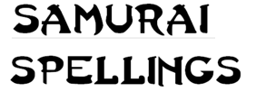
Weekly Spelling homework

Revise the Ninja spellings from year 5.
Learn your new Samurai spellings.

You need to complete the Look / Cover / Check table.

Many of the key spellings are repeated to help ensure that you can spell them accurately.

Cluster: a + e
The letter a is often followed by an e with one letter in between. When this happens, the sound the ’a’ stands for is usually the same as the name of the letter a, and the ‘e’ is not heard.
Ninja
Pane | Mane | Pavement
Made | Separate | Shape
Tape | Average | Scrape
Cape | Persuade | Rotate
Calendar | Material | Increase
Samurai
Alliterate
Manipulate
Immediate
Hesitate
Apparent
Disgraceful
Amazement
Complicated
Imitate
Exaggerate
Primate
Implicate
Illustrate
Discriminate
Subordinate
Cluster: wh
There is a h after the w at the beginning of a number of common words. Many of these words are for asking questions.
Ninja
Why | Where | Whale
Who | Wherever | Whisper
Which | Wheat | While
When | Whisker | Whine
What | Whip | Wheel
Samurai
Whether
Whom
Whoever
Whose
Wharf
Whim
Whereas
Whisky
Whereas
Wheedle
Whiff
Wheeze
Whereabouts
Whirl
Whinny
Cluster: i + e
The letter i is often followed by an e with one other letter in between. When this happens, the sound the i stands for is usually the same as the name of the letter i, and the e is not heard.
Ninja
Guide | Arrive | Excitement
Twice | Quite | Empire
Accident | Describe | Surprise
Exercise | Decide | Favourite
Device | Excite | Opposite
Samurai
Identity
Acquire
Definite
Sacrifice
Precise
Despise
Respite
Capsize
Entirely
Definite
Prejudice
Criticise
Recognise
Advertisement
Fertile
Cluster: O + E
The letter o is often followed by an e with one other letter in between. When this happens, the sound the o stands for is usually the same as the letter o, and the e is not heard.
Ninja
Note | Code | Purpose
Vole | Hole | Clover
Whole | Hope | Suppose
Alone | Those | Envelope
Zone | Smoke | Postpone

Samurai
Gruesome
Controversy
Opponent
Telescope
Grotesque
Compose
Microscope
Erroneous
Kaleidoscope
Biodegrade
Fluorescent
Xylophone
Impose
Condone
Covert
Cluster: U + E
The letter u is often followed by an e with one other letter in between. When this happens, the sound the u stands for is usually the same as the name of the letter u, and the e is not heard.
Ninja
Pure | Refuse | Attitude
Sure | Future | Mature
June | Pressure | Capture
Picture | Confuse | Amuse
Failure | Secure | Minute
Samurai
Signature
Accuse
Assume
Insure
Assure
Fortune
Amusement
Departure
Manicure
Manufacture
Miniature
Leisure
Acute
Temperature
Agriculture
Cluster: ER
Many English words end with –er. Er is also the commonest way of spelling this sound in the middle of words, although or, ir and ur also occur and need to be learnt.
Ninja
Certain | Exercise | General
Quarter | Consider | Exercise
Soldier | Service | Interest
Perhaps | Remember | Experience
Average | Therefore | Experiment
Samurai
Correspond
Sincerely
Government
Interfere
Controversy
Interrupt
Determined
Cemetery
Exaggerate
persuade
Delirious
Mysterious
Persistent
Irrelevant
Desperate
Cluster: OR
The two letters or are often found together to stand for the same sound that there is in the short word or. If it comes at the end of words, the sound is said quickly and seems a bit different, like the sound usually written er.
Ninja
Born | Doctor | History
Organ | Author | Forward
Uniform | Order | Ordinary
Morning | Author | Important
Report | Emperor | Forty

Samurai
Gorgeous
Thorough
Opportunity
Foreign
Information
According
Correspond
Category
Therefore
Extraordinary
Subordinate
Organise
Fortunate
Solicitor
Abnormal
Cluster: AU and AW
The letters au or aw often stand for the same sound. At the end of a word, or before the letter n, we usually find aw. In the middle of the word we usually find au.
Ninja
Saw | Naughty | Caught
Thaw | Sawn | Taught
Law | August | Fault
Straw | Daughter | Because
Autumn | Pause | Dinosaur

Samurai
Naughty
Automatically
Applaud
Nauseous
Awkward
Audience
Auction
Caution
Aural
Audit
Restaurant
Authority
Launch
Automatic
Autobiographical
Cluster: qu
In English words, the letter q is always followed by a u.
Ninja
Quick | Quiz | Require
Quite | Quarrel | Request
Quiet | Quantity | Squirrel
Question | Quarter | Square
Queen | Quality | Squash
Samurai
Equip
Equipped
Equipment
Qualifications
Tranquil
Enquire
Acquire
Quash
Quadrant
Quadruplets
Qualify
Quota
Quotation
Technique
Queue
Cluster: ph
The letters ph are found instead of f in words that have come into English from Greek.
Ninja
photograph | Elephant | Physics
Telephone | Phantom | Paragraph
Microphone | Graphic | Trophy
Photocopy | Telegraph | Phrase
Alphabet | Pheasant | Phase

Samurai
Triumph
Symphony
Physician
Sulphur
Amphibian
Pharmacy
Photosynthesis
Sphinx
Sophisticated
Emphasis
Sphere
Apostrophe
Phobia
Physical
Physically
Cluster : ai
Words that have the same sound in the middle as rain or raid, often have it spelt ai.
Ninja
Snail | Chain | Mountain
Train | Paint | Certain
Trail | Faint | Raid
Rail | Straight | Again
Rain | Britain | Plain
Samurai
Available
Sustain
Maintain
Complain
obtain
Straight
Bargain
Explain
Waist
Stain
Fountain
Saint
Rainbow
Raised
Staircase
Cluster : EA
One of the ways of spelling the ‘long e’ sound is with the two letters ea.
Ninja
Appear | Season | Disappear
Bead | Teacher | Creature
Beach | Feature | Creak
Beautiful | Meaning | Please
Breathe | Repeat | Increase
Samurai
Disappear
Colleagues
Beneath
Repeal
Conceal
Cease
Feasible
Leaflet
Healing
League
Grease
Release
Treatment
Underneath
Meander
Cluster: ie
There is a group of words with a sound like ‘ee’ in feet, where the sound is spelt with an i and an e.
For these words, remember the rhyme: i before e except after c when the sound is ‘ee’.
Ninja
Brief | Shield | Believe
Chief | Priest | Belief
Grief | Niece | Wield
Handkerchief | Relief | Experience
Thief | Achieve | Eerie
Samurai
Achieve
Achievement
Convenience
Experience
Conscience
Variety
Mischievous
Siege
Soldier
Sufficient
Mischief
Hygiene
Relieved
Pierce
Believable
Cluster: ge/ gi
When g is followed by e or i it often stands for the sound that can be written with j.
Ninja
Age | Bridge | Danger
Huge | General | Change
Hinge | Magic | Strange
Ledge | Knowledge | Imagine
Gentle | Germ | Manage

Samurai
Vegetable
Gigantic
Geography
Lounge
Language
Suggest
Generous
Legible
Privilege
Genuine
Exaggerate
Exchange
Merge
Average
Plunge
Cluster: ci / ce
If the letter c is followed by an –i or an –e, or by a –y , it usually has the ‘soft’ sound of an s or ss.
Ninja
Bicycle | Recent | Centre
Piece | Century | Sentence
Deceit | Certain | Special
Decide | Accident | Exercise
Since | Medicine | Circle

Samurai
Existence
Conscience
Excellent
Cemetery
Necessary
Nuisance
Prejudice
Receive
Sacrifice
Circuit
Sincerely
Hindrance
Conscious
Pronunciation
Ancient
Cluster: -tion / -sion
The sound at the end of words like station, pension, or fashion is spelt with –tion, -sion, or –shion. The letters ti can sometimes have the sound usually spelt sh (as they do in the word initials).
Ninja
Position | Potion | Vision
Possession | Option | Fusion
Mention | Question | Occasion
Situation | Competition | Supervision
Invention | Fiction | Erosion

Samurai
Pollution
Competition
Preparation
Dictionary
Conscious
Explanation
Impression
Succession
Introduction
Hesitation
Pronunciation
Profession
Cluster: ia
Ninja
Bias | Piano | Triangle
Diary | Peculiar | Especially
Material | Denial | Carriage
Trial | Special | Diamond
Peculiar | Dialogue | Familiar

Samurai
Familiar
Pronunciation
Appreciate
Musician
Peculiar
Onomatopoeia
Defiant
Phobia
Immediate
Immediately
Appropriate
Parliament
Aerial
Enviable
Alliance
Cluster: le / el
A lot of words end with le. In a smaller number of cases, the same sound is spelt with el. These just have to be learnt.
Ninja
Bicycle | Stable | Length
Double | Battle | Learn
Circle | Angle | Calendar
Handle | Angel | Complete
Possible | Ankle | Knowledge

Samurai
Possible
Vehicle
Bicycle
Illegible
Irreversible
Probable
Impossible
Muscle
Capable
Available
Muscle
Chapel
Syllable
Vegetable
Flexible

Cluster: In, im, il or ir
By adding the prefixes in, im, il, or ir, you often make the antonym (opposite of the word), eg ‘irregular’ means ‘not regular’ and ‘imperfect’ means ‘not perfect’.
Some words do not use these letter combinations as a prefix, eg. ‘imagine’
Ninja
Indifferent | Immature | Invisible
Illegal | Infamous | Improbable
Inexperienced | Immense | Infirm
Impure | Imagine | Irregular
Impossible | immodest | Indirect

Samurai
Irresistible
Impatient
Immediately
Irrelevant
Irritated
Infrequently
Irrational
Independent
Inconvenience
Interfere
Interrupt
Insufficient
Illogical
Insincere
Illustrate

Cluster: Doubling the last consonant
A lot of words double the last consonant before adding a suffix, eg. -ly,- ing, -ed, -ence. They are words that have a single vowel followed by one consonant and the stress is at the end of the word.
If the last syllable isn’t stressed you don’t need to double the consonant.
Ninja
Spotting | Accidentally | Travelling
Occasionally | Fitting | Traveller
Netting | Putting | Actually
Rotted | Wedding | Dropped
Rotting | Written | Skipped
Samurai
Usually
Basically
Marvellous
Actually
occurrence
Especially
Regretted
Regrettable
Admitted
Controller
Verbally
Gratefully
Rebellious
Beginning
Environmentally
Cluster: Words with silent letters
Ninja
February | Business | Honour
Wednesday | Interest | Reign
Answer | Crumb | Knife
Naughty | Lamb | Honest
Queue | Doubt | Whole

Samurai
Government
Environment
Favourite
Reign
Foreign
Tongue
Valuable
Rhythm
Rhyme
Vehicle
Succumb
Parliament
Yacht
Knowledge
Sufficient
Cluster : double consonants – pp,ff, cc, ss
Ninja
Accidentally | Addition | Possession
Occasionally | Disappear | Business
Occasion | Suppose | Pressure
Difficult | Opposite | Possible
Different | Appear | Address

Samurai
Accommodate
Accompany
Occur
Occupy
According
Appreciate
Appreciation
Apparent
Apparently
Equipped
Opportunity
Approximate
Approximately
Profession
Professional
Cluster: double consonants in words
Ninja
Shallow | Patrolling | Running
excellent | Fuelling | Suffix
cancelling | Grammar | Admitted
marvellous | Programme | Arrive
Controlling | Beginning | Sorrow

Samurai
Community
Communicate
Committee
Recommend
Immediate
Attached
Embarrass
Correspond
Interrupt
Approximate
Parallel
Excellent
Aggressive
Anniversary
Suggest
Cluster: Ou or Au
Ninja
Enough | Through | Nought
Group | Famous | Tough
Though | Various | Taught
Although | Fought | Caught
Thought | Bought | August
Samuria
Disastrous
Marvellous
Hideous
Conscious
Self-conscious
Neighbour
Neighbourhood
Thorough
Thoroughly
Restaurant
Authentic
Staunch
Haughty
Naughty
Flaunt
Cluster : Prefixes
A prefix is placed before the stem of a word. Adding it to the beginning of one word changes it into another word. For example, when the prefix un- is added to the word happy, it creates the word unhappy.
Ninja
Unicycle | Discover | Although
Bicycle | Dishonest | Uncaring
Tricycle | Distrust | Unhappy
Triangle | Disappear | Unusual
Tripod | Disappoint | Unkind

Samurai
Antisocial
Autobiography
Antiseptic
Automatically
Autograph
Supervision
Submerge
Submarine
Prejudice
Preview
Disappointment
Misbehave
Mistrust
Mistake
Recognise
Cluster: Suffixes
A suffix is placed after the stem of a word and it often changes the tense or word class which the word belongs to.
Ninja
Eight | Careless | Equipment
Eighth | Careful | Probably
Eighteenth | Sorrowful | Twelfth
Accidentally | Peaceful | Trustworthy
Actually | Hopeful | Lightning

Samurai
Curiosity
Criticise
Definite
Disastrous
Environment
Temperature
Explanation
Frequently
Hindrance
Immediately
Marvellous
Mischievous
Opportunity
Pronunciation
Signature
Cluster: EU & UE
Ninja
Due | Cruel | Queen
Fuel | Blue | Query
Guest | Value | Question
True | Argue | Statue
Virtue | Issue | Continue
Samurai
Amateur
Feud
European
Neutral
Avenue
Antique
Boutique
Technique
Physique
Clique
Pursue
Barbeque
Frequently
Queue
Queueing
Cluster : EA words
Ninja
Breath | Increase | Please
Earth | Learn | Breathe
Early | Reach | Spear
Heard | Teach | Fear
Heart | Stream | Really

Samurai
Appear
Beneath
Creature
Decrease
Defeat
Disease
Ordeal
Reason
Reveal
Season
Treaty
Easter
Health
Wealth
Commonwealth
Cluster: Plurals
All you need to do is add -es to make the plurals words ending in x, sh, s, ss, and ch.
Some words which end with the letter f change the f to a v before adding es to make the plural. Words which end with a consonant and then a y change the y to an i before adding es to make the plural.
Ninja
Boxes | Centuries | Bushes
Foxes | Libraries | Dashes
Potatoes | Histories | Women
Buses | Crashes | Shelves
Atlases | Guesses | Halves
Samurai
Symbols
Vegetables
Yachts
Amateurs
Restaurants
Circuses
Octopuses
Addresses
Heroes
Zeroes
Wolves
Enemies
Flies
Fairies
Libraries
Cluster: ‘i’
‘i’ can be pronounced as a short vowel as in ‘hit’.
‘y’ can also be pronounced as a short vowel as in ‘myth’

Ninja

possible | History | Cinema
Build | Imagine | Ignite
Continue | Interest | Syrup
Different | Medicine | Physical
Difficult | Disappear | Egypt

Samurai
Sincere
Dictionary
Citizen
Vehicle
Believe
Opportunity
Variety
Symbol
System
Equip
Sufficient
Disastrous
Existence
Hindrance
Immediate
Cluster: ‘i’ or ‘y’
‘i’ can be pronounced as a long vowel as in ‘hire’.
‘y’ can also be pronounced as a long vowel as in ‘typist’.

Ninja

Surprise | Height | Library
Guide | Delight | Bicycle
Favourite | Ignite | Apply
Exercise | Bicep | Type
Describe | Biology | Try

Samurai
Stifle
Variety
Decipher
Trial
Silent
Identity
Lightning
Rhyme
Biologist
Hype
Hyperactive
Cyclops
Typhoon
Tyrant
Multiply
Cluster: Drop or Keep ‘e’
For words ending with a silent ‘e’ (achieve), drop the ‘e’ when adding a vowel suffix such as
‘-ing’ (achieving).
Add ‘-ly’ to a word whether or not the word ends with a vowel (extreme + ly) or a
consonant (hopeless + ly). The few exceptions to this rule need to be learned.

Ninja
Believe | Deciding | Important
Believing | Breathe | Importantly
Describe | Breathing | Particular
Describing | Complete | Particularly
Decide | Completing | Famously

Samurai
Immediate
Immediately
Aggressive
Aggressively
Average
Averagely
Conscious
Consciously
Immediate
Immediately
Sincere
Sincerely
Frequent
Frequently
Persuasively
Cluster: Other key spellings
Ninja
Answer | Grammar | Natural
Build | Guard | Often
Extreme | Height | Popular
Forward | Island | Regular
Fruit | Library | Reign
Samurai
Bruise
Develop
Dictionary
Guarantee
Harass
Individual
Lightning
physical
Programme
Secretary
Shoulder
Stomach
Symbol
System
Twelfth
Earn extra epraise points
Earn extra epraise points for bringing in evidence that you have completed one of the following spelling tasks using your week’s spelling words.
- Use Scrabble tiles to spell out as many of your spelling words as you can.
- Cut out individual letters or find the actual words from a newspaper and create a collage.
- Go to the beach and write 10 of your spelling words in the sand, then email your teacher with a photo.
- Play with your food and use alphabet spaghetti to write your words on a plate. Take a photo and email it to your teach rather than trying to bring
it in.

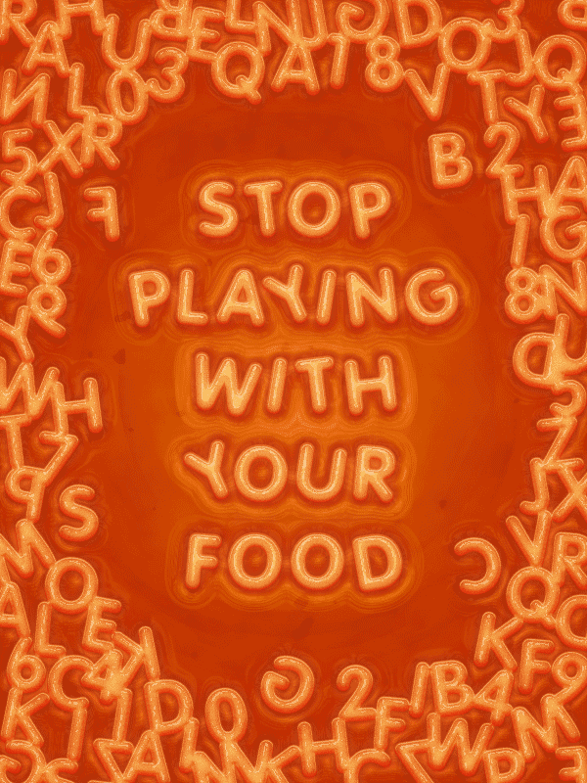
- Write a paragraph using 15 of your spelling words.
- Write all of your spellings in alphabetical order.
- Write down 15 of your words and show how they can be broken down into separate syllables.
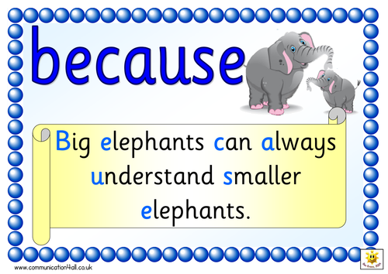
- Create your own mnemonic to help you remember how to spell 3 of your trickier words.

My test scores
Record your score each week.
1 | 2 | 3 | 4 | 5  Revision test
6 | 7 | 8 | 9 | 10  Revision test
11 | 12 | 13 | 14 | 15  Revision test
16 | 17 | 18 | 19 | 20  Revision test
21 | 22 | 23 | 24 | 25  Revision test
26 | 27 | 28 | 29 | 30  Revision test
31 | 32 | 33 | 34  Earn extra epraise points by completing one of the activities on the previous page. | 35  Revision test
36 | 37 | Final test!

