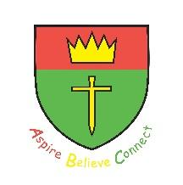
St Oswald’s Vision Ethos and Values Statement
Aspire Believe Connect

Our Vision

Jeremiah 29:11 – “For I know the plans I have for you,” declares the Lord, “plans to prosper you and not to harm you, plans to give you hope and a future.”
We chose this as our vision as theologically, this verse was originally written to people in exile—people who were in a difficult, foreign place for a long time. For a school, this is a powerful metaphor:
- Academic struggle: When a pupil finds a subject difficult, this vision reminds them that the struggle isn't the end of the story.
- Emotional safety: It creates a "foundation of hope" that helps children and staff feel secure even when they face personal or social challenges.
The word often translated as "prosper" is the Hebrew word Shalom. This refers to wholeness, peace, and well-being. St Oswald’s CE VA Primary School feel this shows they care about the "whole child" and all of our stakeholders—their mental health, character, and spirit.
We feel it links to a collective promise. It encourages our pupils to:
- Seek the welfare of their community: Just as the exiles were told to "seek the peace of the city," students are encouraged to be "courageous advocates" and “agents of change” who help others prosper.
- Trust in the journey: It fosters a culture of patience and long-term thinking rather than seeking "quick wins."

Vision, Ethos and Values Statement

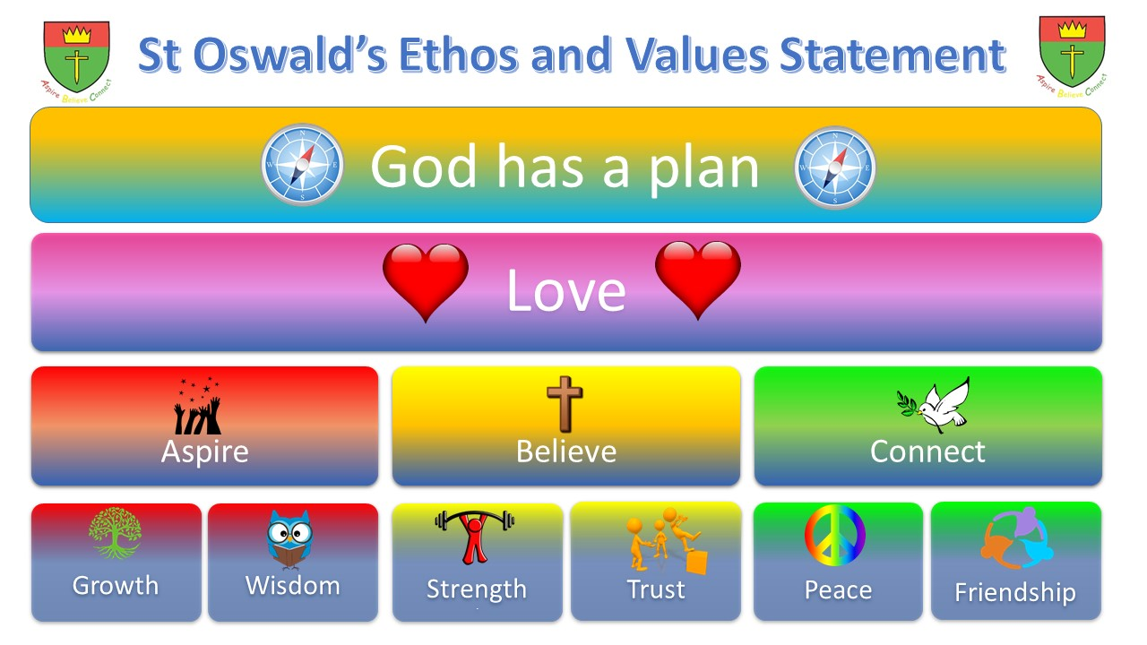

Background

Our Ethos and Values Statement underpins everything we do and are about at St Oswald’s. Children in our school know that love is the most important value of all, in line with the new command that Jesus gave us to love one another, which is why this is placed above all of our other values in our statement.

Mission Statement

Sitting below love lies our school’s mission statement: Aspire, Believe, Connect. As easy as A, B, C, this statement is easy to remember and most importantly represents what we want our children to do in every aspect of their education and lives.

Core Christian Values

The mission statement is underpinned by six core Christian values that each link to one aspect of Aspire, Believe, Connect. As children aspire to be the best they can be in every way, they will grow in wisdom. In order to believe in themselves and develop their own beliefs about the world around them, our children are taught about the importance of trust and strength on their journey. We also believe in the values of peace and friendship in helping us to connect with those around us.
Wisdom
- Proverbs 4:8 - Love wisdom, and she will make you great.
- Acquiring Knowledge and Skills to make the right choices.
- Aspirations for ALL

Growth
- 1 Timothy 4:15 - Practice these things, immerse yourself in them, so that all may see your progress.
- Achievement for ALL
- Life-long learners with readiness for life in Modern Britain

Trust
- Isiah 26:4 - Trust in the Lord forever, for the Lord God is an everlasting rock.
- Always feeling safe and know how to keep safe
- Confidence in each other and oneself.

Strength
- Philippians 4:13 - I can do all things through him who strengthens me.
- Perseverance, Resilience, Determination
- Face Challenges Head On

Peace
- 2 Thessalonians 3:16 - Now may the Lord of peace himself give you peace at all times in every way.
- Inner Peace
- Tranquillity, Calm and Harmony

Friendship
- John 13:34-35 - A new commandment I give to you, that you love one another, even as I have loved you.
- Mutual Respect
- Embracing all of our friends (locally, nationally and globally)

