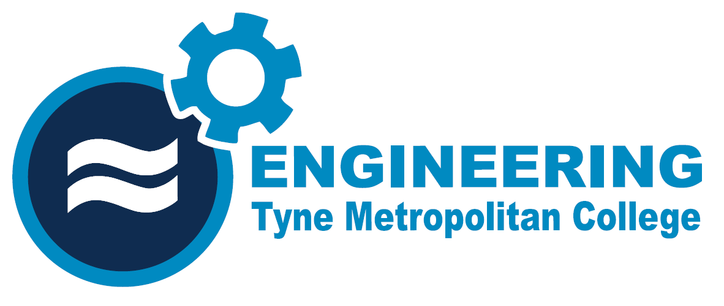
ENGINEERING DEPARTMENT

CANDIDATE RECORD 23.3 Selection and rating of protective devices

EAL First Certificate
Level 2

ELECTRICAL INSTALLATION METHODS, WIRING & CIRCUIT PROTECTION
Engineering Technology NETI/23

CANDIDATES NAME ___ _____________________Group____

Contents & Candidate Record
Contents
Task 23.3a Selection of protective devices 3
Circuit and KW rating 3
Task 23.3b rating of protective devices 4

Task 23.3a Selection of protective devices
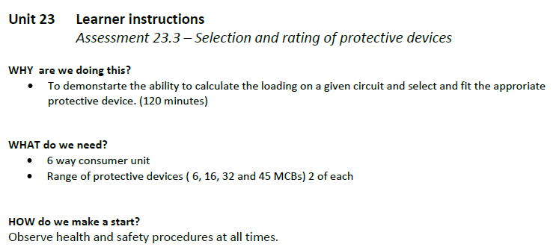
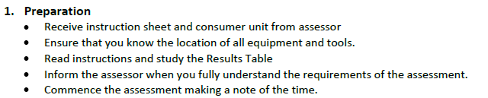
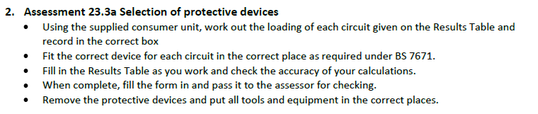
Circuit and KW rating | Rating (Current) | MCB size
1. Shower (8.4KW)
2. Immersion Heater (3KW)
3. Ring final circuit one with Total load (5.2KW)
4. Ring final circuit two with a Total load (3.15KW)
5. Lighting Circuit one with 8 x 100W lamps
6. Lighting Circuit two with 8 x 60W lamps

Task 23.3b rating of protective devices
Load | Current demand | Protection/MCB Rating from 6A, 16A, 32A,45A.
960Watts
875 Watts
3.62 Kilowatts
7.0 Kilowatts
6.4 Kilowatts
8.3 Kilowatts

