ENGINEERING DEPARTMENT

CANDIDATE TRAINING RECORD 23.3 Selection and rating of protective devices

EAL First Certificate
Level 2

ELECTRICAL INSTALLATION METHODS, WIRING & CIRCUIT PROTECTION
Engineering Technology NETI/23

CANDIDATES NAME ___ _____________________Group____

Contents & Candidate Training Record
Contents
MCB, RCD, RCBO Jargon 3
What is an RCD? 3
How does it work? 3
What does an RCD do? 3
RCBO 5
Power circuits Calculations. 6
Q1 A power circuit is to be wired in a factory can you identify three points to comply with BS7671 7
Q2 A consumer unit contains the circuit overcurrent protection and a Main, 7
Q3 A Fuse or a circuit breaker detect which faults 7
RCD Operation. 8
Q2. An imbalance between the line and neutral conductors is monitored by a, 8
Lighting and Power circuits and the differences 8
Q3 what do fuses protect against 11
Q4 What is the advantage of circuit breakers when compared to fuses is that, they can be easily, 11
Q5 A shower is rated at 8000 Watts and connected to a 230 V supply, the current drawn is, 11
Q6 A 3Kw/230V load will be protected by a fuse rated at, 12
Q7A fuse holder identified with a blue dot will have a current rating of 12
Q8 A Socket 12

MCB, RCD, RCBO Jargon

What is an RCD?
An RCD, or residual current device, is a life-saving device which is designed to prevent you from getting a fatal electric shock if you touch something live, such as a bare wire.

How does it work?
An RCD constantly monitors the electric current flowing through one or more circuits it is used to protect. If it detects electricity flowing down an unintended path, such as through a person who has touched a live part, the RCD will switch the circuit off very quickly, significantly reducing the risk of death or serious injury, if an RCD detects an in balance of the flow of current through the live conductor and returning on the neutral conductor it will trip and disconnect the circuit. RCDs offer a level of personal protection that ordinary fuses and circuit-breakers cannot provide.
The On site guide give good detail of how to test an RCD.
Section 11.3 is a good starting point. Most RCD’s art set at a rating of 30ma trip, that is a very low amount of current 0.03A. What 11.3 states is:
- With a leakage current flowing equivalent to 50% of the rated tripping current (15ma) the device should not open (Trip)
- With a leakage current flowing equivalent to 100% of the rated tripping current (30ma) the device should open (Trip) within 300ms.

What does an RCD do?
An RCD is a sensitive safety device that switches off electricity automatically if there is a fault. An RCD is designed to protect against the risks of electrocution and fire caused by earth faults. For example, if you cut through the cable when mowing the lawn and accidentally touched the exposed live wires or a faulty appliance overheats causing electric current to flow to earth.
Socket outlets on domestic dwellings have additional protection by using an 30mA RCD at the consumer unit, the consumer unit also has a Main Switch to allow the Isolation of the entire installation.
The image below shows a combined Main switch which is also an RCD, you will be using this type of protective device within your installations for safety.
If there was a fault the RCD would trip within 300ms (Milli seconds, 0.3 seconds), the rating of this RCD will be 30ma (milli Amps 0.03A)
MCB (Miniture circuit breaker BSEN 60898)
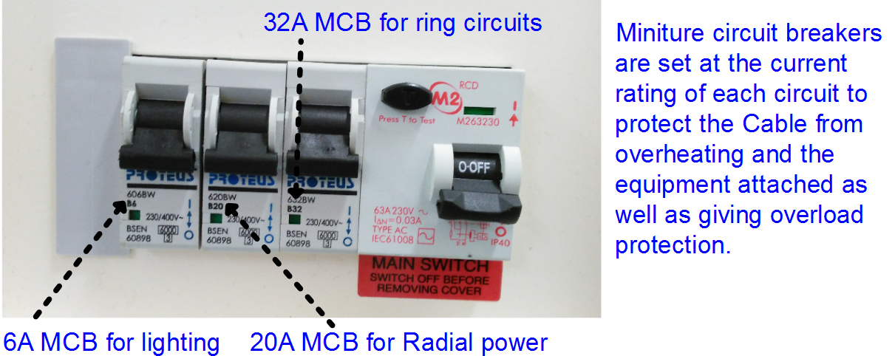
An MCB works in a different way, the downside is that the MCB will not detect an in balance between Live and Neutral, therefor if there is earth leakage between Neutral and earth the MCB will not detect this and therefore will not trip. An MCB relies on a magnetic effect or a heating effect to operate/ (Trip). It will trip on a series of faults as does a fuse, they protect against faults such as:
- if there is a Fault between Live and Neutral. (Short circuit)
- if there is earth fault between Live and Earth. (Earth Fault)
- If the circuit is overloaded beyond its rating. (Overload)

Q 1 Circuit breakers to BSEN 60898 rely upon the,
a. | magnet effect to operate only
b. | magnetic or heating effect to operate
c. | capacitive effect to operate
d. | lighting effect to operate
Where an older installation has protection added sometimes a socket can be replaced with a RCD Protected socket, these are installed within the electrical workshops and you will plug into these to power up your installations.
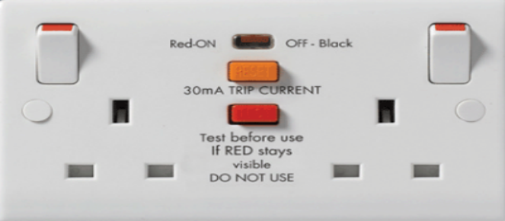
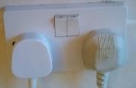
Appendix H of the On site guide is quite specific and along with Regulation 443.1.204 it states. “A single 30A or 32A ring circuit may serve a maximum floor area of up to 100m² however the number of outlets is unlimited.
Q2 A power circuit is to be wired in a factory can you identify three points to comply with BS7671.
a) | The maximum permitted area of the circuit. |  | Ans
b) | The Maximum fuse or MCB size. |  | Ans
C) | The number of outlets allowed. |  | Ans
d) | The minimum conductor size. |  | Ans

RCBO
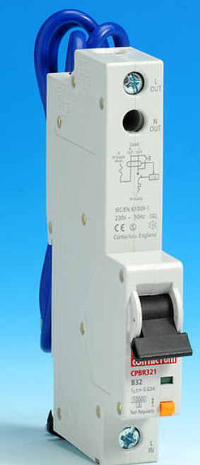  An RCBO is a more expensive device as it replaces an MCB for a device that is a combination of an MCB & an RCD. The RCBO will detect all four types of fault and trip in the same timespans as an RCD. An RCBO will detect and disconnect the circuit if:  - There is a short circuit between Live and Neutral.  - There is earth leakage between Live and Earth.  - There is earth leakage between Neutral and Earth.  - The circuit is overloaded beyond its rating. | An RCBO is a type of circuit breaker with two functions.  1To protect life.  2 To protect an overload on a circuit – overcurrent and short circuit  Electricians will install an RCBO (Residual Current Breaker with Overcurrent) where there is a need to prevent overload on a particular circuit at the same time as preventing anyone getting a shock that has the potential to kill them.  An RCBO will normally have two circuits for detecting an imbalance and an overload, It works in a similar way to an RCD measuring the current on the live and neutral conductors. If they are not equal it suggests there is current leakage to earth.  An RCBO also works as an MCB (Minature or Mains Circuit Breaker). In this operation it is designed to interrupt a current overload in a circuit. A short circuit is an abnormal low-resistance connection between two nodes of an electrical circuit that are meant to be at different voltages, for example if a conductive liquid (water, coffee, tea etc) causes a connection between the live and neutral terminals of a plug or a light switch.

Power circuits Calculations.
Power circuits are quite different as they usually protected with a 32Amp MCB and wired with a minimum size cable of 2.5mm². The power circuit will be protected with either a 16A or a 20A MCB if it is a radial power circuit, this cable can only carry a maximum of 24Amps, therefore generally power circuits are wired in a ring where the cable can carry double the current. The maximum protective device would be a fuse rated at 30A or MCB rated at 32A.
There are also some other rules about the number of outlets permissible on a circuit and the floor area that can be covered with one circuit.

Q3 A consumer unit contains the circuit overcurrent protection and a Main,
a. | Energy meter
b. | Switch
c. | Thermostat
d. | Programmer

Q4 A Fuse or a circuit breaker detect which faults
a. | Overloads, short circuits and Earth faults
b. | Earth faults only
c. | Overloads, short circuits only
d. | Short circuits and Earth faults only.

RCD Operation.
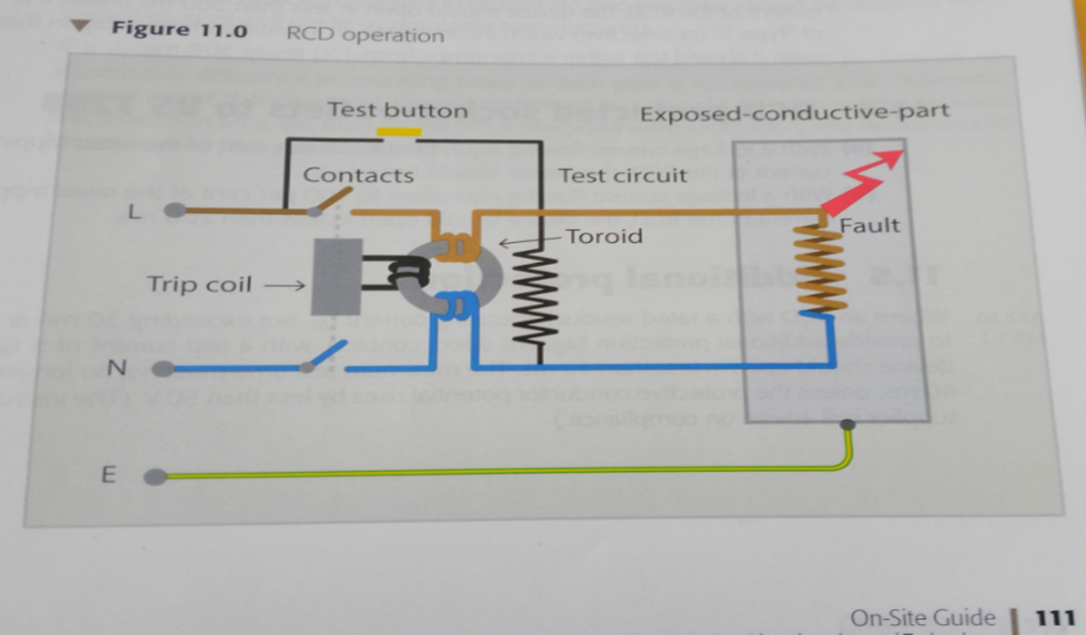

Q5. An imbalance between the line and neutral conductors is monitored by a,
a. | Residual current device
b. | Residual circuit device
c. | Resistance circuit device
d. | Resistance current device

Lighting and Power circuits and the differences
Over the course of the programme you will gain a better understanding of power and lighting circuits.
There are a lot of common mistakes made with the terminology.
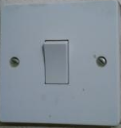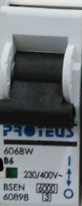 |  | A light is controlled by a switch, which has the purpose of being able to brake the live conductor to operate the lamp.
 | 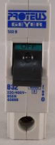 | Socket outlets are provided to give an outlet for appliances to be plugged into. The purpose is to provide an outlet with a connection for appliances.
Cables connected to an MCB are held in place with a clamped connection where a screw moves a clamp to grip the cable.
Lighting circuits are usually protected with a 6Amp MCB and wired with either 1.0mm² or 1.5mm² cable. 1.0mm² cable would be the minimum conductor size used for lighting.
Generally most basic lighting circuits will have a Ceiling rose fitted in a domestic installation where the connection to a lamp holder is flexible, however utility room and bathrooms or where the light is to be fitted to a side wall a batton lamp holder would be used where the connection to the light fitting is permanent.
Power circuits are usually protected with a 20Amp MCB when wired in a radial circuit. To give more scope they are usually wired in a ring usually protected with a Maximum protective device of a 32Amp MCB with a minimum conductor size of 2.5mm² cable. Older circuits with fuses are protected with a 30A Fuse. The main advantage of a Miniature circuit breaker is that it can be reset after “Tripping” where a fuse has to be replaced.
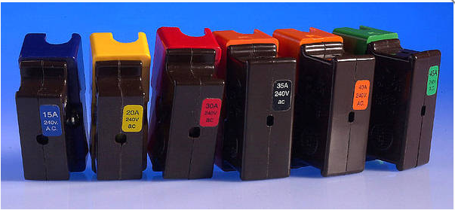
15A Blue, 20A Yellow used for radial power |  | 30A Red maximum size for a ring circuit | 45A Green used for large cookers and showers
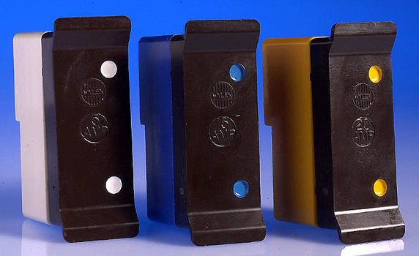
5A White used for lighting |  | 15A Blue used for Radial power as is 20A Yellow | Re-wirable fuses are a lot less common now but still can be found in older places
Power circuits have a maximum floor area of 100m². However, because the maximum size protective device of a 32A MCB /30A fuse provides protection for the cable the number of outlets allowed is unlimited.
This is because if you plugged too many appliances into the outlets the MCB would detect this by heating up and bending causing the mechanism to bend and provide overload protection and trip. If the circuit was protected by a fuse the fuse wire would heat up and slowly melt protecting the circuit from Over Current

Q6what do fuses protect against
a. | heating effect
b. | no-voltage
c. | eddy current
d. | over current

Q7 What is the advantage of circuit breakers when compared to fuses is that, they can be easily,
a. | Disposed of
b. | Adjusted
c. | Reset when tripped
d. | Locked on

Q8 A shower is rated at 8000 Watts and connected to a 230 V supply, the current drawn is,
a. | 35Amps
b. | 3.5Amps
c. | 355 amps
d. | 35 Ohms

Q9 A 3Kw/230V load will be protected by a fuse rated at,
a. | 10A
b. | 23A
c. | 13A
d. | 12A

Q10 A fuse holder identified with a blue dot will have a current rating of
a. | 12A
b. | 16A
c. | 10A
d. | 15A

Q11 A Socket
a. | 10A
b. | 23A
c. | 13A
d. | 12A

Task 2 23.3 Understand the selection and rating of circuit protection.

Once completed you should be able to complete assessments 23a and 23b & 23.3 end test.
Calculating MCB Ratings for set situations using P=I*V I=P/V V= P/I
Ib is known as the design current and is obtained using P/V
The MCB or fuse size is known as In……In > Ib
Using the selected formula Calculate the correct current rating and then the correct size Miniture circuit breaker (MCB) for the given power rating for each of the 230V circuits.
Appliance | Voltage (V) |  | Power (W) |  | Current demand Ib |  | MCB Rating In > Ib from list at bottom of table.
Shower | 230V |  | 9 Kilowatts |  | 9000/230 = 39.13A |  | 45A
Lights | 230V |  | 1000 Watts
Lights | 230V |  | 60Watts X 10
Cooker | 230V |  | 6 Kilowatts
Heating | 230V |  | 9 Kilowatts
Radial power | 230V |  | 3 Kilowatts
Ring Power 1 | 230V |  | 7 Kilowatts
Ring Power 2 | 230V |  | 5 Kilowatts
Immersion heater | 230V |  | 1 Kilowatts
Oven | 230V |  | 4 Kilowatts
MCB Choice | 6A | 10A |  | 16A |  | 20A |  | 32A | 45A
Now using the information gained fit in the correct order the MCB’s into the Consumer Unit for circuits.
Using 6 circuits of your choice explain below your choice of selection.

Task 3 The Largest size MCB’s must be installed from the main switch of the CCU in descending order.
MCB Rating in Amps. |  | Circuit 1-6 |  | Reason
45A |  | 1 |  | Shower - Highest load
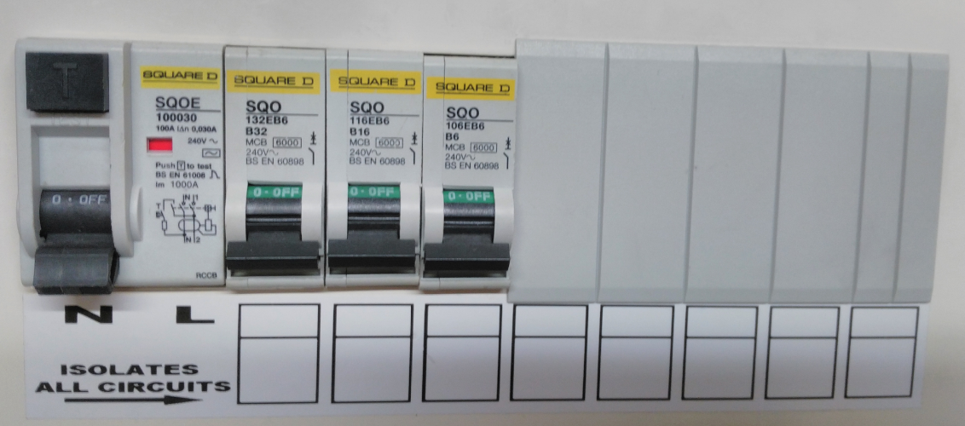
Main Switch/RCD | Circuit Breakers highest rated closest to the Main switch |  | Spare ways

Task 23.3a Selection of protective devices
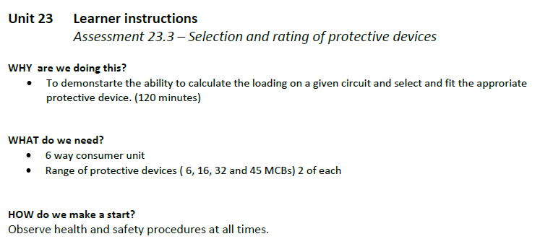
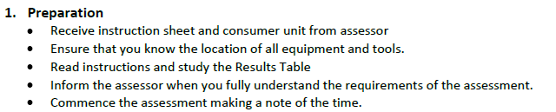
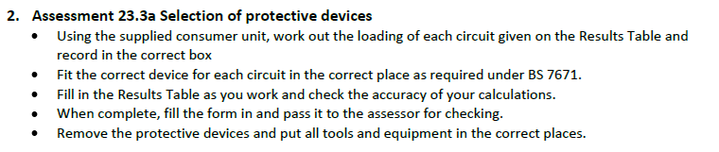
Q12 Circuit and KW rating | Rating (Current) | MCB size
1. Shower (8.4KW)
2. Immersion Heater (3KW)
3. Ring final circuit one with Total load (5.2KW)
4. Ring final circuit two with a Total load (3.15KW)
5. Lighting Circuit one with 8 x 100W lamps
6. Lighting Circuit two with 8 x 60W lamps

Q13 Task 23.3a rating of protective devices
Load | Current demand | Protection/MCB Rating from 6A, 16A, 32A,45A.
960Watts
875 Watts
3.62 Kilowatts
7.0 Kilowatts
6.4 Kilowatts
8.3 Kilowatts

