An update on Science Council - July 2023.
Science Council have had a super year and contributed lots to helping with a pupil voice for science in school. After a busy MST Week in which they organised puzzle books unique to each year group, a whole school ‘Connections’ poster competition with certificate prizes, a distribution of x4 bamboo toothbrushes for every pupil in the school and of course a visit for every year group from the incredible scientist Professor Brainstorm, they have also tried to run a sunflower challenge throughout the school. As it stands, some of the sunflowers were stolen (we think by birds) when accidentally left outside in the school grounds over the weekend, or died. Some have grown and some have thrived and the winning classes left in the race at the moment are 4NW’s at 61 cm and 6GD’s at 59 cm tall. These two will race to the finish line and on Friday a winner will be declared for the best sunflower growers in the school academic year 2022-2023. Watch this space in the head to head between years 4 and 6.

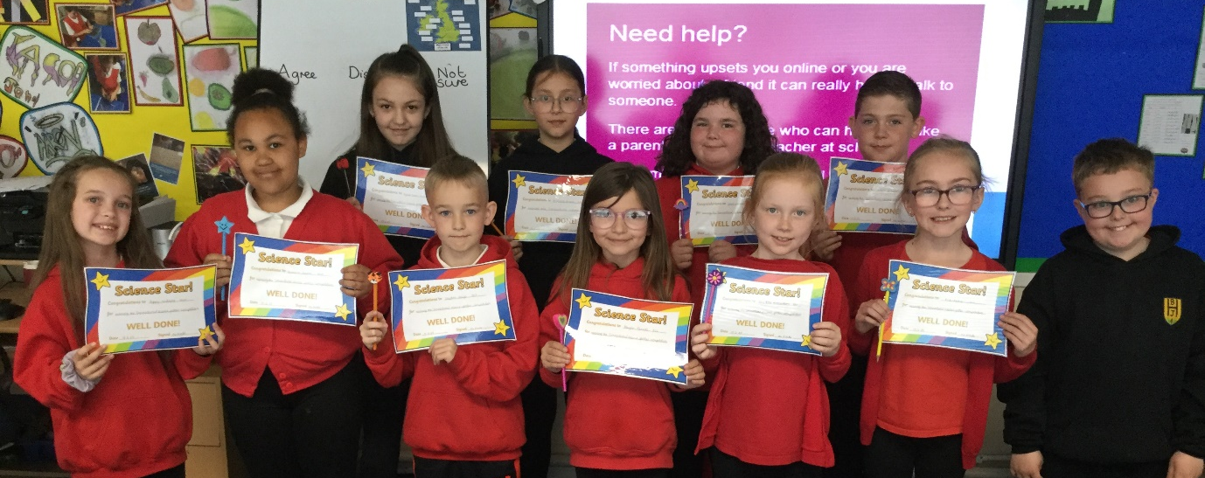
Competition winners for the ‘Connections’ posters: well done.

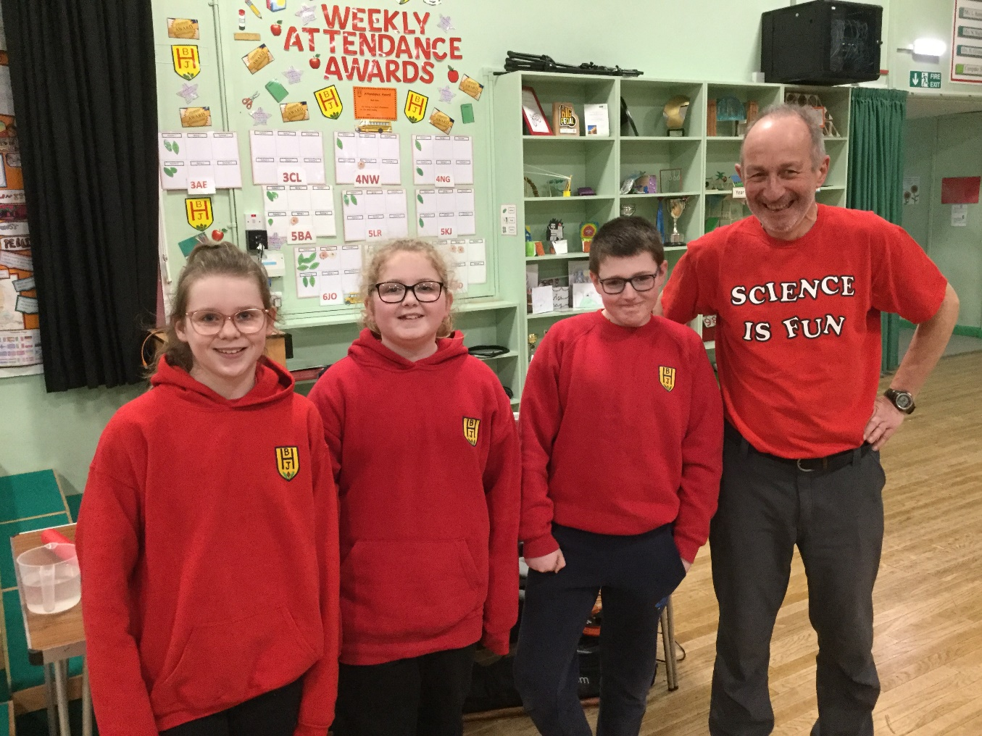
Some of our Council members with the man himself – Professor Brainstorm.

