BIDDICK BULLETiN 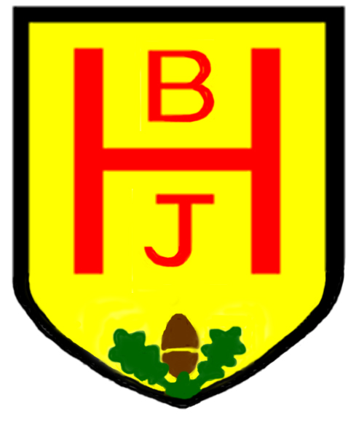
Friday 25th September 2020
Welcome back to a new school year at Biddick Hall Junior School.
We thank you for your continued support.
Each week we will inform you of events taking place and important dates for your diary. It will be sent out every Friday via Parent Mail so please ensure that you have given your details to the school office. It can also be found on the school website.
M.Collinson
Autumn Term Events
16.10.20 | School Nurse in to administer Flu Nasal Spray
w/c 19.10.20 | Multi- cultural week in school - activities planned
23.10.20 | School closes for half term holiday
w/c 26.10.20 | Half Term Holiday
2.11.20 | School re-opens
ATTENDANCE.
Coming to school is important. Each week we will award a certificate to the class with the best attendance. You must ring school and inform school on the first day of absence. Please don’t send your child to school if they have symptoms of COVID-19 or live with someone who has symptoms. Please keep school updated.
Every week all pupils who have 100% attendance go into an envelope and one child per class is chosen to receive a pencil, a ruler or a bookmark. Then once per half term all 100% attendance pupils are put into a year group envelope and one child is chosen to receive a £5 Asda gift voucher.
Parents each term have the chance to win a £25 gift voucher for Asda also.
Any pupil who has 100% attendance each term will receive a wrist band and a certificate.
All children who have 100% weekly receive a 100% sticker.

Attendance Winners of the Week.
w/e 25.9.2020
5KJ
99.44%

Parents
Please remember to adhere to 2m social distancing outside the school gates and inside the school grounds. Thank you for your continued support.

