

**Year 3 (3GB)**

**Teachers**:

Mrs Boardman / Mrs Harvey

**Teaching Assistants/HLTA working in class**:

Mrs Barnes, Mrs Duncan, Mrs Hasan, Mrs Forbister (Mensforth).

It is vital that you support your child as much as possible throughout the year. Whether that be with homework, using the apps at home, reading with them and even chatting to them about their learning – it will make a difference.

Thank you for your continued support.

Hello Year 3,

We are all really excited for you to start Year 3. We hope that you have had a fantastic summer and you are all ready to start your learning journey once again.

Can you believe you are now in Key Stage 2? Don’t worry we are going to have lots of fun this year!

We know that you may be feeling nervous and worried about starting a new year, this is totally normal. We are here to support you to be able to achieve your goals and be successful.

If you have any questions about the year ahead, please speak to any one of us and we will help put your mind at ease.

 

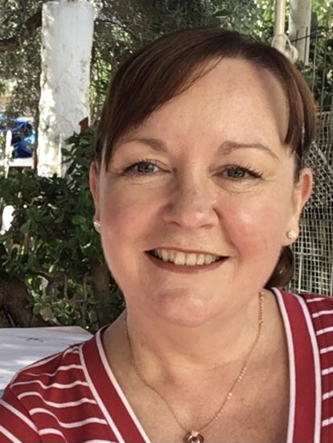 

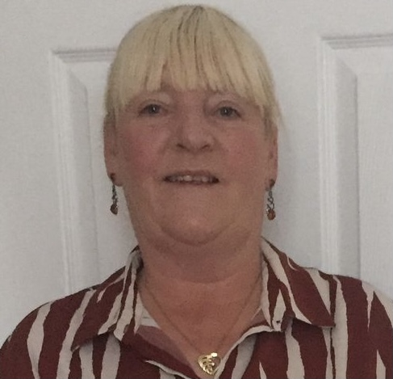 

**Online Learning**

Please use the **myON and Times Tables Rockstars Apps** regularly at home.

Work for all Y3 pupils will be set on these apps each week during the school year.

All passwords and usernames will be sent out to you in September.

**Home Reading**

Please listen to your child read their school reading book or chosen book as often as you can, every day is ideal, even if it is just for 10 minutes. Our expectation is that their reading book will be changed every week (more often if possible.)

As soon as your child has finished their book, return it to school in exchange for a new book.

**The Y3 team are so excited to work with you this year!**

**General Information**

**Homework:** Throughout the year, your child will receive a combination of homework developing their knowledge and skills in Reading, Spelling, Maths and Grammar. Your child will have a homework folder that they will bring home weekly and it must be returned with the completed work on the specified days.

**Year 3 Weekly Timetable – Key days:**

**Monday: Homework will be given out in homework folders to be returned Thursday mornings.**

**A reading task will be set on myON each week to complete by Thursday.**

**Thursday: Return homework to Mrs Barnes.**

**P.E day – come to school in P.E kit.**

**Friday: Mrs Harvey will be teaching you on a Friday.**

**Spellings will be given out and spelling test carried out today.**

**Reading books will be changed when returned.**

**Key Information**

There is a transition from Key Stage 1 to Key Stage 2 and changes to the daily routine. We will support your child with this and make sure they are settled and happy and know the timetable of lessons for each day.

Due to missed learning during lockdowns some interventions will take place during the academic year in order to help and support your child with their English and Maths skills in small group situations. This is highly beneficial and will support gaps in your child’s learning.

If you feel your child needs extra social or emotional support after the uncertain times we have all experienced recently, Miss Thornton our Social/Emotional lead is available to speak to if you have any concerns at all about your child’s well-being.