Stanhope Primary
Early Years Foundation Stage
Nursery
Welcome to Stanhope Primary Early Years Foundation Stage, we are delighted that you have chosen Stanhope Nursery for the next stage of your childs learning journey.
Starting nursery is an exciting time. We hope that time spent with us will be both happy and rewarding. Your involvement in your child’s education is very important throughout their school years; we look forward to developing a strong partnership with you.
If you have any questions about the year ahead, please speak to us and we will help put your mind at ease.
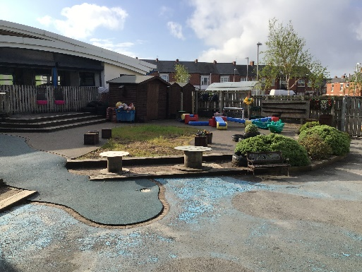
Induction
Once your child has been a allocated a place, you will be invited to come along for a stay and play session in the term before they are due to start. The session lasts about an hour. It’s a lovely time for you and your child to meet the staff and explore the nursery.
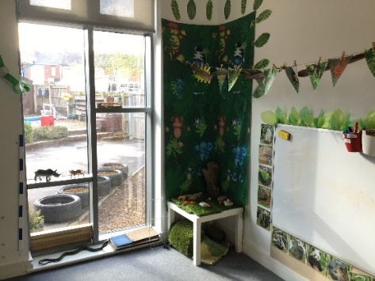
This introduction to nursery is followed by a home visit. This gives us the opportunity to speak to you and meet your child in a familiar setting where information can be shared. We find that children are much more likely to settle well into nursery having spent a short time with staff in their own home. During the visit, you will be given a starting date for your child.
On your visit please inform staff if you have any concerns about your child starting nursery.

Once your child has settled in nursery then they will begin their three-hour session. Should your child need a little longer they will visit for a short time each day as they build their confidence.

Nursery Times
Morning session: 8:30am - 11:30am
Afternoon session: 12:25pm - 3:25pm
Full day session: 8:30am – 3:25pm

The nursery doors open 10 minutes before the end of each session for parents and carers to collect children, this will allow for a smooth transition.
Please ensure you collect your child promptly at the end of a session as lateness can cause anxiety for the child.
During the home visit you will be asked to provide a password. The password system ensures safety at the door. Please tell us if someone other than a parent or guardian is coming to collect your child, so that we know they are being taken home safely.

If there is an occasion where you have to collect your child earlier than usual, please try to arrange this in advance and call at the School Reception area to collect your child.

We would ask parents to supervise children before and after Nursery sessions. Children should not be allowed to run in the car park or along the path. The drop off zone can be very busy, we ask that parents do not park in the ‘dropping off’ zone.
Preparing for Nursery

Please help your child to become independent by putting them in clothing that can be easily managed. Children feel much happier if they can cope with their clothes; allow them to practise fastening buttons and zips. Velcro shoes help children to independently put on wellies for working in the sand, water and mud.

All garments including coats and shoes should be clearly marked with your child’s name.

A spare set of clothes should be brought to the nursery each day in case of accidents.
Children must wear strong sturdy shoes at all times.
In the interest of safety, jewellery must not be worn.

Nursery Uniform

Navy jogging bottoms, trousers, skirt, pinafore, or blue gingham summer dress
White polo shirt
Navy sweatshirt, cardigan or v necked pullover
Black trainers / black shoes

Clothing can be ordered from our uniform suppliers. www.theschooloutfit.co.uk.
Sunshine yellow PE t-shirts can be ordered from the school office.

Healthy Lifestyle

At Stanhope Primary School we promote a healthy lifestyle. In support of this we would ask that parents encourage children to bring a bottle of water to nursery every day. To support healthy choices and good oral hygiene in nursery we will endeavour to:

- Provide healthy snacks
- Only offer milk or water

At birthday times and on special occasions your child may be offered sweets/treats which they can bring home after the session.

Special Needs
Every child is unique and it is important to remember that children develop and learn at different rates. At Stanhope Primary School we believe in early identification so that all children receive the right kind of support in order to make progress in their learning.
In nursery we use a number of programmes to assess children’s progress and to ensure children continue to make the next steps in their learning. Should a child need additional support we may need to refer to external agencies for practical or additional support.
We work closely with a range of professionals including Health visitors and Portage and Pre School services. If you have any concerns at all about your child or feel you need some advice and guidance, please speak to the Nursery Teacher.

School Fund
In order to supplement resources in the nursery, we have a system whereby parents can make a 50p voluntary contribution each Monday. This gratefully supports the work in the nursery. It helps us to purchase fresh ingredients for cooking, play dough resources and other everyday materials as well as special treats, which are not available from the general School budget.

Library

Library sessions take place every Friday. Children are encouraged to choose a book from our school library. Named bags are provided and books are returned in the bag the following Friday.

PE
PE takes place every Friday in the school hall or weather permitting on the school field. Children come to school dressed in their PE kit, with suitable footwear for running and climbing on apparatus.

Healthy Tuck Shop
Children can bring up to 60p to purchase healthy snacks in our healthy tuck shop to eat in school following our PE session on a Friday. Snacks cost 20p each and 10p for bread sticks. A named envelope for each child will be kept in school. Any change will go back in the envelope and can be added to the next Friday. Snacks will include rice cakes, bread sticks crispy fruit slices and raisins.

Supporting your child’s learning

Everyday activities which children share with parents or other members of the family can provide valuable experiences to help prepare children for nursery.

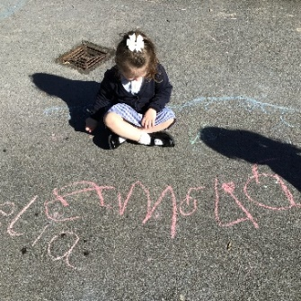
- Count the stairs when going to bed.
- Spend time together sharing a story and looking at the pictures.
- Sing songs or nursery rhymes, dance to music on the radio.
- Work on a jigsaw together.
- Encourage your child to help with everyday jobs around the home.
- Encourage help with shopping tasks e.g. how many apples do we need?
- Encourage your child to dress and undress, put on their own coat.
- Watch TV together, especially programmes for younger children. Talk about the programme.
- Give children the opportunity to draw pictures and make marks using a variety of materials, let them tell you about their drawings.
- When out walking look for numbers on the front doors or the numbers on the bus, the colours of the cars in the car park and shop names on carrier bags.

Make it fun and enjoyable!

