

Year 6 Mathematics

Parent Guide 2020
ADDITION
First add up the ONES:
9 + 2 = 11
The 1 is written in the ONES column and the 1 is carried into the TENS column.

You write the numbers you carry over below the answer bar.

Continue to add up the digits in the TENS and the HUNDREDS.
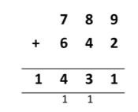

SUBTRACTION
First subtract the ONES:
2 – 7. You cannot do this so we need to exchange (borrow) from the number in the TENS. So the 3 now becomes a 2 and we carry over the 1 so it is now 12 – 7 = 5

Next subtract the TENS:
2 – 5. You cannot do this so we need to exchange again from the number in the HUNDREDS. So the 9 becomes an 8 and we carry over the 1 so it is now 12 – 5 = 7.

Finally subtract the HUNDREDS:
8 – 4 = 4.

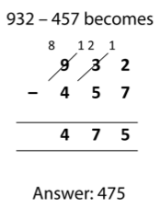

MULTIPLICATION

Multiply 7 by 2 = 14.
The 4 is written in the ONES column and the 1 is carried into the TENS column.

Next multiply 7 by 4 = 28 and then add the 1. The 9 is written in the TENS column and the 2 is carried into the HUNDREDS column.

Finally multiply 7 by 3 = 21 and then add the 2. The 3 is written in the HUNDREDS column and the 2 is written in the THOUSANDS column.

Again, any numbers, which are carried over, are placed underneath the answer bar.
SHORT

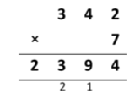

Multiply by the ONES first.
6 x 4 = 24. The 4 is written in ONES column and the 2 is written on the first line (in the TENS column)
6 x 2 = 12 and add on the 2. The 4 is written in the TENS column and the 1 is written on the first line (in the HUNDREDS column)
6 x 1 = 6 and add on the 1. The 7 is written in the HUNDREDS column.

Now it’s time to multiply by 20. Place a zero in the TENS column and then just multiply by 2.
2 x 4 = 8. Place the 8 in the TENS column.
2 x 2 = 4. Place the 4 in the HUNDREDS column.
2 x 1 = 2. Place the 2 in the THOUSANDS column.

Finally, add the two rows of numbers together and place the answer in the answer bar.
LONG

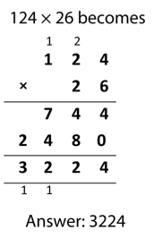

DIVISION

SHORT

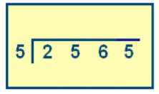
2565 divided by 5 is written like this.

The children may know this method as short division or ‘the bus stop’ method.

To work this out, divide 5 into 2565 one digit at a time – starting with the digit 2 (which represents 2000 in 2565). The result of each division is written on the top of the line.

How many 5s are in 2? – There are none so the 2 is carried over into the next column. Now how many 5s are in 25? - There are 5. So the 5 is written on top of the line.

Next: How many 5s are in 6? – There is 1. So the 1 is written on top of the line. But there is 1 left over (a remainder) so this is carried over into the next column.

Finally, how many 5s are in 15? – There are 3. So the 3 is written on top of the line.

2565 divided by 5 = 513.

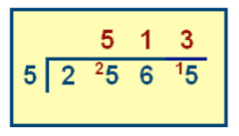

DIVISION

LONG
This is the traditional way of long division. It is set out just like a short division (bus stop method)

Please note: we recommend that the children create a fact box to help them. As we are dividing by 15, the children would write down the 15 times table.

To start, how many 15s are in 8? There are none so we look at the next digit.
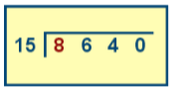

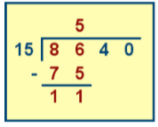

How many 15s are in 86? There are 5. So the 5 is written on the top line.

15 x 5 = 75. So take 75 away from 86.
86 – 75 = 11.

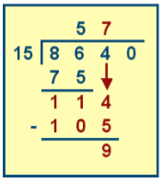
Next, carry the 4 down to make 114.

How many 15s are in 114? There are 7. So the 7 is written on the top line.

15 x 7 = 105. So take 105 away from 114.
114 – 105 = 9

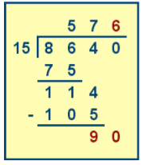
Next, carry the 0 down to make 90.

How many 15s are in 90? There are 6. So the 6 is written on the top line.

15 x 6 = 90. So take 90 away from 90.
90 - 90 = 0.

ANSWER: 8640 divided by 15 = 576.

FACTORS, MULTIPLES AND PRIME NUMBERS

Factors are numbers that divide exactly into another number. E.g. Factors of 12 include 1, 2, 3, 4, 6 and 12.
Multiples are really just extended times tables. Multiples of 2 always end in 0, 2, 4, 6, and 8.
Prime numbers are numbers that can only be divided by itself and 1. E.g. 2, 3, 5, 7, 11, 13, 17.

RATIO AND PROPORTION

Ratio compares part: part

E.g. Yellow: Red = 2:5 Red: Yellow = 5:2

You can also simplify ratios. E.g. 6:4 can be simplified to 3:2, 12:18 can be simplified to 2:3

Proportion compares the part in relation to the whole. This is expressed as a fraction.

E.g. Proportion of triangles is 4 out of 11 = 4/11

ALGEBRA

Algebra is all about solving puzzles with letters, numbers and symbols. It is about finding the unknown by using whatever information you are given.
a = 5 and b = 3

3a + b = 18 (3 x 5 = 15 15 + 3 = 18)

5a - 3b = 16 (5 x 5 = 25 3 x 3 = 9 25 – 9 = 16)
FRACTIONS

A denominator is the bottom number of a fraction.
A numerator is the top number of a fraction.
Equivalent means the fractions are the same size or amount.
A mixed number has a whole number and a fractional part.
An improper fraction is when the numerator is larger than the denominator.

Equivalent Fractions, Decimals and Percentages

1 whole = 1.0 = 100%
¾ = 0.75 = 75%
½ = 0.5 = 50%
¼ = 0.25 = 25%
1/10 = 0.1 = 10%
1/100 = 0.01 = 1%

Percent means ‘out of 100’ E.g. 40% = 40 out of 100 15% = 15 out of 100.

ANGLES

An acute angle is less than 90º
A right angle is exactly 90º
An obtuse angle is between 90º and 180º
A reflex angle is between 180º and 360º
A complete turn is 360º
Angles in a straight line add up to 180º
Angles in a triangle add up to 180º

Use a protractor to measure angles accurately.

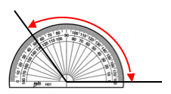

CO-ORDINATES

When plotting co-ordinates, always go along the corridor first (x axis) then up or down the stairs (y axis)
Remember your brackets!
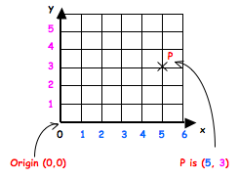

MEASUREMENT

Converting Metric Measurements
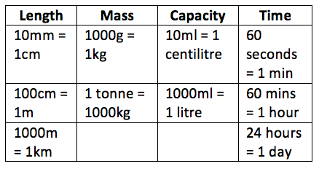
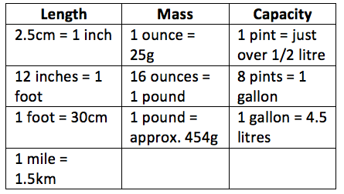

Converting Imperial Measurements

AREA & PERIMETER

Area = length x width
3cm
8cm
E.g. 8 x 3 = 24cm²

Perimeter = add all
of the sides together
E.g. 8 + 3 + 8 + 3 = 22cm

MEAN

Mean (average) – add up all of the numbers and divide by how many numbers there are.
E.g. 6 + 11 + 7 = 24 24 divided by 3 = 8

SOLVING PROBLEMS

R
U
C

Read the question. What is the important information?

Understand the question. What do you need to find out?

Choose the correct method of calculation and operation(s).
S

Solve the problem. Make sure you follow the stops.

A
Answer the question. What were you meant to find out?

C
Check your answer. Use the inverse to check your working out.

