

Year 6 Reading

Parent Guide 2020

Every KS2 reading assessment will contain questions designed to test different reading skills (called ‘domains’). Your child has been practising these skills throughout KS2 and the SATs reading test is an assessment of how well your child can apply these skills to unfamiliar texts.

The seven main types of reading question that your child may encounter are:

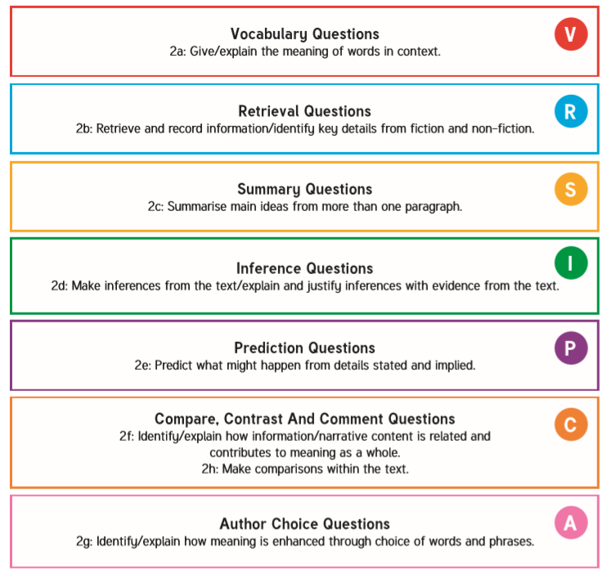

2a: Vocabulary Questions

Give/explain the meaning of words in context.

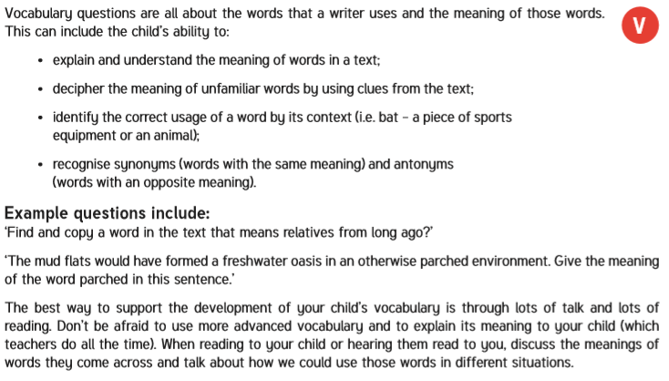

2b: Retrieval Questions

Retrieve and record information/identify key details from fiction and non-fiction.
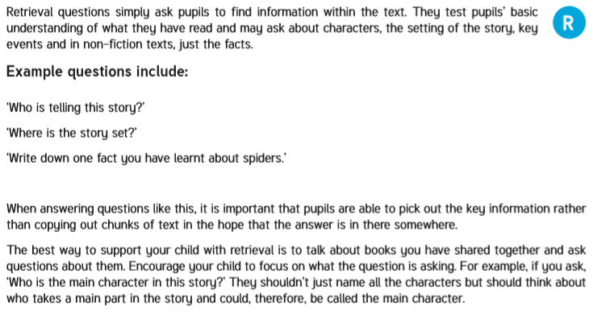
2c: Summary Questions

Summarise main ideas from more than one paragraph.

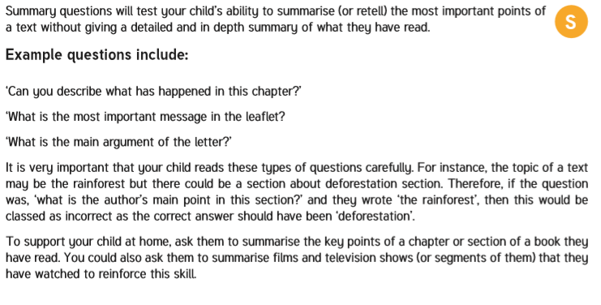

2d: Inference Questions

Make inferences from the text/explain and justify inferences with evidence from the text.
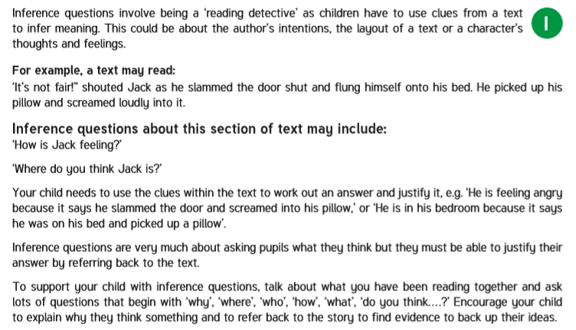

2e: Predict Questions

Predict what might happen from details stated and implied.

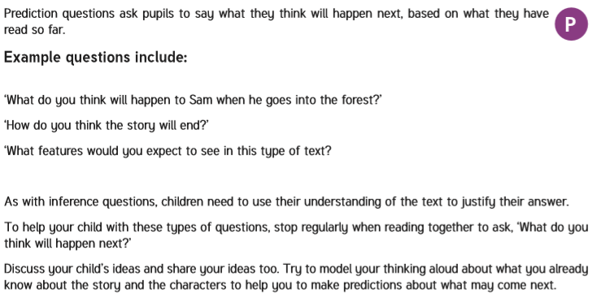
2f&h: Compare, Contrast and Comment Questions

Identify/explain how information/narrative content is related and contribute to meaning as a whole
Make comparisons within the text.

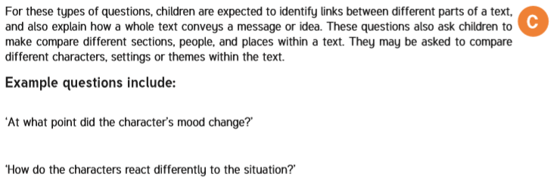

2g: Author Choice Questions

Identify/explain how meaning is enhanced through choice of words and phrases.

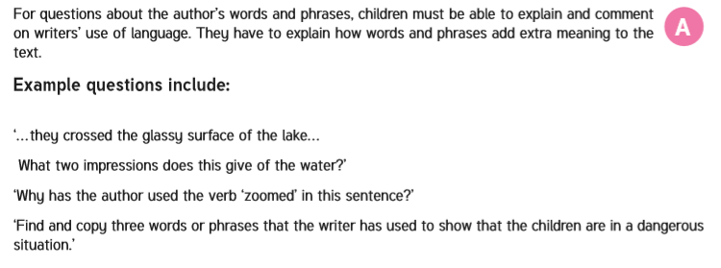

Key Stage 2 SATs Reading Paper – What to expect

Pupils take one reading test at the end of KS2. The tests usually contain 3 different texts (both fiction and non-fiction) with accompanying questions based on each text. The texts are usually within 1 booklet and there is a separate answer booklet with question. Children have an hour to read through the texts and answer the questions at their own pace. They should read the first texts, then answer the questions about it, before reading the second text and so on.

The types of questions your child will be asked are as follows:

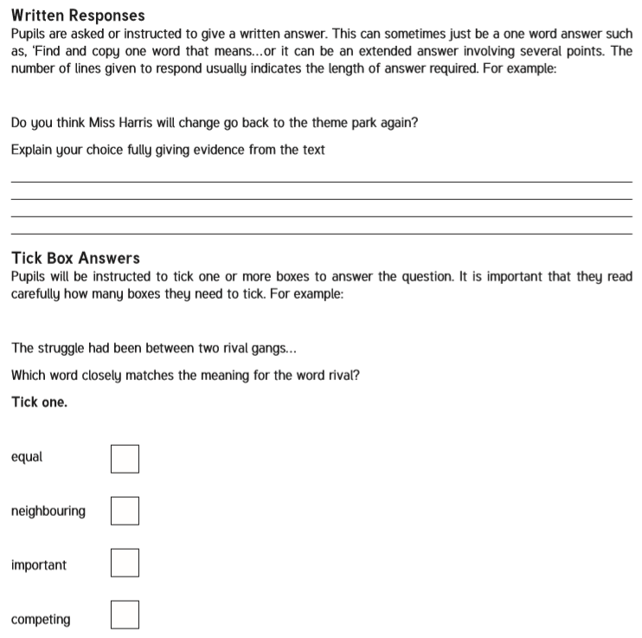

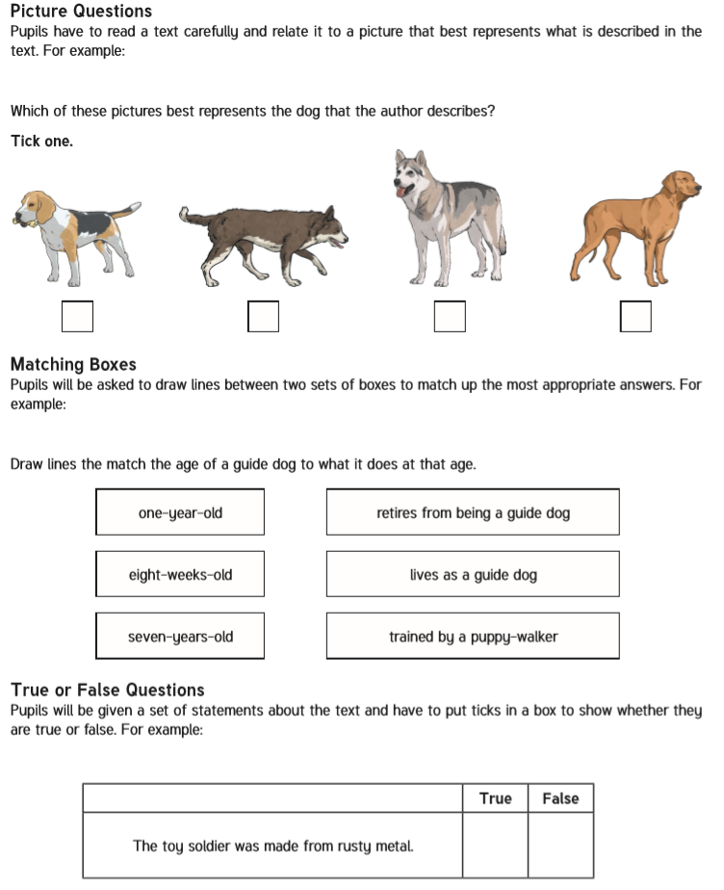

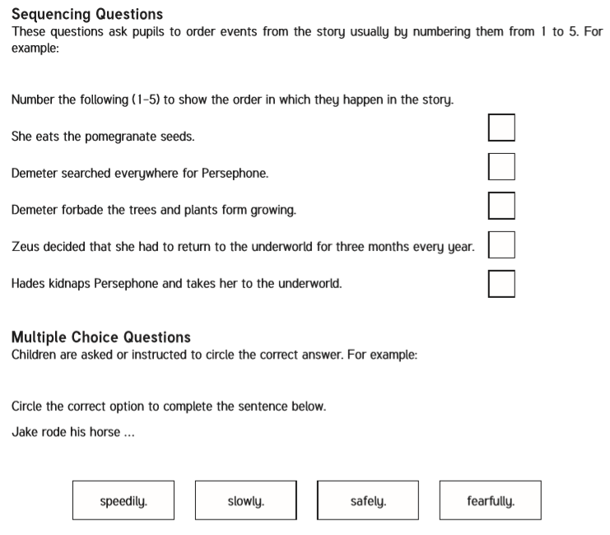

Questions to Discuss with Your Child when Reading Together



