New Parent Hub channels

STEP 1
As your child has now moved year groups, you will need to follow their new class in Parent Hub. Please find instructions below on how to do this (there are 3 steps to follow):

When you open your app your will see the screen below:
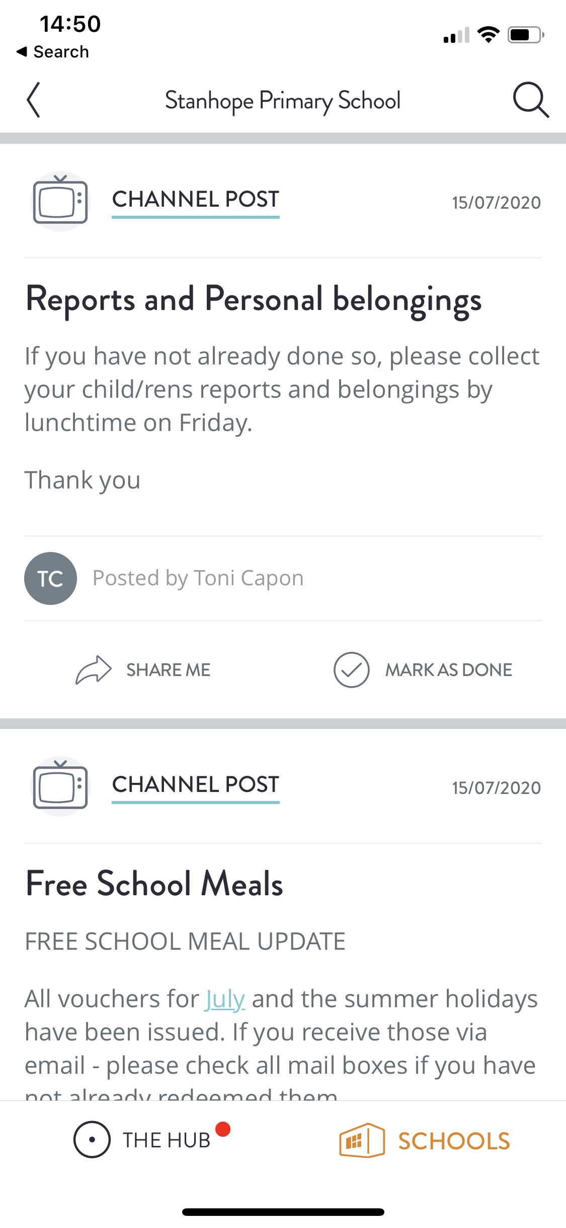

Please click on ‘SCHOOLS’ at the bottom of the page

STEP 2

You will then see the following screen:
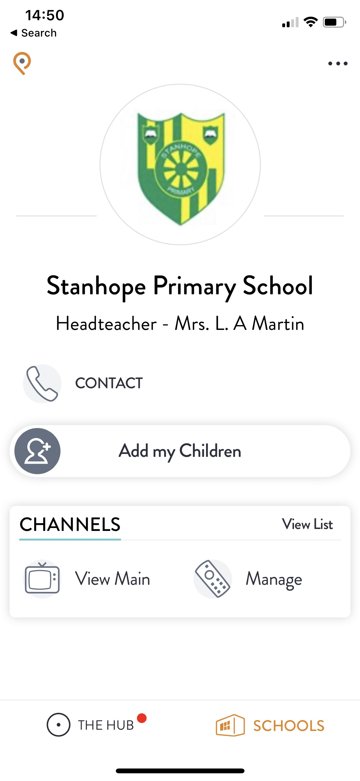

Click on ‘Manage’

STEP 3

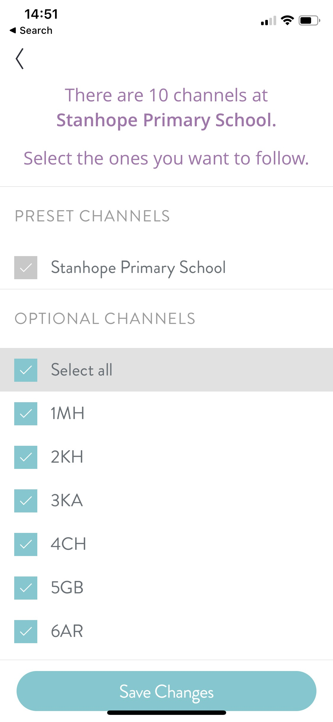You will see the following screen:

Select which channels you wish to follow and press save

