**Reading Books**

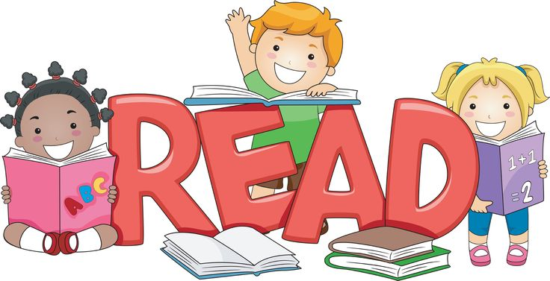

As soon as your child has finished their book, please return it to school so it can be changed.

**Water Bottles**



Please make sure your child has a bottle in school.

**Monday**

PE in the afternoon

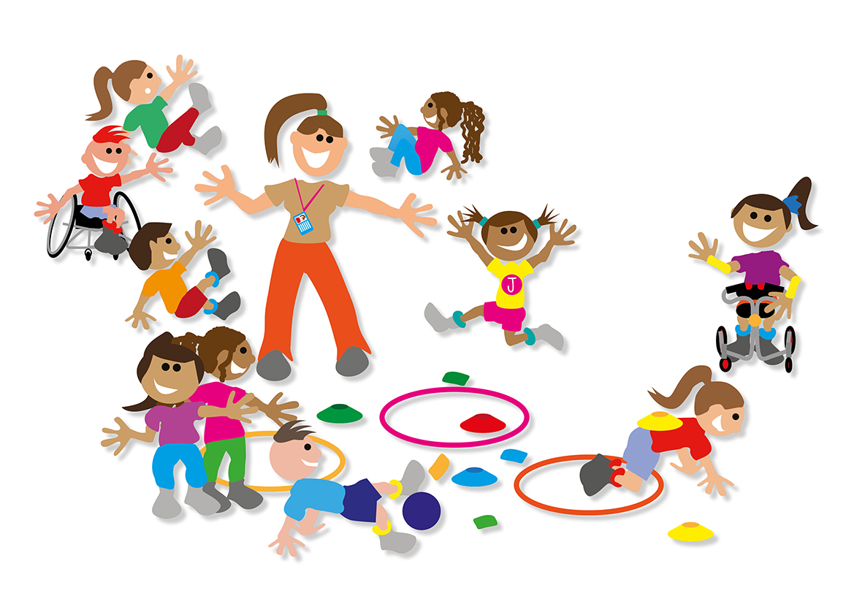

**Wednesday**

Homework returned to school



Healthy Tuck Shop (Maximum 60p)



**Thursday**

School Library visit



**Friday**

Spelling test and Homework sent home

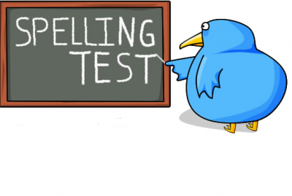

Weekly 50p fund for classroom resources can be handed in any day of the week.

Thank you for your continued support.

Mrs Harvey and Mrs Hasan

**WHAT’S HAPPENING IN YEAR 1?**