Difference between water, ice, and steam
Water exists in three states-solid ice,liquid water and gaseous steam.Solids have a fixed shape and size.Liquids can change in shape but have a fixed size.Gases can change shape and size.

Water is the liquid form,Ice is the solid form of water and steam is the gaseous form. 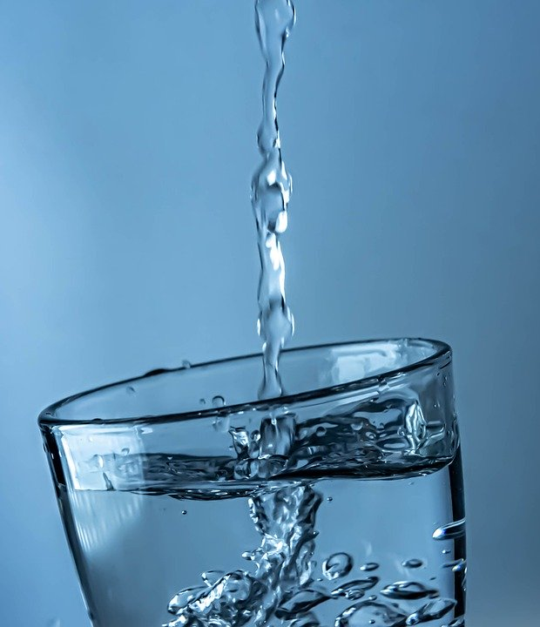 Water 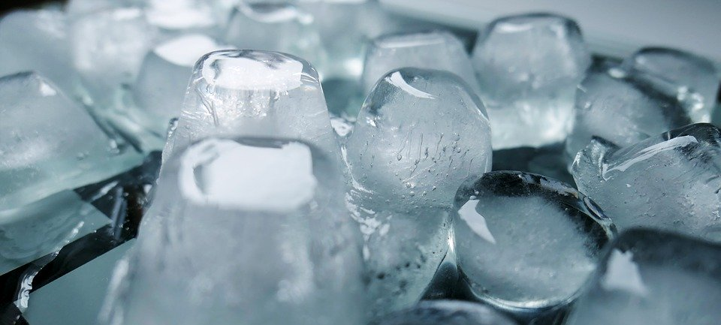 Ice 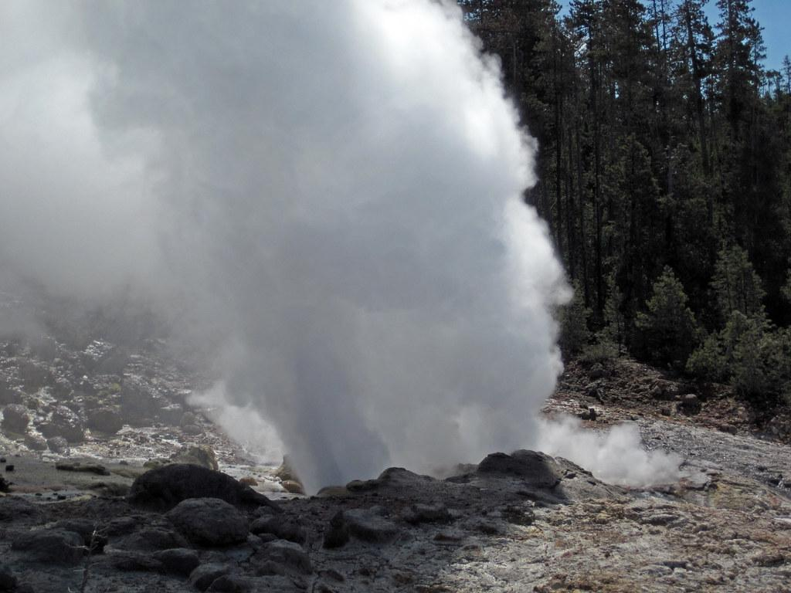
steam

