THE HAPPY NEWS
By Stanhope Primary
KINDNESS

Special Edition
THE HAPPY NEWS
By Stanhope Primary
Online Wellbeing Sessions
During Mental Health Awareness Week, Stanhope Primary has held their first online sessions. Staff and our children were able to see and speak to each other in a safe and happy environment.

We all enjoyed the ‘check-ins’, stories and activities.
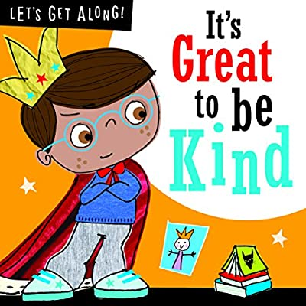

We learned lots about how we can be kind to others, how others are kind to us and how we can be kind to ourselves.

THE HAPPY NEWS
By Stanhope Primary
Your Happy News
‘I have been doing lots of drawing, colouring and some painting. We put the pictures on our windows. I’ve been in the garden a lot. I was playing with the ladybirds they love my garden and crawling on me.’

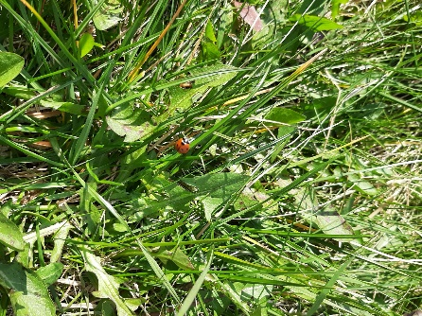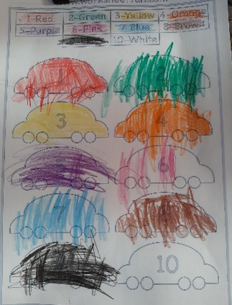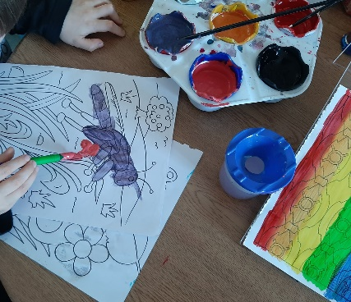

‘My neighbour left me a chocolate Easter egg on my door step with some sweets for me too which made me smile :)’


THE HAPPY NEWS
By Stanhope Primary
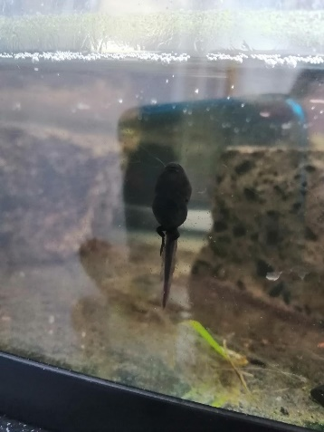
‘I have been drawing rainbows for my family's windows and hopefully it brightens up their day and they think of me every time they look at them.
I have been helping my mam out a lot with house work hoovering and doing dishes and laundry and she has been teaching me how to cook. I play out on the grass outside my house making obstacle courses with cones and hurdles with my sister and also I have been doing online dance classes and playing bingo with my dance friends and their families.’

‘The tadpoles that we collected a couple of weeks ago, have started growing legs. He is so excited for them to turn into frogs so that we can release them back into the pond.’

‘Last night I saw two deer running through the fields behind my house as happy as Larry. I ran outside with excitement! They ran through the fields together and then across the road into forest land on the other side. 🌈😊 I love seeing wildlife. They have actually been out during the day recently I don’t know if it’s because it’s quieter or because there are more people taking daily exercise and disturbing them!’ – Mrs Boardman

THE HAPPY NEWS
By Stanhope Primary
‘Hello! I have been playing with my new mud kitchen and my new sand and water table that my mam and dad bought for me. I am enjoying walks and bike rides and can't wait to see my teachers and friends soon.’


‘Mam put ice cream with fresh squirty cream, sprinkles and little foam chicks in our chocolate Easter eggs. One of the games we played over facetime was to guess what item was missing off the tray.’
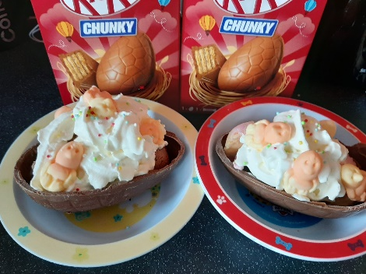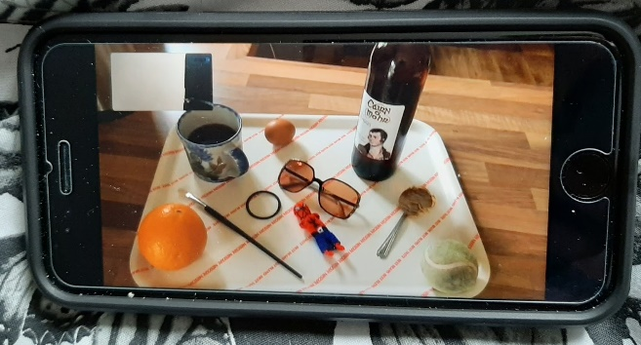

‘I had the best time I'm never bored.’
‘I have been doing loads of experiments with baking soda n vinegar n food colouring also baking cakes with my mum and I have been planting flowers in my garden with my dad’
THE HAPPY NEWS
By Stanhope Primary
SIMPLE SPAGHETTI RECIPE
METHOD
- Fry garlic in oil unit golden.
- Add cooked spaghetti & parsley
- Season with salt & pepper
- Squeeze in lemon juice
- Serve and top with parmesan
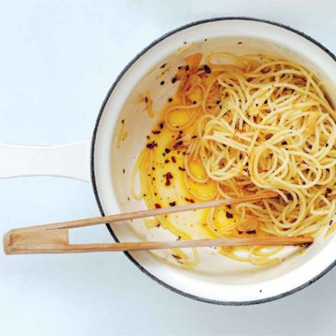
INGREDIENTS
- 400g Fresh Spaghetti cooked
- 4 tablespoons olive oil
- 6 cloves garlic, thinly sliced
- Large handful chopped parsley
- Parmesan
- Salt & pepper
- Half a lemon

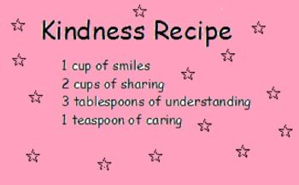

THE HAPPY NEWS
By Stanhope Primary

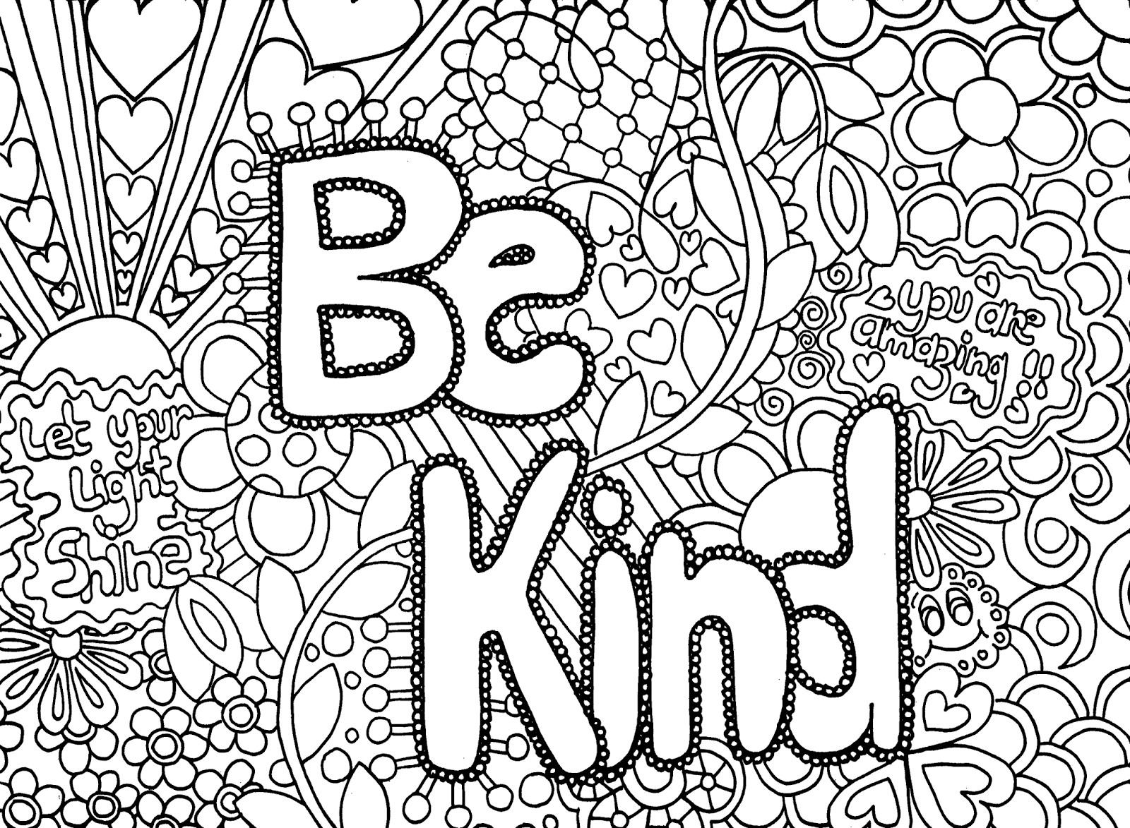

Be kind to yourself and do some mindful colouring.

