Stanhope Primary
Strengths Recognised, Achievements Celebrated

Google Classroom User's Guide

Please be aware that by logging on using a range of devices, can result in a slight variation as to how the pages look. We recommend you use Chrome or Safari, preferably on a laptop computer rather than a mobile phone or iPad.

- Sign in to your Stanhope Primary account via our school website. There is a ‘login’ button at the top right of the page. Use your username and password (if you require this information please get in touch with school).
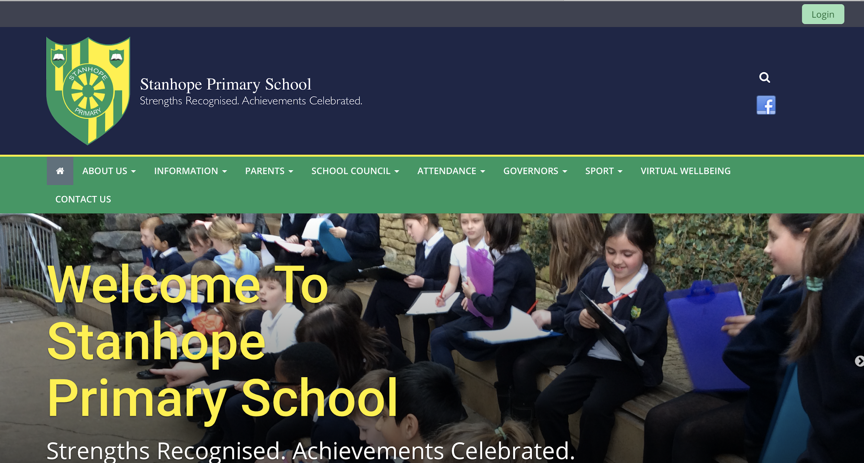

- Once you have logged in, select the ‘Google Classroom’ icon along the top left of the screen. It has a yellow border, green insert with an outline of a person).

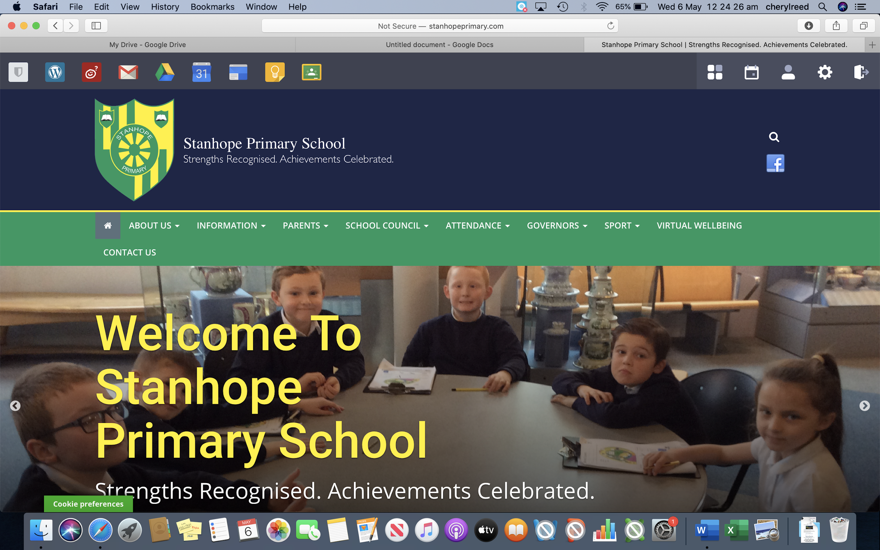

- You may be greeted with a Welcome message and some terms to adhere to.

- The next page you see will be what we call the ‘classroom’ area. You will again be greeted with an introduction page. Please confirm if the details on the screen are correct (you should see your email address).

- The next page will ask you to select one of the following. Please make sure you select ‘student’.

- Once you have followed the on screen instructions, you will see the ‘classes’ in which a member of staff has invited you. You can join via this page by clicking on ‘join’ or you can also join via your email that invites you. You only need to join once.

*You may be a member of more than one ‘class’. If this is the case, you will have more classes visible compared to this example. All children are a part of Miss Coil’s Mindful Moment Class.
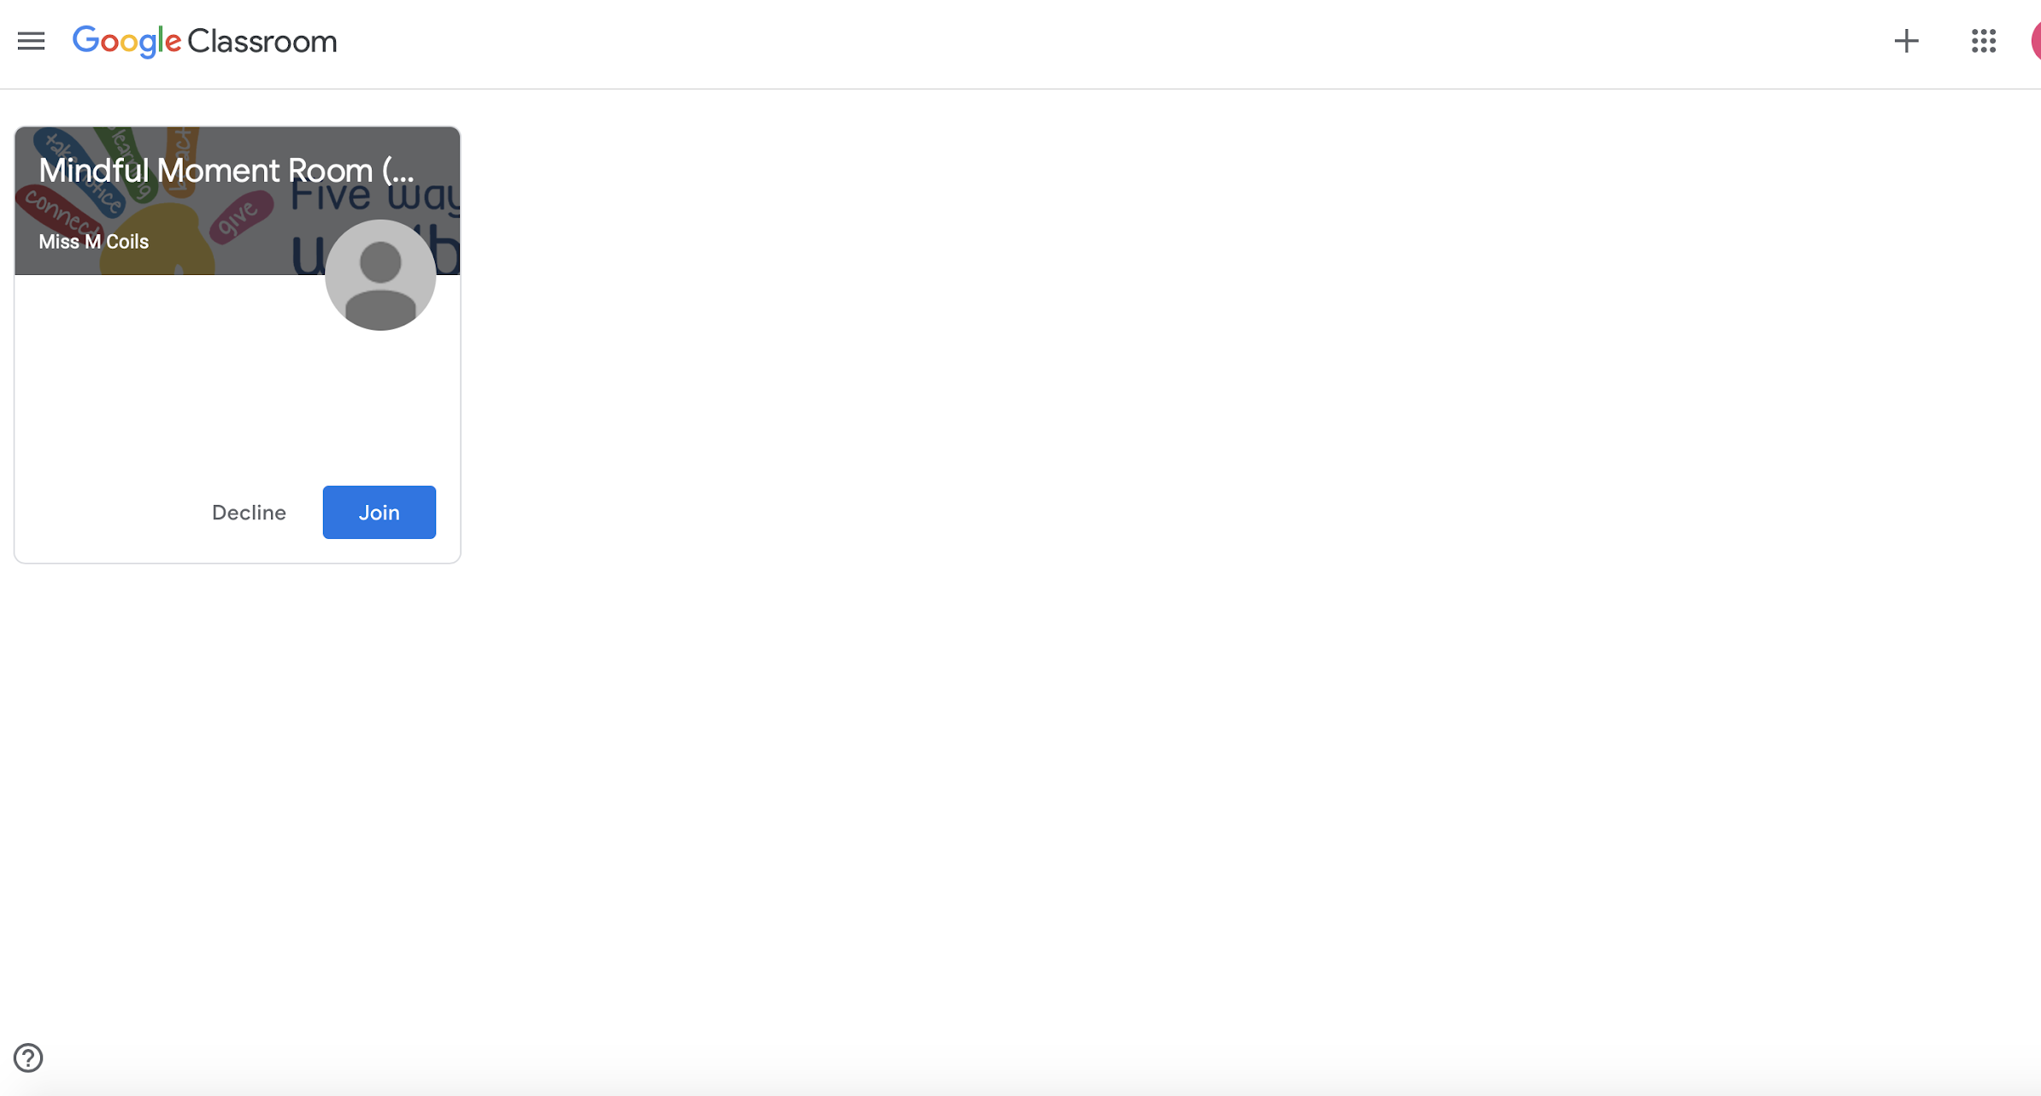

- You will be able to see the ‘class’ in full once you have joined. Below is an example. It shows you the areas or access points needed across the top (centre). There's 3 main sections:
- Stream- This is where new activities, materials, quizzes etc will be loaded. This is usually the first page you will see once you click to enter the group or ‘class’. You may be able to join in with a chat depending on if the staff member has allowed a chat area to take place. If a chat area is visible, everyone in that ‘class’ can read this.

- Classwork- The main area of the ‘class’ that is used. Any assigned tasks will be present here. Click onto the activity you would like to try and it will open with either a message (if one was left by the teacher) and/or a list of attachments in which you can view, open and save directly to the drive (storage area for work linked to your Stanhope account). During the initial set up of the ‘Google Classroom’ platform, you will be given a handy guide at this point, explaining some features available. Please take note as they may be useful at a later date.
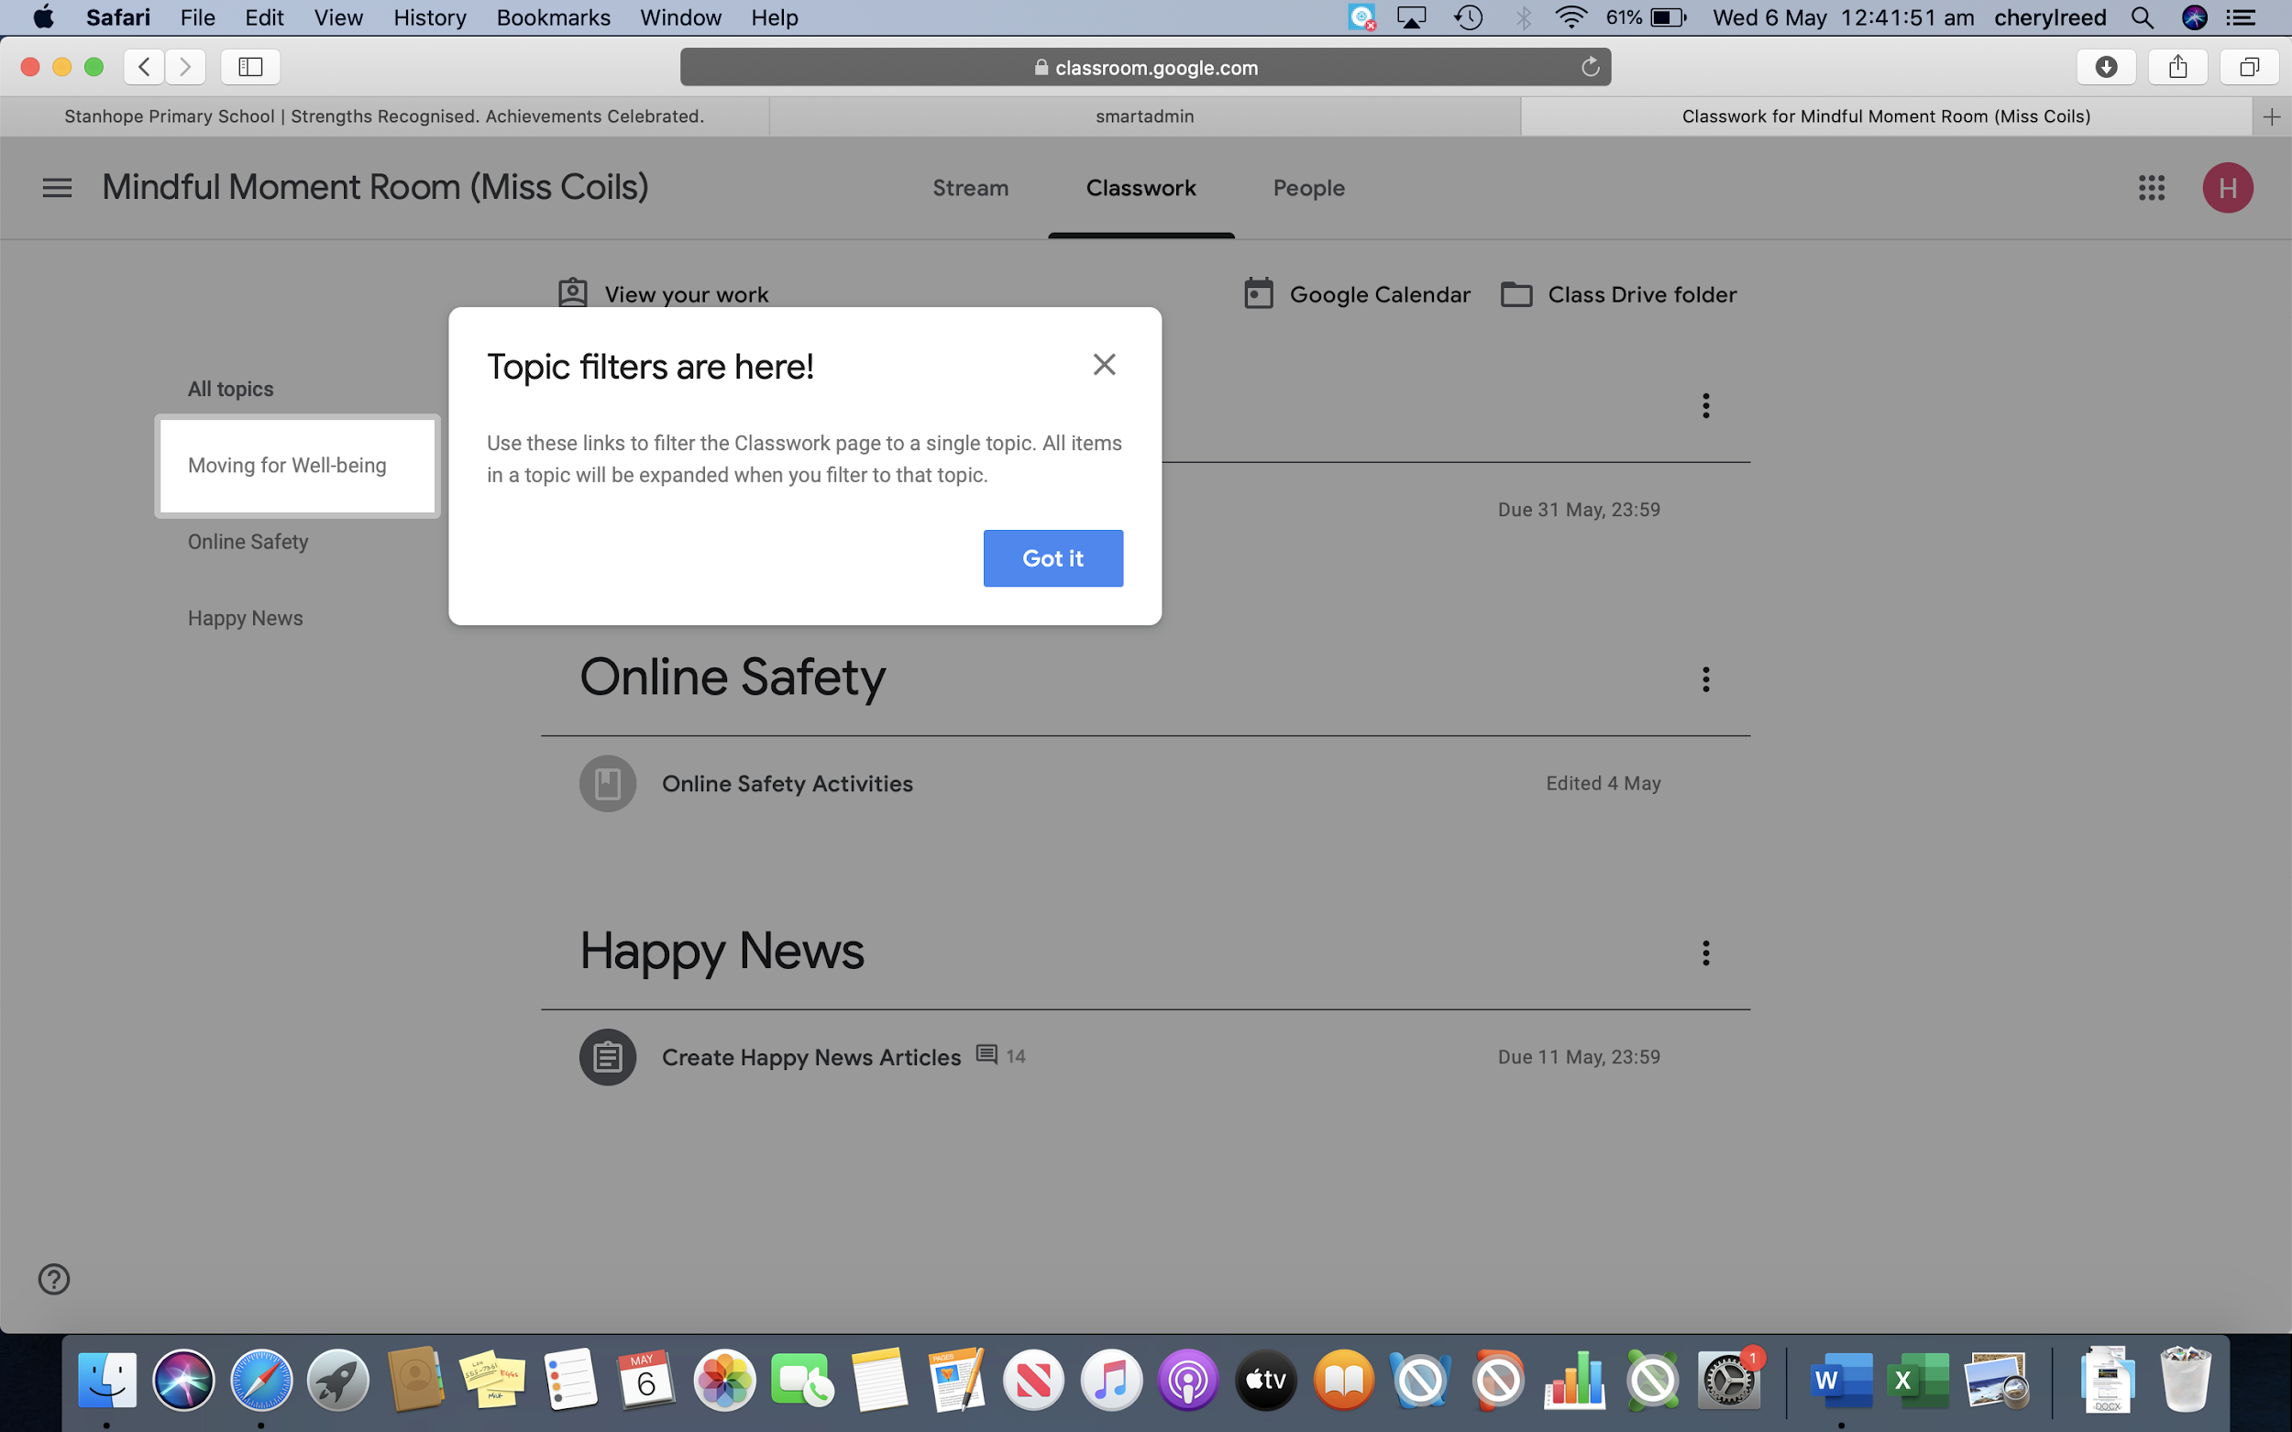
- People- This allows you to see who is also part of this class.

Please enjoy exploring ‘Google Classroom’ with your child. If you see the three dots (see below) this will provide you with more options.

If you need any support with the use of Google Classroom, please leave an email with the school office and a member of staff will make contact with you at the earliest opportunity.

Thank you for your continued support during this difficult time.

Stanhope Primary

