Stanhope Primary School
Strengths recognised, Achievements celebrated

Logging in to your school account

In your Chrome web browser, type in www.stanhopeprimary.com
You should see the homepage like this...

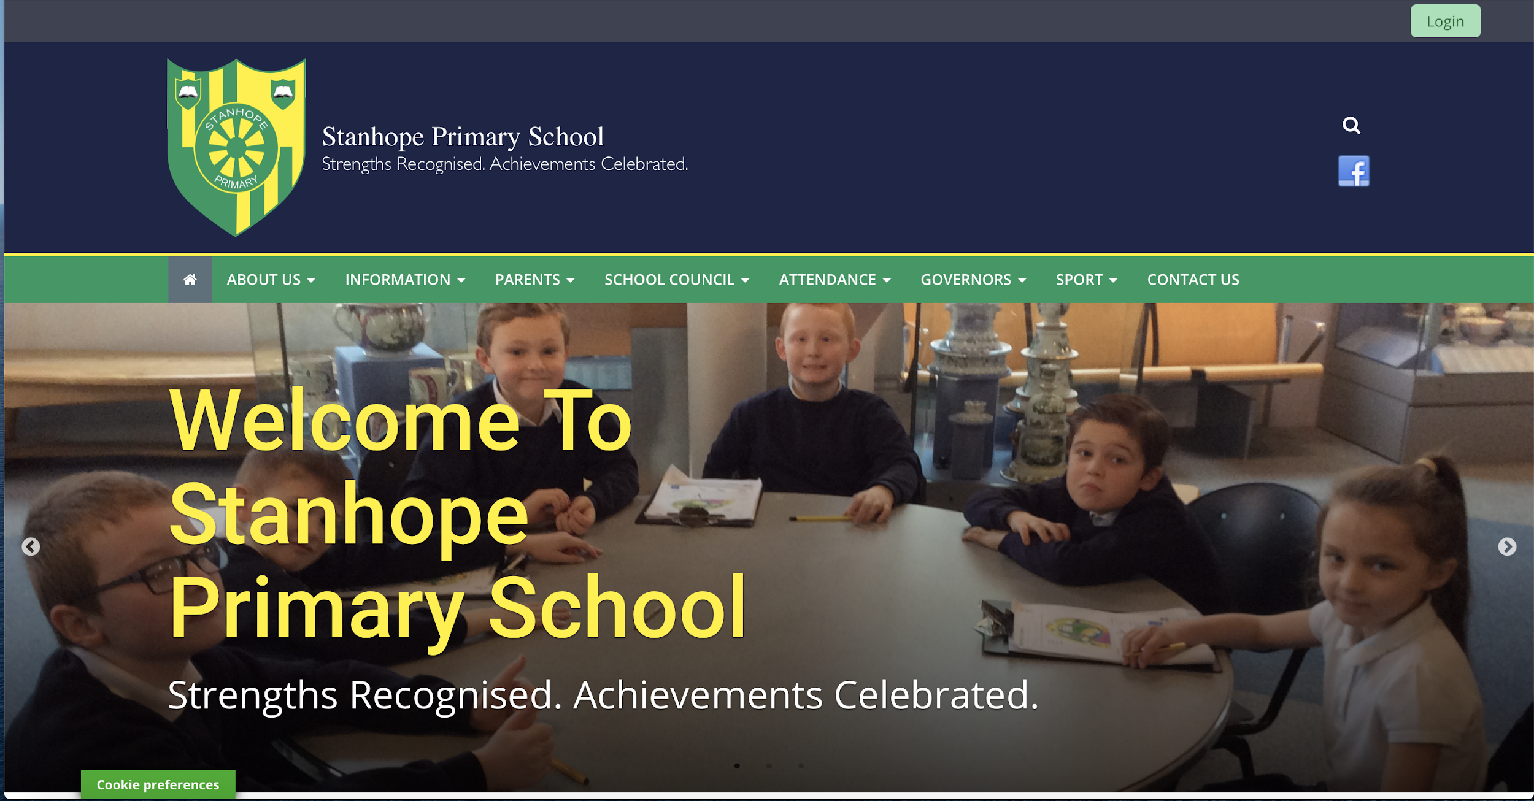
NOTE: Issues may occur if using ‘explorer’ as some features become restricted.

In the top right hand corner, click on the green ‘login’ icon.

You will see the real smart login page. Type in your child’s details (provided by school). Please keep your child’s log in detail in a safe place and keep them private. Schools have created a secure password specifically for your child. Should you suspect someone else aware or using these details, please inform the school ASAP.

You will see the following page to input your child’s details.

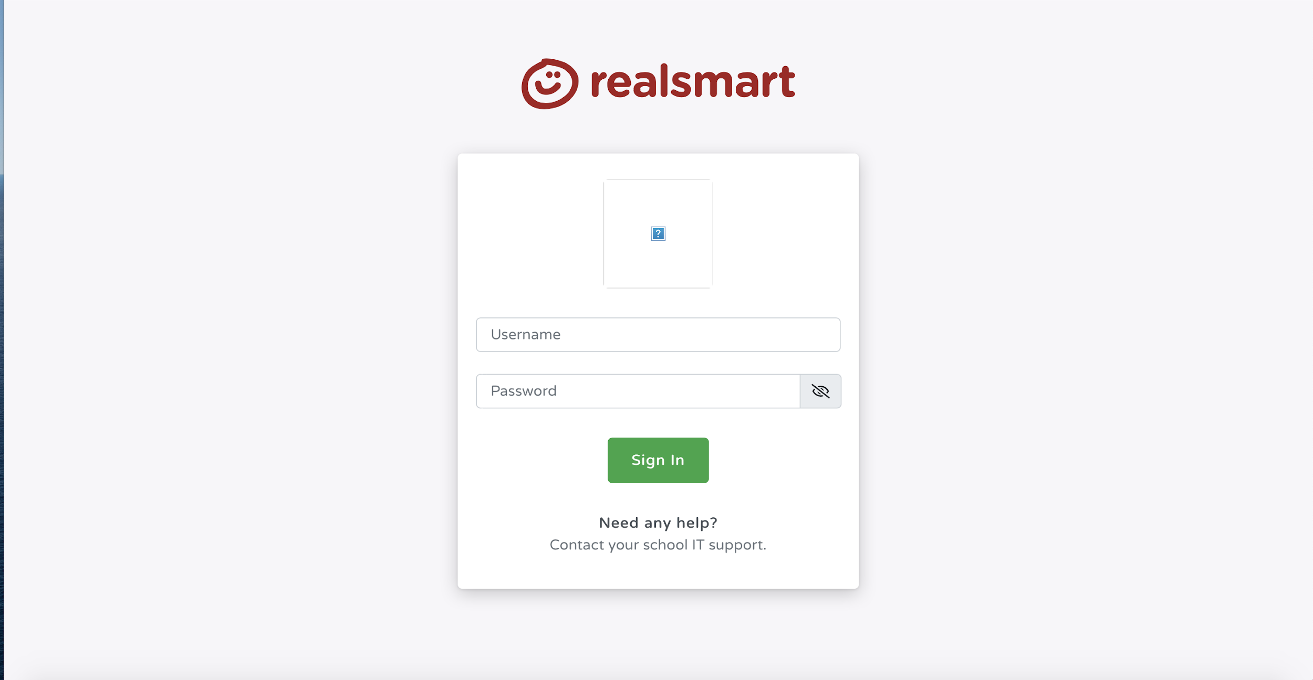

You may have a small pop-up notice explaining the form is non-secure. Click on send. It is safe but realsmart is recognising it is not on the school internet server.

Your next page will look familiar. It is the main homepage of the school site. If you look at the top right you should see your child’s name. This means they have successfully signed in. You may have a cookie notification- allow cookies for the site to work to its full potential.
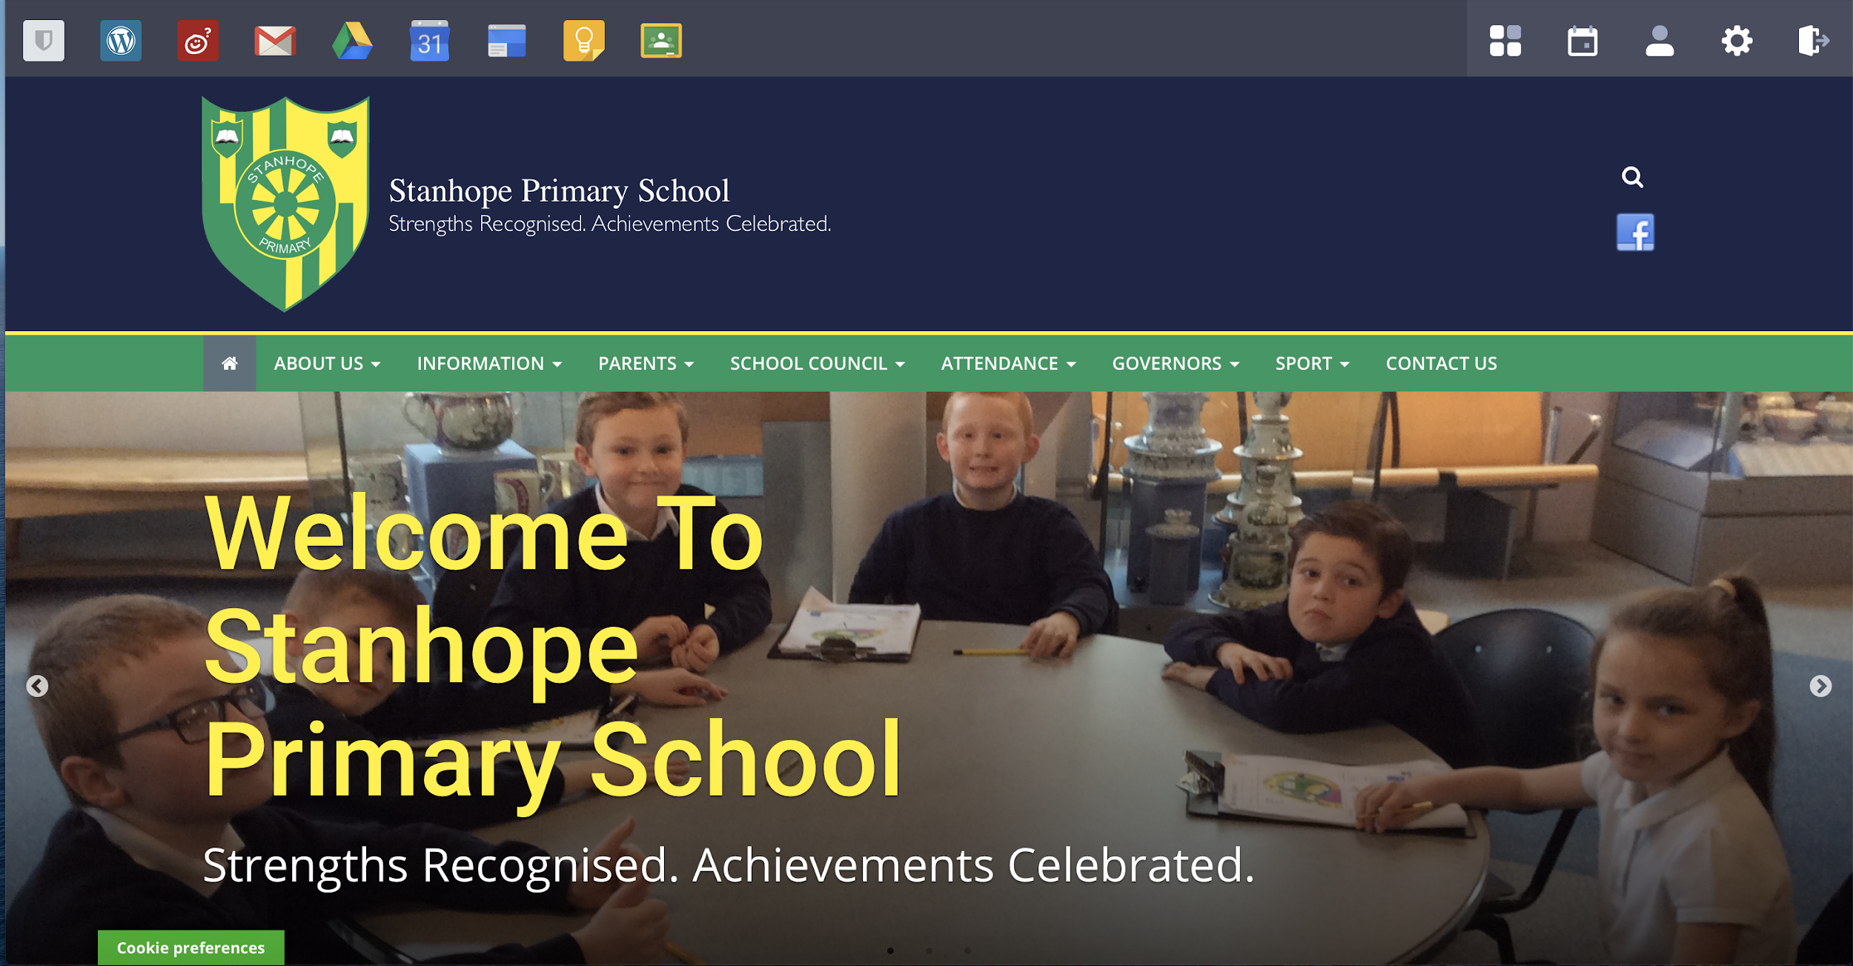

If you look across the top left of the screen, you will see many icons (the children have selected icons set up by school). Here are some explained,

School email icon. Your child will probably have some unopened mail, one being a test email. This is how you access the ‘Google Meet’ video conferencing tool.

Drive icon. Storage provided by school for school work only.

Google Classroom. Your teacher may set up a group for school work or activities. Generally used by the older children.

These icons usually open in a new tab. When signing out make sure each tab has been signed out.

Logging out:
In the top right hand corner of each window you will see the following (see below). The letter ‘M’ changes according to the child’s name. Click on the letter and it will ask if you want to sign out. Do this for each tab opened.

logging out icon for the school’s homepage (located top right hand of the screen).

Accessing Google Meet:
Select your child’s email. You will be welcomed with terms and conditions.
If you accept, you will be directed to a quick guide section as follows:
Then you have access to the emails. Your child may already have emails waiting as part of the set up process. Your child may receive an email inviting them to a scheduled meet with the teacher/class/group. Please see Stanhope Primary’s Policy Use for further details in using this tool. If your child is invited to a video conference, as soon as you click to join, your teacher will be waiting at the time scheduled.

Always remember:

SMART rules for using the internet. If you need help, ask your grown up.

Never share your passwords with people. Keep them private to protect yourselves.

