Home Learning Links
Suggested free resources and activities to help you in supporting your children at home. This is not a list of ‘must-dos’ but instead a lists of ‘might helps’.
What | How to access | Image
Spelling Shed / Maths Shed  Practise spellings (Rec-Y6) and maths activities - they are offering a free 14 day trial of access to parents – just sign up | https://www.spellingshed.com/en-gb  https://www.mathshed.com/en-gb | 
Classroom secrets  Home learning packs, answers and guidance can be downloaded here. | https://classroomsecrets.co.uk/free-home-learning-packs | 
Classroom secrets kids  Pupils can play online maths and English games. | https://kids.classroomsecrets.co.uk/ | 
Mr Thorne does Phonics  Geraldine Giraffe’s videos help the children with phonic sounds and words | https://www.youtube.com/channel/UC7sW4j8p7k9D_qRRMUsGqyw | 
David Walliams reads audio books  David Walliams (and friends) will be reading stories every day at 11am. | https://www.worldofdavidwalliams.com/elevenses/ | 
Twinkl  For worksheets and home learning packs linked to the curriculum; they are offering a month of free access to parents – just sign up and enter the offer code | https://www.twinkl.co.uk/offer |  Offer Code: CVDTWINKLHELPS
Phonics Play  A website full of phonic games ideal for Nursery to Year 2. | https://www.phonicsplay.co.uk/ | 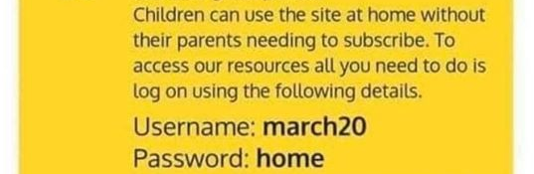
Oxford Owl  A great online resource for parents for home learning activities. | https://home.oxfordowl.co.uk/ | 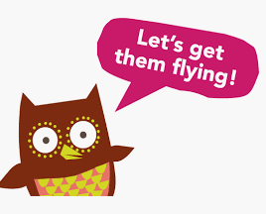
I See Maths  Home lessons for maths. | http://www.iseemaths.com/home-lessons/ | 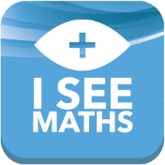
White Rose Maths  Home learning packs for every age. This includes videos and email support at mathshelp@whiterosemaths.com | https://whiterosemaths.com/homelearning/ | 
The Maths Factor  A maths page for children by Carol Volderman. | https://www.themathsfactor.com/ | 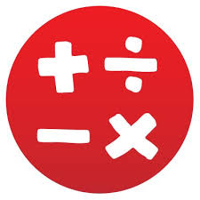
Pobble 365  Posts amazing images every day with activities and lessons for writing based on the images. | http://www.pobble365.com/ | 
Audible  An online audio book library. You can download books for children to listen to. They have made many of their stories | https://stories.audible.com/start-listen | 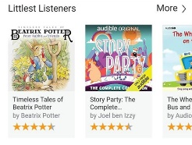
Dough Disco  Shonette Bason Spread the Happiness TV. Uses playdough to develop fine motor and handwriting skills. | https://www.youtube.com/watch?v=i-IfzeG1aC4 | 
Cosmic Kids Yoga  They have a YouTube yoga channel. | Free videos on YouTube:  https://www.youtube.com/user/CosmicKidsYoga | 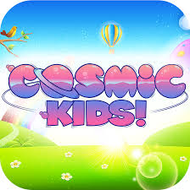
30 Day Lego Challenge –  30 days of Lego challenges. | Google ‘30 Day Lego challenge’ and download. | 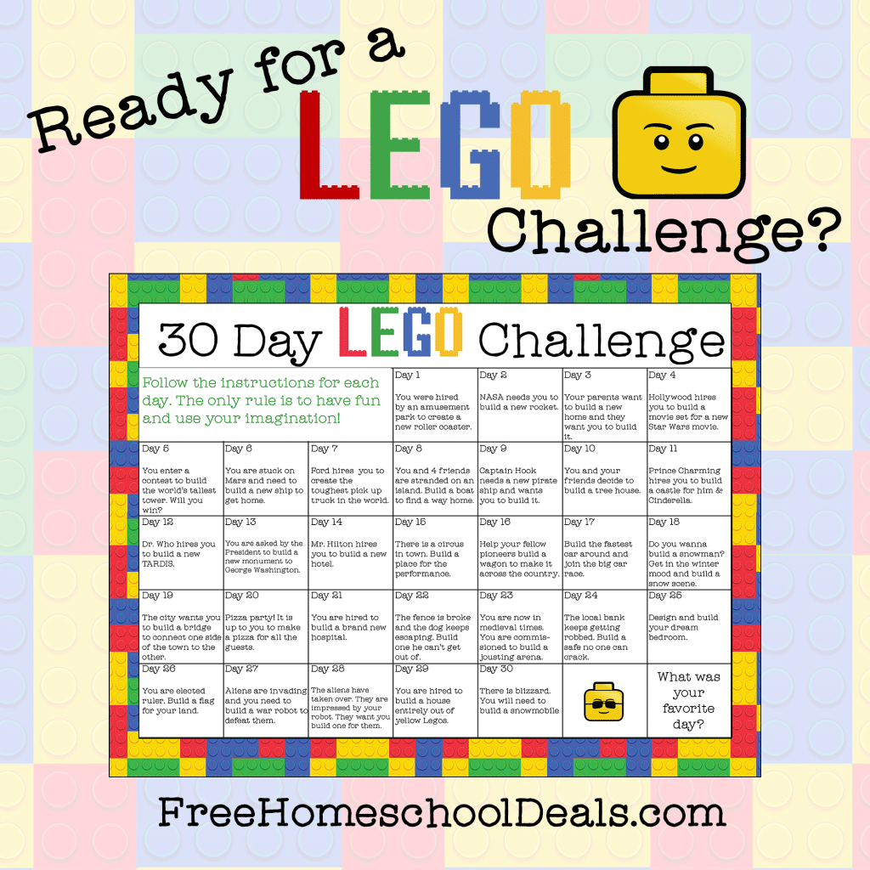
Joe Wick’s Daily PE lessons 9am daily | https://www.youtube.com/thebodycoachtv | 
Les Mills – move like an Avenger  A short workout available on YouTube | https://www.youtube.com/watch?v=uYi1kyMeFHQ | 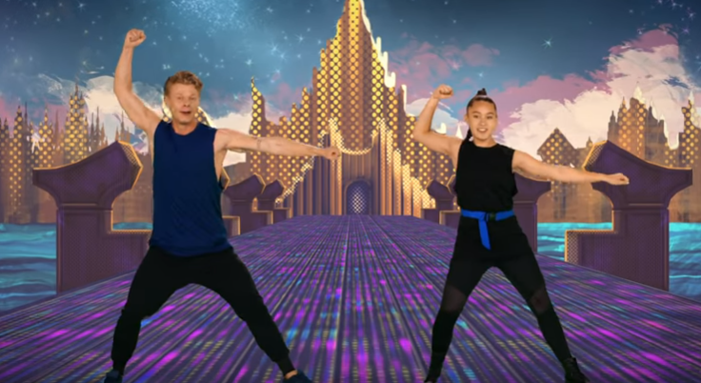
Lunch Doodles with Mo  Mo Willems is an artist. He is leading daily drawing classes on YouTube. | https://www.youtube.com/playlist?list=PL14hRqd0PELGbKihHuTqx_pbvCLqGbOkF | 
Oliver Jeffers  Author and illustrator of books such as ‘ The Day the Crayons Quit’ and ‘Boy’ is reading stories daily at 6pm. | https://www.oliverjeffers.com/books#/abookaday/ | 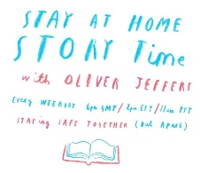
The Scouts  Have created a list of indoor activities you can do during isolation | https://www.scouts.org.uk/the-great-indoors/ | 
Code.org  A great resource for learning computer coding. | https://code.org/ | 
The Ballet Coach  Online ballet classes during the closure. | https://www.youtube.com/channel/UCjoXKtJLuyb6gAG3sQlyq0Q?fbclid=IwAR1nFvdv5z8l3QsTYO-Ead_oHy22EQzMuHfheMOejohMudb9fB-lyD7sgIU | 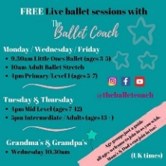
Blockly  Learn computer programming skills - fun and free. | https://blockly.games | 
Scratch  Creative computer programming. | https://scratch.mit.edu/explore/projects/games/ | 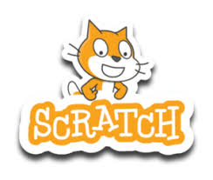
National Geographic Kids  Activities and quizzes for younger children. | https://www.natgeokids.com/uk/ | 
Duolingo  Learn languages for free. | https://www.duolingo.com | 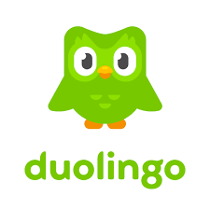
Cbeebies Radio  Listening activities for the younger children. | https://www.bbc.co.uk/cbeebies/radio | 
Nature Detectives  A lot of these can be done in a garden. | https://www.woodlandtrust.org.uk/blog/2020/03/kids-nature-activities-self-isolation/ | 
Geography Games  Geography gaming! | https://world-geography-games.com/world.html | 
Red Ted Art  Easy arts and crafts for young children. | https://www.redtedart.com | 
The Imagination Tree  Suggestions for activities that encourage learning through play. Ideal for KS1 and younger children. | https://theimaginationtree.com | 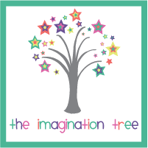
Third Space Learning  Good year group guides on how to teach/understand maths that the children do in school. Also links to activities. | https://thirdspacelearning.com/blog/home-learning/?utm_campaign=19_03_2020_COVID-19_Parent_Blog&utm_medium=email&utm_source=Pardot&utm_content=button | 

