How to access school emails

In your Chrome web browser, type in www.stanhopeprimary.com
You should see the homepage like this...

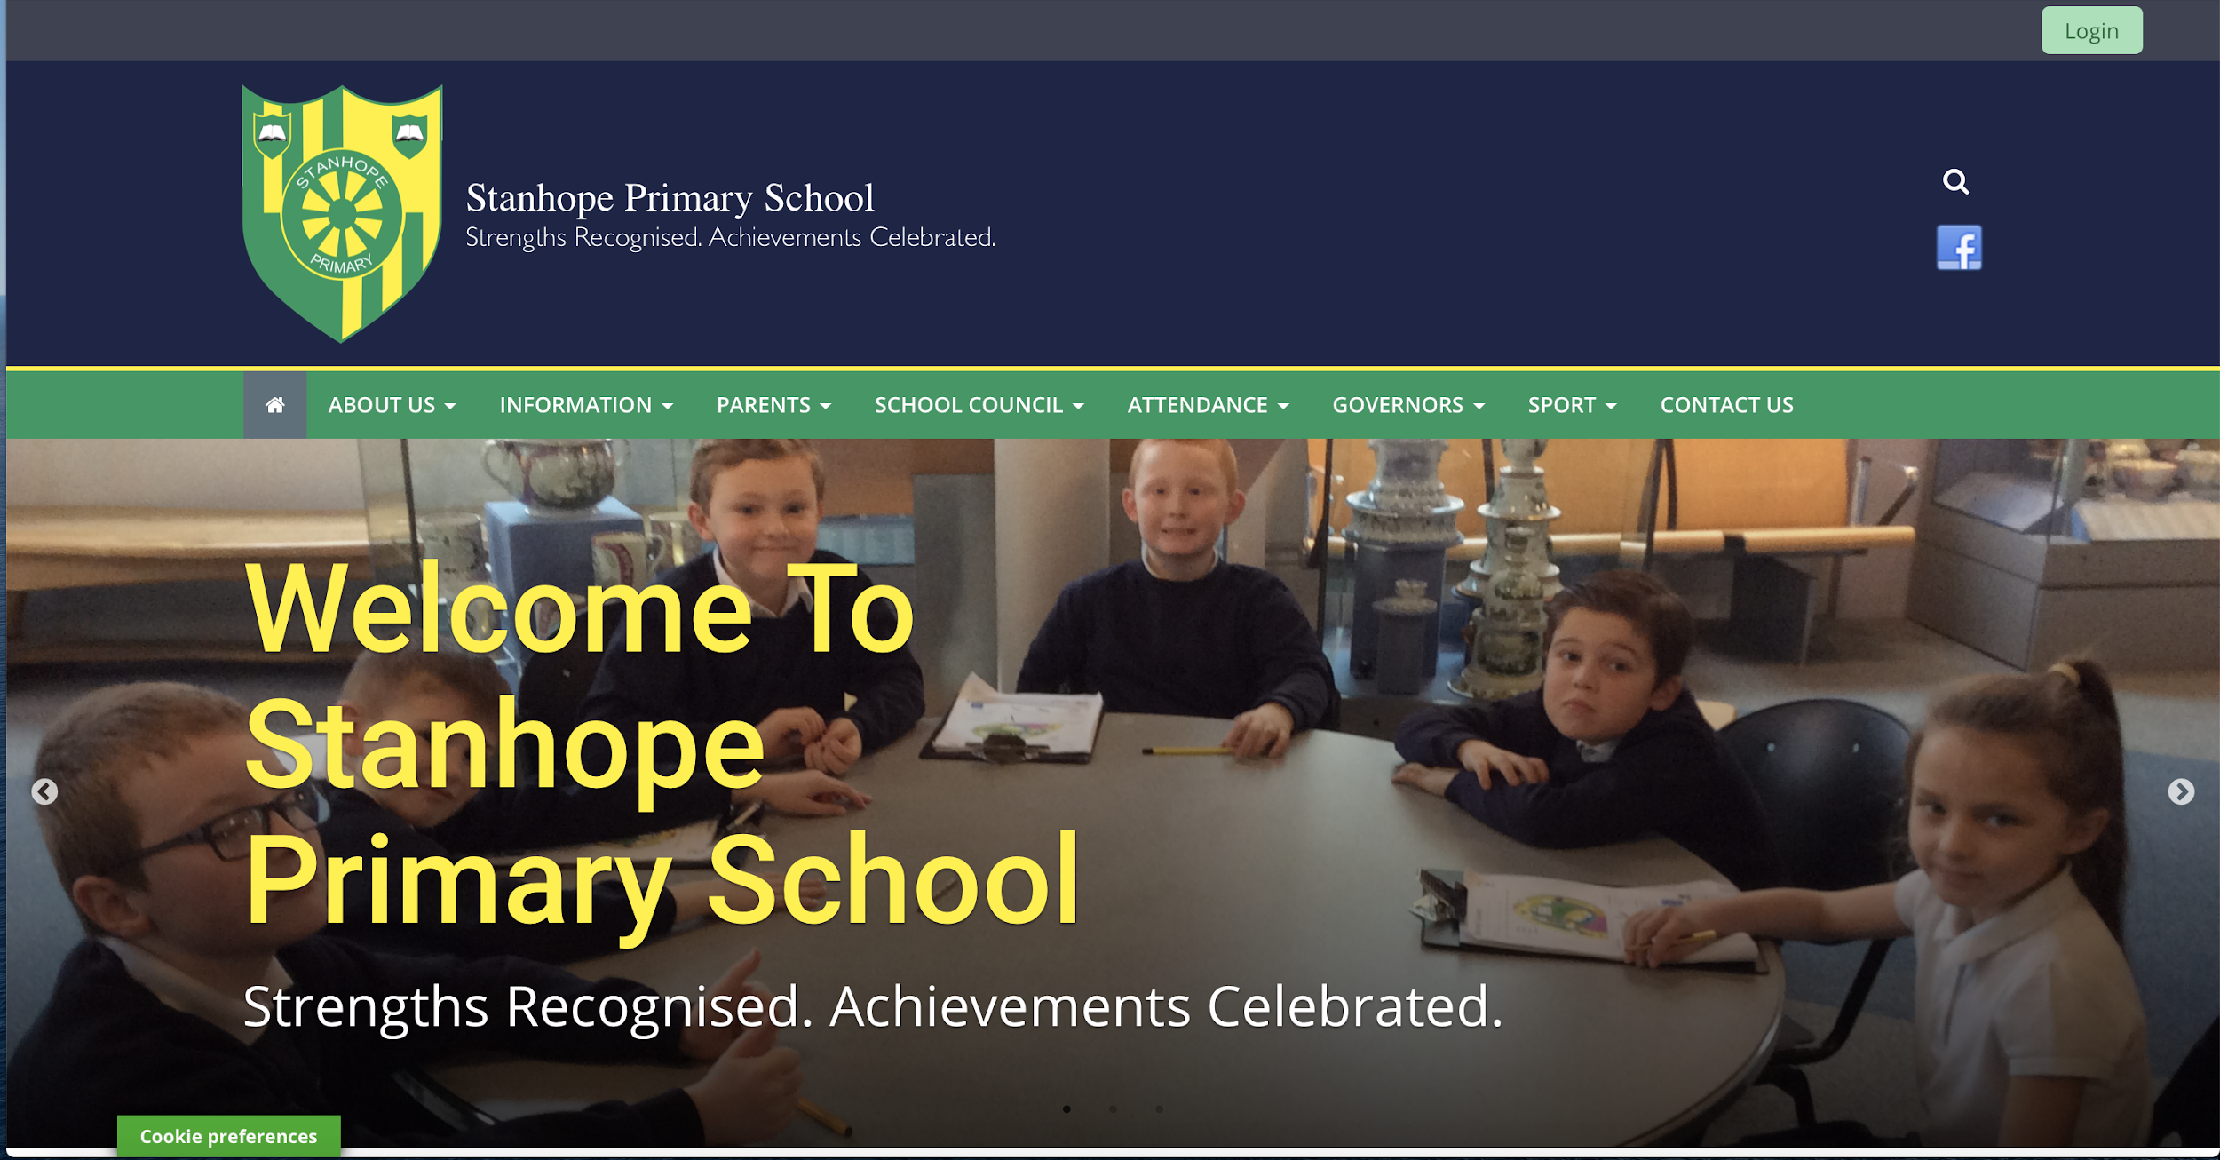
NOTE: Issues may occur if using ‘explorer’ as some features become restricted.

In the top right hand corner, click on the green ‘login’ icon.

You will see the real smart login page. Type in your details
Usernames are usually first names with the first letter of surname, however there are some exceptions.
All children should have created their own 8 letter password consisting of two four letter words such as ‘bluecars’, ‘doorpink’ etc (DO NOT USE THESE EXAMPLES). South Tyneside Local Authority suggest this as an extra measure of security whilst on the internet.
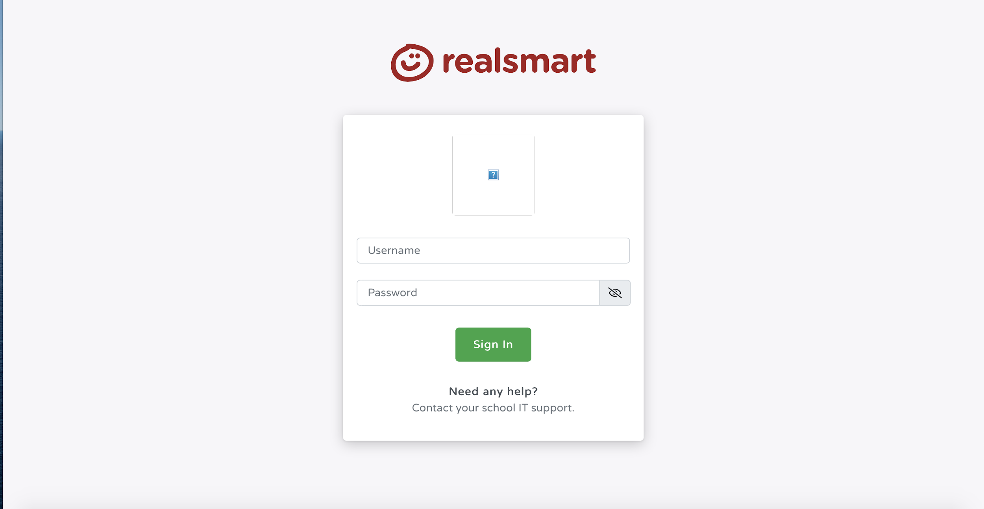

You may have a small pop-up notice explaining the form is non-secure. Click on send. It is safe but recognising it is not on the school internet server.
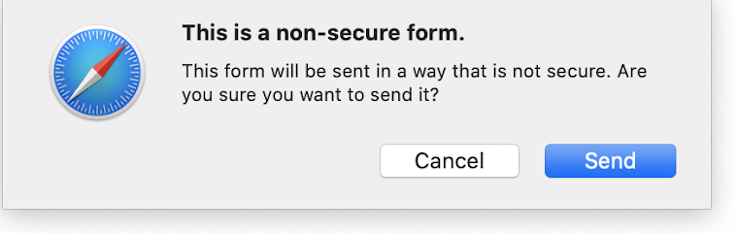

Your next page will look familiar. It is the main homepage of the school site. If you look at the top right you should see your child’s name. This means they have successfully signed in. You may have a cookie notification- allow cookies for the site to work to its full potential.
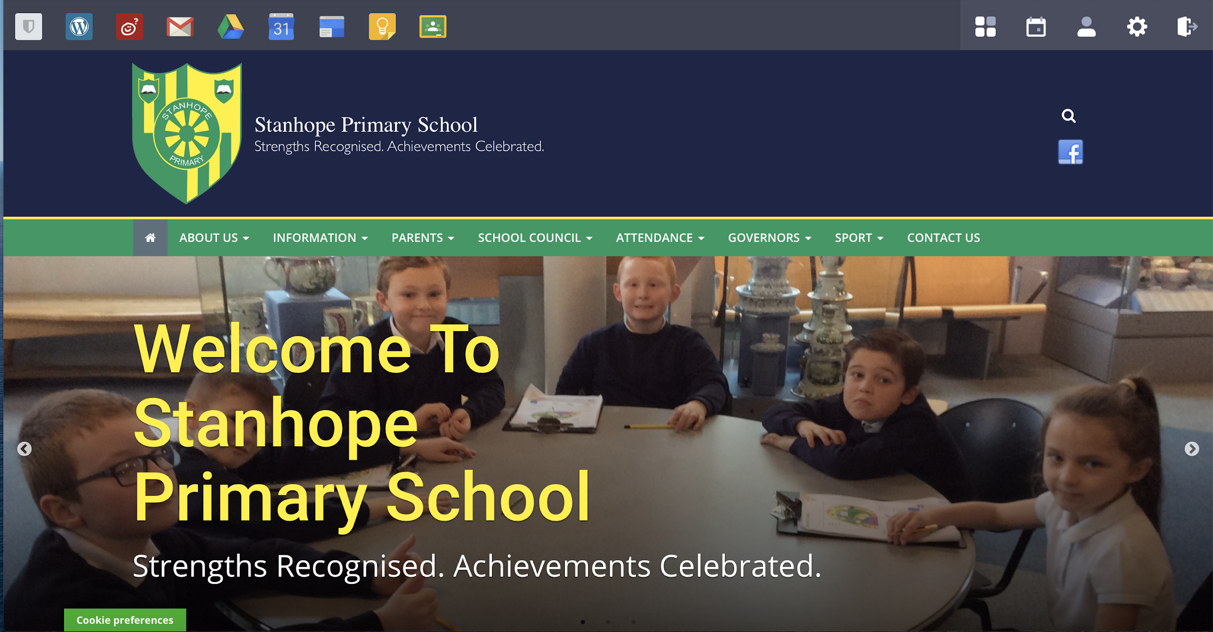

If you now look across the top left of the screen, you will see many icons (some may look different to this as the children have selected icons set up by school).

You will see the following icons (not necessarily in the same order) emails and school drive (storage for school work). If you look at the end icon in the picture below, this is the google classroom where teachers have set school work for home learning (yellow frame with green background and people in the frame).

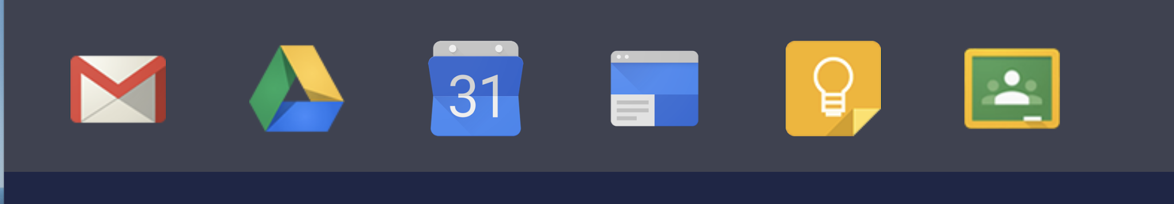
These icons usually open in a new tab. When signing out make sure each tab has been signed out.

Logging out:
In the top right hand corner of each window you will see the following (see below). The letter ‘M’ changes according to the child’s name. Click on the letter and it will ask if you want to sign out. Do this for each tab opened.

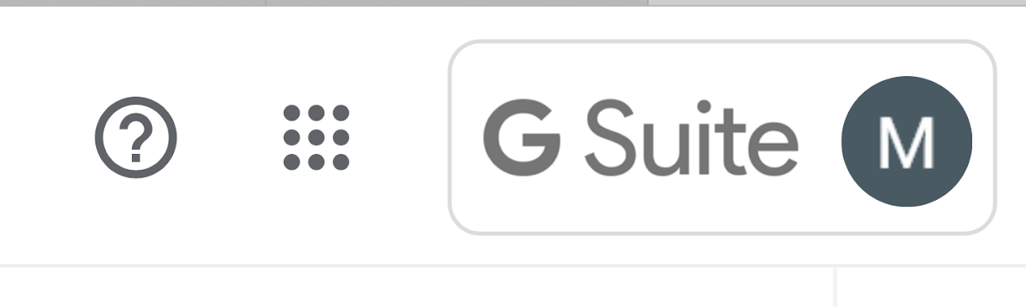

Always remember:

SMART rules for using the internet. If you need help, ask your grown up.

Never share your passwords with people. Keep them private to protect yourselves. 

