Safer Internet Week 2020

This year, Stanhope Primary School are educating, celebrating and promoting Safer Internet use for a whole week, week beginning Monday 3rd February 2020.

What is E-Safety?
This can also be called ‘internet safety’, ‘online safety’ or ‘web safety’. E-safety is often defined as the safe and responsible use of technology. This includes the use of the internet and other means of communication using electronic media (eg text messages, gaming devices, email etc).
It is important that we equip children with the skills they need to keep themselves safe so they can experience the internet positively and responsibly.

During Safer Internet Week we wanted to reinforce this message to the children.



Safety rules:
- Don’t talk to strangers (in real life or on the internet)

- Always tell an adult if you don’t like something.

- Never give out any details on the internet.

- Play games for your age.

Guidance at home

Parents and Guardians play an essential role in supporting children in learning about how to stay safe online. Please find a number of links to provide you with the relevant guidance to help support your child.

- https://www.saferinternet.org.uk/safer-internet-day/2020
- www.thinkuknow.co.uk
- www.kidsmart.org.uk
- www.inctinschools.org
- www.twinkl.co.uk
- https://www.netsmartzkids.org Games, videos for children to use

Reading List:
If you are interested in extending your child’s knowledge through a love of books, here are some recommended stories linked with internet safety. All good libraries and bookstores stock these texts available.

- Clicking Chicken
- Troll Stinks
- Once Upon a Time Online
- Goldilocks (a Hashtag Cautionary Tale)
- But it's just a game
- Webster's Friend
- Webster’s Email
- PenguinPig
- Tek
- Clicker the Cat
- The Technology Tale

If any guidance is needed, please do not hesitate to ask in school.

Introducing Smartie the Penguin, Digiduck and Clicking Chicken...
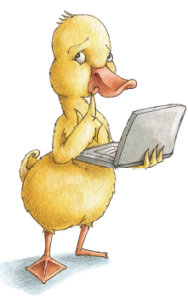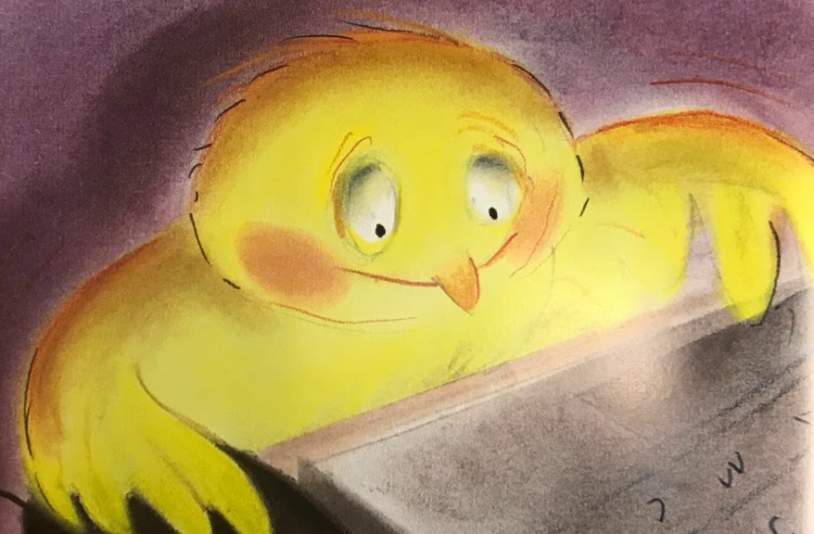

Keep an eye out for some of the work we do this week...

