Court Fields School
What’s Happening: Information for Parents, Carers & Families
23rd to 29th March 2020
A Message from Mrs Matthews
My message is very simple this week: Stay home, protect the NHS, save lives.
Thank you for all your support over the last week. We continue to show how much we have grown as a community together, and improved as a school. Please keep yourselves and your families safe and keep up to date with news and information via our website, social media or our direct emails to you.
Thank you, Mrs Matthews.

Year 11 Leavers 2020
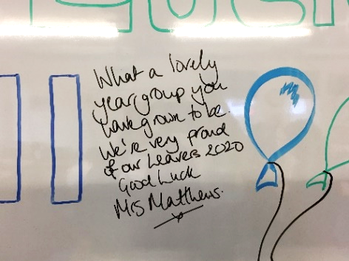
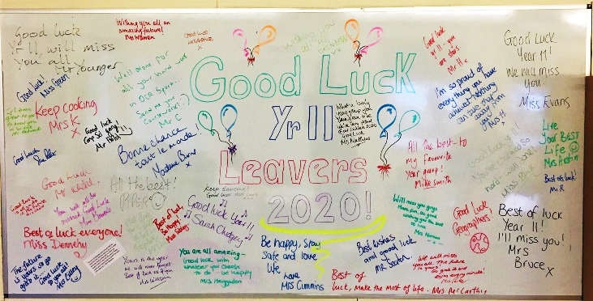
Last Friday we wished our Year 11 students a very fond farewell. It was extremely sad to see them leave Court Fields early, due to the current circumstances.
We wish you all a bright future and looking forward to hearing about your successes in later life. We will see you at Prom, whether that be on the current calendared date, or later this year. In the meantime, please stay safe and use this time wisely to prepare for future learning, embed current learning, learn new skills or expand your general or subject knowledge.

COVID-19 Update
Please see the information on our website and social media for the most up to date information regarding school closure and the coronavirus response. We will also continue to contact parents/carers by email with information, so please ensure that you are receiving emails, and if not, please contact us on the main school email.

Eco Council Project
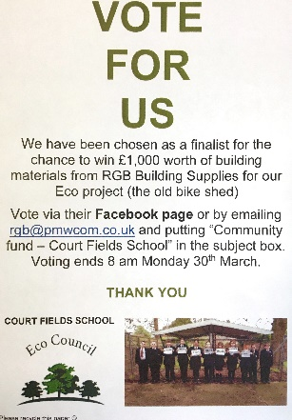
Don’t forget to vote for our Eco Project, you have until the 30th March! All you have to do is go to RGB’s Facebook page.
A post will be pinned to the top of their page and like the photo of our Eco Council. You can also vote by emailing RGB@pmwcom.co.uk and putting ‘Community Fund – Court Fields School’ in the subject box. Only one vote will be counted from each email address. Votes can be cast between Monday 16th and Monday 30th March 2020.
Votes cast outside of these times will not be counted. This project is really important to our Eco Council, the environment and our school students. Your vote would help make this project happen and we really appreciate your support!
Please support us by visiting RGB on Facebook here:
https://www.facebook.com/RGBBuildingSupplies
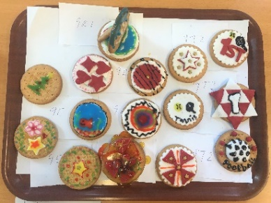
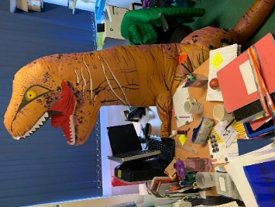
Sport Relief!
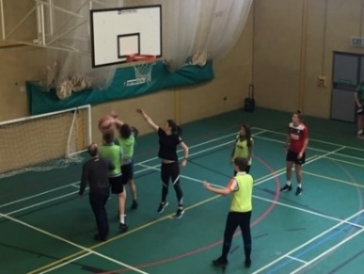
Staff and Students joined in with a number of events to help raise funds for Sport Relief. There was a non-uniform day, a staff v student basketball match which was won by the staff and Mrs Poole ran a biscuit decorating competition. Well done to winners 9T2 in first and second place, 9E in third, and highly commended to 9R1 and 9T1. Nice try from Max E for trying to bribe Mrs McCarthy as judge by producing a Harry Kane themed biscuit! Overall, we raised almost £700, which was fantastic, and we were even visited by a dinosaur from Year 9 who took up residence in Miss Stephenson & Mrs McCarthy’s office!

Year 10 Work Experience
We are reviewing the practicalities of Work Experience taking place in the summer term, given the Covid-19 disruption. In the meantime please continue to seek placements asap if you have not already done so. Students should use their Link2 password to access a list of Work Experience opportunities and secure the placement. Over the next few weeks we will make a decision regarding Work Experience for Year 10 and will update you as soon as any decision is made.

Year 11 Photographs
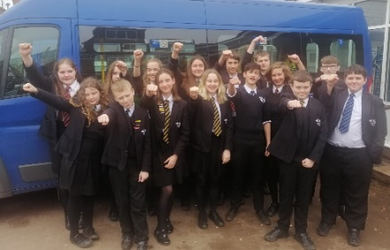
Year 11 students have been given proof packs. Please order your photos online. If you have not received your child’s proof pack please email the main school email address.

Community Youth Action Group
Last week our Action Group went to Taunton to begin the planning stage of our action. Our students are working hard with Hero Austin and Citizens UK to present an issue that effects them to people in power, to support making a change. Students have created speeches and have a creative plan to ensure their voices are heard. We are super excited about sharing more information as the action takes place, once we return to being fully operational at school
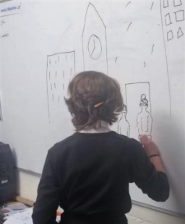
Safer Somerset Schools Media Project
Last month 30 Yr 9 students worked with Safer Somerset learning about knife crime and County lines. They were set the challenge to create a podcast or video, to raise awareness of support for teenagers. This was part of a competition which was then sent to a panel of judges to review. In the first round those selected would go on to take part in a public vote. I’m delighted to tell you that one of our entries has made it to the final public vote phase of the Safer Somerset Schools Media Competition. It features Yr 9 students Amber F-F, Ned O, Madi B , Alex H, Ronnie M and Theo C. We are extremely proud of all the students who took part. Once we are clearer on the school’s reopening, we will be contacting you to spread the news and share the link for people to watch, as the podcasts/videos with the largest views will progress further in the competition. We will keep you updated once the public viewing platform begins.

Online Safety
As many of our students will not be in school, please ensure you continue to discuss and support students to remain safe online. Many students screen time will increase not being in structured lessons as well as needing their devices to access key learning tasks. Please encourage students to not have phones where possible while completing school based tasks and monitor usage. Below is the NSPCC Online Safety guidance for parents to support you while your child is not accessing daily school. https://www.nspcc.org.uk/keeping-children-safe/online-safety/ If you have any concerns, I will be accessible to support via the safeguarding email, Safeguarding@courtfields.net. This email will be checked regularly between 8.40am and 4pm, Monday to Friday.
Events this week, and coming soon
All school events have now been cancelled in line with Government Guidance
03 April | INSET Day
6 to 17 April | Easter Holidays (students will not be expected to access the ‘home learning’ sessions during this 2 week period)

