Date set: _________________ Date due: _________________
Civilisations
Year 7 independent learning project

This is your chance to focus on an area that you want to work on. This homework project will be checked every two weeks in line with your homework timetable. If you lose this booklet it is YOUR responsibility to download it off Google Docs and ensure the missing bits are filled in.

Your project will be marked on:

- Presentation | - Effort | - Content

All three of these things need to be of the highest quality!

If you have any questions you MUST come to speak to me – but it is no good coming to me the day beforehand. You have lots of time to do this project, so plan when you are going to work on it and DON’T leave it until the last day.

Homework 1:
Pick an Ancient Civilisation to research from the list below.
- Ancient China: 2100-221 BC
- Ancient Egypt: 3150-31 BC
- Inca Civilisation 1200-1542 AD
- Ancient Greece 800BC-146BC
- Rama Empire 10,000 – 2,500 BC (Modern day India and Pakistan)
- The Aztecs
- The Mongols
- The Mayans
I am happy for you to choose your own if it is in the Ancient Civilisation era. These website will help you as well as the LRC.
https://www.ancienthistorylists.com/ancient-civilizations/10-oldest-ancient-civilizations-ever-existed/
https://www.historyonthenet.com/
TASK | Identify and choose your civilisation
EXPECTED OUTCOME | Image of the picture that represents the civilisation
SKILLS AUDIT | Understanding the significance of a civilisation
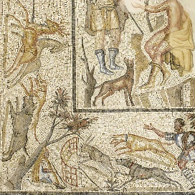
Find an image that best represents your civilisation and write a reason why you have chosen that civilisation. This could be a drawing, an illustration a photograph of a replica a cave drawing etc.
For example, Romans I have picked a mosaic this is because it represents not only their ability to design beautiful paintings but also what they did in their spare time, their culture and their hobbies. You cannot pick the Romans sorry we have already studied them!
Name of ancient civilisation I have picked to research: ______________________________________
Date that it was around (approx.) ______________________________________________________
I have picked this civilisation because ___________________________________________________
________________________________________________________________________________
Another reason is __________________________________________________________________
This image represents the civilisation the best because of the following reasons____________________
_________________________________________________________________________________
_________________________________________________________________________________

Image I have picked:

EXT: What do you hope to learn about this civilisation?
___________________________________________________________________________________________________________________________________________________________________________________________________________________________________________________________________________________________________________________________________________________________________

Peer assessment : Date _________________-
WWW:

EBI:

Peer effort mark
Homework 2:
- Colour in on this world map where your civilisation originated (came from) and where it expanded to,
- In the box below draw the flag of your civilisation.
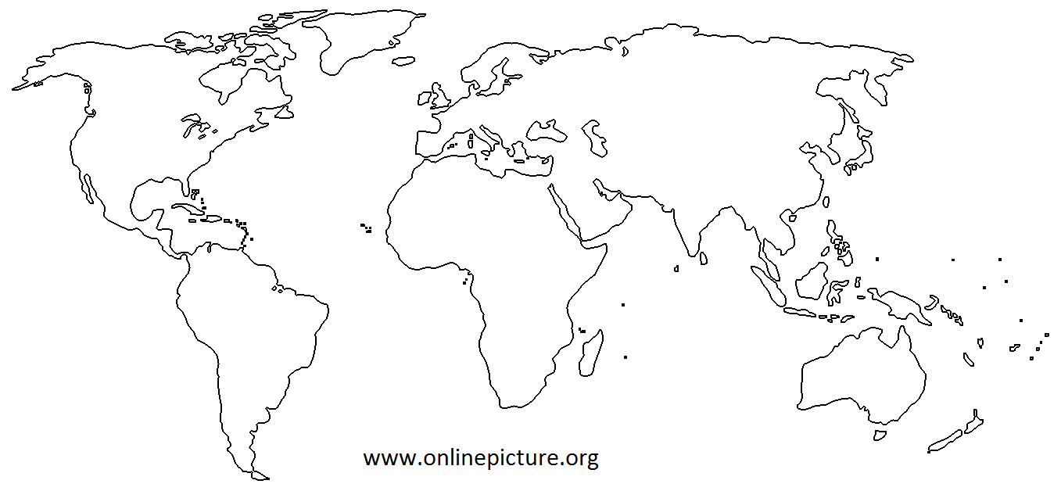

EXT: What is the name of the place of this area now? Write down 5 facts about it
______________________________________________________________________________________________________________________________________________
TASK | Find the place that the civilisation was from
EXPECTED OUTCOME | Your civilisation on the map and a flag
SKILLS AUDIT | Research and cross curricular

WWW:

EBI:

Homework 3: Produce a factfile about your civilisation
Date of the civilisation
What were the leaders of this civilisation?
What weapons did they use?
Did they have a religion?
Did they have any Gods?
EXT: Why did they die out/ why do you think they are not alive today?
____________________________________________________________________________________________________________________________________________________________________________________________________________________
TASK | Research your civilisation
EXPECTED OUTCOME | Factfile on chosen civilisation
SKILLS AUDIT | Research, information gathering and using key vocabulary

WWW:

EBI:

Extra task: each one done additionally gets 3 e-praise points extra.
What was life like in your civilisation? Choose one of the tasks from below to complete
- Write a menu of the food your civilisation would eat
- Draw/print out an image of the clothes people in your civilisations would wear
- Write a list of job description in your civilisation (min 4)
- Print off an alphabet from your civilisation and write a sentence in their language for someone to decipher
- Was there a famous leader of your empire/civilisation? Find an image of them and write down 5 interesting facts about them

Running total of e-praise/effort points
Week | E-praise award | Running total
1
2
3
Extension tasks
Total points for the end of the project

Self-reflection:
WWW:

EBI:

