Date set: _________________ Date due: _________________
Extreme Weather
Year 8 independent learning project

This is your chance to focus on an area that you want to work on. This homework project will be checked every two weeks in line with your homework timetable. If you lose this booklet it is YOUR responsibility to download it off Google Docs and ensure the missing bits are filled in.

Your project will be marked on:

- Presentation | - Effort | - Content

All three of these things need to be of the highest quality!

If you have any questions you MUST come to speak to me – but it is no good coming to me the day beforehand. You have lots of time to do this project, so plan when you are going to work on it and DON’T leave it until the last day.
Wild Weather homework One.
Extremes of… | Can cause … | A place facing this challenge is … | The impacts on the people living there include …
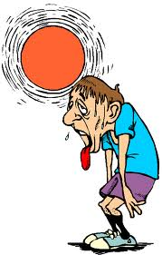
Heat

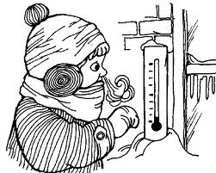

Cold

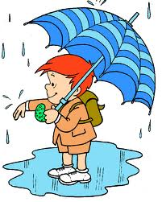
Precipitation (wet)
Dry
Wind

Peer assessment : Date _________________-
WWW:

EBI:

Peer effort mark

TASK | Research a place and how it is affected
EXPECTED OUTCOME | Completed table
SKILLS AUDIT | Research and identifying impacts

Homework 2 - Wild Weather Assessment
Choose a type of Wild Weather from this list: Circle the one you would like to choose.
Tornado Hurricane Blizzard Thunderstorm Cyclone
Task - Research and produce an information fact file about WILD WEATHER: Use the page below
You should include the following parts to your final piece of work.
- What causes this Wild Weather?
- Describe what this wild weather is like – what would we see?
- How is your wild weather measured? (e.g. is there a scale that shows how big or small it is)
- Where does your wild weather usually happen? A map would be good to include.
- What effects can your wild weather cause? Give examples of damage caused to human and physical features (towns and cities plus the environment)
- How can people be kept safe from your wild weather? Give advice about what people should do.
- Any other relevant info. Eye catching facts would really catch peoples attention.
Make sure you include labelled images and pictures and some details about one real event as an example or ‘case study’. For example, if you are finding out about tornadoes, you need to have some facts about ONE particular tornado (as well as the general facts above) explaining about the damage it did, etc.
Good web sites to try include:
Tornado:
http://www.sciencekids.co.nz/sciencefacts/weather/tornado.html
http://www.weatherwizkids.com/weather-tornado.htm
Hurricane:
http://www.sciencekids.co.nz/sciencefacts/weather/hurricane.html
http://www.weatherwizkids.com/weather-hurricane.htm
Blizzards (winter storms):
http://www.weatherwizkids.com/weather-winter-storms.htm
Thunderstorms:
http://www.weatherwizkids.com/weather-thunderstorms.htm
Cyclones:
http://www.ema.gov.au/www/ema/schools.nsf/Page/Get_The_FactsCyclones
A4 Information fact file
What causes your chosen wild weather? Extra effort points for labelling a diagram
_____________________________________________________________________________________________________________________________________________________________________________________________________________________________________________________________________________________________
Describe what this wild weather is like –what would you see?
__________________________________________________________________________________________________________________________________________________________________________
How is your wild weather measured? (e.g. is there a scale that shows how big or small it is)
__________________________________________________________________________________________________________________________________________________________________________
Where does your wild weather usually happen? Label on the map below
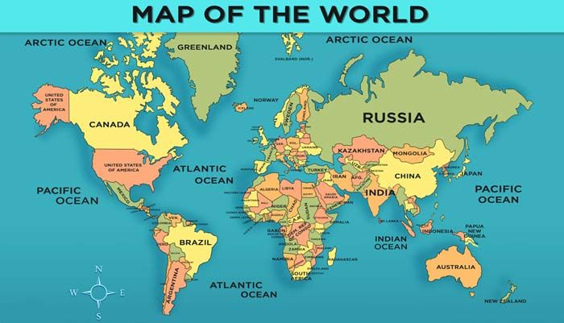
It happens in the following countries:

What effects can your wild weather cause? Give examples of damage caused to human and physical _________________________________________________________________________________________________________________________________________________________________________________________________________________________________________________________
How can people be kept safe from your wild weather? Give advice about what people should do
_________________________________________________________________________________________________________________________________________________________________________________________________________________________________________________________
EXT: Any other relevant info. Eye catching facts would really catch people’s attention.
WWW:
EBI:

Extension tasks:
- Write a short diary entry as if you were a survivor of a hurricane! You might want to consider the following:
-What did you hear and see during the hurricane?
- What effect did the hurricane have on your life?
-How did you feel during this event?
2. Why might a richer country be better at preparing for extreme weather than a poorer country? Do some research to find out.
3. Create a survival kit for a typhoon- what is most important to keep for survival and why?
4. Find some examples of where extreme weather has happened in the UK and label it on a map to show where it happened.
5. Design an building designed to survive different types of extreme weather- label off of your building to explain how each design piece will reduce damage.

Running total of e-praise/effort points
Week | E-praise award | Running total
1
2
3
Extension tasks
Total points for the end of the project

Self-reflection:
WWW:

EBI:

