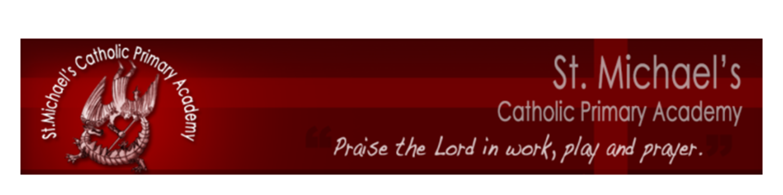

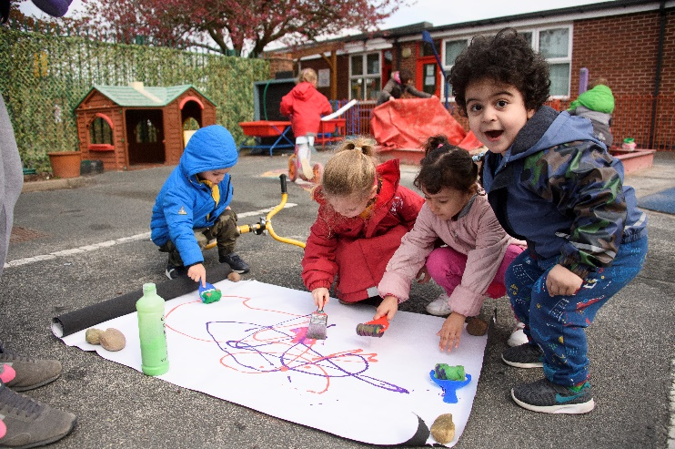



Part of the Bishop Cleary Catholic Multi Academy
a company limited by guarantee in England and Wales (company number 08578428) whose registered office address is Compton Park, Wolverhampton, WV3 9DU


Foundation Stage
Prospectus 2014-15
Nursery
Prospectus
The Mission Statement of St Michael’s Catholic Primary Academy & Nursery is:
‘Praise the Lord in Work, Play and Prayer’



Dear Parents,

The Local Governing Body, staff and children of St Michael’s Catholic Primary Academy welcome you to our academy family.

As the Principal of St Michael’s Catholic Primary Academy I am delighted that you have entrusted your child to our care. Should you have any queries or concerns regarding your child and his/her education please do not hesitate to contact me. I am always happy to meet with parents to discuss any matters pertaining to the children’s education and welfare. I extend a warm welcome to you and your child.

Mrs L Bradley
Principal
St Michael’s Catholic Primary Academy is established to support parents in their responsibility for the academic, physical, spiritual, moral and religious education of their children in accordance with the teachings of the Catholic Church.

This means that members of the Local Governing Body, staff, parents and pupils are committed to:

- Being part of the Church's mission, to place Christ and the teaching of the Catholic Church at the centre of people's lives.

- Upholding the uniqueness of the individual in which each person is seen as made in God’s image and loved by Him.

- Promoting achievement and excellence in which each pupil is given every opportunity to develop individual talents to the full.

- Forming pupils’ consciences, nurturing their relationship with God through prayer and fostering a sense of social responsibility.

Our Multi Academy Company:

In July 2013, St Michael’s School converted to academy status and became one of five founder members of the Bishop Cleary Catholic Multi Academy Company (frequently referred to as the Bp Cleary MAC).

In September 2019, Bp Cleary MAC merged with Pope John XXIII MAC to become St Francis and St Clare Catholic Multi Academy Company.

The other academies in our MAC are:
~ Our Lady & St Chad’s Catholic Academy (Secondary), WV10 8BL
~ St Edmund’s Catholic Academy (Secondary), WV3 9DU
~ SS Mary and John’s Catholic Primary Academy, WV2 1HZ
~ SS Peter and Paul’s Catholic Primary Academy & Nursery, WV6 0HR
~ St Teresa’s Catholic Primary Academy, WV4 6AW
~ St Bernadette’s Catholic Primary Academy, WV5 8DZ
~ St Patrick’s Catholic Primary Academy, WV11 1PG
~ Corpus Christi Primary Catholic Academy, WV11 2LT
~ St Mary’s Catholic Primary Academy, WV10 8PG
~ Holy Rosary Catholic Primary Academy, WV1 2BS

Our Foundation Stage:

The Foundation Stage Unit is an integral part of our Catholic Academy and caters for the education and welfare of pupils from the age of 3 until the end of the Reception year of their education. Please note that separate admission criteria apply for entry to the Reception year. See information regarding transfer to full-time education. This prospectus will provide you with information and guidance whilst your child is attending our Nursery provision.

In accordance with our Academy’s Mission Statement, staff working in the Foundation Key Stage recognise that each child is special and unique and, in recognising the needs of the individual, will aim to provide the best possible care and education for each one of the children.

In recognition that each child is special and unique staff understand:

that each child needs

* to know that he/she is valued
* an environment that enriches and nurtures their development
* opportunities to explore, investigate and make mistakes without experiencing a sense of failure

that each child deserves

* sensitive, skilled and qualified adults who value them
* good-quality resources
* time to share experiences with other adults and children
* space to be themselves

that each child will thrive

* when activities are exciting, purposeful and relevant
* when involved physically and mentally in first-hand experiences
* when encouraged to become independent and confident individuals
* when encouraged to play together
* when home and school work in close partnership

The Foundation Stage staff are keen to establish excellent relationships between home and school. It is important that the children see the staff and parents interacting in a supportive and positive way. At St Michael’s Catholic Primary Academy we see good relationships as an essential building block in the foundations of our ethos. The principles and policy on which our Early Years’ curriculum is based are in common with those identified in Wolverhampton’s document ‘Early Excellence - A curriculum for Early Years’, and the Department of Education curriculum guidance for the Foundation Stage.

Within the Foundation Stage we recognise that:

- all children have a vast capacity to learn
- what the child can already do is the starting point of the child’s learning
- childhood is seen as valid in itself as part of life and not simply as a preparation for
adulthood
- the development of the whole child is essential - the emotional, physical and spiritual, as well as cognitive aspects of development, are important
- learning is holistic and not compartmentalised
- the child’s education is seen as a total experience of, and interaction within, a rich learning environment, enabling children to develop independence and understanding
- expectations should be high and realistic with learning matched to individual needs
- children need to be encouraged to develop positive attitudes to self and others and develop confidence and self esteem
- the curriculum needs to be accessible to all pupils regardless of gender, race, religion, social needs, disability and ethnic background
- parents/carers are acknowledged as the first educators of their child
- partnership with parents/carers enhances learning and achievement.

The activities children follow are considered under 7 main areas of learning:-

Prime Areas -
- Communication and Language
- Physical Development
- Personal, Social and Emotional Development

Specific Areas –
- Literacy (phonics, reading and writing)
- Mathematics
- Understanding the World
- Expressive Arts and Design

Learning Environment:

The Early Years’ Foundation Stage classes (Nursery and Reception) are positioned within a specially created unit within the academy. The unit has been developed to address the educational and social needs of the young children who are entrusted to our care and benefits from:

- A separate entrance gate

- An excellent range of stimulating Early Years resources

- A separate playground

- Innovative & child-friendly technological hardware

In addition, children in Nursery also access the academy hall, chapel, woodland exploration area, outdoor trim trail and activity zones.
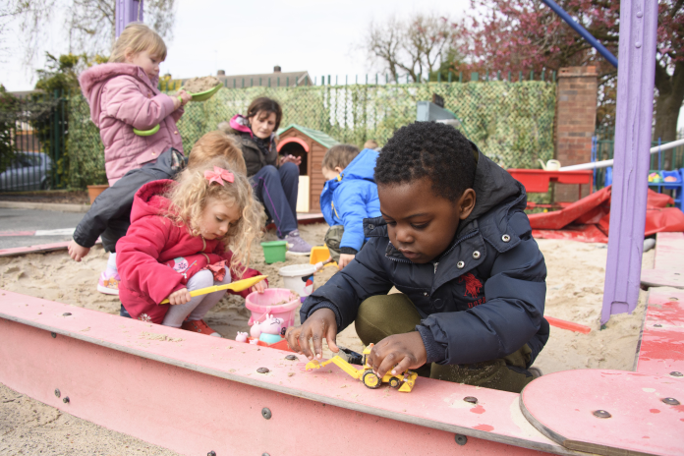

Nursery Provision:
We offer a range of options for our 3 and 4 year old nursery pupils:-
- 15 Hours per week Nursery Provision
5 morning sessions 8.45am – 11.45am (Monday – Friday)

- 15 Hours per week Nursery Provision
5 afternoon sessions 12.30pm – 3.30pm (Monday – Friday)

- 30 Hours per week Nursery provision (Free)
A number of 30 hours places are available at St Michael’s Catholic Primary Nursery.
Children registered for 30 hour provision will attend 5 daily sessions of Monday- Friday 8:45am – 3:30pm each week.
St Michael’s Academy is not able to agree individualised weekly or daily attendance and collection times.
A voucher code needs to be provided for academy staff to check that the government will fund the 30 hours place. A registration form (sent in the offer pack) must be completed before an offer of a place is given in writing. Voucher codes can be obtained from www.gov.uk/help-with-childcare-costs/free-childcare-and-education-for-2-to-4-year-olds
NB Children’s lunchtime (11.45- 12.30) is not covered by the free 30 hour entitlement and therefore will be charged at £3 per day / £15 per week.

- 30 Hours per week Nursery provision (Paid)
St Michael’s can also offer 15 free hours nursery provision and parents can pay for an additional 15 additional hours each week. This is for families who are not eligible for 30 hour government funding.
The charge for the additional 15 hours is £60/week (the equivalent of £4.00 per hour). The total weekly cost per child will be £75 to include lunchtime provision (as above). This can be paid monthly or half-termly. Should a parent require more regular payment options they are invited to speak with the Principal directly.

Charges must be paid monthly in advance, by the 7th of the month; or half-termly in advance by the end of the first week of each half term.

- Morning Nursery with Lunch
5 morning sessions 8.45am – 11.45am (Monday – Friday)
with lunchtime (11.45am- 12.30pm) will be charged at £3 per day / £15 per week.

- Afternoon Nursery with Lunch before
5 afternoon sessions 12.30pm – 3.30pm (Monday – Friday)
with lunchtime (11.45am- 12.30pm) will be charged at £3 per day / £15 per week.
Nursery Life:

Settling In

As your child starts Nursery they may need support with settling. Initially you are welcome to briefly stay with your child but often it may be better if you leave them to build relationships with the Nursery staff.

If you have a younger child, it may be advisable to leave him or her with someone during the settling-in period when your child first starts Nursery. For Health and Safety reasons, prams and pushchairs are not allowed in Nursery as they would create a danger and would hinder evacuation procedures in the event of fire or other hazards. We very much appreciate your understanding and co-operation in this matter.

End of the session

Children should be collected promptly at the end of the session. Please ensure that the teacher is informed if any different person will be arriving to collect your child. Children are never allowed to leave Nursery until they can be handed into the care of a known parent/carer. We operate a password system and you will be asked to provide a password when your child starts with us. If anybody is collecting your child other than the known carer, please ensure you share the password with them as they will be required to provide the password to the staff before the child can be handed over.

Please do ensure that you are punctual in your arrival at both the beginning and end of the session. It is important that our young children develop a healthy daily routine. Children may worry or become upset if they either arrive late or are not collected on time.

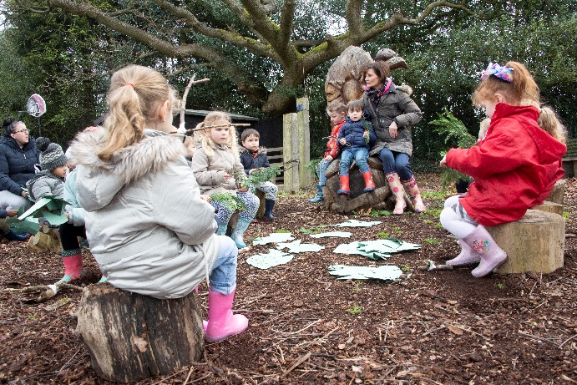

Clothing

Our Nursery children are not required to wear a uniform.

Each child should have a drawstring bag containing shorts and t-shirt (red shorts and white t-shirt or polo shirt if parents wish to provide kit that matches our main academy uniform). A pair of pants and socks in a plastic bag in case of a toileting accident would also be useful. Please mark the drawstring bag and all clothing clearly with your child’s name. We recommend that your child has a pair of wellies that can stay in Nursery. The children enjoy outdoor learning on a very regular basis including ‘Welly Wednesday’ as part of their weekly Forest Schools routine.

Children should also come to school with clothing (including a coat) and shoes that are suitable for outside use as the children will use the Foundation Stage outdoor area regularly. For Health and Safety reasons we advise that your child does not wear any jewellery.

Snack time

The children are offered a choice of milk or water at snack time and the fruit of the day. Occasionally the children will be offered other foods that they have cooked or children have brought into Nursery for their birthday. It is important that you let a member of staff know if your child has any allergies or dietary requirements.

Lunch time

Children accessing the 30 hours provision (or options E & F on page 7) will need to bring a sensible, healthy packed lunch from home. They will have lunchtime between 11:45am-12:30pm. There is a daily charge of £3 for this.
Academy staff will supervise the children during lunchtimes. Parents will need to ensure that lunchtime fees are paid monthly in advance, using our cash–free ParentPay system, please ask for a login for this online payment system.

Special educational needs

If either home or school have concerns about your child’s progress, we will discuss ways that we can help your child. The academy has a comprehensive Special Educational Needs Policy which enables us to support children with a range of learning needs.

We also work closely with a range of outside agencies, for example Speech Therapy, Occupational Therapy, Special Educational Needs Early Years team and Educational Psychologists who may also support your child. We always gain parental permission before referring a child to any service outside school. More information about Special Educational Needs support and the policy are available on our website or by request from Mrs A Brereton, SENCO: senco@stmichaels-academy.co.uk .

Behaviour

We are proud that OFSTED rated the behaviour and welfare in our academy as “Outstanding”. Children are all taught to respect each other, the environment and resources in our academy as part of their curriculum.
We understand that young children often have impulsive behaviour and we support them with understanding the need to wait for their turn and share resources. Occasionally it may be necessary to give children quiet time to reflect on their behaviour and calm down.

More information about our behaviour rewards, sanctions and code of conduct can be found in our Behaviour Policy available on our website.

Illness

When your child is absent from the academy you must telephone on the first day of absence, before 9.30am to inform us of the nature of the illness. As part of our rigorous safeguarding procedures, you may receive a text message from us prompting you to call if you do not inform us of the reason for your child’s absence. You can also send a text before 9:30am using our ‘School Gateway App’.

We have many staff trained in Paediatric First Aid and Emergency First Aid who will look after children in the case of sickness or accident. Please make sure we always have at least two up-to-date telephone numbers where we can contact you or a named contact during the day. Parents/named contacts will be contacted if your child is considered to be unwell or if staff are concerned about your child’s health or welfare.

Medication

Should your child suffer from any medical condition e.g. asthma, please ensure that the academy are fully informed about medication etc. that your child may need to take. It is important that we know if your child has any allergies.

Only prescribed medicines, including those for long-term illnesses such as asthma, epilepsy, diabetes, heart and kidney conditions are allowed in the academy or nursery. Any medication should be taken to the academy office. Staff will ask you to complete a consent form for administering medication. It is the responsibility of the parent/carer to collect any medication at the end of the session/day. Medication will not be given unless a consent form is completed. Please note that antibiotics will not be administered by the academy staff unless your child has 30 hours’ provision and requires 4 doses per day.

Photographs
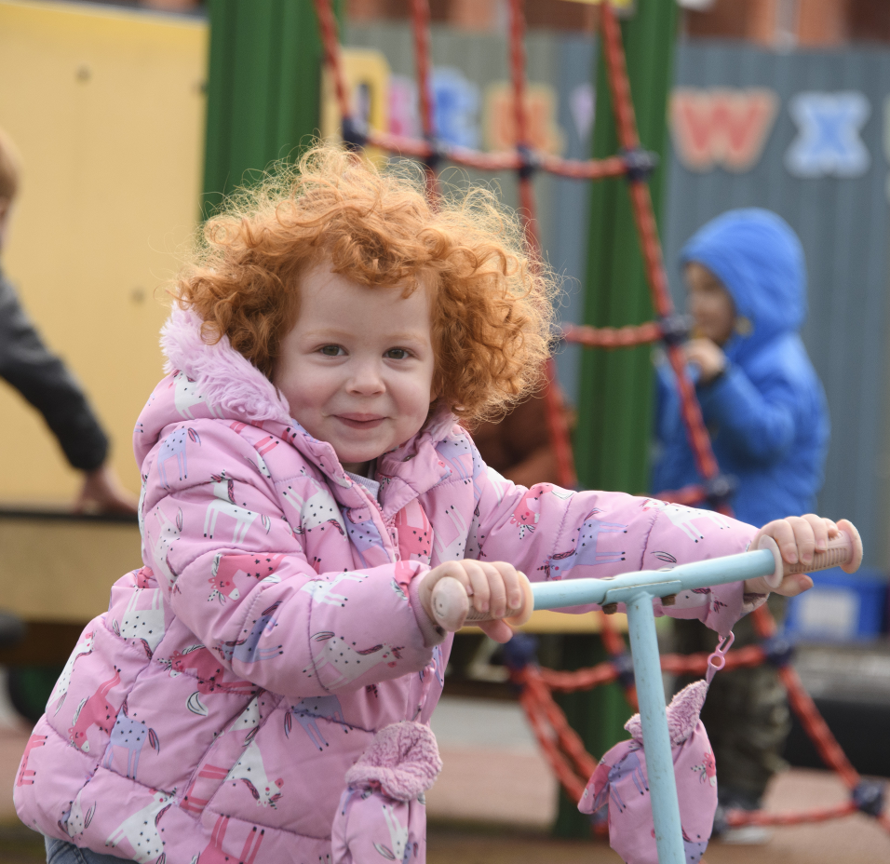
Each term in Nursery, many photographs will be taken of your child.

They will be used to document their learning and special events. This will be used in their Learning Journal and on the classroom walls. They may also be used (without names) on our website.

If you have any concerns or questions about how your child’s photographs will be used, please talk to a member of staff.

Safeguarding

St Michael’s Catholic Primary Academy and Nursery has a comprehensive and robust Safeguarding and Child Protection Policy, which can be found on our website.
Parents should be aware that all academy staff are committed to safeguarding and promoting the welfare of children. As a result, we will take any reasonable action to ensure the safety of all children. In cases where the academy has reason to be concerned that a child may be subject to ill-treatment, neglect, or any other form of abuse, the Principal is obliged to follow the procedures established by the Wolverhampton Safeguarding Board and inform Social Services of the concern.
Parents are invited to visit the ‘Keeping Safe’ area of our website to access a range of support services, helplines, internet-safety guides and whistle–blowing contacts.
Children who need to be changed or require intimate care if they have soiled themselves are changed in our nursery washroom area by a member of staff. The staff change the children on a rota basis and all other staff are informed when a child is being changed. We strongly recommend your child has begun toilet training before they start in our Nursery. Please arrange to speak to the Nursery teacher or Principal when your child starts if you need to discuss this.

Communication

We use letters, newsletters, our website and texts - sent from our secure text system ‘SchoolComms’ - to communicate with you.
A free APP can now be downloaded to receive all text messages which is suitable for Android & Apple devices. (SEARCH: School Gateway)
A termly ‘Dates Booklet’ is sent from the Principal which contains forthcoming dates and events that parents may wish to enter in their diaries.
A monthly newsletter is sent home to share recounts and pictures of some of the events that have taken place across the academy throughout the month. It also announces winners of the weekly attendance award.
In addition, each class teacher sends a ‘Curriculum Newsletter’ home at the start of every term containing information about the curriculum the children will be covering during that term.
Parents’ evenings
Three parents’ evenings are held each year, one in each of the Autumn, Spring and Summer terms. On the consultation evenings in the Autumn and Spring terms, parents are given the opportunity to meet with the class teacher to talk about their child’s progress and achievements. During these evenings the Principal and the Special Educational Needs Co-ordinator are also available to answer any questions that parents may have. An open evening is held in the Summer term for parents to view their children’s work and to visit their new classroom.
Reports
A written report is sent home in the summer term prior to the open evening. Each child’s development is monitored and recorded in every subject.

ParentPay

We are a cash-free academy and do not accept cash payments. We use an online system called ParentPay (www.parentpay.com). When your child starts at our academy you will be provided with a unique activation code to enable you to set up your online account.
- ParentPay is easy to use and will offer you the freedom to make online payments whenever and wherever you like.
- The technology used is of the highest internet security available ensuring that your money will reach us safely – offering you peace of mind.
- Payments can be made by credit/debit card or also through PayPoint.
- Full payment histories and statements are available to you securely online at any time.
Using ParentPay also ensures that all financial transactions are safe and secure - helping us to remove costs associated with us having to manage cash securely on the academy premises.

Parent and Teachers Association (PTA)
St Michael’s Academy boast a very active and supportive Parent Teachers Association. All parents of children attending St Michael’s Academy are automatically members of the association. We ask that as parents you do become actively involved in the life of the academy. You are cordially invited to attend any PTA meeting or event. We welcome the opportunity to listen to your ideas as to how we can do more work for the good of the children who attend our Academy.
The aims of the Association/ Charity are:
To advance the education of pupils in the school in particular by:-
- Developing effective relationships between the staff, parents and others associated with the school.
- Engaging in activities or providing facilities or equipment, which support the school and advance the education of the pupils.
PTA REGISTERED CHARITY NUMBER:- 1114511

Transfer to full-time schooling

The Local Authority has determined that there will be a single admission date when children will transfer to full-time schooling. Before your child’s 5th birthday, Wolverhampton Local Authority will automatically contact you, inviting you to formally apply for a reception school place using their online system.

Acceptance of a place within the Nursery class in no way guarantees that a place will be provided in the Reception class of our academy when your child reaches statutory school age although we encourage parents to apply for a Reception place in our academy.
See our Admission Policy & Criteria found at www.stmichaels-academy.co.uk

Useful Information

Principal: Mrs L Bradley

Acting Vice Principal: Mrs A Brereton

SENCO: Mrs A Brereton [email: senco@stmichaels-academy.co.uk ]

Academy address: St Michael’s Catholic Primary Academy & Nursery
Telford Gardens
Merry Hill
Wolverhampton
West Midlands
WV3 7LE

Academy telephone number: 01902 556368

Academy email address: office@stmichaels-academy.co.uk
We will answer emails between 9.00am – 4.30pm Monday to Friday and within 3 working days of receipt.

Academy website: www.stmichaels-academy.co.uk

Academy office opening times: 8.15am – 4.15pm Monday – Thursday
8.15am - 4.00pm Friday

The information contained in this booklet is correct at the time of printing but is subject to alteration should circumstances change.

Praise the Lord in work, play and prayer


