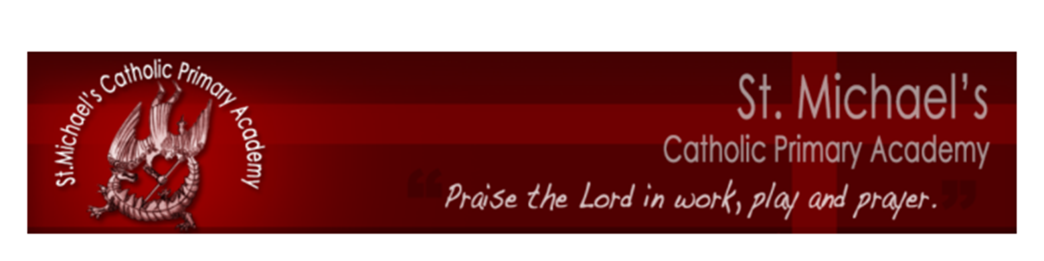



Part of the Bishop Cleary Catholic Multi Academy
a company limited by guarantee in England and Wales (company number 08578428) whose registered office address is Compton Park, Wolverhampton, WV3 9DU


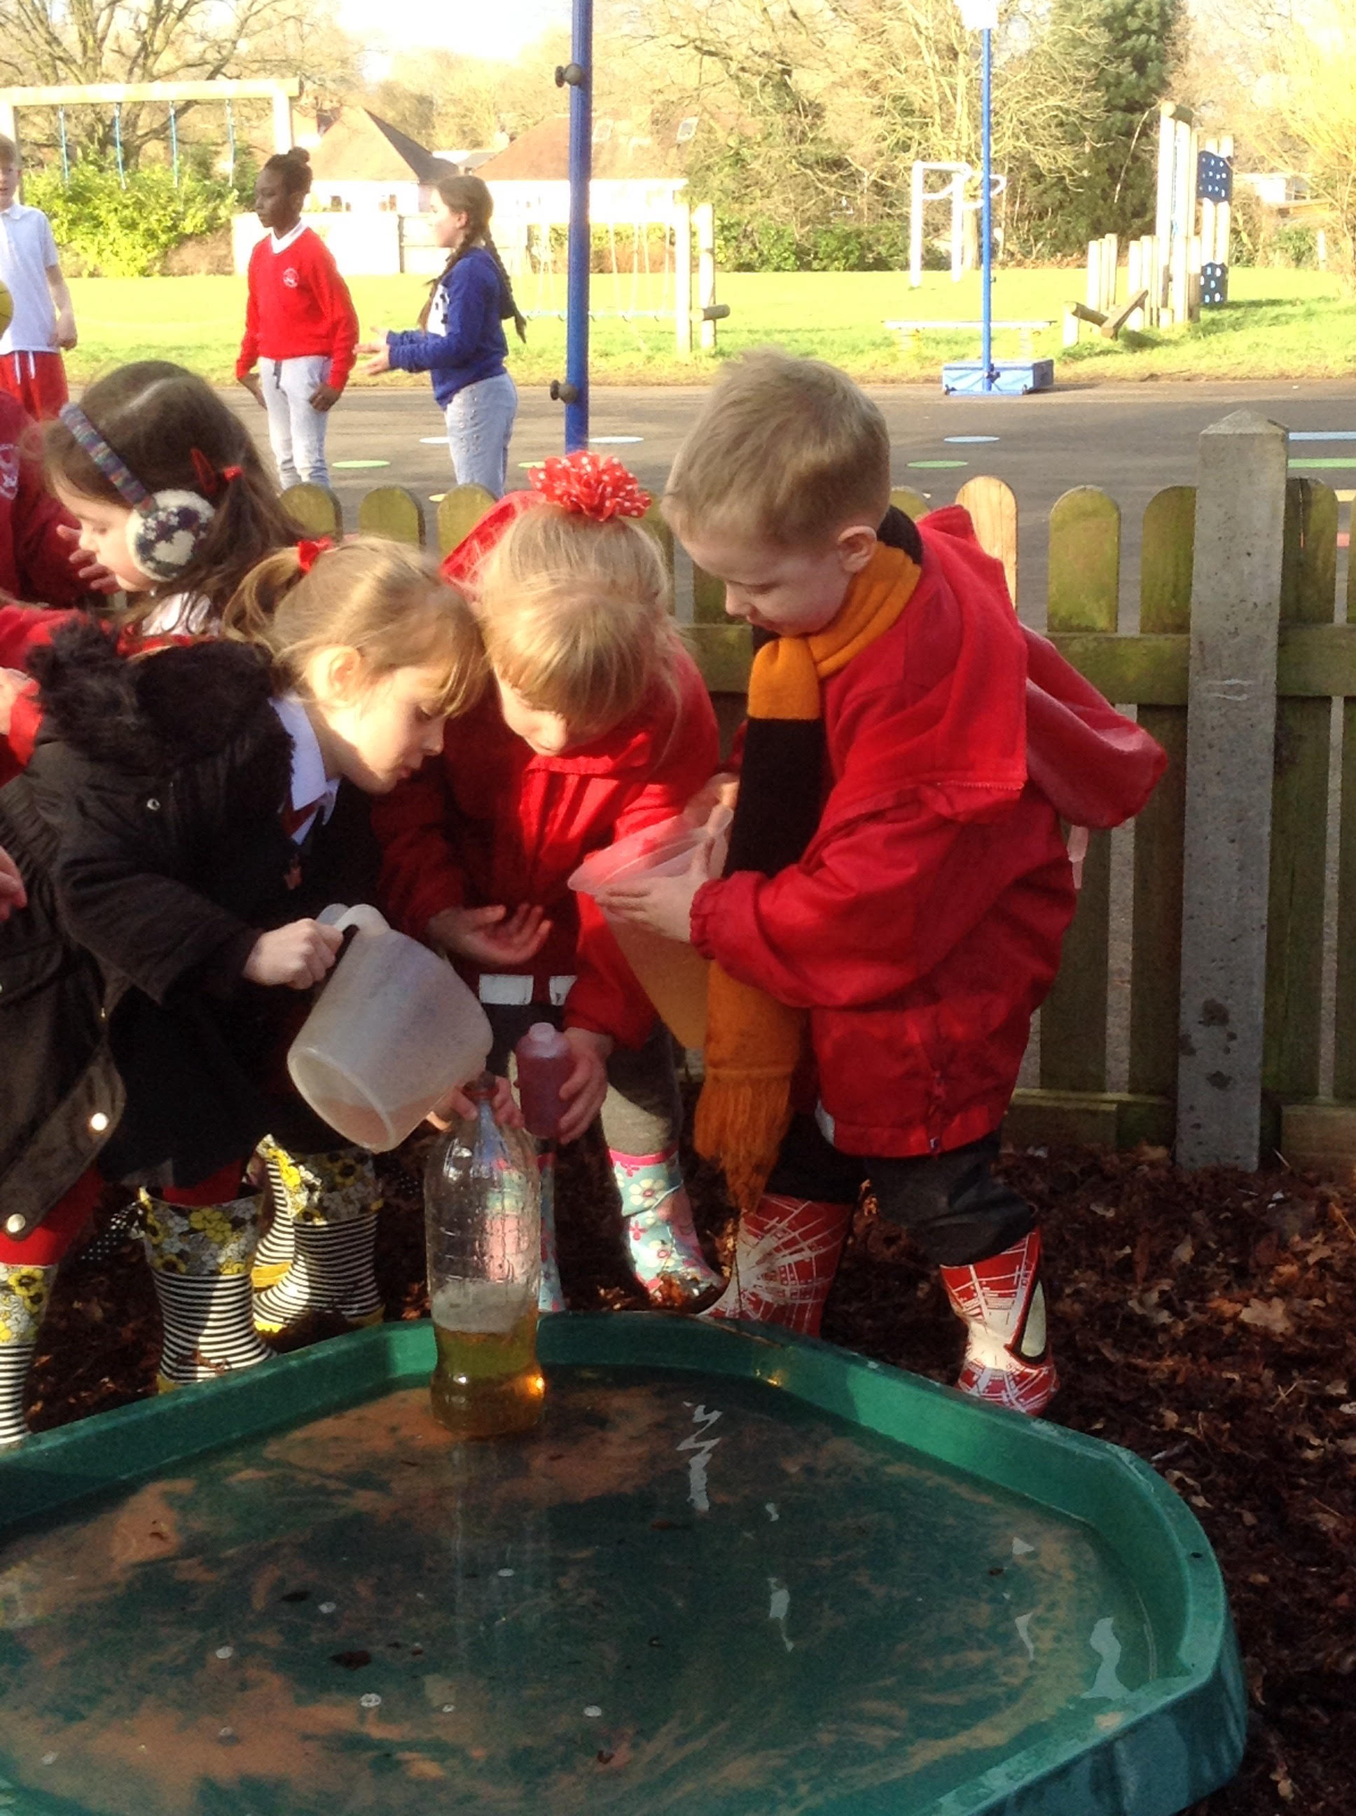
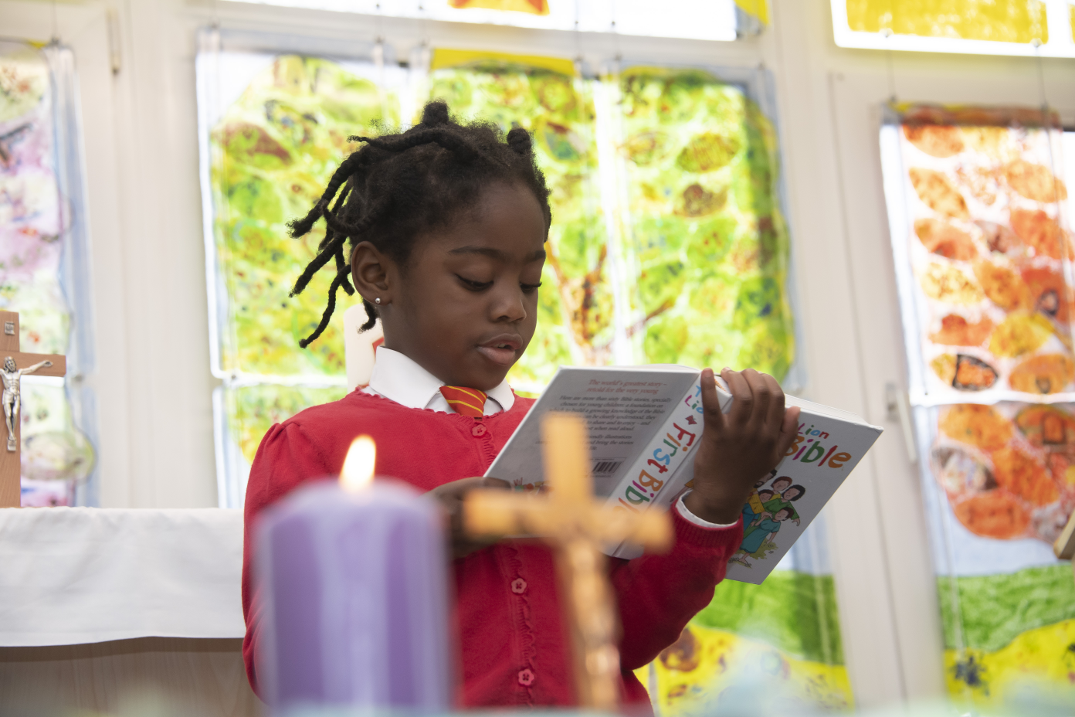
Foundation Stage
Prospectus 2014-15
Reception
Prospectus

The Mission Statement of St Michael’s Catholic Primary Academy & Nursery is:
‘Praise the Lord in Work, Play and Prayer’



Dear Parents and Carers,

The Local Governing Body, staff and children of St Michael’s Catholic Primary Academy welcome you to our academy family.

As the Principal of St Michael’s Catholic Primary Academy, I am delighted that you have entrusted your child to our care. Should you have any queries or concerns regarding your child and his/her education please do not hesitate to contact me. I am always happy to meet with parents to discuss any matters pertaining to the children’s education and welfare. I extend a warm welcome to you and your child.

Mrs L Bradley
Principal
St Michael’s Catholic Primary Academy & Nursery

St Michael’s Catholic Primary Academy and Nursery is established to support parents in their responsibility for the academic, physical, spiritual, moral and religious education of their children in accordance with the teachings of the Catholic Church.

This means that members of the Academy Committee, staff, parents and pupils are committed to:

- Being part of the Church's mission, to place Christ and the teaching of the Catholic Church at the centre of people's lives.

- Upholding the uniqueness of the individual in which each person is seen as made in God’s image and loved by Him.

- Promoting achievement and excellence in which each pupil is given every opportunity to develop individual talents to the full.

- Forming pupils’ consciences, nurturing their relationship with God through prayer and fostering a sense of social responsibility.

Our Multi Academy Company:

In July 2013, St Michael’s School converted to academy status and became one of five founder members of the Bishop Cleary Catholic Multi Academy Company (frequently referred to as the Bp Cleary MAC).

In September 2019, Bp Cleary MAC merged with Pope John XXIII MAC to become St Francis & St Clare Multi Academy Company.

The other academies in our MAC are:
~ Our Lady & St Chad’s Catholic Academy (Secondary), WV10 8BL
~ St Edmund’s Catholic Academy (Secondary), WV3 9DU
~ SS Mary and John’s Catholic Primary Academy, WV2 1HZ
~ SS Peter and Paul’s Catholic Primary Academy & Nursery, WV6 0HR
~ St Teresa’s Catholic Primary Academy, WV4 6AW
~ St Bernadette’s Catholic Primary Academy, WV5 8DZ
~ St Patrick’s Catholic Primary Academy, WV11 1PG
~ Corpus Christi Primary Catholic Academy, WV11 2LT
~ St Mary’s Catholic Primary Academy, WV10 8PG
~ Holy Rosary Catholic Primary Academy, WV1 2BS

Our Foundation Stage:

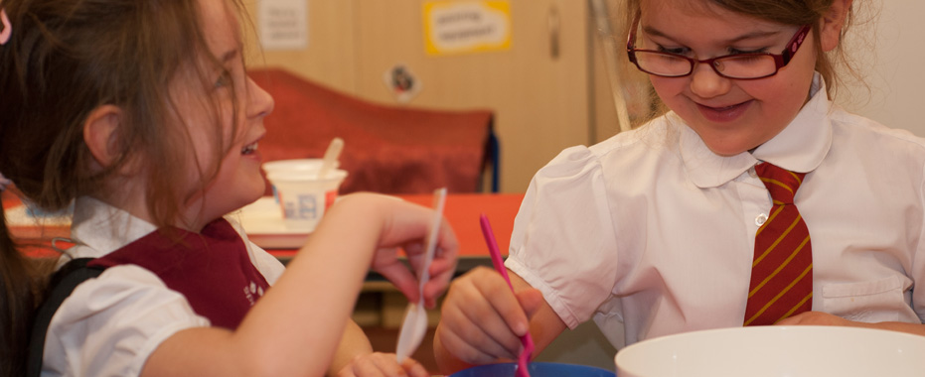

The Foundation Stage Unit is an integral part of our Catholic Academy and caters for the education and welfare of pupils from the age of 3 to the end of the Reception year of their education. Please read our Admission Policy for further information on the required formal application for a place in our Reception class.

Our full Early Years Foundation Stage Policy can be found at www.stmichaels-academy.co.uk .

In accordance with our Academy’s Mission Statement, staff working in the Foundation Key Stage recognise that each child is special and unique and, in recognising the needs of the individual, will aim to provide the best possible care and education for each one of the children.

In the recognition that each child is special and unique staff understand:

that each child needs

* to know that he/she is valued
* an environment that enriches and nurtures their development
* opportunities to explore, investigate and make mistakes without experiencing a sense of failure

that each child deserves

* sensitive, skilled and qualified adults who value them
* good-quality resources
* time to share experiences with other adults and children
* space to be themselves

that each child will thrive

* when activities are exciting, purposeful and relevant
* when involved physically and mentally in first-hand experiences
* when encouraged to become independent and confident individuals
* when encouraged to play together
* when home and school work in partnership.

The Foundation Stage staff are keen to establish excellent relationships between home and school. It is important that the children see the staff and parents interacting in a supportive and positive way. At St Michael’s Catholic Primary Academy & Nursery we see good relationships as building the strong Foundations of our ethos.

The principles and policy on which our Early Years curriculum is based are in common with those identified in Wolverhampton’s document ‘Early Excellence - A curriculum for Early Years’ and Department of Education curriculum guidance for the Foundation stage.

Within the Foundation Stage we recognise that:

- all children have a vast capacity to learn
- what the child can do is the starting point of the child’s learning
- childhood is seen as valid in itself as part of life and not simply as a preparation for adulthood
- the development of the whole child is essential. The emotional, physical and spiritual, as well as cognitive aspects of development are important
- learning is holistic and not compartmentalised
- the child’s education is seen as a total experience of and interaction within a rich learning environment, enabling children to develop independence and understanding
- expectations should be high and realistic with learning matched to individual needs
- children need to be encouraged to develop positive attitudes to self and others and develop confidence and self esteem
- the curriculum needs to be accessible to all pupils regardless of gender, race, religion, social needs, disability and ethnic background
- parents/carers are acknowledged as the first educators of their child
- partnership with parents/carers enhances learning and achievement.

Early Years Foundation Stage Curriculum

The curriculum activities that Reception children follow are considered under 7 main areas of learning:-

Prime Areas -
- Communication and language
- Physical Development
- Personal, Social and Emotional Development

Specific Areas –
- Literacy (phonics, reading and writing)
- Mathematics
- Understanding the World
- Expressive Arts and Design
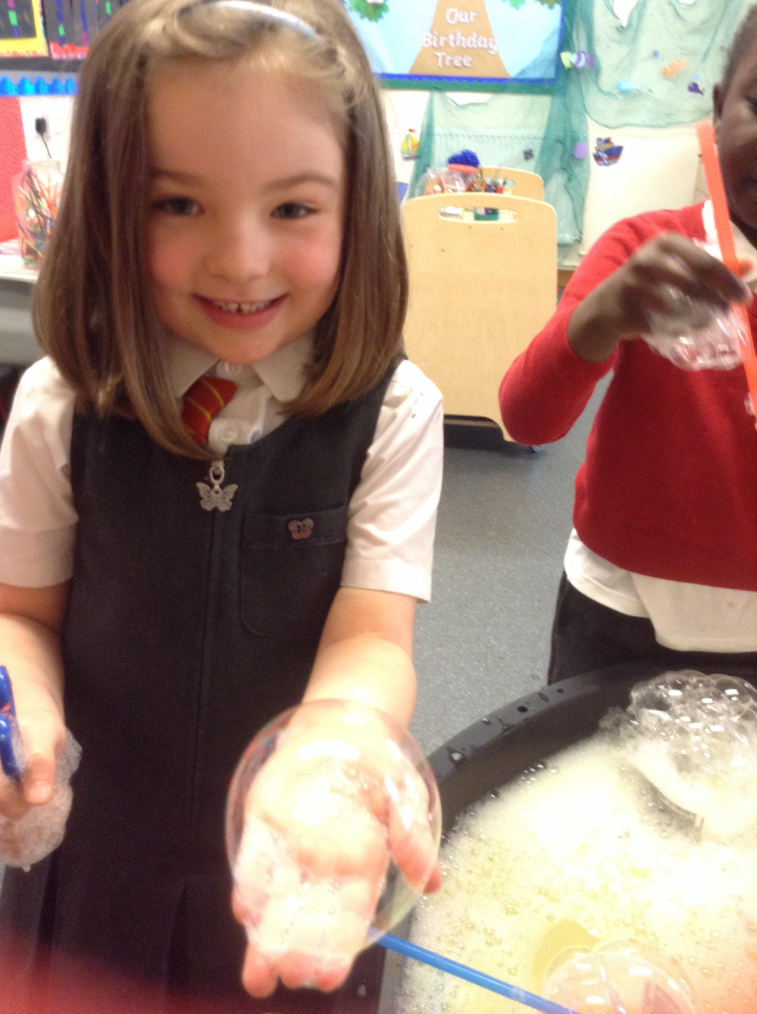

Learning Environment:

Children within the Early Years Foundation Stage (from the age of 3 to the end of Reception class year group) will be positioned and taught within a specially created unit within the academy. The unit has been developed to address the educational and social needs of the young children who are entrusted to our care and benefits from:

- A separate entrance gate

- An excellent range of stimulating Early Years resources

- A separate playground

- Innovative & child-friendly technological hardware

In addition, children in Reception also access the dining hall, Moon Room, chapel, woodland exploration area and our outdoor trim trail and activity zones on the main playground and field.

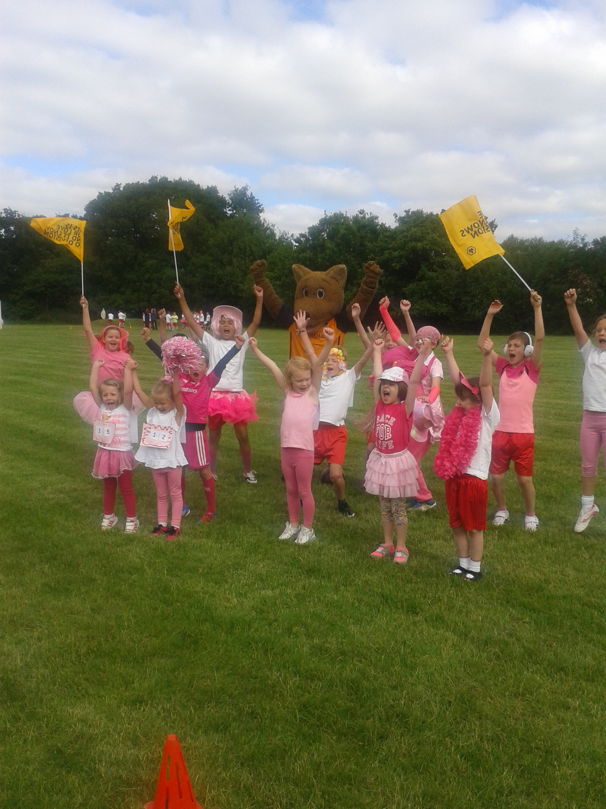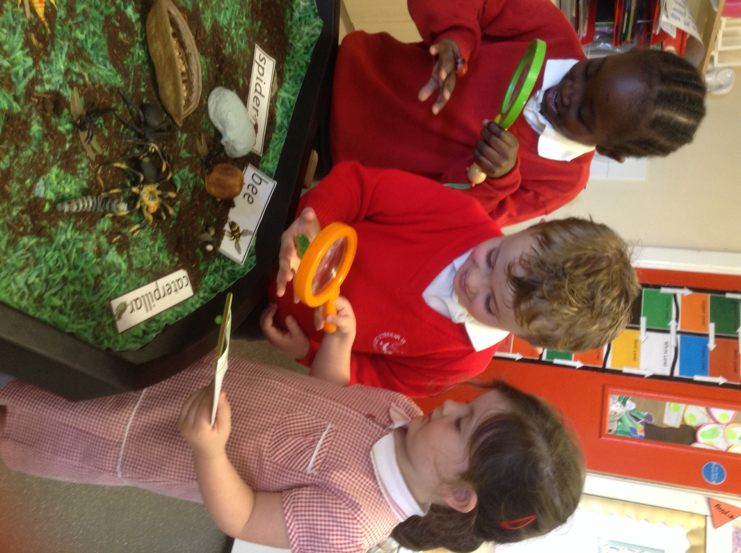

How can I prepare my child for life in Reception?

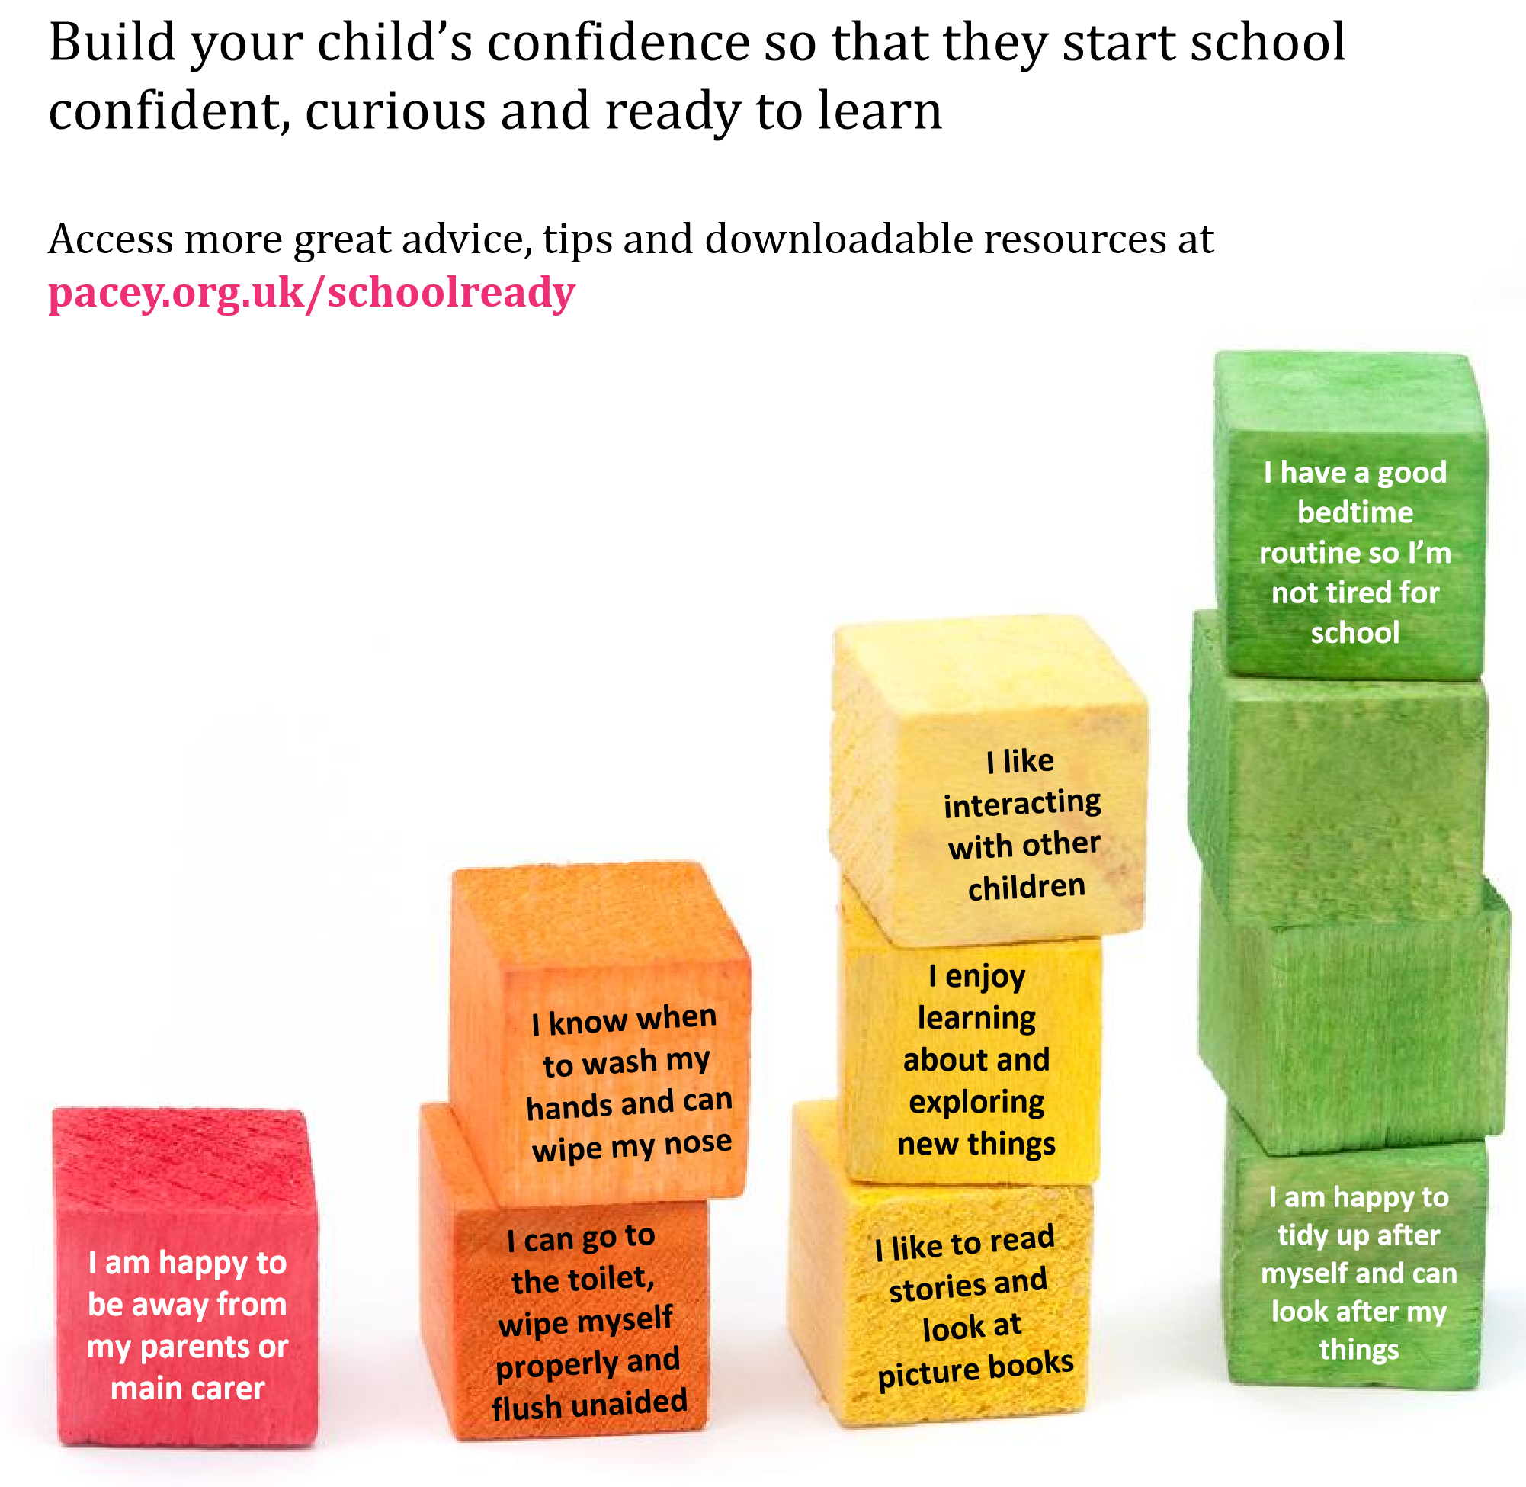
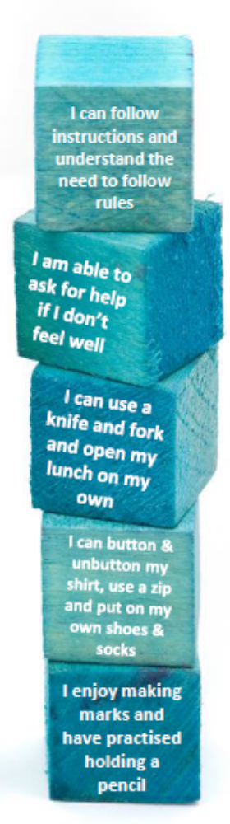
This ‘Steps to starting school’ guide from P.A.C.E.Y (The professional association for childcare and early years) may help you and your child prepare for September:-
I can share
toys and take turns
I can use a knife and fork and open my lunch on my own
I am able to sit still and listen for a while

I can share
toys and take turns
More top tips from ‘PACEY’ - the Early Years experts:
* Get your child ready for their new routine by switching their meal times to match those of the school day.  (We have lunch at 12pm) | * Encourage your child to explore new environments and interact with new people. | * Talk to your child about what they are most looking forward to at school | * Let your child practise putting their uniform on and taking it off with increasing independence.
General Information:

Settling In
As your child starts Reception, teachers plan activities under the title ‘Welcome Weeks’ to help children settle in. Initially you are welcome to enter the classroom with your child as they discover where to hang up their coat, before saying goodbye. Our experienced staff often find it better if parents leave promptly, allowing children to build relationships with staff and peers. Talking through morning routines will also help your child to know what to expect in the morning and will help them settle into the classroom. We encourage you to explain that after a hug from a carer/parent all they need to do is put their coat and bag away before they can have lots of fun learning with their friends. This can put children’s minds at rest and gives them a task to focus on.
Staff will be able to answer questions and give feedback on how children are settling at home time each day.

If you have a younger child it may be advisable to leave him or her with someone during the settling in period when your child first starts school. As part of our Health and Safety Policy, prams and pushchairs are not allowed in our Reception class. We very much appreciate your understanding and co-operation in this matter.

Arriving & Departing

Children in Reception are to be escorted to, and collected from, the classroom door which can be accessed using the gate to the right of our main entrance, near our Nursery classroom.
The Reception classroom door is opened at 8.45am. Children should be ‘handed over’ to Reception staff at this door between 8.45am – 8.55am. The door and gate are locked at 8.55am. Children arriving late after this point will need to be taken by their parent/carer to the main academy entrance, to sign them in the late register. School staff will then take your child to the Reception classroom.

At the end of the day, children should be collected promptly at 3.15pm from the Reception classroom door. Children are never allowed to leave the Reception Class until they can be handed into the care of a known parent/carer. We operate a password system and you will be asked to provide a password when your child starts with us. If someone, other than the known carer, is collecting your child they will be asked to provide the password to the staff before the child can be handed over.

Please ensure that you are punctual in your arrival at both the beginning and end of the day. It is important that children develop a healthy daily routine. Children may worry or become upset if they either arrive late or are not collected on time. When parents are late collecting at home time, children will be placed in our after-school care club until parents can collect them (charges will apply).
Uniform / Clothing:

St Michael's recommended uniform is:
Boys | Girls
Winter:  - Grey formal full length school trousers  - White or grey cotton shirt  - Scarlet V-necked long sleeved pullover (academy logo optional)  - Scarlet and yellow striped tie  - White or grey socks  - Black shoes  - Wellies | Winter:  - Grey pinafore slip / recommended formal full length school trousers  - White cotton blouse or cotton shirt  - Scarlet V-necked pullover or cardigan (academy logo optional)  - Scarlet and yellow striped tie  - Grey or white socks / red, grey, white or black tights  - Black shoes  - Wellies
Summer:  - Grey formal full length school trousers / formal, grey school shorts  - White or grey cotton shirt / white open-neck polo-type shirt (school logo optional)  - Scarlet V-necked long sleeved pullover (academy logo optional)  - Scarlet and yellow striped tie (not required with the polo-type shirt)  - White or grey socks  - Black shoes | Summer:  - Grey pinafore slip / recommended formal full length school trousers / Red and white gingham check summer dress  - White cotton blouse or cotton shirt (unless wearing gingham dress)  - Scarlet V-necked pullover or cardigan (academy logo optional)  - Scarlet and yellow striped tie  - Grey or white socks  - Black shoes
PE
Each child should have a drawstring bag containing red shorts, a white P.E. t-shirt or polo shirt (academy logo optional) and black plimsolls.
Parents may choose to purchase items of uniform from any retailer they wish. Ties, jumpers and cardigans with the academy logo are available from Lads and Lasses, 50a Warstones Road, WV4 4LP.
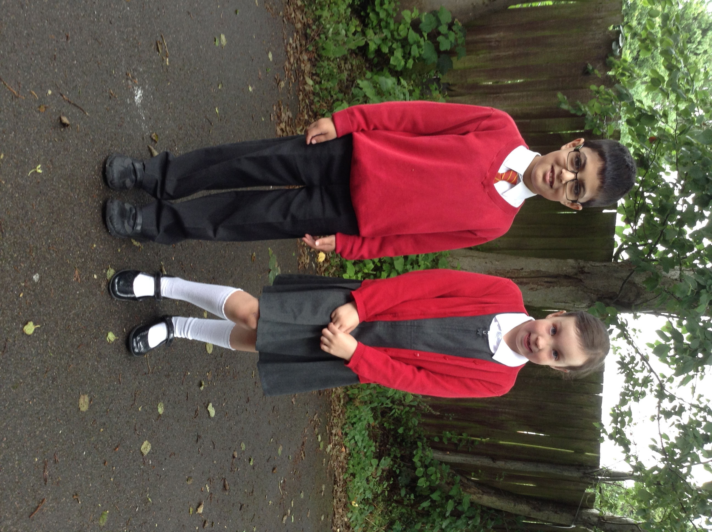

Children should also come to school with clothing and shoes that are suitable for outside use as the children will use the outdoor areas regularly. As part of our Health and Safety Policy we advise that your child does not wear any jewellery. All pupils are required to attend the academy appropriately dressed. For the assistance of parents, St Michael's has adopted these guidelines on dress.

Food:
Snack time

The children are offered a choice of milk or water at snack time and the fruit of the day. Children are entitled to free milk each day until they are 5 years old.
Occasionally the children will be offered other foods that they have cooked or children have brought into school for their birthday. It is important that you let a member of staff know if your child has any allergies or dietary requirements.

Lunch time

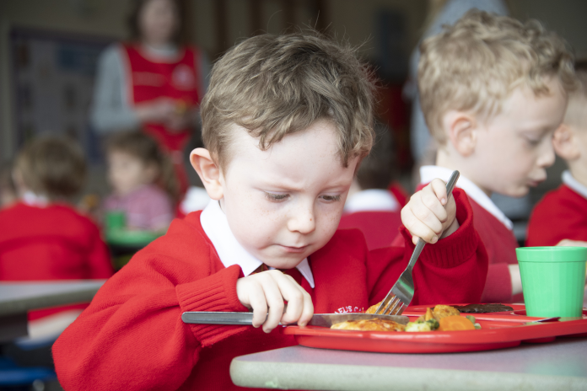
Academy meals are made from scratch on our premises daily using fresh ingredients. Our wonderful cook makes meals attractive and nutritious for the children, in line with Local Authority and government healthy eating / food standards guidelines. Parents are encouraged to select to have a FREE academy meal each day for their child. Our cook is able to provide for children with specific dietary requirements such as allergies or religious requirements.
Children enjoy choosing from a range of dishes including daily options for:-
- hot meals
- sandwiches
- salad cart
- jacket potato with a range of fillings
- vegetarian options
- home-made bread, cookies, desserts, fresh fruit salad or yoghurt … and much more!

Alternatively parents may choose to provide a balanced, healthy packed lunch for their child each day. We ask you to notify the academy in writing, in advance, if you wish your child to change from one form of meal to another.
Each child having a packed lunch must bring their own lunch in a rigid plastic container, clearly and indelibly marked with their name. Fizzy drinks, chocolate, sweets, hot drinks are not permitted.
Sandwich boxes are kept in a designated place until it is time for the children to eat. All wrapping and other remnants must be put in the boxes which will be replaced in the classroom and taken home. No food may be eaten at any other time or anywhere other than the stipulated place.

Why are academy meals free?
All children who are in Reception, Year 1 and Year 2 classes in a state-funded school will be offered a free healthy school lunch. We encourage all children to take advantage of this government ‘Universal Infant Free School Meals Scheme’ rather than bringing a packed lunch from home.

Special Educational Needs:

If either parents or staff have concerns about your child’s progress then we will discuss ways that we can help you. The academy has a comprehensive Special Educational Needs Policy which enables us to support children with a range of difficulties.

We also work closely with a range of outside agencies, for example Speech Therapy, Occupational Therapy, Special Educational Needs Early Years team and Educational Psychologists who may also support your child. We always gain parental permission before referring a child to any service outside of the academy. More information about Special Educational Needs Support can be found on our website or by request from Mrs A Brereton, SENCO.
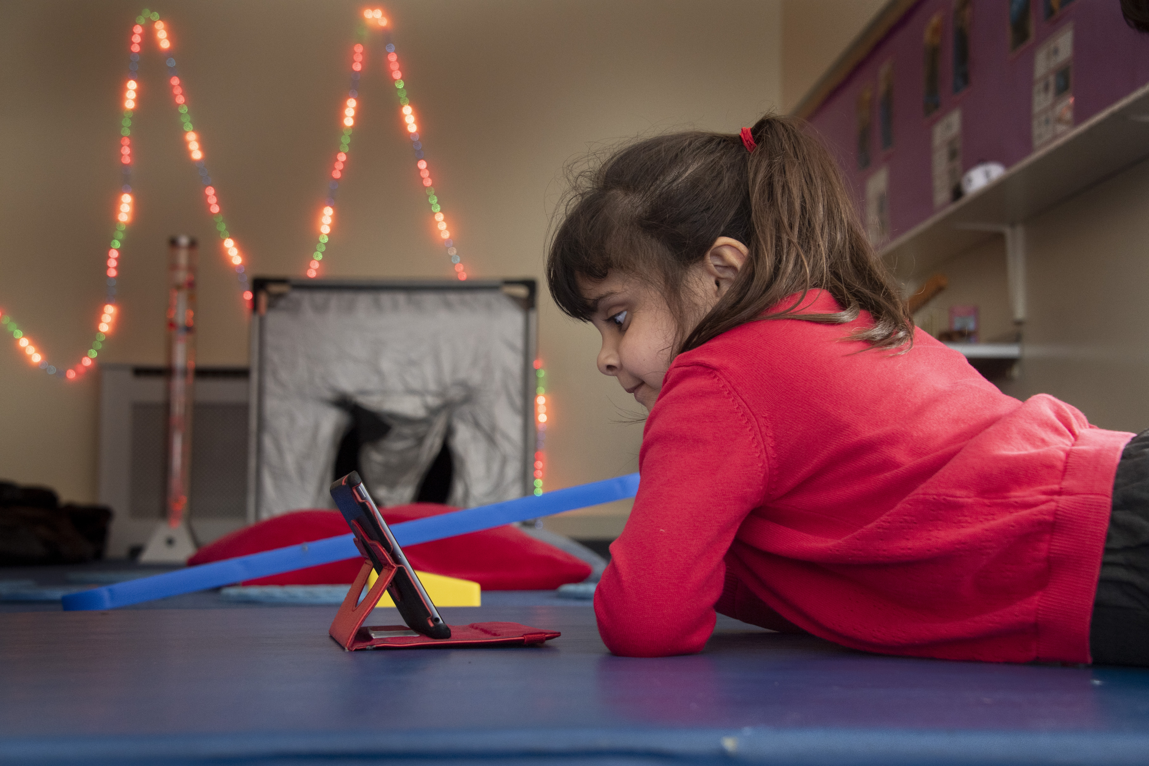

Behaviour


We are proud that OFSTED rated the behaviour and welfare of our academy as ‘Outstanding’. All children are taught to respect each other, the environment and resources in our academy as part of their curriculum.
We understand that young children often have impulsive behaviour and we support them with understanding the need to wait for their turn and share resources. Occasionally it may be necessary to give children quiet time to reflect on their behaviour and calm down.

More information about our behaviour rewards, sanctions and code of conduct can be found in our Behaviour and Discipline Policy available on our website.

Illness

When your child is absent from the academy you must telephone the main office on the first day of absence, before 9.30 am to inform us of the nature of the illness. As part of our rigorous safeguarding procedures, you may receive a text message from us prompting you to call if you do not inform us of the reason for your child’s absence.
You can also send a text before 9:30 am using our School Gateway App.
We have many staff trained in Paediatric First Aid and Emergency First Aid who will look after children in the case of sickness or accident. Please make sure we always have at least two up-to-date phone numbers where we can contact you, or a nominated family member, during the day. Parents will be contacted if your child is considered to be unwell or if staff are concerned about your child’s health or welfare.

Medication

Should your child suffer from any medical condition, e.g. asthma, please ensure that the academy is fully informed about medication etc. that your child may need to take. A medical care plan may need to be drawn up and agreed with the Principal / Vice Principal and parents. It is important that we know if your child has any allergies.

Only medicines prescribed for long-term illnesses such as asthma, epilepsy, diabetes, heart and kidney conditions are allowed in school. ALL medication must be taken to the academy office. Staff will ask you to complete a ‘Consent to Administer Medication’ form. It is the responsibility of the parent/carer to collect any medication at the end of the day. Medication will not be given unless a consent form is completed.

Photographs
Throughout the year in Reception, many photographs will be taken of your child. They will be used to document their learning, special events and on the classroom walls.  If you have any concerns or questions about how your child’s photographs will be used, please talk to a member of staff. | 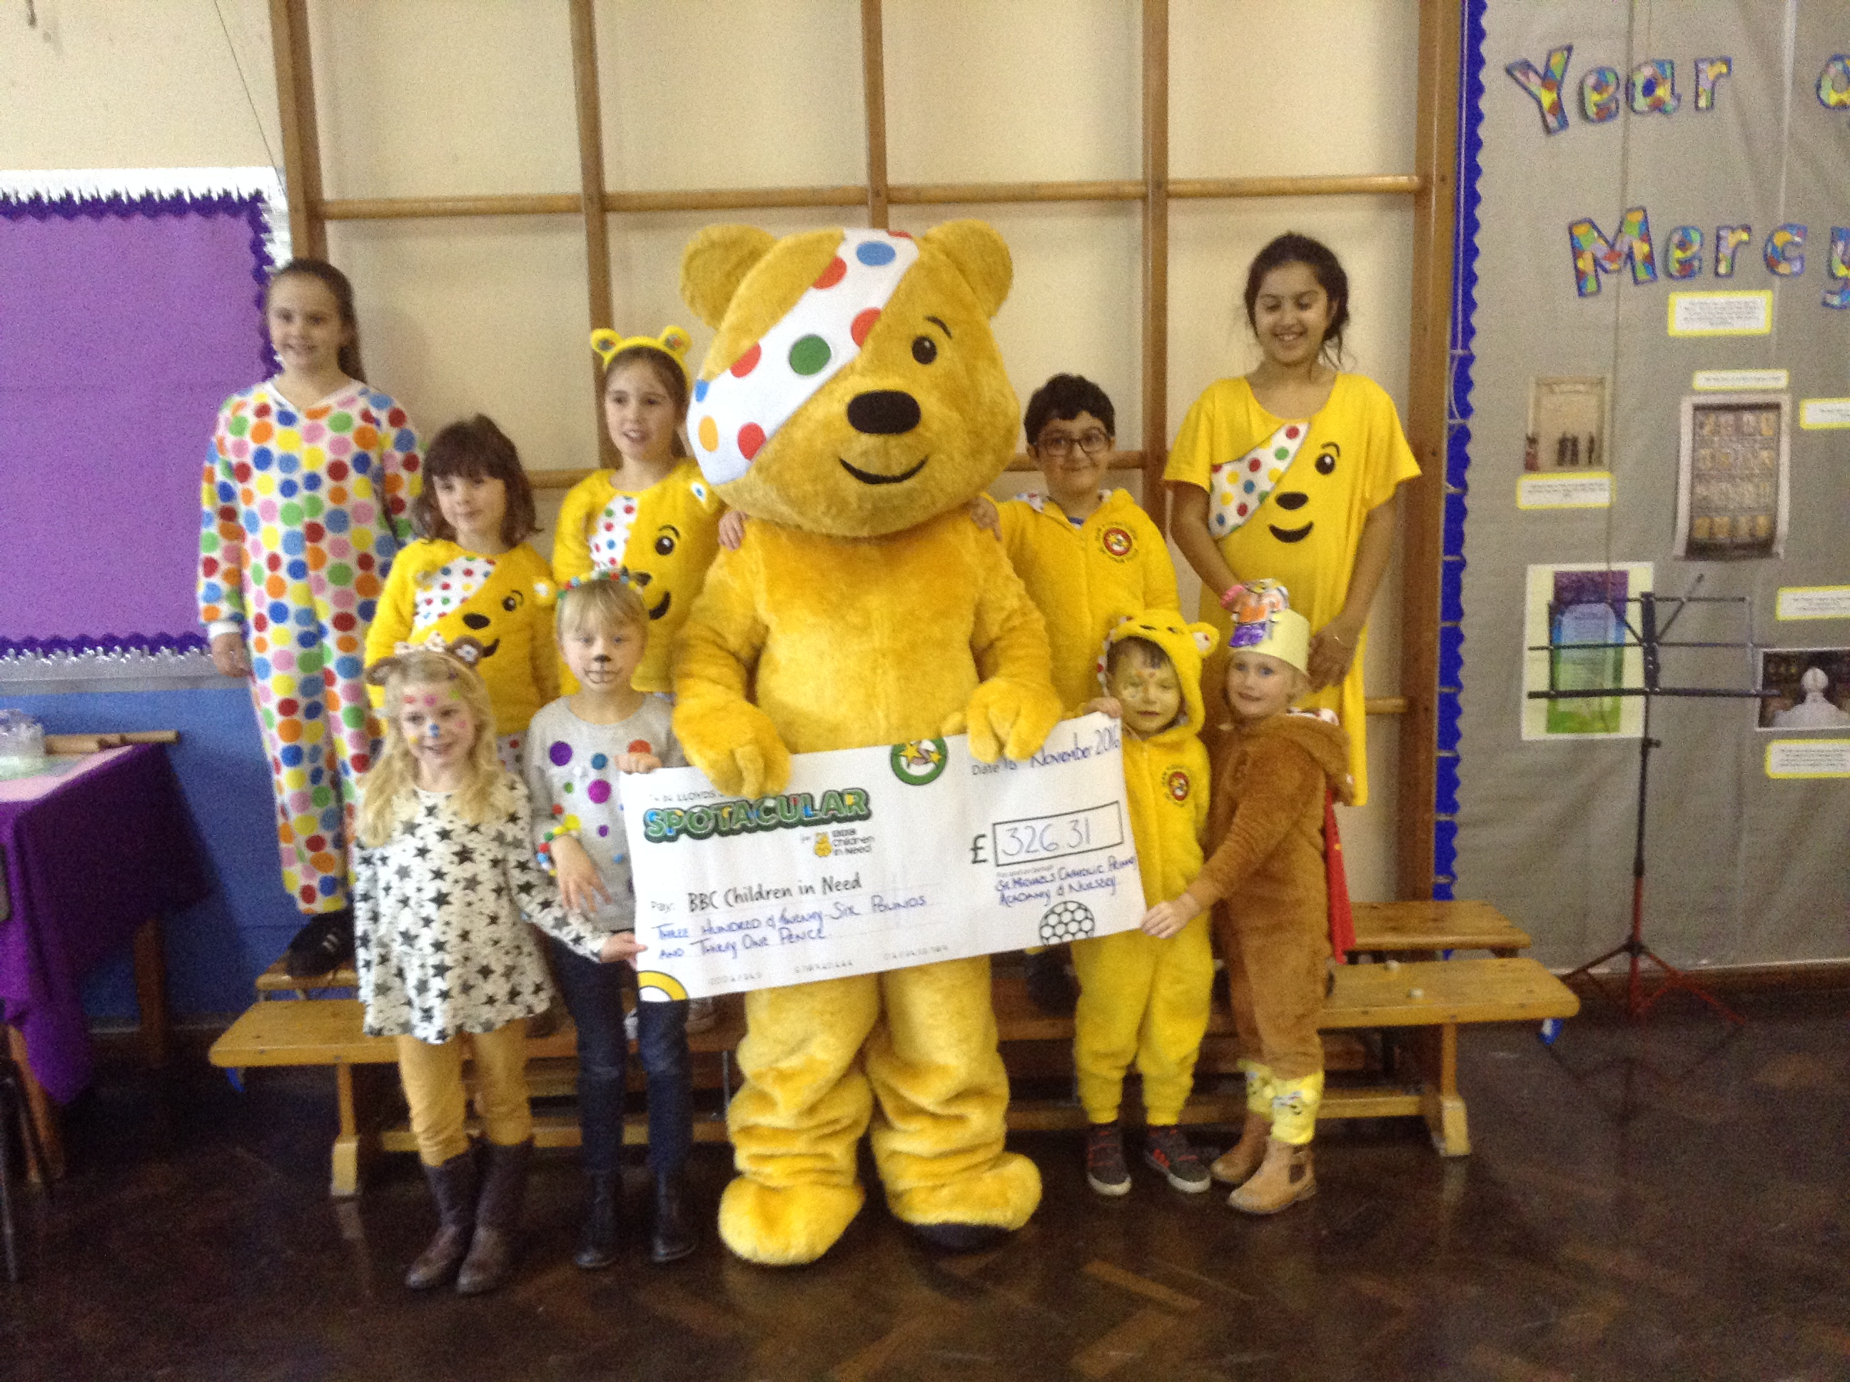

Safeguarding

The academy has a comprehensive and robust Child Protection and Safeguarding Policy, which can be found on our website.
Parents should be aware that all academy staff are committed to safeguarding and promoting the welfare of children. As a result, we will take any reasonable action to ensure the safety of all children. In cases where the academy has reason to be concerned that a child may be subject to ill-treatment, neglect, or any other form of abuse, the Principal is obliged to follow the procedures established by the Wolverhampton Safeguarding Children’s Board and inform social services of the concern.
Parents are invited to visit the ‘Keeping Safe’ area of our website to access a range of support services, helplines, Internet-Safety guides and whistle –blowing contacts.

Communication

We use letters, newsletters, our website and texts - sent from our secure text system ‘Schoolcomms’ - to communicate with you.
A free APP can now be downloaded to receive all text messages, which is suitable for Android & Apple devices. (SEARCH: School Gateway)
A termly ‘Dates Booklet’ is sent from the Principal which contains forthcoming dates and events that parents may wish to enter in their diaries, and refer to throughout the term. Parents and wider family are welcome to attend many of these events.
A monthly newsletter is sent home to share recounts and pictures of some of the events that have taken place throughout the month. It also announces winners of the weekly attendance award.
In addition, each class teacher sends a ‘Curriculum Newsletter’ home at the start of every term containing information about the curriculum the children will be covering during that term.

Parents’ evenings
Three parents’ evenings are held each year, one in each of the Autumn, Spring and Summer Terms. On the consultation evenings, in the autumn and spring terms, parents are given the opportunity to meet with the class teacher to talk about their child’s progress and achievements, and to view their child’s learning. During these evenings the Principal and the Special Educational Needs Co-ordinator are also available to answer any questions that parents may have. An open evening is held in the summer term where parents can view their child’s learning, and visit both their current classroom and next year’s classroom for informal conversations with staff. Children are welcome to attend the Summer open evening, but we recommend that, where possible, children do not attend the Autumn and Spring parents’ evening so that parents and staff are able to fully focus on their conversations with each other.

Reports
A written report is sent home in the summer term prior to the open evening. Each child’s development is monitored and recorded in every subject.

Feedback
We welcome your feedback and may request you to complete a parent survey at some point each academic year. There is also a link to our general parent feedback area on our academy website, which you are welcome to complete after attending any of our events, after meeting with staff etc.


ParentPay

We are a cash-free academy and do not accept cash payments. We use an online system called ParentPay (www.parentpay.com). When you child starts at our academy you will be provided with a unique activation code to enable you to set up your online account.
- ParentPay is easy-to-use and will offer you the freedom to make online payments whenever and wherever you like, 24/7.
- The technology used is of the highest internet security available ensuring that your payment will reach us safely – offering you peace of mind.
- Payments can be made by credit/debit card or also through PayPoint.
- Full payment histories and statements are available to you securely online at any time
- Using ParentPay also ensures that all financial transactions are safe and secure - helping us to remove costs associated with us having to manage cash securely on the academy premises.

Breakfast Club and After-School Care
The Academy offers ‘wrap-around care’ provision in the form of Breakfast Club and After School Care during term time for children in Reception – Year 6.
Both Breakfast Club and After-School Care are held daily in the Moon Room between Nursery & Reception. They provide a safe, secure and enjoyable extension to the academy day for pupils and all are welcome to attend. Both breakfast and after-school care has a maximum of 30 places with a staffing ratio of 1:15 or less.
Breakfast Club – Monday – Friday 7.30am – 8.45am. £5 per child (£8 for 2 siblings)
After-School Care – 3.15pm – 5.15pm. £6 per child (£10 for 2 siblings)
A registration form must be completed to attend Breakfast and After–School Care clubs. Bookings and payments are both completed through ParentPay.
Arrears for fees are not permitted, therefore parents must pay in advance to prevent their child losing their place.
Registration forms are available from the academy office.
All payments must be made using ParentPay and arrears are not permitted. Please read full terms and conditions attached to the booking form.

Parent and Teachers Association (PTA):

St Michael’s Academy boast a very active and supportive Parent and Teachers Association. All parents of children attending St Michael’s Academy are automatically members of the association. We ask that as parents you do become actively involved in the life of the Academy. You are cordially invited to attend any PTA meeting or event. We welcome the opportunity to listen to your ideas as to how we can do more work for the good of the children who attend our Academy.

The aims of the Association/ Charity are:
To advance the education of pupils in the school, in particular by:-
- Developing effective relationships between the staff, parents and others associated with the school.
- Engaging in activities or providing facilities or equipment, which support the school and advance the education of the pupils.

PTA REGISTERED CHARITY NUMBER:- 1114511

Financial Support
If your family is on a low income, your child (or children) may be entitled to additional ‘Pupil Premium Funding’. This would mean free milk beyond 5 years old, free meals beyond Year 2 and the academy receives extra funds which enables us to pay for all school trips until age 11 for those eligible. In addition, the academy often uses this additional funding for additional learning support should your child need it.
We encourage parents and carers to contact either the Academy, or the Pupil Support Department in the Civic Centre if you think your child might be eligible for this funding.
To be eligible, you should be in receipt of Income Support, Income Based Jobseeker’s Allowance, Child Tax Credit (but not Working Tax Credit), be registered as LAC, Post-LAC or receive support from the National Asylum Support Service. If you would like school to check on your behalf whether your child is eligible, please contact the academy office with parent’s full name, parent’s date of birth and parent’s National Insurance number.

Admission to Reception

The Local Authority has determined that there will be a single admission date when children will transfer to full-time schooling. Before your child is 5 years old, Wolverhampton Local Authority will automatically contact you to formally apply for a reception school place using the online system.
Please see our Admission Policy & Criteria found at www.stmichaels-aacdemy.co.uk

Useful Information

Principal: Mrs L Bradley

Acting Vice-Principal: Mrs A Brereton

SENCO: Mrs A Brereton [e-mail: senco@stmichaels-academy.co.uk ]

Academy address: Telford Gardens
Merry Hill
Wolverhampton
West Midlands
WV3 7LE

Academy telephone no: 01902 556368

Academy email address: office@stmichaels-academy.co.uk
We will answer emails between 9.00 – 4.30 Monday to Friday and within 3 days of receipt.

Academy website: www.stmichaels-academy.co.uk

Academy office opening times: 8.15 am – 4.15 am Monday – Thursday
8.15 am - 4.00 pm Friday

Breakfast & After School Care Club: 07486 279943

The information contained in this booklet is correct at the time of printing
but is subject to alteration should circumstances change.

Praise the Lord in work, play and prayer


