St Michael’s Parish Boundaries
(Pink on maps)
Please use this link to zoom further: https://www.birminghamdiocese.org.uk/boundary-map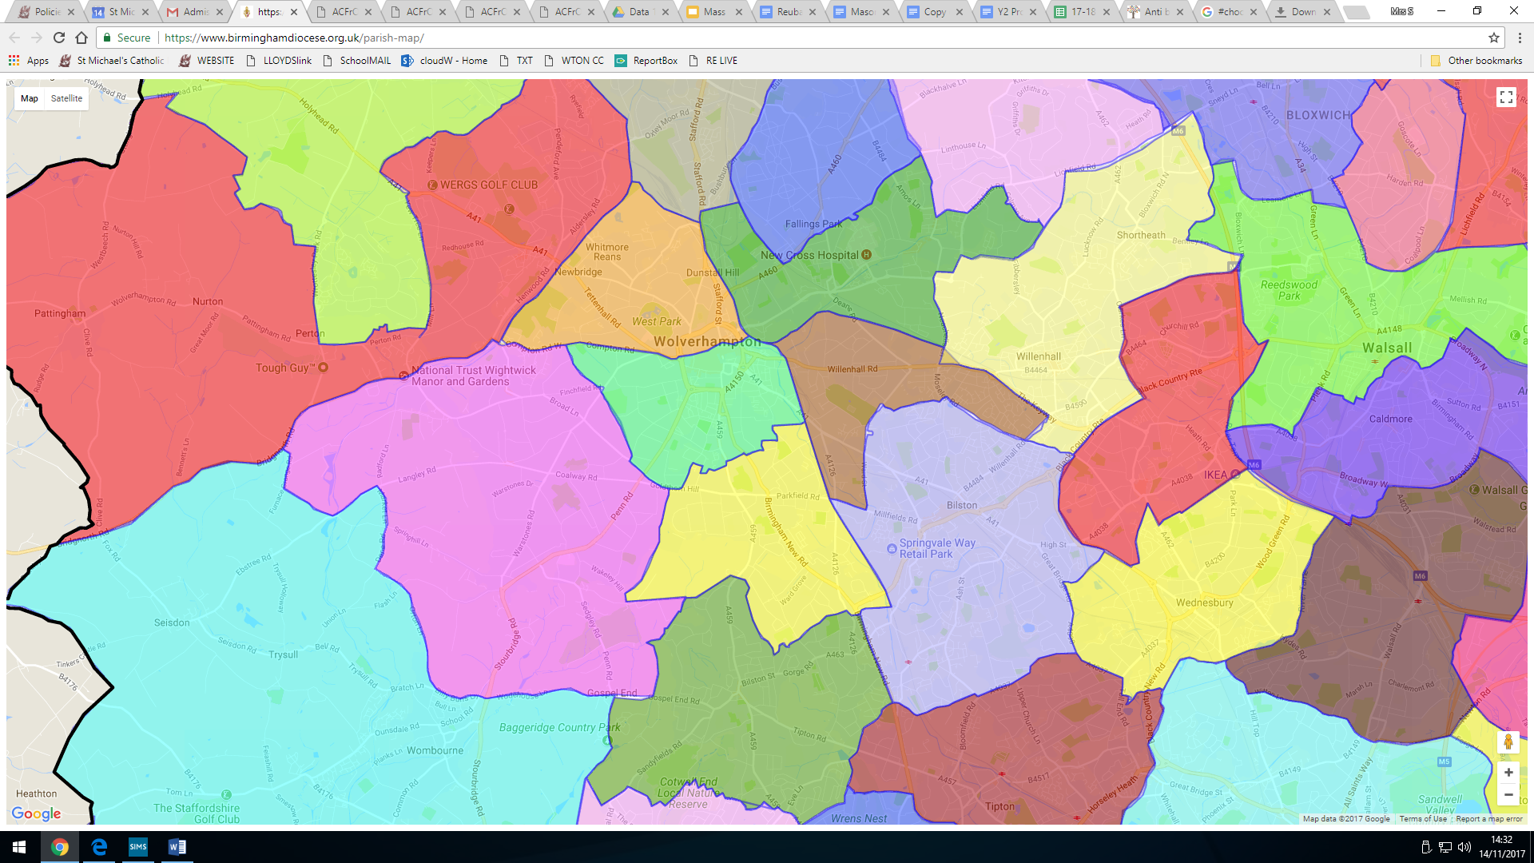
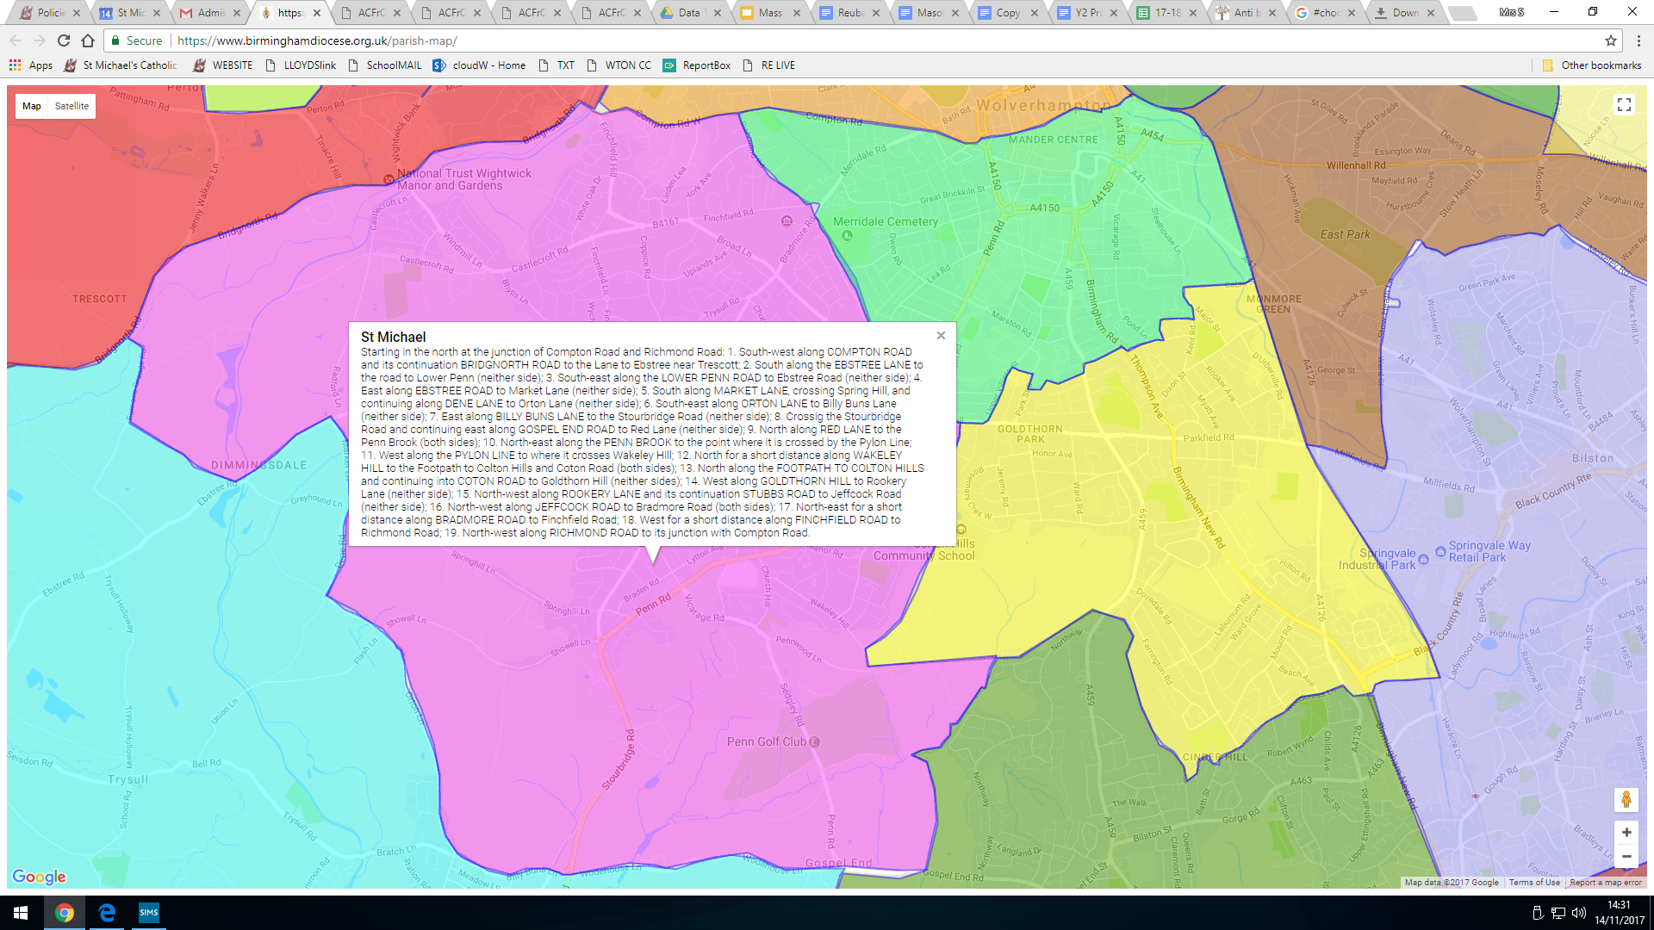
St Michael’ PARISH : Starting in the north at the junction of Compton Road and Richmond Road: 1. South-west along COMPTON ROAD and its continuation BRIDGNORTH ROAD to the Lane to Ebstree near Trescott; 2. South along the EBSTREE LANE to the road to Lower Penn (neither side); 3. South-east along the LOWER PENN ROAD to Ebstree Road (neither side); 4. East along EBSTREE ROAD to Market Lane (neither side); 5. South along MARKET LANE, crossing Spring Hill, and continuing along DENE LANE to Orton Lane (neither side); 6. South-east along ORTON LANE to Billy Buns Lane (neither side); 7. East along BILLY BUNS LANE to the Stourbridge Road (neither side); 8. Crossing the Stourbridge Road and continuing east along GOSPEL END ROAD to Red Lane (neither side); 9. North along RED LANE to the Penn Brook (both sides); 10. North-east along the PENN BROOK to the point where it is crossed by the Pylon Line; 11. West along the PYLON LINE to where it crosses Wakeley Hill; 12. North for a short distance along WAKELEY HILL to the Footpath to Colton Hills and Coton Road (both sides); 13. North along the FOOTPATH TO COLTON HILLS and continuing into COTON ROAD to Goldthorn Hill (neither sides); 14. West along GOLDTHORN HILL to Rookery Lane (neither side); 15. North-west along ROOKERY LANE and its continuation STUBBS ROAD to Jeffcock Road (neither side); 16. North-west along JEFFCOCK ROAD to Bradmore Road (both sides); 17. North-east for a short distance along BRADMORE ROAD to Finchfield Road; 18. West for a short distance along FINCHFIELD ROAD to Richmond Road; 19. North-west along RICHMOND ROAD to its junction with Compton Road.

