Gender Pay Gap

Document title |  | Gender Pay Gap report
Owner |  | Human Resources
Last updated | 28 March 2024 | Review date | 31 March 2025
Purpose
Under the legislation launched in April 2017 for Gender Pay reporting (developed by the Government Equalities Office), in line with ACAS guidance and under the Equality Act 2010 (Gender Pay Gap Information) Regulations 2017, and as an employer with over 250 employees, St Chad’s Academies Trust has a duty to measure and report their gender pay gap for workers in scope and captured as of 31st March 2023 (‘snapshot’ date). Data is captured as of 31 March in each year.

“As we follow Christ in the footsteps of St Chad, we seek to be servant leaders who have a desire to see all those, within our Trust family, truly flourish both spiritually and academically.”

Introduction
Under the legislation launched in April 2017 for Gender Pay reporting (developed by the Government Equalities Office), in line with ACAS guidance and under the Equality Act 2010 (Gender Pay Gap Information) Regulations 2017, and as an employer with over 250 employees, St Chad’s Academies Trust is required to measure and report their gender pay gap for workers in scope as of 31st March 2023 (‘snapshot’ date).
This is our seventh-year reporting Gender Pay.
National context
As the education sector continues to seek a solution to recruitment and retention in the sector and following a year of much debate and action to support colleagues in both teaching and support roles achieve pay in line with inflation, the Trust has remained in line with nationally agreed pay scales and has sought to consider other benefits and rewards across the organisation to support the whole colleague.
Trust context
Established in 2014, St Chad’s Academies Trust is Diocesan Multi Academy Trust operating within one of the largest Dioceses in the country. The Trust is diverse and collaborative in its approach, operating within Sandwell, Stoke on Trent, Walsall, Wolverhampton, Telford & Wrekin, Stafford, and Shropshire.
Our Trust succeeds and prides itself on true collaboration, system leadership and academy to academy support rooted in our distinctively Christian foundations; spiritually, morally, socially, culturally, and academically. The Trust works effortlessly with the 17 primary, 1 Middle and 1 First academies within the Multi Academy Trust to develop an inclusive and diverse working environment through continual CPD for senior and middle leaders, working to remove unconscious bias in all aspects of the employment life cycle through use of language/feedback and allowing reasonable time to support all in progression and development opportunities.
In line with the GPG guidance - The gender pay gap data you must gather - GOV.UK (www.gov.uk) colleagues with irregular working hours, who have not worked during the 3 months period (12 weeks) up to the snapshot date, have not been included in our calculations.
General Principles
The report involves carrying out six calculations that show the difference between the average hourly earnings of men and women in our organization.

- Mean gender pay gap in hourly pay.
- Mean bonus gender pay gap (if relevant)
- Proportion of males and females receiving a bonus payment (if relevant)
- Median gender pay gap in hourly pay.
- Median bonus gender pay gap (if relevant)
- Proportion of males and females in each pay quartile

This report will not involve publishing individual colleagues’ data, in line with Trust GDPR practice.
The challenge in our organization and across Great Britain is to eliminate any gender pay gap.
The overall gender pay gap is defined as the difference between the mean (average) or median (actual midpoint) hourly rate of male and female colleagues.
The Trust supports the fair and equitable treatment of all colleagues, irrespective of gender and through our continual evolution in line with changes in employment law and practice, continue to develop a robust suite of policies and procedures which demonstrate inclusion and equity for our colleagues, working in collaboration with the Trust’s established JCNC (Union body representatives).
We are confident that all our colleagues are paid appropriately and in line with the education sector through remaining in line with national teacher’s terms and conditions (School Teachers Pay & Conditions Document) and support staff (National Joint Council). This process includes annual reviews by the School Teachers Review Board, NJC and Union consultation (including Trust own JCNC) prior to adoption by the Trust, on behalf of its academies, which are applied equally. There is no variation in pay between female and male colleagues undertaking the same role and through our compliance framework we ensure equal pay.
Gender pay, not equal pay.
It is noted for the purpose of this report, gender pay gap reflects workplace or labour market disadvantage and is measured using a range of data. Equal pay is measured at an individual level by comparing the pay for men and women whose work is assessed as being equal.
How we continue to close the gender pay gap.
With the launch of our new policies time is taken to ensure senior leaders are secure in their learning and our information sharing. All colleagues have immediate access to policies through our compliance software upon approval, giving them access to make informed choices. The Trust now needs to measure the impact of the changes made through the policies and procedures launched to be assured they are achieving the principle aims to remove discrimination and unequal/unequitable practice across the Trust, which in turn will further enhance and promote the Trust’s offer as an employer of choice.
The further development of our Family Friendly policies will promote and encourage men and women to share childcare responsibilities and encourage colleagues to take advantage of current arrangements. Alongside these policies the development and embedding of Carers policy and a refocus on Time Off policies which focus on all genders providing the options available to all, removing the stigma, these requirements are gender specific. The Trust will continue to review and refocus practice as legislative and regulatory change is presented to ensure this is considered and factors in our forward thinking, promotion, and change management through inclusive policy launch practice.
At Trust Board our data reporting on starters and leavers will focus on the recruitment and retention of all genders; to determine patterns, turnover, reasons for leaving, length in post, time for appointments which in turn will inform our real time policies and procedures for recruitment, talent management, and equality and diversity.
Work continues to establish a Trust wide support staff pay table as a Trust operating across seven local Authorities. All academies operate within the NJC agreed pay scales, yet it is noted by the Trust, there are differentials between the pay grades min and max points, which may have a bearing on our gender pay reporting.
The Trust needs to develop a clear set of job descriptions to run alongside the pay table which will allow us to apply consistently in practice. Work has been completed which has determined the existing job groups.
The Trust recognizes we need to reach out to other job groups within the organisation, to tap into the other skills in our settings, through inclusion in working groups where they have the relevant skills to enhance the offer and development opportunities. Further work will commence in breaking down barriers where historically expectation has been all matters cascade down through the senior leadership; this will support our effort to develop inclusivity across all job groups.
Supporting gender equality in St Chad’s Academies Trust
The Trust continues to:
- Successfully recruit and retain apprentices of both genders through the utilization and incorporation of the apprenticeship levy – upskilling employees to promote and maximize capability.
- Supporting Early Career teachers with an effective induction and robust mentoring and monitoring
- Access to Subject Leaders in Education, National Professional Qualifications for middle leaders, senior leaders, Principals and Executive Principals
- Monitoring positions across all quartiles through periodic staffing structure reviews and remodeling, where required.
- Appropriately and consistently grade positions irrespective of gender and in line with agreed evaluation scheme: equal pay for equal work, and
- Provide a Financial Wellbeing policy which focuses on in-work poverty and learning and upskilling opportunities which are accessible to all.
This operational perspective continues to enhance the Trust’s vision for a transparent, equal, diverse, and inclusive employer of choice, incorporating succession planning and enhancement of its workforce through open, fair, and equitable recruitment and retention practice, thus sustaining and future proofing the Trust’s vision, and values.
St Chad’s Academies Trust Gender Pay gap information.
The Trust’s Gender Pay Gap Report is based on ‘snapshot’ data taken on the 31 March to include all Trust colleagues: teaching and support (including central function).
Whilst a gap is shown below, this is relatively in line with the education sector as a whole and other multi academy trusts (MATS).

Having reviewed the gender pay gap information for St Chad’s Academies Trust is as follows:
- The mean gender pay gap is 22.93%.
- The median gender pay gap is 29.64%.
- Mean and Median Bonus gap:

 | Male | Female | Percentage Difference
Mean | £2,229.17 | £2,464.29 | -2.61%
Median | £2,500.00 | £2,500.00 | 0.00%

Bonus proportions:
Number of Males receiving bonus: | 4/103
Proportion of Males receiving bonus: | 3.88%
Number of Females receiving bonus: | 7/730
Proportion of Females receiving bonus: | 0.96%

Proportion of males and females in each quartile band: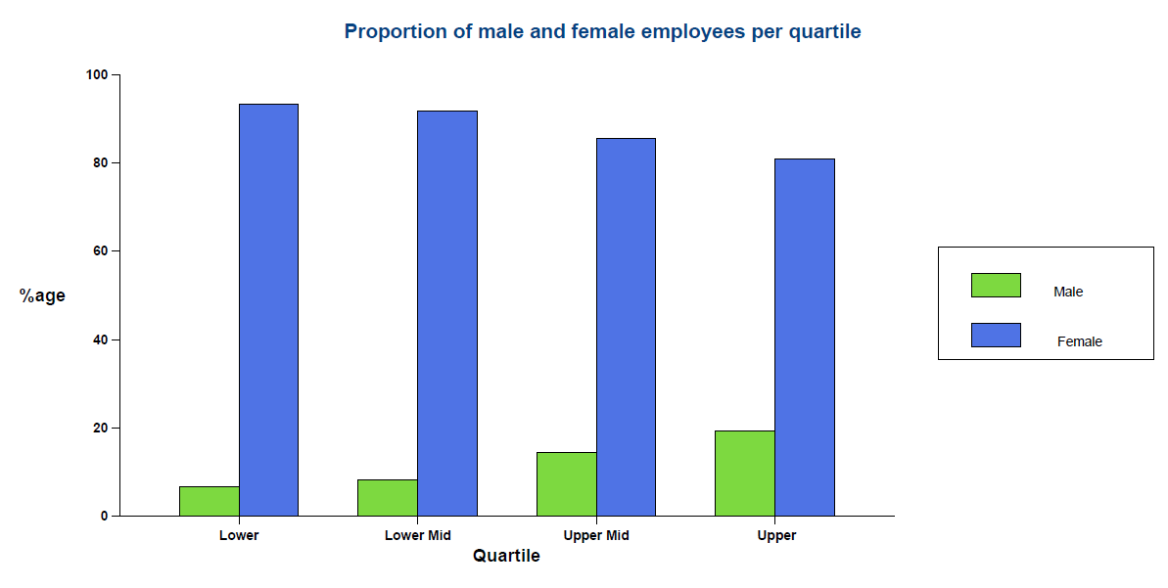
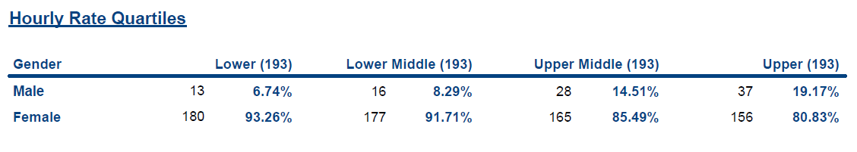
Underlying causes of our Gender Pay Gap
The Trust is confident that our gender pay gap is not caused by paying men and women differently for the same equivalent work/ salaries the roles attract; the Trust believes the gap is affected by workforce distribution and workforce make-up in the primary education sector, where a flexible approach to hours and positions supports colleagues with other personal responsibilities. The Trust approach as outlined above will seek to change this mindset amongst our work force.
St Chad’s Academies Trust employs more women than men, and more women than men in every pay quartile, including the top one. There are a total of 833 colleagues within the period.
Overall female colleagues make up 87.64% of our employees and the greater proportion covered in the Lower and Lower Middle quartiles, who are in essential support roles such as cleaning, catering, lunchtime supervisors, teaching support, and administration. These roles aid a productive, efficient, and effective education and administration working environment, yet are also predominantly part time and term time.

12.36% 87.64%
However, women employed also represent most of our higher paid roles (Upper quartile) such as, teachers, school leadership staff, Principals, Executive Principals and Trust Directors, roles which are paid all year round and are often full time.
I can confirm that the information collated in this report has been drawn from our HRMS and is an accurate reflection of the position relating to gender pay in our organisation.
Zoe Heath – Director of Operations, March 2023
Signed on behalf of the trustees of St Chad’s Academies Trust

Sarah Cockshott, St Chad’s Academies Trust CEO - March 2024

