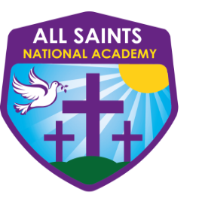
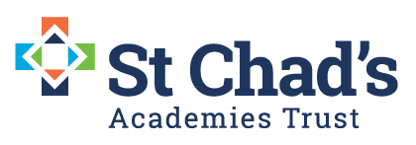

Apprentice Receptionist/Administrator – Apprenticeship rate of pay (dependant on course completion and in line with gov.uk)
Contract: 37 hr p/w (8.15am – 4.15pm) term time only-Fixed Term
Start Date : September 2022
All Saints National Academy, High Street, Bloxwich, West Midlands. WS3 3LP.

We are looking to appoint an Apprentice Receptionist/Administrator to add capacity and support in a range of areas within the academy office/reception. This is a demanding and exciting role, which involves working as part of the team. You will be the professional welcoming face of All Saints National Academy.
The successful candidate would be expected to:
- Be the first point of contact for the school, dealing with all caller/ visitors in a polite and tactful manner;
- To provide an effective reception service at the academy’s main reception.
- To ensure that the front of house runs efficiently and effectively.
- To be presentable and welcoming at all times;
- To actively develop positive, supportive relations with visitors, staff, students and their parents/carers;
- To be organised, able to multitask, work flexibly and have a ‘can do’ approach to work, as no two days are the same.
- To assist the academy with a wide variety of administrative tasks, requiring a good level of IT skills.

We can offer you:
- Level 2 Diploma in Business Administration
- Fantastic, enthusiastic children
- An excellent teaching and learning environment
- Supportive leaders, teachers and assistants
- Support for professional development
Please visit www.asna.walsall.sch.uk for an application pack or email Michelle Skidmore mskidmore@asna.walsall.sch.uk
Visits to the academy are welcome please contact Michelle to arrange a visit on 01922 710210
Closing date for applications: Friday 1st July 12:00 noon
Shortlisting: Monday 4th July 2022
Interview date: Thursday 7th July 2022
The academy is committed to safeguarding and promoting the welfare of children and young people/ vulnerable adults and we expect all staff and volunteers to share this commitment.
The post is subject to an enhanced DBS disclosure check along with other relevant pre-employment checks.
St Chad’s Academies Trust is committed and working towards equal opportunity in employment

