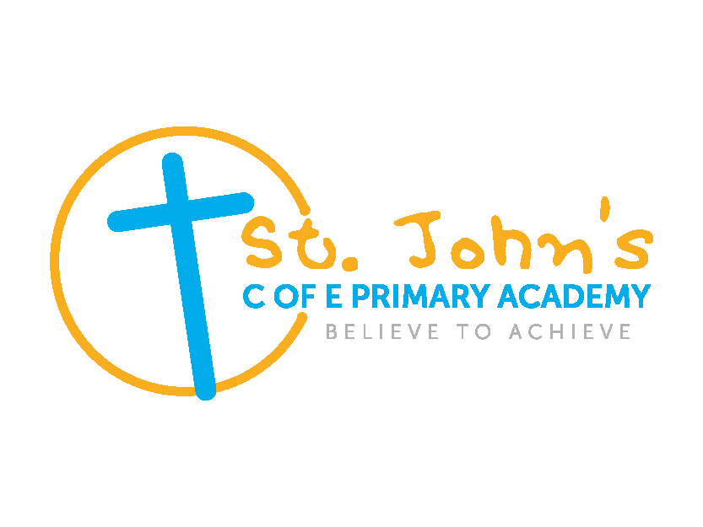

ASSISTANT PRINCIPAL

CANDIDATE PACK
St. John’s C of E Primary Academy (Sandwell)
St Chad’s Academies Trust thrives from the rich diversity of each other’s communities, working together, seeking the common good, raising standards and aspirations, working for equality and hope for all.

Welcome from Sarah Cockshott Interim Executive Principal, St. John’s C of E Primary Academy.
I am pleased that you have shown an interest in this new and exciting post as assistant principal at St. John’s C of E Primary Academy. We are looking to appoint a successful and experienced leader with a particular strength in EYFS.
As the Diocesan Multi Academy Trust for the Lichfield Diocese our Christian values underpin all that we do to improve outcomes and life chances for the children in our care. Our focus is, and will always remain, ‘Children First’.

5969
28%
Pupils
EAL
Working
across
31.5%
4
Communities of Practice
7 LAs
Pupil
Premium
20 1%
Academies
CIC
1034
Employees

As the largest primary multi academy trust in the West Midlands region there are nineteen academies within the Trust across seven local authorities.
- Sandwell
- Stoke-on-Trent
- Staffordshire
- Shropshire
- Telford and Wrekin
- Walsall
- Wolverhampton

We enjoy effective partnerships with the local authorities that we serve, and benefit from sharing good practice across the region. We celebrate and benefit from rich, diverse communities and work with academies situated in small villages to large inner- city organisations.

We have developed four Communities of Practice where smaller groups of academies geographically connected meet and work together on generic and identified issues and developments. We also meet regularly as one family to support, guide, challenge and look out for one another.
We enjoy open and honest relationships, where academy leaders shoulder the responsibilities of all children within the Trust and work for the success of other academies as well as their own, working together for the greater good and actively demonstrating effective system leadership. We are in this together!
We work in an environment where we learn together collectively as a group. Everyone sees the bigger picture and understands how parts of the organisation connect to each other and the whole. Attitudes, behaviour, and the overall culture within the organisation are embedded and have contributed to a successful learning community.
We believe:
- All children have the right to the best education that can be provided.
- All academies can improve to become good and outstanding.
- All children and young people in our care have an entitlement to spiritual care and guidance.
- Every academy will champion the ethos and values of the Trust enabling children to clearly identify themselves as children of God.
- All staff have access to well-planned, bespoke professional development to meet the needs of the academy and the individual
- Partnership and collaboration with and between academies will bring about
significant improvement in the education of all children in our care.

We are seeking to appoint a like-minded assistant principal for St. John’s C of E Primary Academy, Wednesbury.
The academy is enriched and enhanced by a hard-working energetic staff who put children at the forefront of their thinking. Children are nurtured and supported within the academies taking full advantage of the opportunities laid before them.
If you want to make a difference to the lives of children, support fellow colleagues then please express your interest. Please do make contact for a conversation Sarah Cockshott: sarah.cockshott@stjohnsacademy.co.uk

Sarah Cockshott, Executive Principal, St. John’s C of E Primary Academy

St. John’s C of E Primary Academy (Sandwell)

Overview

St. John’s C of E Primary Academy admits pupils from age 5 to 11 years. We ensure that within the Anglican tradition we uphold the principle of being inclusive and in promoting cohesion in our academy and across our local community. We currently have 202 pupils on roll across 7 years groups.

We not only serve pupils from Wednesbury but also surrounding areas such as Walsall, Tipton and other areas within Sandwell.

The academy is situated in the town of Wednesbury and is an oasis for our pupils. The original building was a Victorian build located near the Church of St. John’s/ However, both the church and the school were closed, and a new school built in the 1970s.

The vision at St. John’s is that we are an inclusive and loving family who celebrate our similarities and differences. Together we face new challenges with endurance whilst generously supporting each other along the way. When things go wrong, we forgive others as well as asking for forgiveness ourselves. We are the generation of today, empowered by our personal faith and beliefs. All children and staff are valued and encouraged to fulfil their potential in all aspects of academy life.
The school motto of ‘Together we ‘Believe to Achieve’ knowing that “Everything is possible for one who believes”. Mark 9:23. exemplifies what we expect of pupils and adults and in conjunction with our academy values is the driver for our reward system. Our values are central to academy life:

G - Generosity
E - Endurance
T - Tolerance
F - Forgiveness
A - Ambition
B – Belief

We have links with our local Church; St. Bartholomew’s and have been to worship there several times.

St. John’s C of E Primary Academy’s curriculum is broad and balanced and is underpinned by its unique curriculum drivers: Knowledge of the World, Enterprise and Environment. It raises children’s aspirations demonstrating possibilities for their future lives, fostering independence and resilience. High expectations in speech, language and communication strengthen children’s ability to learn at a deeper level, allowing them to articulate their learning, demonstrating quality thinking and application of skills and knowledge. We provide pupils with rich learning experiences, a full range of educational visits are encouraged in all a year groups including residentials for every year group, extra-curricular activities and enrichment opportunities.
In September 2017 Ofsted graded the school as ‘Good’ and following this an outstanding SIAMs was awarded.

The school is well resourced and with capital works programme has been well maintained. The school also has excellent outdoor facilities for all pupils including a field with a gym, a quieter reflection area, a story circle and a sensory garden.

The academy holds the Primary Science Quality Mark, Music Mark and is working towards gaining the History Mark. Music is taught by a specialist music teacher who works closely with our staff and is a strength of the school.

Our school day:

8:50am Registration
10.30 KS1 Morning Break
10.45 KS2 Morning Break
12.00 EYFS and KS1 Lunch
12.15 KS2 Lunch
1.00 Afternoon Sessions start for EYFS and KS1
1.15 Afternoon Session start for KS1
2.15 KS1 Afternoon Break
3:30pm End of school day

We offer a breakfast club from 8.00am a charge is made for this and places have to be booked in advance.

After school clubs run and offer a variety of activities such as multi-skills, boxing, dance, gymnastics, film club, coding club, homework club to name a few.

