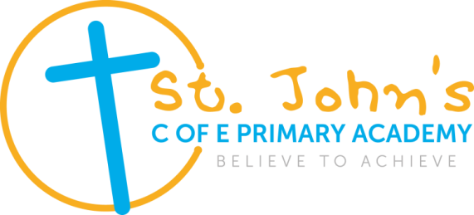 

**1:1 Level 3 Teaching Assistant (with additional needs responsibilities) required.**

**Salary**: Grade D Scale point range 9-17- £20,903-£24,491 whole year/FTE

Actual salary range £16,683 - £19,549 per annum (dependent on experience)

**Hours:** 32.5 hours per week

**Contract:** Permanent until the child with the EHCP leaves the academy, or during the review process it is deemed an EHCP is no longer required.

Term Time only (including INSET days)

**Start Date** : 3rd June 2021 or as soon as is possible.

**St John’s C of E Primary Academy**

Addison Terrace, Wednesbury, West Midlands, WS10 9AR

St John’s CE Primary Academy (part of St Chad’s Academies Trust) is seeking an enthusiastic, energetic and innovative teaching assistant with experience working 1:1 with a primary aged child with cognitive learning needs.

The role will involve providing 1:1 support to an individual child for 32.5 hours per week. The post is term time and permanent until the child leaves the academy, or during the review process it is deemed an EHCP is no longer required.

The successful candidate will be dedicated to improving outcomes for this child and supporting the family and other professionals. The programmes to support this individual child will include support learning in the core subjects (class based during the morning) as well as assessing both the learning and social/emotional needs. They will also deliver a range of 1:1 and small group interventions with other primary age children who have learning and social needs.

**We are looking for a teaching assistant who is:**

* Qualified with a minimum of a level three childcare related qualification.  
* Advantage in working within a SEND setting.  
* Resilient and able to overcome difficult situations.  
* Confident interacting with a wide range of personalities.  
* Able to work independently and confidently with children and young people of primary ages  
* Able to use their initiative and take on additional responsibilities as and when necessary  
* A personable and caring individual who is committed to providing excellence to children in their

Care and also to be able to provide feedback on a regular basis to parents.

*Provide feedback to pupils and teachers in relation to progress, achievement, behaviour, attendance etc.

* Experience of working in the classroom and delivering individual or small group interventions.

**We offer:**

* Motivated, enthusiastic children with outstanding behaviour.
* Children who are eager to contribute, learn and are highly proud of their academy communities that live out their Christian values.
* Professional and dedicated colleagues.
* A thorough and robust induction programme.
* A welcoming environment.
* Opportunities for training and professional development.
* Supportive parents and Governors.
* A principal with a clear vision for the future.

Interviews will be held according to the current COVID-19 guidance but this also means that we cannot allow visits to the school. See the Academy website for more information.

For further information and an application pack please contact the Academy Business Manager Ruth Owen on 0121 556 0269 or e-mail ruth.owen@stjohnsacademy.co.uk

Closing date for application: Midday on Monday 19th April 2021.

Short listing will take place on the afternoon of Monday 19th April 2021.

Interviews will be held on Monday 26th April 2021.

The academy is committed to safeguarding and promoting the welfare of children and young people/ vulnerable adults and we expect all staff and volunteers to share this commitment.

The post is subject to an enhanced DBS disclosure check along with other relevant pre-employment checks.

St Chad’s Academies Trust is committed and working towards equal opportunity in employment.

