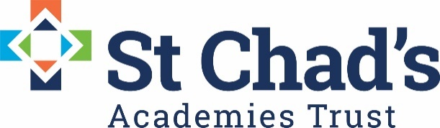

CALENDAR DATES FOR MATHS QUALITY LEARNING CIRCLE 2020/21

DATE | TIME | VENUE | EVENT
Thursday 12th  November  2020 | 3.30-5.00 | Virtual Teams Meeting | Maths QLC
Thursday  3rd  December  2020 | 3.30-5.00 | Virtual Teams Meeting | Maths QLC
Thursday 11th  February  2021 | 3.30-5.00 | Virtual Teams Meeting | Maths QLC
Tuesday  9th  March  2021 | 3.30-5.00 | Virtual Teams Meeting | Maths QLC

