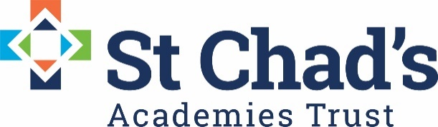

CALENDAR DATES FOR ENGLISH QUALITY LEARNING CIRCLE 2020/21

DATE | TIME | VENUE | EVENT
Wednesday 4th November  2020 | 3.30-5.00 | Virtual Teams Meeting | English QLC
Wednesday 25th  November  2020 | 3.30-5.00 | Virtual Teams Meeting | English QLC
Wednesday 3rd  February  2021 | 3.30-5.00 | Virtual Teams Meeting | English QLC
Wednesday  3rd  March  2021 | 3.30-5.00 | Virtual Teams Meeting | English QLC

